KPV 10mg
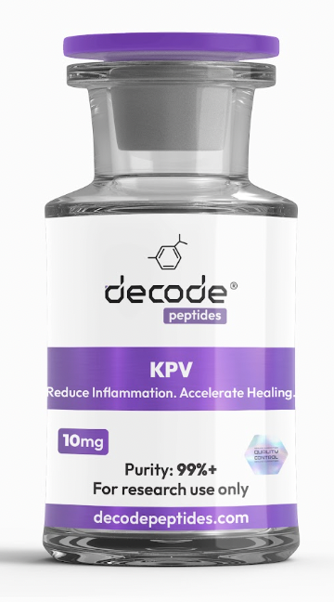

WHAT IT’S FOR
KPV is a small anti-inflammatory peptide best known for its potential to support gut health, intestinal inflammation, immune balance, and tissue healing. It is especially researched for its effects on inflammatory pathways in the digestive tract. Think of it as a peptide focused on calming inflammation and supporting the gut lining.

HOW IT WORKS
KPV is a three-amino-acid peptide fragment derived from alpha-melanocyte-stimulating hormone (α-MSH). Research suggests KPV may influence inflammatory signaling pathways, including pathways involving NF-κB and inflammatory cytokines. Run it for at least six to eight weeks. KPV works by blocking NF-KB signaling, so it takes time to calm the inflammatory environment before you see real tissue healing - but it works!

HOW YOU’LL FEEL
KPV is not generally associated with an immediate stimulant or noticeable energy effect. Any perceived changes would typically be gradual. People exploring KPV commonly focus on changes in digestive comfort, skin, gut-related symptoms, inflammation, and recovery, although these effects have not been established in controlled human trials.

EXAMPLE RESEARCH PROTOCOL
— KPV 10MG
Using the protocol you’ve been working with:
• Add 2 mL (200 units) bacteriostatic water to the 10mg vial
• Concentration: 50 mcg per syringe unit
Week 1
• 250 mcg once daily
• Draw 5 units
Weeks 2–3
• 500 mcg once daily
• Draw 10 units
If a research protocol progresses to 1,000 mcg/day:
• Split into 500 mcg morning + 500 mcg evening
• Draw 10 units AM + 10 units PM

SIMPLE BREAKDOWN
10mg KPV + 2mL water
250 mcg = 5 units
500 mcg = 10 units
1,000 mcg = 20 units total
At 500 mcg/day, one 10mg vial contains 20 daily doses.

KPV Protocol — Inflammatory / Itchy Skin / Gut Health
Duration: 6–8 weeks minimum before assessing the full response.
Week 1: 250 mcg once daily
Weeks 2–4: 500 mcg once daily
If responding: Continue 500 mcg daily through weeks 6–8.
If there is little improvement after the initial period: The protocol you were given escalates to 1,000 mcg/day, split into 500 mcg AM + 500 mcg PM, for up to 4 weeks.
Maintenance if it works: 250–500 mcg daily was suggested, with a 4-week break every 3 months.

What you’re looking for
KPV is being used here primarily for its proposed anti-inflammatory effects, including inhibition/modulation of NF-κB signaling. The rationale is strongest when the skin problem appears inflammatory, immune-mediated, histamine-related, or connected with gut inflammation.
If there is no meaningful reduction in itching, redness, or active inflammation after several weeks, reconsider the underlying cause rather than simply increasing the dose. A persistent rash can have fungal, bacterial, allergic/contact, medication-related, hormonal, metabolic, autoimmune, or other dermatologic causes that KPV would not necessarily address.
LL-37 and thymosin alpha-1—have different immune effects and shouldn’t automatically be stacked onto KPV without identifying what is actually driving the rash. In particular, suspected infection is a reason to get the skin evaluated rather than empirically treating it with peptides.

Where to get it:
DecodePeptides.com stocks KPV 10mg. Third-party tested. Comes with a full reconstitution guide and injection tutorial.
WhatsApp: +43 681 81917872
For research purposes only. Not for human consumption.

Disclaimer & Usage Guidance:
This protocol is provided for educational and informational purposes only. KPV is an investigational peptide and is not FDA-approved for treating inflammatory, gastrointestinal, or other medical conditions. The dosing information above reflects illustrative research practices and should not be interpreted as medical advice, diagnosis, or treatment. Human safety, efficacy, optimal dosing, and long-term risks have not been established. Any therapeutic consideration involving an investigational compound should be discussed with an appr

Source links
http://decodepeptides.com

