MOTS-C
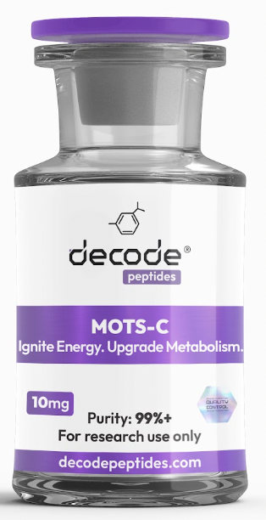

WHAT IT'S FOR
MOTS-C is often referred to as the "exercise mimetic" peptide. It is designed to improve mitochondrial function, increase energy production, enhance metabolic flexibility, and support fat loss. Think of it as a tool that helps your body become more efficient at producing and using energy.

HOW IT WORKS
MOTS-C is a mitochondrial-derived peptide that activates AMPK, often called the body's metabolic master switch. This helps cells use glucose more efficiently, improves insulin sensitivity, encourages fat burning, and supports mitochondrial health. It essentially teaches your body to create energy more effectively while reducing metabolic stress.

HOW YOU'LL FEEL
Within the first 1-2 weeks, many people notice improved energy, better workout performance, and increased motivation to move. By weeks 3-6, fat loss often becomes more noticeable, endurance improves, and recovery between workouts feels easier. Many users report feeling more resilient and energetic throughout the day.

WHO IT'S FOR
Ideal for individuals looking to improve energy levels, enhance fat loss, support healthy aging, improve exercise performance, optimize metabolic health, or break through weight loss plateaus.

WHO IT'S NOT FOR
Not recommended for pregnant or nursing women. Individuals with uncontrolled medical conditions should consult their healthcare provider before use. Not intended as a replacement for exercise, nutrition, or healthy lifestyle habits.

RECONSTITUTION GUIDE
• Vial size: MOTS-C 10mg
• Add: 1.8ml (180 units) bacteriostatic water
• Dose: Draw 0.3ml (30 units)
• Doses per vial: 6 injections
• One vial provides approximately 2 weeks of use
• Storage: Refrigerate after mixing
• Use within: 30 days
• Needle: 29–31g insulin syringe
• Injection site: Abdominal fat (subcutaneous)

SIMPLE BREAKDOWN
1 vial = 6 doses
Monday = 30 units
Wednesday = 30 units
Friday = 30 units
Repeat for 2 weeks until vial is complete.
You are your own best study. Pay attention to energy, recovery, training performance, body composition, and overall resilience during both the ON and OFF phases.

BEST STACKS
With Retatrutide
For enhanced fat loss, appetite control, and metabolic optimization. Retatrutide reduces hunger while MOTS-C helps improve energy expenditure and metabolic flexibility.
With NAD+
For mitochondrial health and cellular energy production. One of the most popular longevity combinations.
With CJC-1295/Ipamorelin
For body recomposition, recovery, lean muscle support, and healthy aging.

PROTOCOL EXAMPLES

BEGINNER PROTOCOL
MOTS-C 5mg per week for 4-6 weeks.
Goal: Increase energy, improve exercise performance, and support metabolic health.

INTERMEDIATE PROTOCOL
MOTS-C 10mg per week + NAD+ 100-200mg weekly for 6-8 weeks.
Goal: Improve mitochondrial function, fat loss, recovery, and overall vitality.

ADVANCED PROTOCOL
MOTS-C 10mg per week + Retatrutide + CJC-1295/Ipamorelin for 8 weeks.
Goal: Comprehensive body recomposition, improved metabolic health, enhanced recovery, and longevity support.

Where to get it:
DecodePeptides.com stocks the highest quality MOTS-C. Third-party tested. Comes with a full reconstitution guide and injection tutorial. We can walk you through your first injection if needed. WhatsApp: +43 681 81917872
For research purposes only. Not for human consumption.
Disclaimer & Usage Guidance: This protocol is provided for educational and informational purposes only. All compounds referenced are intended for research and therapeutic exploration and are not presented as medical advice, diagnosis, or treatment. Dosing guidelines are illustrative and based on commonly reported practices. Individual requirements may vary significantly. All peptides are highly individualised. Factors such as age, metabolism, mitochondrial health, lifestyle, and overall wellbeing play a significant role in determining response, benefits, and outcomes. Cycling peptides is commonly used as a precautionary measure, although requirements may vary depending on the individual and protocol. General Administration Guidance: Morning injections are typically performed in a fasted state; wait approximately 30 minutes before eating. Evening injections are best administered 2 hours after the last meal to optimise absorption. Any use of these compounds should be undertaken with appropriate medical oversight where applicable. The author assumes no responsibility or liability for any outcomes resulting from the use or misuse of the information provided.

