PROTOCOL  BPC157/TB500 10/10mg AKA The Wolverine Stack | 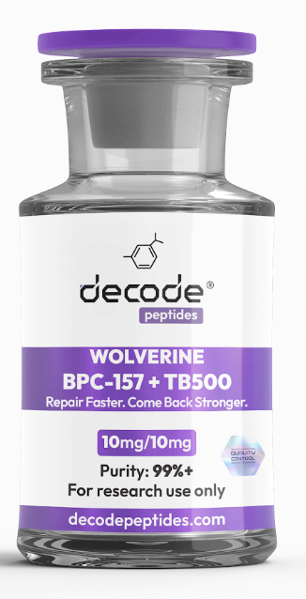

01 WHAT IT’S FOR
BPC-157 + TB-500 is a popular regenerative peptide combination researched for tissue repair, injury recovery, inflammation, tendons, ligaments, muscles, and connective tissue. The idea behind combining them is that they may influence different aspects of the repair process.

02 HOW IT WORKS
BPC-157 is a synthetic peptide derived from a protective gastric protein fragment. Preclinical research suggests effects on tissue repair, blood-vessel formation, inflammatory signaling, and tendon and ligament healing.
TB-500 is a synthetic peptide related to thymosin beta-4. Thymosin beta-4 has been studied for roles in cell migration, tissue remodeling, angiogenesis, and wound repair.

03 EXAMPLE RESEARCH PROTOCOL
BPC-157 10mg + TB-500 10mg combined vial
If reconstituted with 2mL (200 units) bacteriostatic water:
• 5 units = 250 mcg
• 10 units = .5mg
• 20 units = 1mg
A commonly discussed experimental approach uses 500 mcg of each peptide once daily, which would equal 10 units with this reconstitution.

04 SIMPLE BREAKDOWN
10mg BPC-157 + 10mg TB-500
Add 2mL bacteriostatic water
250/250 mcg = 5 units
500/500 mcg = 10 units
1mg/1mg = 20 units
At 10 units per day, one combined vial provides approximately 20 daily doses.

05 INJECTION LOCATION
Subcutaneous administration is commonly discussed in experimental protocols. There isn’t good human evidence showing that injecting directly beside an injury produces better results than another subcutaneous location, so injections should not be placed into an injured tendon, ligament, joint, or muscle without medical supervision.

06 COMMONLY DISCUSSED RESEARCH COMBINATIONS
With KPV
Studied or discussed in regenerative research contexts involving inflammation, tissue repair, and recovery. Human evidence for the combination remains limited.
With GHK-Cu
A regenerative research combination focused on tissue remodeling, inflammatory signaling, and repair.
With NAD+
Sometimes explored alongside metabolic and cellular-energy protocols, although evidence supporting the combination specifically with KPV is limited.

07 Where to get it:
DecodePeptides.com stocks BPC157 10mg. Third-party tested. Comes with a full reconstitution guide and injection tutorial.
WhatsApp: +43 681 81917872
For research purposes only. Not for human consumption.

08 Disclaimer & Usage Guidance:
This protocol is provided for educational and informational purposes only. KPV is an investigational peptide and is not FDA-approved for treating inflammatory, gastrointestinal, or other medical conditions. The dosing information above reflects illustrative research practices and should not be interpreted as medical advice, diagnosis, or treatment. Human safety, efficacy, optimal dosing, and long-term risks have not been established. Any therapeutic consideration involving an investigational compound should be discussed with an appr

09 Source links
http://decodepeptides.com

