PROTOCOL  CJC-1295 (NO DAC) | 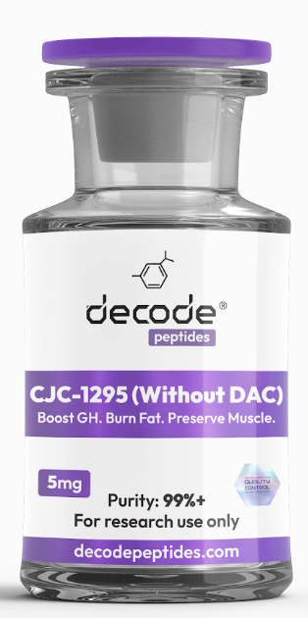

01 WHAT IT'S FOR
CJC-1295 (No DAC) is a growth hormone-releasing peptide (GHRH) analogue designed to stimulate your body's natural production of growth hormone. Unlike synthetic growth hormone, it works by signaling your pituitary gland to release more of your own GH in a natural pulse-like pattern. Think of it as a tool for recovery, fat loss, muscle preservation, sleep optimization, and healthy aging.

02 HOW IT WORKS
CJC-1295 (No DAC) binds to GHRH receptors in the pituitary gland, stimulating natural growth hormone release. This leads to increased IGF-1 production, enhanced recovery, improved fat metabolism, deeper sleep, and better tissue repair. Because it has a shorter half-life than DAC versions, it more closely mimics the body's natural GH rhythms.

03 HOW YOU'LL FEEL
Within the first few days, many users report deeper sleep, vivid dreams, and improved recovery from training. Over several weeks, body composition improvements become more noticeable, including increased muscle fullness, reduced body fat, improved skin quality, and better overall recovery capacity.

04 WHO IT'S FOR
Ideal for individuals focused on fat loss, recovery, performance, healthy aging, muscle preservation, sleep optimization, and body recomposition.

05 WHO IT'S NOT FOR
Not recommended for pregnant or nursing women. Individuals with active cancer or untreated serious medical conditions should consult their healthcare provider before use. Not intended as a substitute for proper nutrition, sleep, or exercise.

06 DOSING PROTOCOL
• Add 2ml (200 units) bacteriostatic water to the vial
• Draw 12 units per injection
• Inject subcutaneously once daily
• Best taken before bed
• Avoid food for approximately 2 hours before injection
• Wait approximately 30 minutes before eating after administration
• Typical cycle length: 8-16 weeks
Many users combine CJC-1295 (No DAC) with Ipamorelin for a stronger GH pulse.

07 IMPORTANT
• Consistency matters more than increasing the dose
• Sleep quality plays a major role in results
• Best results occur when combined with strength training and adequate protein intake
• More is not always better

08 SIMPLE BREAKDOWN
Daily Protocol
Every Evening
• Draw 12 units
• Inject before bed
• Remain fasted for approximately 2 hours beforehand
Typical Cycle
Weeks 1-8
• Improved sleep quality
• Enhanced recovery
Weeks 8-16
• Body composition improvements
• Increased muscle retention
• Improved fat loss
• Enhanced recovery capacity

09 COMMON SIDE EFFECTS
• Mild water retention
• Headaches
• Temporary tingling sensations
• Increased hunger
• Mild injection site irritation

10 BEST STACKS
With Ipamorelin
The classic pairing. CJC stimulates growth hormone release while Ipamorelin amplifies the pulse for greater recovery and body composition benefits.
With MOTS-C
Combines mitochondrial support and metabolic optimization with recovery and growth hormone support.
With Retatrutide
Popular body recomposition stack combining fat loss, appetite control, recovery, and muscle preservation.

11 Where to get it:
DecodePeptides.com stocks the highest quality CJC-1295 (No DAC). Third-party tested. Comes with a full reconstitution guide and injection tutorial. We can walk you through your first injection if needed. WhatsApp: +43 681 81917872
For research purposes only. Not for human consumption.
Disclaimer & Usage Guidance: This protocol is provided for educational and informational purposes only. All compounds referenced are intended for research and therapeutic exploration and are not presented as medical advice, diagnosis, or treatment. Dosing guidelines are illustrative and based on commonly reported practices. Individual requirements may vary significantly. All peptides are highly individualised. Factors such as age, metabolism, sleep quality, training status, nutrition, and overall wellbeing play a significant role in determining response, benefits, and outcomes. Any use of these compounds should be undertaken with appropriate medical oversight where applicable. The author assumes no responsibility or liability for any outcomes resulting from the use or misuse of the information provided.

