PROTOCOL  CJC-IPA 5mg/5mg Process: | 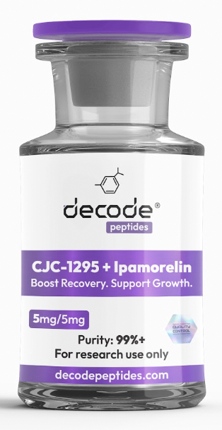

01 Protocol
Make 2x vials at a time which will cover 20x days
Remove cap off each and clean top with alcohol swab
Use a 27G syringe to draw out 100units (1ml) of sterile water
Insert into the vial and let the water slowly run onto the side of the vial as if pouring a beer
Draw another 100units (1ml) of water and repeat putting into the vial using same gentle water on side of vial
You now have 200units (2.0ml) of sterile water in your vial which will, over 24hrs, dissolve your CJC/IPA and create a juicy wonderful solution.
Repeat with the second vial.
DO NOT SHAKE BOTTLE. Peptides are fragile and you will literally break them.
Keep these vials in the fridge, ideally still in the box (with their non reconstituted friends) and in the cheese compartment.
Each night, just before bed, you will take out your made up vial, wipe the top with an alcohol swab, turn it upside down and use your 29G syringe to draw out 20units (0.2ml) of solution = 500mcg of each
Without letting the needle touch a surface, then use same alcohol swab to rub the skin you intend to inject into so it’s sterile.
Pinch the skin/fat together and ‘punch’ the needle through surface of skin - doesn’t have to go full depth, as long as it’s under the skin you’re done.
Push plunger to inject your desired amount Eg. 20units (0.2ml) and then withdraw the needle and throw this in sharps bin provided.
Hop into bed and let the magic happen.
Remember… make two vials at a time and then when you finish the *second* vial on day 20, make the next two vials as only needs 24hrs to ‘set’.
Another tip - rotate sides for injection each night so left side, ride side, left side etc.
Must let CJC-IPA ‘set’ for 24hrs after adding water or else it will not have reconstituted and dosages will not be accurate. Think of it like allowing cordial to mix throughout the water after you pour it in.
Therefore:
Cycle Length | Vials Needed
8 weeks (56 days) | 3 vials
12 weeks (84 days) | 4 vials
16 weeks (112 days) | 5 vials
24 weeks (~6 months) | 7 vials

02 Timing tips
Inject subcutaneously.
Ideally avoid eating for 60–90 minutes before and 30–60 minutes after the injection, particularly foods containing carbohydrates or fat, as elevated insulin may blunt the growth hormone pulse.
Protein alone is generally less disruptive than carbohydrate or mixed meals.

03 What to expect
Effects tend to build gradually:
Weeks 2–4: Improved sleep quality and recovery.
Weeks 4–8: Better workout recovery, body composition changes, and increased training capacity.
Weeks 8–12: More noticeable improvements in lean mass, fat loss (if nutrition is appropriate), skin quality, and overall recovery.
For research purposes only. Not for human consumption.

04 Disclaimer & Usage Guidance:
This protocol is provided for educational and informational purposes only. All compounds referenced are intended for research and therapeutic exploration and are not presented as medical advice, diagnosis, or treatment. Dosing guidelines are illustrative and based on commonly reported practices. Individual requirements may vary significantly. All peptides are highly individualised. Factors such as age, metabolism, sleep habits, stress levels, lifestyle, and overall wellbeing play a significant role in determining response, benefits, and outcomes. Any use of these compounds should be undertaken with appropriate medical oversight where applicable. The author assumes no responsibility or liability for any outcomes resulting from the use or misuse of the information provided.

