PROTOCOL  GHK-Cu 50mg | 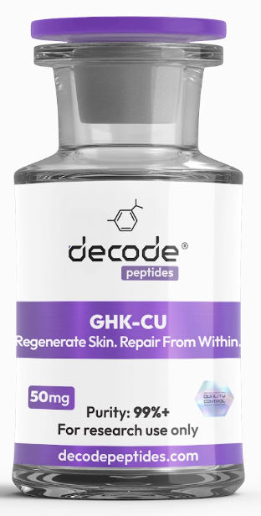

01 WHAT IT'S FOR
GHK-Cu is one of the most researched regenerative peptides available. It is best known for supporting skin rejuvenation, collagen production, wound healing, hair growth, tissue repair, and healthy aging. Think of it as a peptide that helps your body repair, regenerate, and restore itself from the inside out.

02 DOSING PROTOCOL
• Add 3ml (300 units) bacteriostatic water to the vial
• Draw 10 units daily (1.7mg daily)
• Best to inject in the inner thigh (anywhere but your stomach)
• Best taken in the morning
• Typical cycle length: 8 weeks on/8 weeks off
TIPS To avoid GHKCU lumps and bruises:
Keep it out the fridge for 15 mins before
Inject super slow and not too close to the surface of skin. Make sure needle is in
Pinch the fat with other hand as you inject
Rub firmly for 20 seconds after
Top of the butt cheek is the easiest for me as more fat.
You can try diluting it with a bit more bacteriostatic water. A slightly weaker concentration can reduce the sting and post-injection lumps.
Another trick that’s worked well for some people is injecting KPV straight afterwards, it seems to calm the area down very quickly.
For research purposes only. Not for human consumption.

03 Disclaimer & Usage Guidance:
This protocol is provided for educational and informational purposes only. All compounds referenced are intended for research and therapeutic exploration and are not presented as medical advice, diagnosis, or treatment. Dosing guidelines are illustrative and based on commonly reported practices. Individual requirements may vary significantly. All peptides are highly individualised. Factors such as age, metabolism, nutrition, lifestyle, and overall wellbeing play a significant role in determining response, benefits, and outcomes. Any use of these compounds should be undertaken with appropriate medical oversight where applicable. The author assumes no responsibility or liability for any outcomes resulting from the use or misuse of the information provided.

