PROTOCOL  GLOW (BPC-157 + TB-500 + GHK-Cu) | 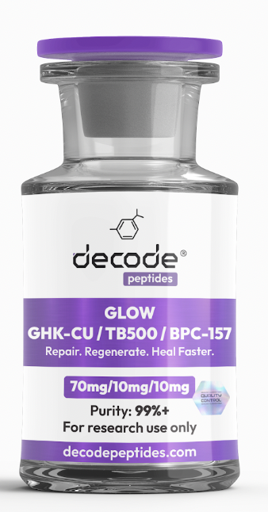

01 WHAT IT'S FOR
This is a premium recovery and rejuvenation blend. It's designed for deep tissue repair, accelerated healing from injuries, and significant skin anti-aging effects. Think of it as a triple-action tool for fixing damage from the inside out and turning back the clock on your skin.

02 HOW IT WORKS
It combines three powerful peptides. BPC-157 promotes healing in tendons, ligaments, and the gut. TB-500 (Thymosin Beta-4) reduces inflammation and builds new blood vessels for repair. GHK-Cu is the superstar for skin—it remodels collagen, reduces wrinkles, and improves elasticity by activating skin stem cells.

03 HOW YOU'LL FEEL
Within 1-2 weeks, you'll notice reduced joint stiffness and faster recovery from workouts. By week 3-4, skin starts feeling tighter and more hydrated. By week 8, significant improvements in skin texture, firmness, and a visible reduction in fine lines are commonly reported. The overall feeling is one of enhanced resilience.

04 WHO IT'S FOR
Ideal for athletes managing chronic joint pain, individuals recovering from soft tissue injuries, or anyone over 30 looking for a serious, injectable anti-aging protocol for skin and connective tissue health.

05 WHO IT'S NOT FOR
Anyone with active cancer, pregnant or nursing women, or individuals with a known copper allergy (due to GHK-Cu). Not for those seeking purely muscle-building effects.

06 DOSING PROTOCOL
• Dose: 1mg (10 units)
• Frequency: 2 times per day
• Cycle length: 8-12 weeks
• Method: Subcutaneous injection
• Timing: Morning and evening, at least 8 hours apart

07 RECONSTITUTION GUIDE
• Vial size: 3ml vial containing BPC-157 10mg + TB-500 10mg + GHK-Cu 50mg
• Add: 3ml bacteriostatic water
• Concentration: Each 0.1ml (10 units) delivers the full blend dose.
• Example: One dose = draw to the 10 unit mark on an insulin syringe.
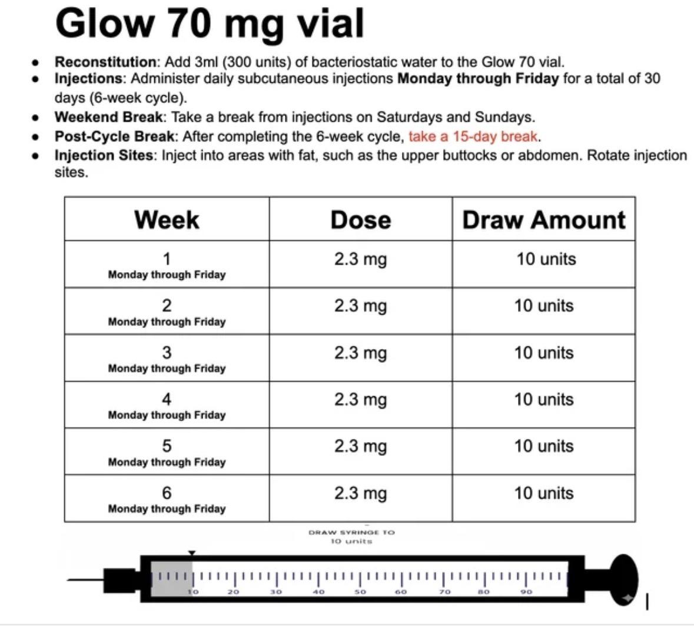

08 BEST STACKS
1. With CJC-1295/Ipamorelin: For amplified anti-aging and recovery. Increases your body's own GH pulse, synergizing with the repair and collagen synthesis of GLOW.
2. With AOD-9604: For targeted fat loss in stubborn areas while the skin is being tightened and remodeled by GLOW.
3. With NAD+ (injectable or nasal): For cellular energy and mitochondrial support, creating a comprehensive longevity and rejuvenation stack.

09 Where to get it:
Decodepeptides.com stocks the highest quality Retatrutide. Third-party tested. Comes with full reconstitution guide and injection tutorial. We can walk her through the first injection if needed. Whatsapp: +43 681 81917872
For research purposes only. Not for human consumption. Disclaimer & Usage Guidance
This protocol is provided for educational and informational purposes only. All compounds
referenced are intended for research and therapeutic exploration and are not presented as medical advice, diagnosis, or treatment. Dosing guidelines are illustrative and based on commonly reported practices. Individual requirements may vary significantly. All peptides are highly individualised. Factors such as age, metabolism, mitochondrial health, lifestyle, and overall wellbeing play a significant role in determining response, benefits, and outcomes. Cycling peptides is commonly used as a precautionary measure, although requirements may vary depending on the individual and protocol. General Administration Guidance: Morning injections are typically performed in a fasted state; wait approximately 30 minutes before eating. Evening injections are best administered 2 hours after the last meal to optimise absorption. Any use of these compounds should be undertaken with appropriate medical oversight where applicable. The author assumes no responsibility or liability for any outcomes resulting from the use or misuse of the information provided.

