PROTOCOL  Glutathione 1500mg | 

01 Protocol
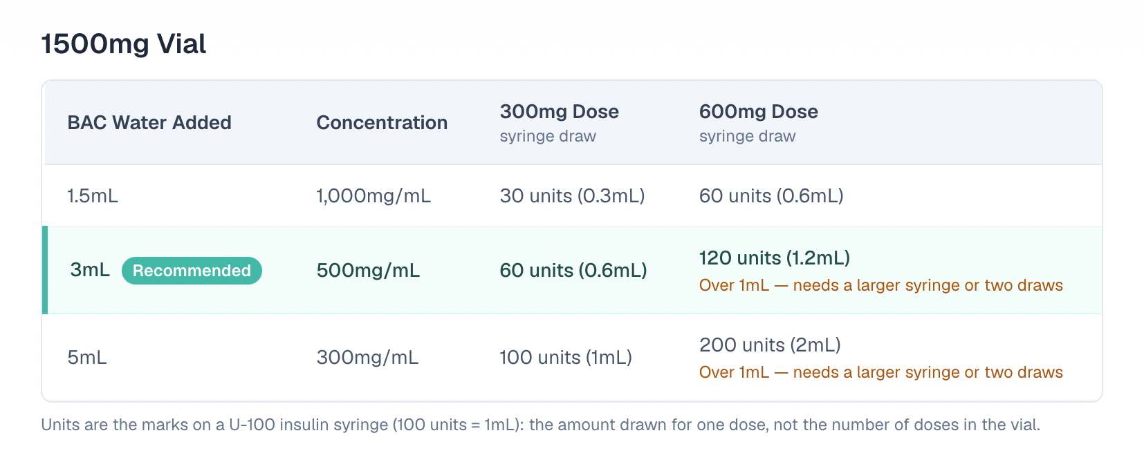
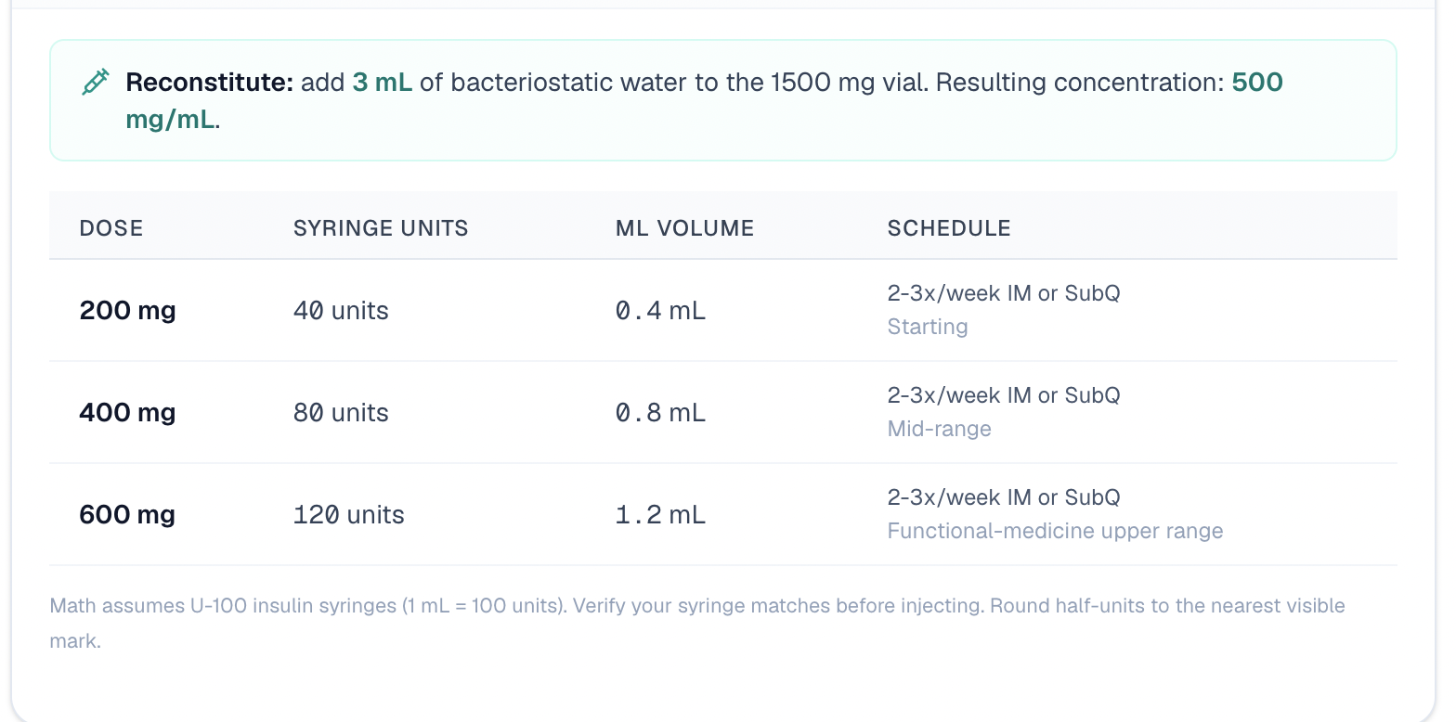

02 TIP:
Make sure to keep it in the fridge!

