PROTOCOL  KISSPEPTIN-10mg | 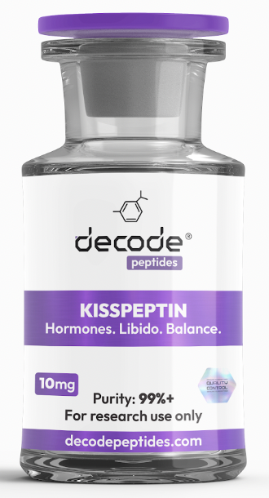

01 WHAT IT'S FOR
Kisspeptin is a hormone-signaling peptide that plays a key role in regulating testosterone production, fertility, libido, reproductive health, and hormone balance. Unlike testosterone replacement therapy, Kisspeptin works upstream by stimulating your body's own natural hormone production. Think of it as a peptide that helps "wake up" your natural hormone signaling pathways.

02 HOW IT WORKS
Kisspeptin stimulates the hypothalamus to release GnRH (Gonadotropin-Releasing Hormone), which signals the pituitary gland to produce LH and FSH. These hormones then stimulate the testes or ovaries to produce natural sex hormones. In men, this can support healthy testosterone production. In women, it plays an important role in reproductive hormone signaling.

03 HOW YOU'LL FEEL
Many users report improvements in libido, mood, motivation, confidence, and overall wellbeing within the first few weeks. Men often notice improved morning erections, increased sexual desire, and improved energy. The effects are generally subtle and natural rather than dramatic or artificial.

04 WHO IT'S FOR
Ideal for men seeking natural testosterone support, individuals looking to improve libido, those coming off hormone suppression, and people interested in optimizing reproductive hormone function.

05 WHO IT'S NOT FOR
Not recommended for pregnant or nursing women. Individuals with hormone-sensitive cancers or serious endocrine disorders should consult their healthcare provider before use. Not intended to replace medically necessary hormone therapy.

06 DOSING PROTOCOL
• Add 2ml (200 units) bacteriostatic water to the vial
• Draw 10 units daily
• Inject subcutaneously once daily
• Best taken in the morning
• Typical cycle length: 8-12 weeks
Many users notice the best results when Kisspeptin is combined with proper sleep, resistance training, and adequate nutrition.

07 IMPORTANT
• Kisspeptin stimulates natural hormone production rather than replacing hormones
• Results are generally gradual and natural
• Bloodwork before and after a cycle is recommended
• Lifestyle factors significantly influence results

08 SIMPLE BREAKDOWN
Daily Protocol
Every Morning
• Draw 10 units
• Inject subcutaneously
• Continue daily

09 COMMON SIDE EFFECTS
• Mild headache
• Temporary flushing
• Increased libido
• Mild injection site irritation
Most users tolerate Kisspeptin extremely well.

10 BEST STACKS
With CJC-1295 (No DAC)
Combines hormone optimization with recovery, growth hormone support, and body composition benefits.
With HCG
Often used by men focused on fertility, testosterone production, and reproductive health.
With MOTS-C
Supports metabolic health, energy production, recovery, and overall vitality.

11 WHAT TO EXPECT
Week 1-2
• Increased libido
• Improved mood
• Better motivation
Week 3-6
• Enhanced energy
• Improved sexual health
• Greater sense of wellbeing
Week 6-12
• Improved hormone optimization
• Better recovery
• Sustained improvements in libido and vitality

12 Where to get it:
DecodePeptides.com stocks the highest quality Kisspeptin. Third-party tested. Comes with a full reconstitution guide and injection tutorial. We can walk you through your first injection if needed.
WhatsApp: +43 681 81917872
For research purposes only. Not for human consumption.

13 Disclaimer & Usage Guidance:
This protocol is provided for educational and informational purposes only. All compounds referenced are intended for research and therapeutic exploration and are not presented as medical advice, diagnosis, or treatment. Dosing guidelines are illustrative and based on commonly reported practices. Individual requirements may vary significantly. All peptides are highly individualised. Factors such as age, metabolism, hormone status, lifestyle, nutrition, and overall wellbeing play a significant role in determining response, benefits, and outcomes. Any use of these compounds should be undertaken with appropriate medical oversight where applicable. The author assumes no responsibility or liability for any outcomes resulting from the use or misuse of the information provided.

