PROTOCOL  MT-2 (Melanotan II) | 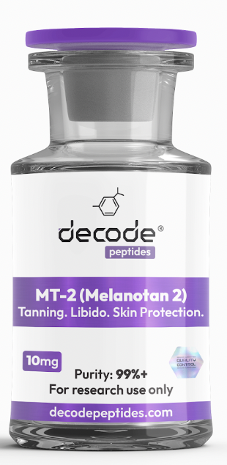

01 WHAT IT'S FOR
MT-2 is a synthetic peptide designed to stimulate melanin production, helping the skin tan more easily with less UV exposure. Many users also report increased libido and reduced appetite. Think of it as a tool for achieving a darker, longer-lasting tan while potentially supporting confidence and body composition goals.

02 HOW IT WORKS
MT-2 mimics alpha-MSH (melanocyte stimulating hormone), which signals melanocytes in the skin to produce melanin. More melanin means a greater tanning response when exposed to sunlight or UV light. It also interacts with receptors involved in appetite regulation and sexual function.

03 HOW YOU'LL FEEL
Within the first few doses, some people notice facial flushing, increased warmth, mild nausea, or increased libido. Over 1-2 weeks, freckles and moles often become darker and the skin begins developing a tan much more easily. Over several weeks, most users achieve a deeper tan while requiring less sun exposure than normal.
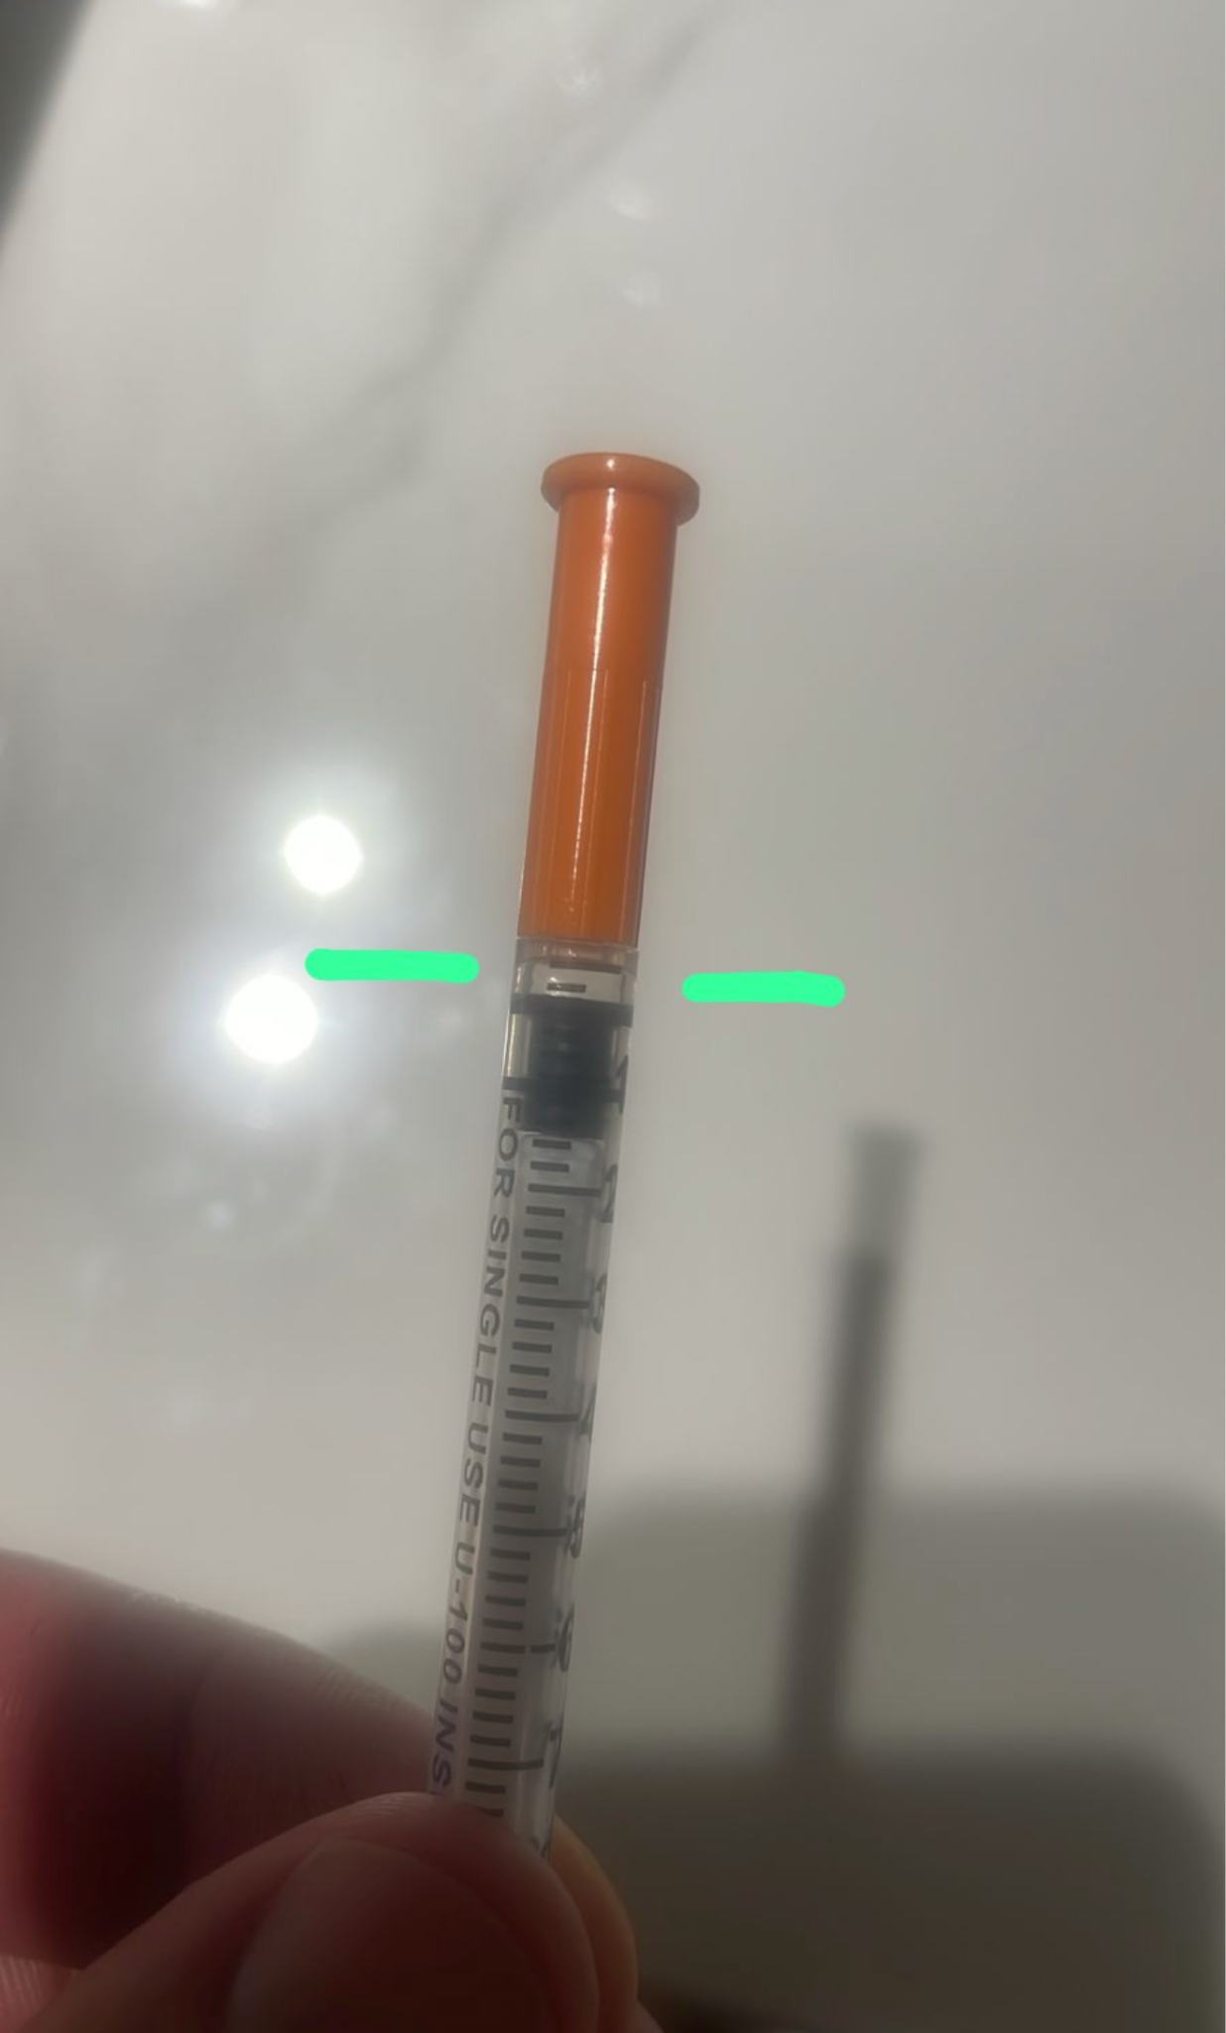

04 WHO IT'S FOR
Ideal for fair-skinned individuals who struggle to tan, people seeking a year-round bronzed appearance, and those wanting to reduce the amount of sun exposure needed to maintain a tan.

05 WHO IT'S NOT FOR
Not recommended for pregnant or nursing women. Individuals with a history of melanoma or active skin cancer should avoid use unless advised by their healthcare provider. Anyone unwilling to monitor skin changes should not use MT-2.

06 DOSING PROTOCOL
• Add 2.5ml (250 units) bacteriostatic water to the vial
• Draw 0.025ml (2.5 units) on an insulin syringe
• Inject into belly fat before bed
• Repeat daily until desired tanning level is achieved
• Once desired tan is reached, reduce to 1-2 injections per week for maintenance
• Less is more with MT-2

07 IMPORTANT
• This is 2.5 units, NOT 25 units
• The dose is extremely small
• Many people accidentally overdose because they misread the syringe
• If unsure, err on the side of less

08 COMMON SIDE EFFECTS
• Mild nausea
• Facial flushing
• Increased libido
• Darkening of freckles and moles
• Temporary fatigue
• Increased skin pigmentation
For research purposes only. Not for human consumption.
Disclaimer & Usage Guidance: This protocol is provided for educational and informational purposes only. All compounds referenced are intended for research and therapeutic exploration and are not presented as medical advice, diagnosis, or treatment. Dosing guidelines are illustrative and based on commonly reported practices. Individual requirements may vary significantly. All peptides are highly individualised. Factors such as age, metabolism, lifestyle, sun exposure, and overall wellbeing play a significant role in determining response, benefits, and outcomes. Any use of these compounds should be undertaken with appropriate medical oversight where applicable. The author assumes no responsibility or liability for any outcomes resulting from the use or misuse of the information provided.

