PROTOCOL  NAD+ 500mg Protocol | 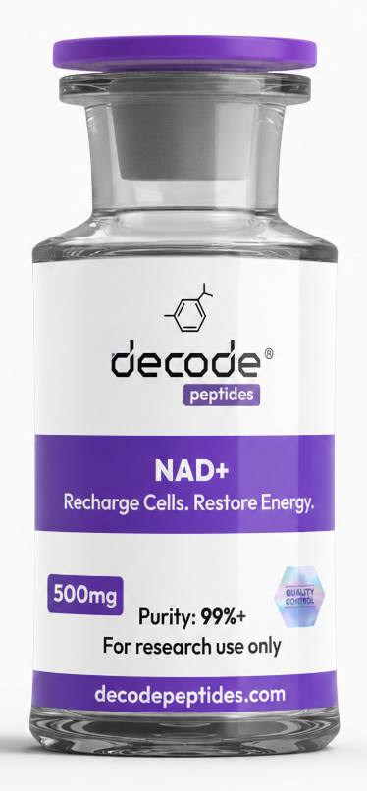

01 Protocol
Master regulator of cellular energy production but also plays a vital role in DNA repair and longevity signaling. NAD+ production declines with age in human tissue, and by your mid-40s you have typically lost +50% of what you carried in your 20s.
This has been shown by extensive research to be one of the central mechanisms driving accelerated aging, metabolic dysfunction, neurodegeneration, and collapsing resilience.

02 Reconstitution
Vial: NAD+ 500mg
Add: 3mL bacteriostatic water
Storage: Refrigerate after mixing
Use a U100 insulin syringe (0.5mL or 1mL)
Protocol Options
⭐ Longevity / Maintenance
Dose: 50mg
Draw: 30 units
Frequency: 3 times weekly (Mon/Wed/Fri)
Timing: Morning, ideally fasted
Cycle: 4–8 weeks or ongoing. WOMEN: 3 months on and one month off
One vial provides:
10 doses
Approximately 3 weeks at 3 injections/week

03 Recovery / Burnout / Low Energy Support
Dose: 100mg
Draw: 60 units
Frequency: 3 times weekly
Timing: Morning, preferably fasted
Cycle: 4–8 weeks
One vial provides:
5 doses
About 1.5 weeks at 3 injections/week
Administration
Subcutaneous injection.
Morning administration is preferred.
Wait ~30 minutes before eating if taken fasted.
Suggested Stacks
Energy + Mitochondrial Support
NAD+ 50–100mg
+
MOTS-c 10mg
5mg (50 units) Monday, Wednesday, Friday
Cycle 4–6 weeks
Longevity Stack
NAD+ 50mg 3× weekly
+
SS-31 5–10mg daily
4–8 week cycle
Performance & Recovery Stack
NAD+ 100mg three times weekly
MOTS-c 5mg three times weekly
CJC-1295/Ipamorelin before bed
Creatine 5g daily
Electrolytes and high protein intake
Example Weekly Schedule
Day | Morning
Monday | NAD+ 50-100mg
Tuesday | —
Wednesday | NAD+ 50-100mg
Thursday | —
Friday | NAD+ 50-100mg
Saturday | —
Sunday | —

Key Benefits
Cellular energy production
Mitochondrial support
Mental clarity and focus
Healthy aging and longevity
Recovery from stress and burnout
Supports overall metabolic function
Educational purposes only. Individual dosing should always be personalized.

04 Source links
https://pubmed.ncbi.nlm.nih.gov/22848760/

