PROTOCOL  Retatrutide (RETA) 10mg | 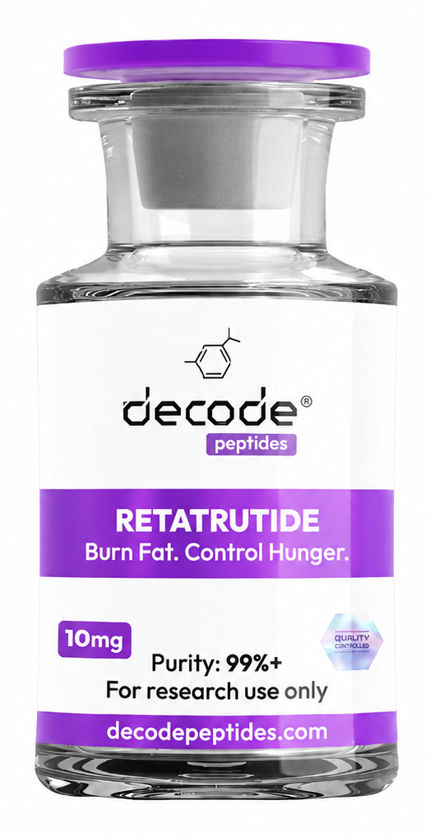

01 What it is
Triple agonist peptide — hits GIP, GLP-1, and glucagon receptors. Think of it as the next-gen fat loss peptide. Clinical trials showed average 24% body weight loss over 48 weeks. It's powerful.

02 Mechanism of action
Works on three pathways: reduces appetite (GLP-1), improves insulin sensitivity and fat metabolism (GIP), and increases energy expenditure (glucagon). Basically tells your body to burn fat, feel full, and stop storing excess energy.

03 Primary applications
• Significant fat loss (especially stubborn areas)
• Appetite suppression
• Improved metabolic health and insulin sensitivity
• Improves Fatty liver disease
• Improves blood pressure and cholesterol

04 Dosing
The amount is increased gradually over time rather than starting at a higher amount.
Weeks 1–4: 1–1.5 mg = 20–30 units
Weeks 5–8: 2–3.5 mg = 40–70 units
Week 9 onward: 3.5–5 mg = 70–100 units (if tolerated and needed)

05 Reconstitution (Mixing)
10 mg vial + 2 mL BAC water
2 mL = 200 units on a U-100 syringe
= 5 mg/mL (50 mcg per unit)
So if the syringe only holds 100 units/1 mL, 2 mL is two full syringe volumes.
Adding water changes the concentration, not the total 10 mg.
For 1mg dose = draw 20 units
For 2mg dose = draw 40 units
For 4mg dose = draw 80 units
For 6mg dose = draw 120 units

06 Where to Inject
Under the skin (SC) — usually into fatty tissue such as the abdomen or side of the waist.
Watch video tutorial https://youtube.com/shorts/r93r0rfPHmQ?si=tsWB3576Nz39FBln
Refrigerate the vial after mixing - you will draw from the same vial everytime
you don’t need the water anymore at this point, you can store it in the fridge for your next powder vial round.

07 What to expect
Week 1–2: Appetite drops noticeably. Some nausea possible (usually mild).
Week 4+: Fat loss becomes visible. Energy improves. Cravings basically disappear.
Week 8+: Significant body composition changes. Most people lose 1–2% body weight per week.

08 Stacks well with
MOTSC (5-9mg per week) — energy and mitochondria health
CJC-1295/Ipamorelin — adds muscle-building signal while losing fat
NAD+ for longevity

09 Watch out for
Nausea (especially first 2 weeks — eat small meals, avoid greasy food). Fatigue if you drop calories too hard. Constipation (drink more water, add fibre). Don't rush the dose — titrate slowly.

10 On the injection fear:
Totally normal to be nervous! But here's the thing — insulin syringes are tiny (29–31 gauge). You pinch belly fat, insert at 45°, and it's over in 2 seconds. Most people say it's easier than they thought. Once weekly is super manageable.

11 On consistency:
RETA will make consistency WAY easier. The appetite suppression is real — you won't be fighting cravings. That said, she still needs to eat enough protein (aim for 100g+/day) to preserve muscle. Clean eating + RETA = results.

12 Practical advice:
• Start at 1.3mg/week(26 units) for the first month
• Inject same day/time each week (Sunday night works for most people)
• Keep protein high, hydration high
• Don't drop calories too aggressively — let the peptide do the work
• Bloodwork at 8 weeks (glucose, lipids, liver enzymes)

13 Where to get it:
Decodepeptides.com stocks the highest quality Retatrutide. Third-party tested. Comes with full reconstitution guide and injection tutorial. We can walk her through the first injection if needed. Whatsapp: +43 681 81917872
For research purposes only. Not for human consumption. Disclaimer & Usage Guidance
This protocol is provided for educational and informational purposes only. All compounds
referenced are intended for research and therapeutic exploration and are not presented as medical advice, diagnosis, or treatment. Dosing guidelines are illustrative and based on commonly reported practices. Individual requirements may vary significantly. All peptides are highly individualised. Factors such as age, metabolism, mitochondrial health, lifestyle, and overall wellbeing play a significant role in determining response, benefits, and outcomes. Cycling peptides is commonly used as a precautionary measure, although requirements may vary depending on the individual and protocol. General Administration Guidance: Morning injections are typically performed in a fasted state; wait approximately 30 minutes before eating. Evening injections are best administered 2 hours after the last meal to optimise absorption. Any use of these compounds should be undertaken with appropriate medical oversight where applicable. The author assumes no responsibility or liability for any outcomes resulting from the use or misuse of the information provided.

