PROTOCOL  SS31 10mg | 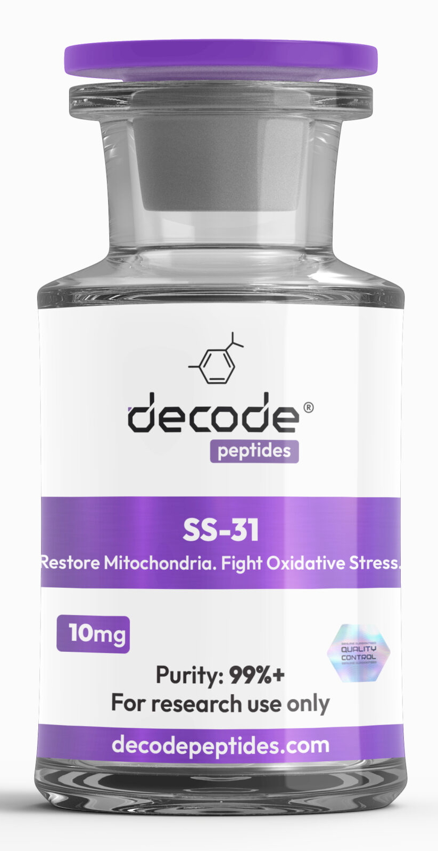

01 Protocol
If you use this protocol, you will need four vials to complete the cycle.
Add 2ml of bac water
Recommended dosage:
First two weeks= .5mg (10 units)
Then 1mg (20 units)
5 days on /2 days off
Take in the MORNING
8 weeks on/8 weeks off
SS-31 + MOTS-c Synergy:
* Weeks 1–4: SS-31 alone (stabilize mitochondria)
* Weeks 5–12: Add MOTS-c at 1–2mg/day (overlap 4–8 weeks)
* Discontinue SS-31, finish out MOTS-c cycle, or alternate thereafter
Tracking results:
* Subjective: Energy, workout capacity, recovery, sleep quality.
* Biomarkers: Fasting glucose, fasting insulin, HOMA-IR, A1C, lipid panel, liver enzymes.
* Performance: HRV, resting HR, VO₂ max, body composition.

