Resume-Job Matching System
Competitive programming lab

Project Developed By:
Saumil Agarwal(2401030363)
Aditya Thakur(2401030360)
Khushi Aggarwal(2401030356)
Submitted to: Dr Amitesh

Table of Contents

1. Summary
1.1 Brief Overview of the Project
1.2 Objectives

2. Introduction
2.1 Background and Context
2.2 Problem Statement
2.3 Project Objectives
2.4 Scope of the Project

3. System Requirements
3.1 Functional Requirements

4. Design and Implementation
4.1 UML Diagrams
4.2 Algorithms Implementation
4.3 Algorithms and Their Complexities
4.4 Code Snippets
4.5 Output Screenshots with Description

5. Conclusion
5.1 Summary & Achievement of Objectives
5.2 Future Work and Recommendations

6. References
6.1 List of All Sources

1. Summary

1.1 Brief Overview of the Project
The Resume-Job Matching System is a software application designed to automate the process of matching job candidates' resumes against job requirements. It leverages graph-based algorithms for skill relationships, sequence matching for skill patterns, and natural language processing (NLP) for extracting information from resumes. The system processes text and PDF resumes, computes relevance scores based on direct skill matches, related skills, experience, and skill sequences, and ranks candidates accordingly. A web interface built allows users to input job skills and upload resumes for real-time analysis.

1.2 Objectives
- To develop an efficient algorithm-based system for resume-job matching.
- To implement graph algorithms (Dijkstra's) for modeling skill relationships.
- To apply sequence matching (LCS) for enhanced skill compatibility assessment.
- To integrate NLP for automated resume parsing.
- To provide a user-friendly web interface for practical usability.

2. Introduction

2.1 Background and Context
In today's competitive job market, recruiters face challenges in manually reviewing large volumes of resumes to find suitable candidates. Traditional keyword-based matching systems often overlook skill relationships and contextual relevance. This project addresses these issues by incorporating advanced algorithms from Design and Analysis of Algorithms (DAA), such as graph shortest path and dynamic programming for sequence matching, combined with some python techniques for data extraction.

2.2 Problem Statement
Manual resume screening is time-consuming, error-prone, and subjective. Existing automated systems lack depth in understanding skill interconnections and sequential patterns. There is a need for a system that:
- Accurately matches resumes to jobs considering skill hierarchies and relationships.
- Handles diverse resume formats (text and PDF).
- Provides objective, algorithm-driven rankings.

2.3 Project Objectives
- Implement Dijkstra's algorithm for shortest path in a skill graph to score related skills.
- Use Longest Common Subsequence (LCS) for matching skill sequences.
- Develop NLP-based parsing for extracting resume data.
- Create a web application for user interaction.
- Achieve efficient performance with acceptable time complexities.

2.4 Scope of the Project
The system focuses on skill-based matching for software development and related fields. It processes resumes in English, supports PDF and text formats, and outputs ranked lists.

Out of scope: Multi-language support, advanced ML models, or integration with external job portals.

3. System Requirements

3.1 Functional Requirements
- Resume Upload and Parsing: Resume Upload and Parsing: Accept PDF/text resumes, extract name, skills, experience, education, and projects.
- Job Skill Input: Job Skill Input: Allow users to specify required skills via text input or file.
- Skill Matching: Skill Matching: Compute scores based on direct matches, graph-based relationships, and sequence similarity.
- Ranking and Output: Ranking and Output: Generate a ranked list of candidates with scores.
- Web Interface: Web Interface: Provide a browser-based UI for input and result display.
- Data Persistence: Data Persistence: Store processed data in files for analysis.

4. Design and Implementation

4.1 UML Diagrams
The system uses object-oriented design with the following key classes:

- Resume (Struct): Holds candidate data — name, skills, experience, education, projects, filename.
- Graph: Manages skill relationships using an adjacency list and implements Dijkstra's shortest path.
- Analyzer: Orchestrates the scoring pipeline using LCS dynamic programming and graph distances.
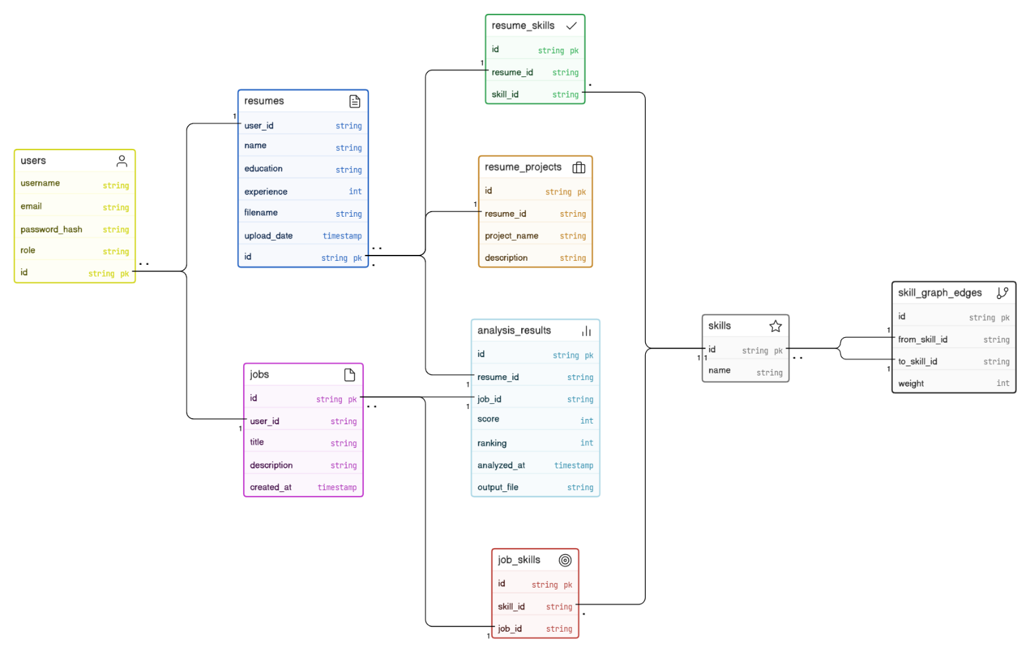

4.2 Algorithms Implementation
Two core DAA algorithms power the scoring engine:

Dijkstra's Algorithm
Implemented in Graph::shortestDistance, this finds the shortest weighted path between two skills in the skill graph. It enables the system to score candidates who possess skills that are indirectly related to the job requirements — for example, a candidate with 'PyTorch' knowledge being partially credited for a 'TensorFlow' requirement.

Longest Common Subsequence (LCS)
Implemented in Analyzer::longestCommonSubsequence using bottom-up dynamic programming. This method identifies the longest ordered sequence of matching skills between a candidate's skill list and the job's required skill list, capturing sequential skill compatibility that simple keyword matching misses.

Priority Queue for Ranking (Heap Sort Variant)
Purpose: Ranks candidates by score in descending order. Uses a max-heap to maintain the highest-scoring resumes.

String Matching and Tokenization (Basic Algorithms)
Purpose: Parses job skills from comma-separated input and extracts skills from resume text.

4.3 Algorithms and Their Complexities

Dijkstra's Algorithm
- Time Complexity: O((V + E) log V) using a min-heap priority queue, where V = number of skill vertices and E = number of skill relationship edges.
- Space Complexity: O(V + E) for the adjacency list and distance map.

Longest Common Subsequence (LCS)
- Time Complexity: O(m × n), where m and n are the lengths of the two skill sequences being compared.
- Space Complexity: O(m × n) for the DP table.

4.4 Code Snippets

Dijkstra's Shortest Path — graph.cpp

int Graph::shortestDistance(string start, string target) {
unordered_map<string, int> dist;
for(auto &node : adj) dist[node.first] = INT_MAX;
priority_queue<pair<int,string>,
vector<pair<int,string>>, greater<pair<int,string>>> pq;
dist[start] = 0;
pq.push({0, start});
while(!pq.empty()) {
auto current = pq.top(); pq.pop();
int currDist = current.first;
string node = current.second;
if(node == target) return currDist;
for(auto &neighbor : adj[node]) {
string next = neighbor.first;
int weight = neighbor.second;
if(currDist + weight < dist[next]) {
dist[next] = currDist + weight;
pq.push({dist[next], next});
}
}
}
return INT_MAX;
}

LCS Dynamic Programming — analyzer.cpp

int Analyzer::longestCommonSubsequence(
vector<string> seq1, vector<string> seq2) {
int m = seq1.size(), n = seq2.size();
vector<vector<int>> dp(m+1, vector<int>(n+1, 0));
for (int i = 1; i <= m; ++i) {
for (int j = 1; j <= n; ++j) {
if (seq1[i-1] == seq2[j-1])
dp[i][j] = dp[i-1][j-1] + 1;
else
dp[i][j] = max(dp[i-1][j], dp[i][j-1]);
}
}
return dp[m][n];
}

4.5 Output Screenshots with Description

1. Web Interface Home Page
Displays the main form with a file upload button for resumes and a text field for entering required job skills. The Analyze button triggers the full pipeline — PDF parsing, NLP extraction, and C++ scoring.
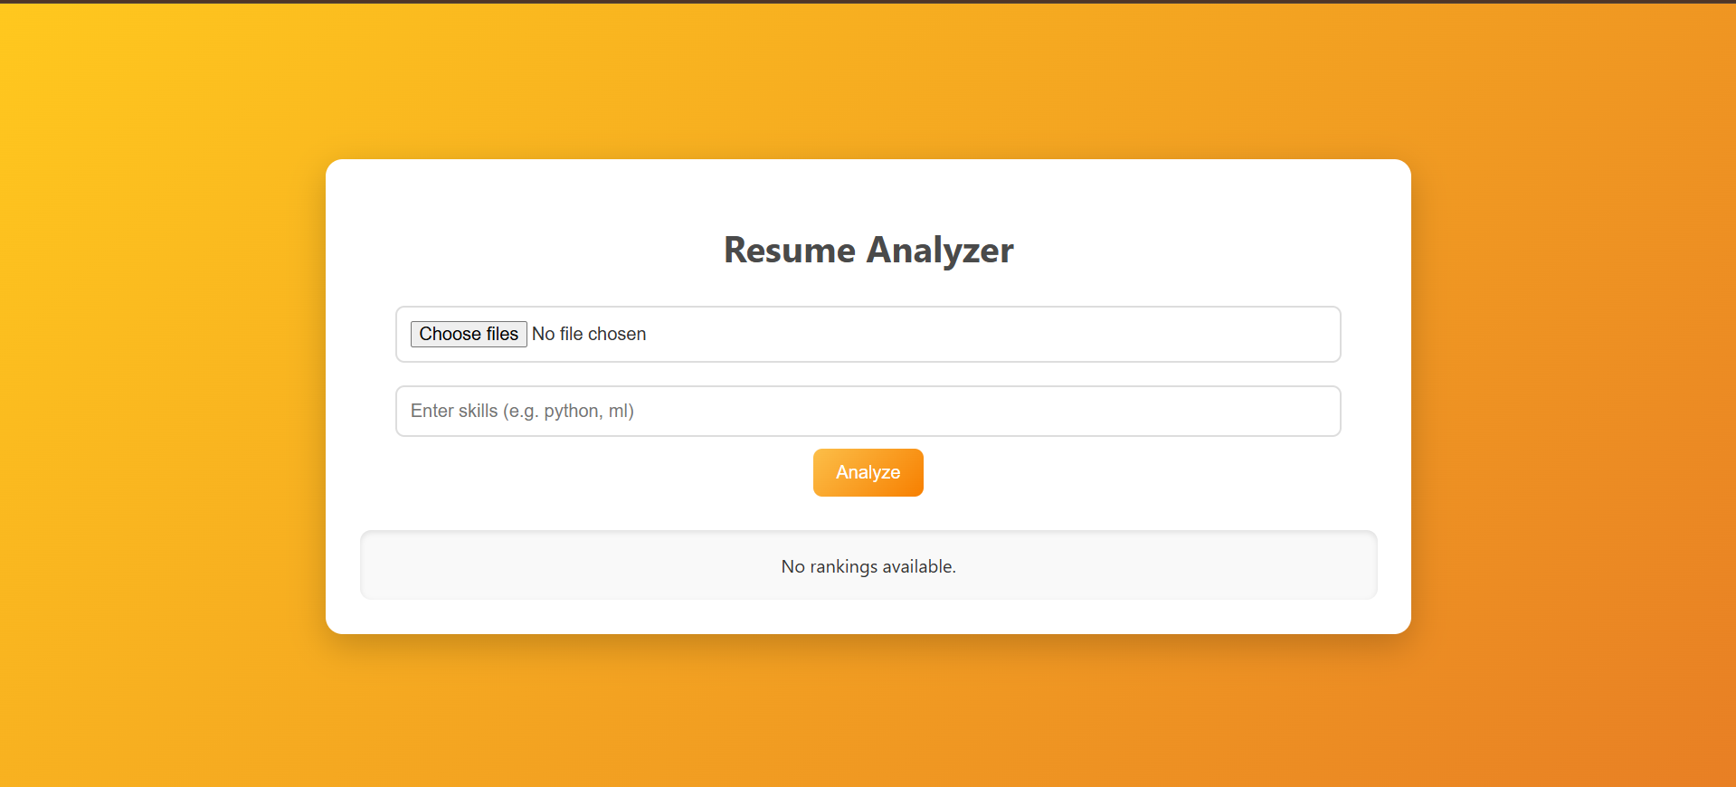

2. Ranking Results Page
After analysis, the results page renders the ranked list of candidates with their computed scores, e.g., "Elena Vance Score: 85". Candidates are sorted in descending score order.
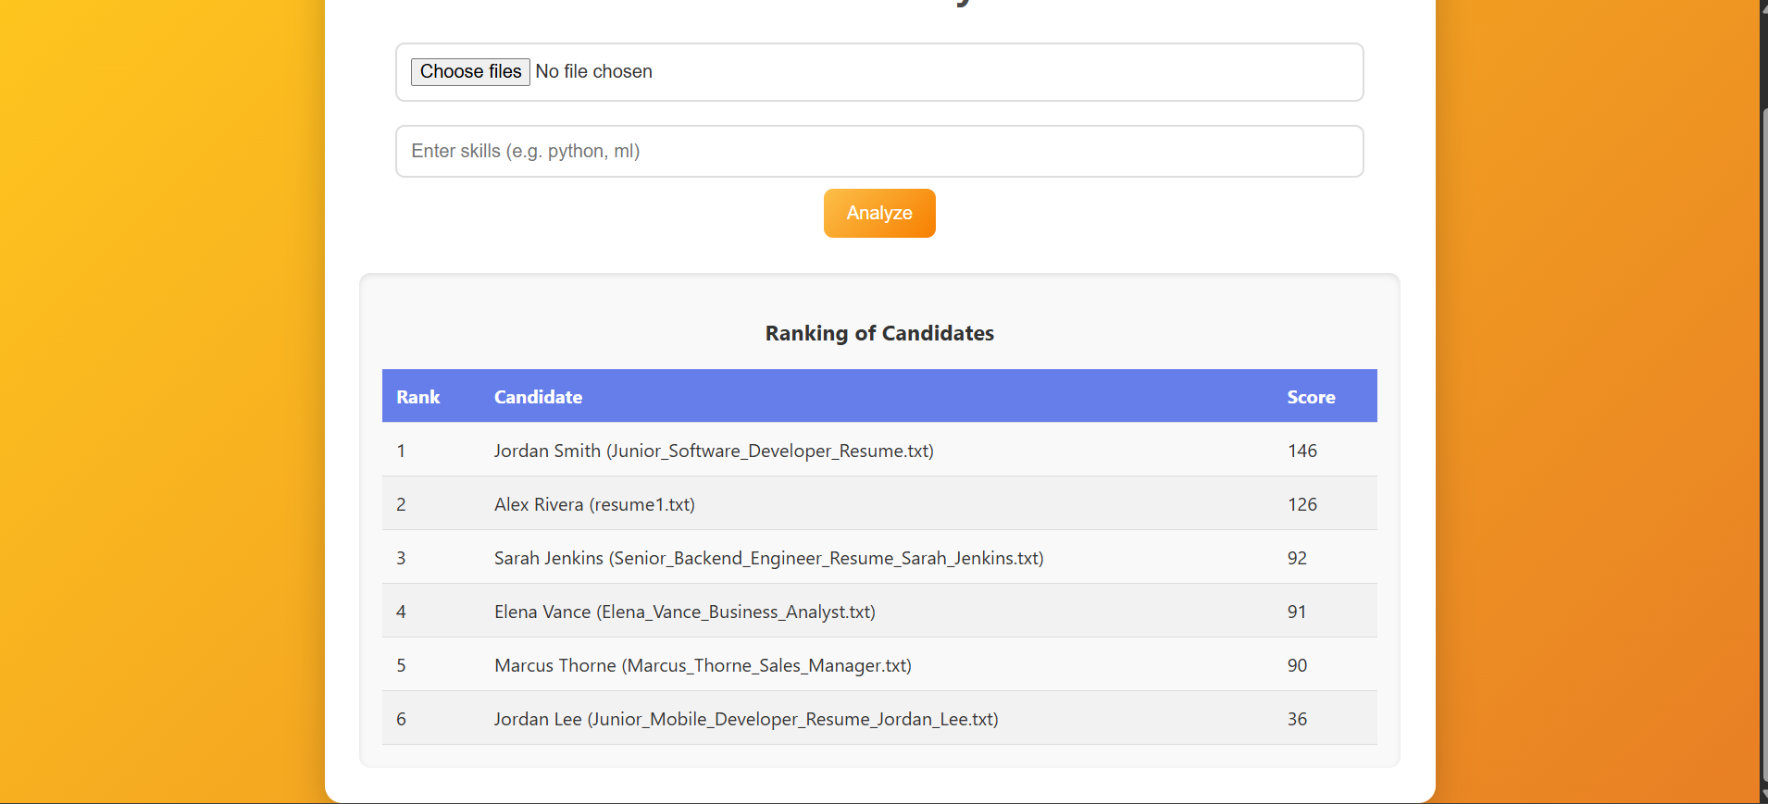
3. Console / Terminal Output
The terminal shows the g++ compilation output, successful build confirmation, and execution logs including the Python parser run and C++ analyzer completion messages.

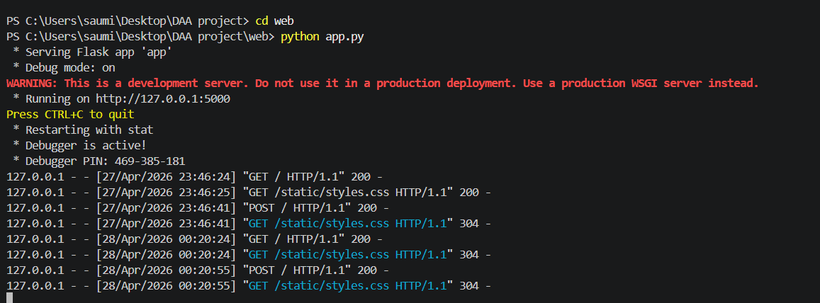

5. Conclusion

5.1 Summary & Achievement of Objectives
The project successfully implemented a resume-job matching system using core DAA algorithms. All stated objectives were met:

- Dijkstra's algorithm was applied to model and traverse skill relationship graphs.
- LCS dynamic programming was implemented for sequential skill pattern matching.
- NLP-based parsing was developed using pdfplumber for automated data extraction.
- A Flask web application was created for user-friendly interaction.
- The system achieves O((V+E) log V) time for graph operations and O(m×n) for LCS.

The system effectively automates candidate ranking, reducing manual review effort and delivering objective, algorithm-driven results.

5.2 Future Work and Recommendations
- Integrate machine learning models for improved NLP accuracy and contextual understanding.
- Add support for additional resume formats and multiple languages.
- Optimize for large-scale data processing using parallel computing techniques.
- Implement user authentication and persistent database storage.
- Expand the skill graph with a richer, domain-specific ontology.

6. References

6.1 List of All Sources

- Cormen, T. H., Leiserson, C. E., Rivest, R. L., & Stein, C. (2009). Introduction to Algorithms (3rd ed.). MIT Press.
- Flask Documentation. Pallets Projects. Retrieved from https://flask.palletsprojects.com/
- pdfplumber Library. Retrieved from https://github.com/jsvine/pdfplumber
- C++ Standard Library Reference. Retrieved from https://en.cppreference.com/
- Dijkstra's Algorithm Explanation. GeeksforGeeks. Retrieved from https://www.geeksforgeeks.org/

