ASSIGNMENT-1

# TechShop, an electronic gadgets shop

## Task 1: Database Design

1. Create the database named "TechShop"

Create database techshop;

Use techshop;

1. Define the schema for the Customers, Products, Orders, OrderDetails and Inventory table based on the provided schema.
2. Customers:

Create table customers(

customerId integer(3) Primary key,

FirstName varchar(20),

LastName varchar(20),

Email varchar(20),

Phone integer(10),

Address varchar(50) );

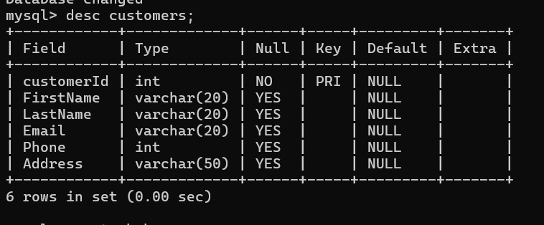

1. Products:

Create table products(

ProductId integer Primary key,

ProductName varchar(20),

Description varchar(50),

Price integer );

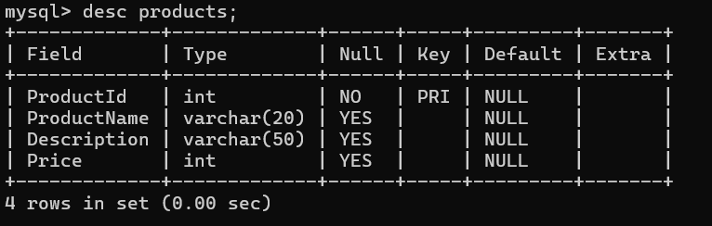

1. Orders :

Create table Orders(

OrderId integer Primary key,

CustomerId integer,

OrderDate date,

TotalAmount integer,

Constraint Orders_CustomerId_fk Foreign key(CustomerId) references Customers(CustomerId));

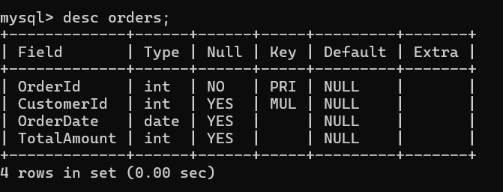

1. OrderDetails:

Create table OrderDetails(

OrderDetailsId integer Primary Key,

OrderId integer,

ProductId integer,

Quantity integer

Constraint OrderDetails_OrderId_fk Foreign key(OrderId) references Orders(OrderId),

Constraint OrderDetails_ProductId_fk Foreign key(ProductId) references Products(ProductId));

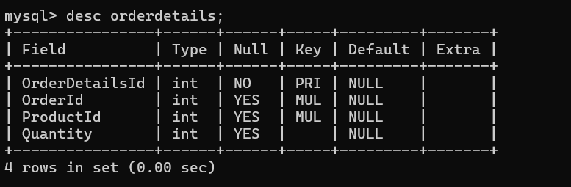

1. Inventory:

Create table Inventory(

InventoryId integer Primary key,

ProductId integer,

QuantityInStock integer,

LastStockUpdate date

Constraint Inventory_ProductId_fk Foreign key(ProductId) references Products(ProductId) );

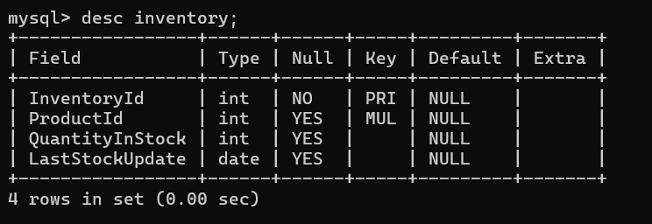

1. Create an ERD (Entity Relationship Diagram) for the database.

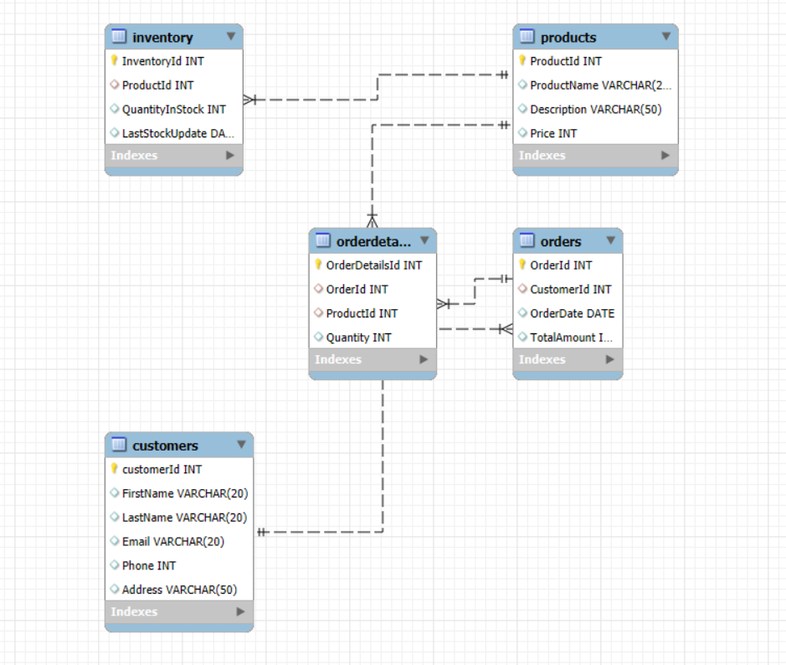

1. Create appropriate Primary Key and Foreign Key constraints for referential integrity.
2. Customer:

CREATE TABLE Customers (

CustomerID INT PRIMARY KEY,

FirstName VARCHAR(20) NOT NULL,

LastName VARCHAR(20) NOT NULL,

Email VARCHAR(20) NOT NULL UNIQUE,

Phone INT,

Address VARCHAR(50) );

1. Products:

CREATE TABLE Products (

ProductID INT PRIMARY KEY,

ProductName VARCHAR(20) ,

Price DECIMAL(10,2),

Description VARCHAR(50)NOT NULL);

1. Orders:

CREATE TABLE Orders (

OrderID INT PRIMARY KEY,

CustomerID INT,

OrderDate DATE,

TotalAmount DECIMAL(10, 2) NOT NULL,

FOREIGN KEY (CustomerID) REFERENCES Customers(CustomerID) ON DELETE CASCADE );

4.OrderDetails:

CREATE TABLE OrderDetails (

OrderDetailID INT PRIMARY KEY,

OrderID INT,

ProductID INT,

Quantity INT NOT NULL,

Contraint OrderDetails_OrderId_fk FOREIGN KEY (OrderID) REFERENCES Orders(OrderID) ON DELETE CASCADE,

Contraint OrderDetails_ProductId_fk FOREIGN KEY (ProductID) REFERENCES Products(ProductID) ON DELETE CASCADE );

v. Inventory:

CREATE TABLE Inventory (

InventoryID INT PRIMARY KEY,

ProductID INT,

Contraint Inventory_ProductId_fk FOREIGN KEY (ProductID) REFERENCES Products(ProductID) ON DELETE CASCADE );

1. Insert at least 10 sample records into each of the following tables.
2. Customers:

insert into customers values(101,'John', 'Doe', 'johndoe@gmail.com',9876543, '123 Main St, New York');

insert into customers values(102,'Jane', 'Smith', 'janesmith@gmail.com', '9873210', '456 Oak St, Los Angeles');

insert into customers values (103,'Alice', 'Johnson', 'alicej@gmail.com', '1234567', '789 Pine St, Chicago');

insert into customers values (104,'Bob', 'Williams', 'bobwill@gmail.com', '3334444', '321 Maple st');

insert into customers values (105,'Michael', 'Brown', 'mbrown@example.com', '5556666', '987 Cedar St, Phoenix');

insert into customers values (106,'Emily', 'Davis', 'emily@gmail.com', '4445555', '654 Elm St, San Francisco');

insert into customers values (107,'David', 'Miller', 'davidm@gmail.com', '2223333', '432 Birch St, Seattle');

insert into customers values (108,'Sarah', 'Wilson', 'sarah@gmail.com', '8889999', '876 Spruce St, Miami');

insert into customers values (109,'Paul', 'Taylor', 'paul@gmail.com', '8887777', '123 Aspen St, Denvi');

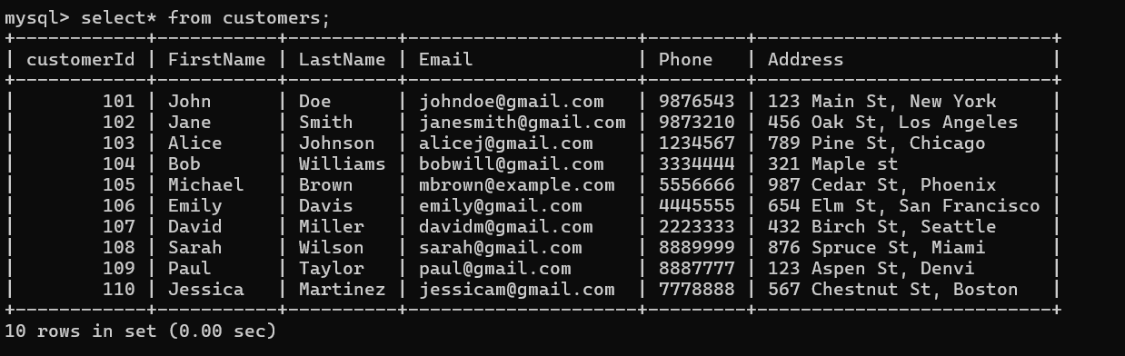 insert into customers values (110,'Jessica', 'Martinez', 'jessicam@gmail.com', '7778888', '567 Chestnut St, Boston');

1. Products:

insert into products values(1,'Smartphone', '5G smartphone, 128GB', 20000);

insert into products values(2,'Laptop', 'RTX 3070, 16GB RAM',50000);

insert into products values(3,'BluetoothEarbuds', 'Noise cancelling',3000);

insert into products values(4,'Smart TV', '55inch UHD TV',60000);

insert into products values(5,'PowerBank', '20,000mAh fast',2000);

insert into products values(6,'Smart Speaker', 'Voice-controlled',5000);

insert into products values(7,'Wireless Charger', 'Fast Qi charger',1000);

insert into products values(8,'VR Headset', '360-degree VR',15000);

insert into products values(9,'Fitness Tracker', 'Heart rate monitor',5000);

insert into products values(10,'Camera Drone', '4K camera, GPS',90000);

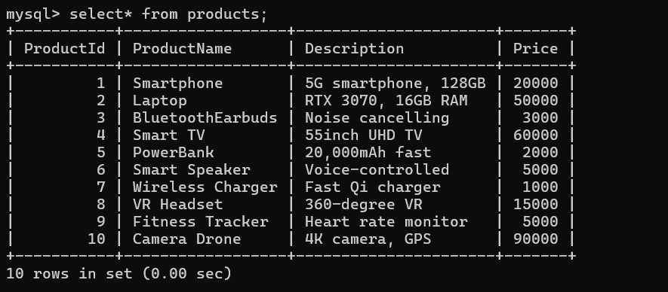

1. Orders:

insert into orders values(1001,101,'2024-09-15',5000);

insert into orders values(1002,103,'2024-07-14',1000);

insert into orders values(1003,104,'2024-06-24',10000);

insert into orders values(1004,102,'2024-06-16',50000);

insert into orders values(1005,102,'2024-05-16',45000);

insert into orders values(1006,106,'2024-06-06',3000);

insert into orders values(1007,107,'2024-07-23',35000);

insert into orders values(1008,108,'2024-06-05',23000);

insert into orders values(1009,109,'2024-02-13',42000);

insert into orders values(1010,110,'2024-05-22',22000);

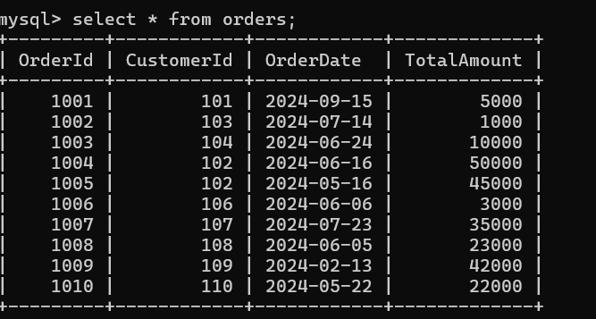

1. OrderDetails:

insert into orderdetails values(31,1001,1,500);

insert into orderdetails values(32,1005,2,200);

insert into orderdetails values(33,1003,3,100);

insert into orderdetails values(34,1002,4,50);

insert into orderdetails values(35,1003,5,600);

insert into orderdetails values(36,1007,6,250);

insert into orderdetails values(37,1008,7,400);

insert into orderdetails values(38,1006,8,150);

insert into orderdetails values(39,1009,9,350);

insert into orderdetails values(40,1010,10,550);

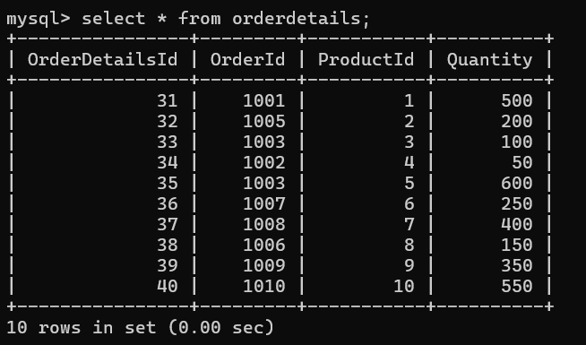

1. Inventory:

insert into inventory values (11,1,15,'2024-05-10');

insert into inventory values (12,2,25,’2024-05-15’);

insert into inventory values (13,3,10,’2024-05-20’);

insert into inventory values (14,4,05,’2024-05-13’);

insert into inventory values (15,5,25,’2024-05-17’);

insert into inventory values (16,6,10,’2024-05-22’);

insert into inventory values (17,7,24,’2024-05-14’);

insert into inventory values (18,8,07,’2024-05-25’);

insert into inventory values (19,9,25,’2024-05-27’);

insert into inventory values (20,10,13,’2024-05-29’);

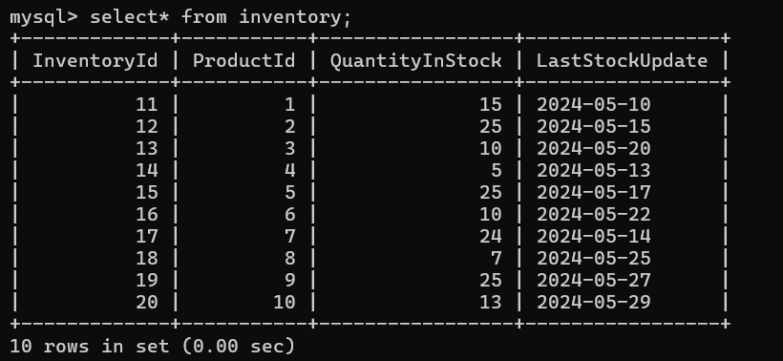

## Task 2: Select, Where, Between, AND, LIKE:

1. Write an SQL query to retrieve the names and emails of all customers.

Query: select firstname, lastname, email from customers;

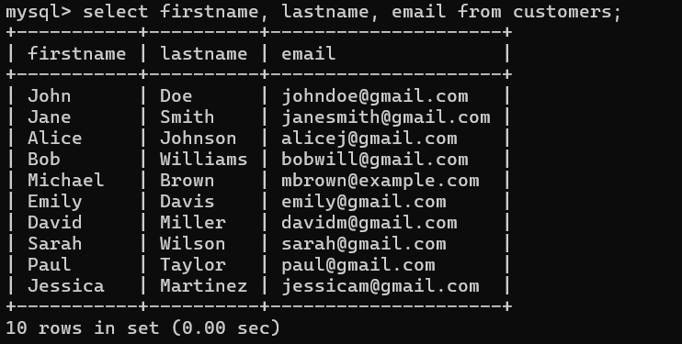

1. Write an SQL query to list all orders with their order dates and corresponding customer names.

Query: SELECT o.OrderDate, c.FirstName FROM Orders o, Customers c WHERE o.CustomerID = c.CustomerID;

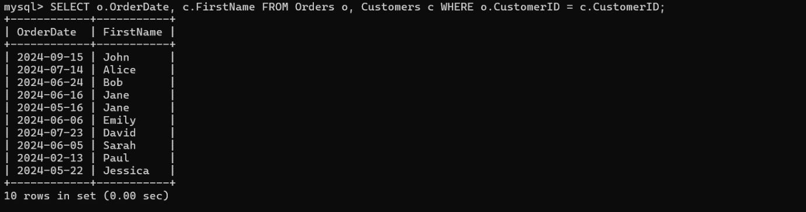

1. Write an SQL query to insert a new customer record into the "Customers" table. Include customer information such as name, email, and address.

Query: insert into customers values(111,'John','Mathew','john234@gmail.com',null,'678,Town St,USA');



1. Write an SQL query to update the prices of all electronic gadgets in the "Products" table by increasing them by 10%.

Query: update products set price = price *1.10 ;

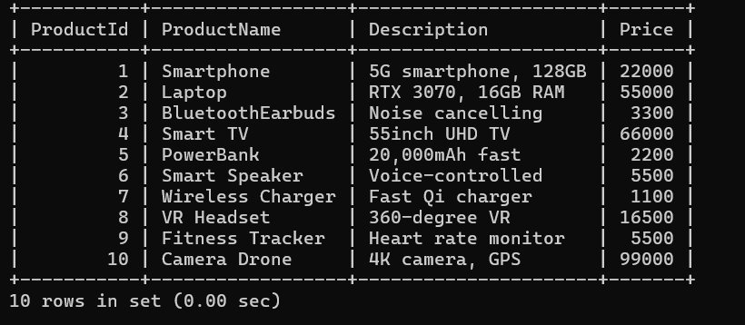

1. Write an SQL query to delete a specific order and its associated order details from the "Orders" and "OrderDetails" tables. Allow users to input the order ID as a parameter.

Query: DELETE FROM OrderDetails WHERE OrderID =1001;

DELETE FROM Orders WHERE OrderID = 1001;

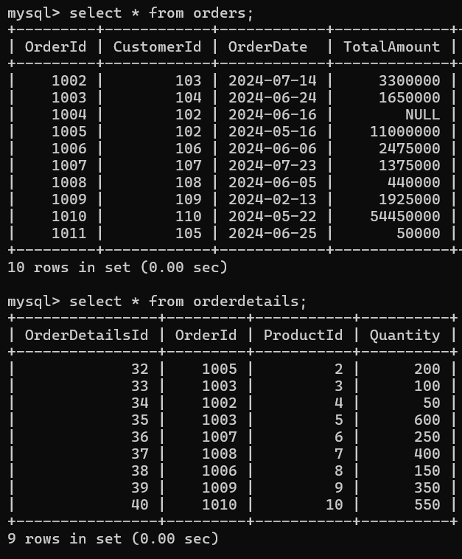

1. Write an SQL query to insert a new order into the "Orders" table. Include the customer ID, order date, and any other necessary information.

Query: insert into orders values (1011,105,'2024-06-25',50000);



1. Write an SQL query to update the contact information (e.g., email and address) of a specific customer in the "Customers" table. Allow users to input the customer ID and new contact information.

Query: UPDATE Customers SET Email = 'newemail@gmail.com',Address = 'new_address' WHERE CustomerID = 101;



1. Write an SQL query to recalculate and update the total cost of each order in the "Orders" table based on the prices and quantities in the "OrderDetails" table.

Query: SELECT OrderID,

SUM(

Quantity * (

SELECT Price FROM Products WHERE ProductID = od.ProductID))

AS TotalAmount

FROM OrderDetails od GROUP BY OrderID;

UPDATE Orders

SET TotalCost = CASE WHEN OrderID = 1001 THEN

(SELECT SUM(Quantity * (SELECT Price FROM Products WHERE ProductID = od.ProductID)) FROM OrderDetails od WHERE od.OrderID = 1001)

WHEN OrderID = 1002 THEN (SELECT SUM(Quantity * (SELECT Price FROM Products WHERE ProductID = od.ProductID)) FROM OrderDetails od WHERE od.OrderID = 1002)

WHEN OrderID = 1003 THEN (SELECT SUM(Quantity * (SELECT Price FROM Products WHERE ProductID = od.ProductID)) FROM OrderDetails od WHERE od.OrderID = 1003)

WHEN OrderID = 1004 THEN (SELECT SUM(Quantity * (SELECT Price FROM Products WHERE ProductID = od.ProductID)) FROM OrderDetails od WHERE od.OrderID = 1004)

WHEN OrderID = 1005 THEN (SELECT SUM(Quantity * (SELECT Price FROM Products WHERE ProductID = od.ProductID)) FROM OrderDetails od WHERE od.OrderID = 1005)

WHEN OrderID = 1006 THEN (SELECT SUM(Quantity * (SELECT Price FROM Products WHERE ProductID = od.ProductID)) FROM OrderDetails od WHERE od.OrderID = 1006)

WHEN OrderID = 1007 THEN (SELECT SUM(Quantity * (SELECT Price FROM Products WHERE ProductID = od.ProductID)) FROM OrderDetails od WHERE od.OrderID = 1007)

WHEN OrderID = 1008 THEN (SELECT SUM(Quantity * (SELECT Price FROM Products WHERE ProductID = od.ProductID)) FROM OrderDetails od WHERE od.OrderID =1008)

WHEN OrderID = 1009 THEN (SELECT SUM(Quantity * (SELECT Price FROM Products WHERE ProductID = od.ProductID)) FROM OrderDetails od WHERE od.OrderID = 1009)

WHEN OrderID = 1010 THEN (SELECT SUM(Quantity * (SELECT Price FROM Products WHERE ProductID = od.ProductID)) FROM OrderDetails od WHERE od.OrderID = 1010)

ELSE TotalCost

END WHERE OrderID IN (1001, 1002, 1003, 1004, 1005, 1006, 1007, 1008, 1009, 1010);

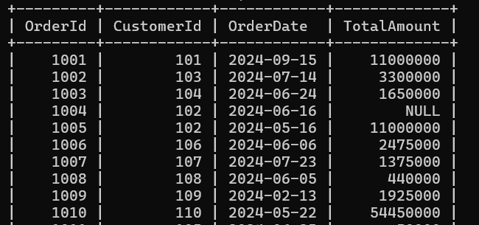

1. Write an SQL query to delete all orders and their associated order details for a specific customer from the "Orders" and "OrderDetails" tables. Allow users to input the customer ID as a parameter.

Query: DELETE FROM OrderDetails WHERE OrderID IN (

SELECT OrderID FROM Orders WHERE CustomerID = 102);

DELETE FROM Orders WHERE CustomerID = 102;

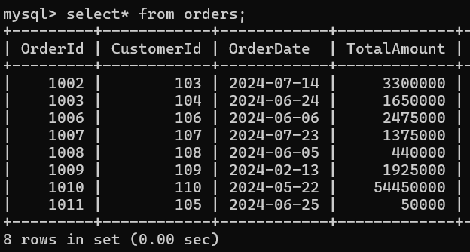

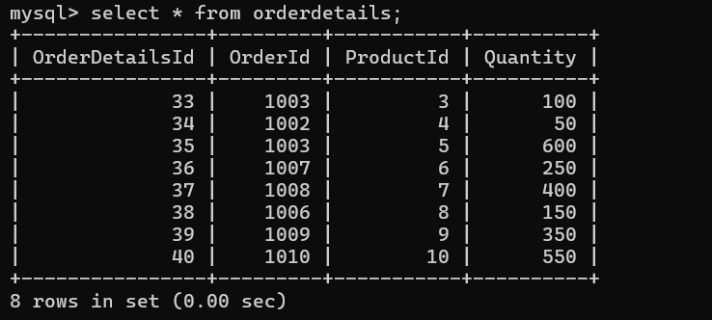

1. Write an SQL query to insert a new electronic gadget product into the "Products" table, including product name, category, price, and any other relevant details.

Query: insert into products values(11,'SmartWatch','Advanced Watch',5000);



1. Write an SQL query to update the status of a specific order in the "Orders" table (e.g., from "Pending" to "Shipped"). Allow users to input the order ID and the new status.

Query: alter table orders add column OrderStatus varchar(50) ;

update orders set orderstatus ='Shipped' where orderId in(1001,1002,1003,1004,1005,1006,1007,1008,1009,1010,1011);

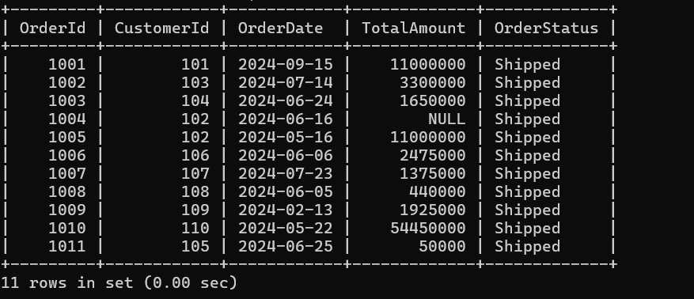

1. Write an SQL query to calculate and update the number of orders placed by each customer in the "Customers" table based on the data in the "Orders" table.

Query: ALTER TABLE Customers ADD COLUMN NumberOfOrders INT DEFAULT 0;

UPDATE Customers SET NumberOfOrders = ( SELECT COUNT(*) FROM Orders WHERE Orders.CustomerID = Customers.CustomerID ) WHERE CustomerID IN (SELECT DISTINCT CustomerID FROM Orders);

