CEL72, DSL, Monsoon 2020
Lab 3: Implementation of Election Algorithm
Name: Saumitra Chaskar
Batch: A
Student ID: 2017130011

Objective
Implementation of Bully Election Algorithm.

Problem statement
Your bank account details replicated at a few servers and out of these one these servers is responsible for receiving all reads and writes. That means it is the leader who coordinating among all replicas.

- What if there are two leaders per customer?
- What if servers disagree about who the leader is?
- What if leader crashes?

Each of the above scenarios leads to the inconsistency.

Examples: Sequencer based algorithm for the order Multicast – Sequencer is leader, Group of NTP servers – who is the root server, Other systems they need leader election: e.g Apache Zookeeper and Google’s Chubby.

Leader is useful for coordinating among distributed servers. In a nutshell;
- Group of processes, elect a ,Leader’ to undertake special task
  - Let everyone know in this group about this leader
- What happens if leader fails or Crashes?
  - Some processes detects this using failure detector!
  - What next…. Motivation for Election Algo.

Election Algorithm:
- Elect only one leader among the non-faulty processes
- All non-faulty processes agree on who is the leader

System Model
- N processes
- Each process has unique ID (IP addr, Port no.)
- Messages are eventually delivered
- Failures may during election protocol - When you tried to elect leader, a leader may fail or other processes in system might fail, Election algo. Should be tolerant to such failures

Requirement: Calling for an Election
- Any process can call for an election
- A process can call for at most one election at a time
- Multiple processes are allowed to call an election simultaneously
  - All of them together must yield one a single leader
- The result of election should not depend on which process calls for ti

A run of election algorithm always guarantee at least two properties at the end:
- Safety: For all non-faulty process p: ( p’s elected =(q: a particular non-faulty process with best attribute value) or null
- Liveness: For all election run : (election run terminates) & for non-faulty process p: p’s elected is not NULL
At the end of the election protocol the non-faulty process with (=best (highest) election attribute is elected.
- Common attribute: Leader has highet ID
- Other attribute examples: leader has highet IPaddr or fastest CPU, more disk space or most no. of files etc.

Bully Algorithm:
The bully algorithm is a method in distributed computing for dynamically electing a coordinator by process ID number. The process with the highest process ID number is selected as the coordinator. When a process P determines that the current coordinator is down because of message timeouts or failure of the coordinator to initiate a handshake, it performs the following sequence of actions:
- P broadcasts an election message (inquiry) to all other processes with higher process IDs, expecting an "I am alive" response from them if they are alive.
- If P hears from no process with a higher process ID than it, it wins the election and broadcasts victory.
- If P hears from a process with a higher ID, P waits a certain amount of time for any process with a higher ID to broadcast itself as the leader. If it does not receive this message in time, it re-broadcasts the election message.
- If P gets an election message (inquiry) from another process with a lower ID it sends an "I am alive" message back and starts new elections.
Assumptions:
- Each process knows the ID and address of every other process
- Communication is reliable
- A process initiates an election if it just recovered from failure or it notices that the coordinator has failed
- Three types of messages: Election, OK, Coordinator
- Several processes can initiate an election simultaneously
- Need consistent result

Details:
- Any process P can initiate an election
- P sends Election messages to all process with higher IDs and awaits OK messages
  - If no OK messages, P becomes coordinator and sends Coordinator messages to all processes with lower IDs – If it receives an OK, it drops out and waits for an Coordinator message
- If a process receives an Election message
  - Immediately sends Coordinator message if it is the process with highest ID – Otherwise, returns an OK and starts an election
- If a process receives a Coordinator message, it treats sender as the coordinator.

Example

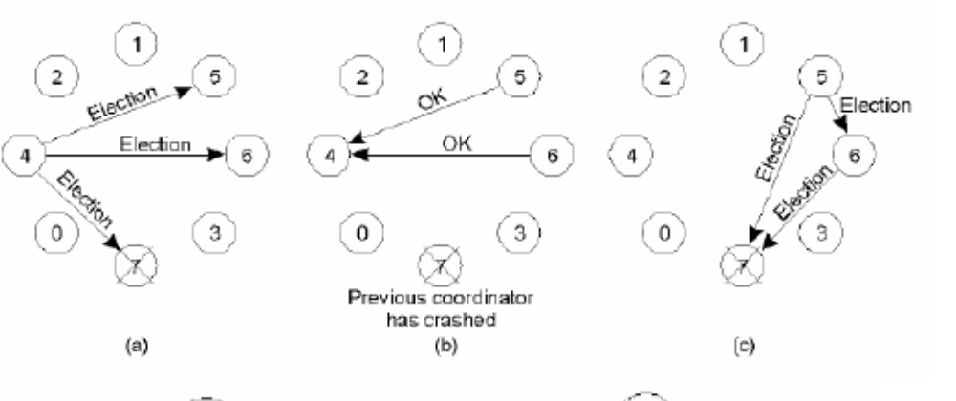
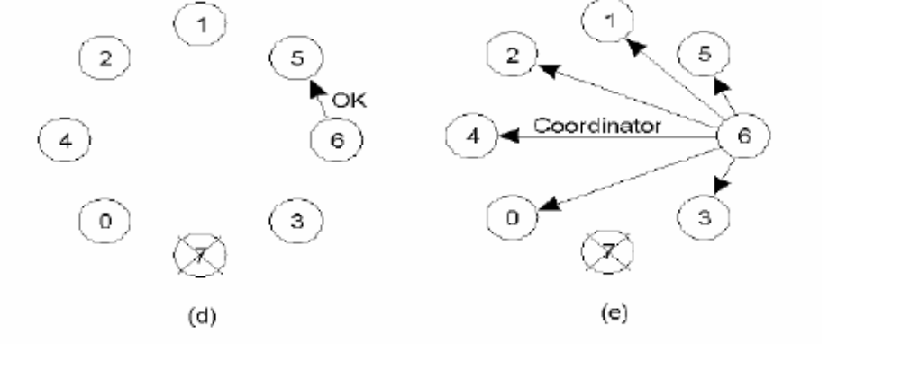

Conceptual Architecture:

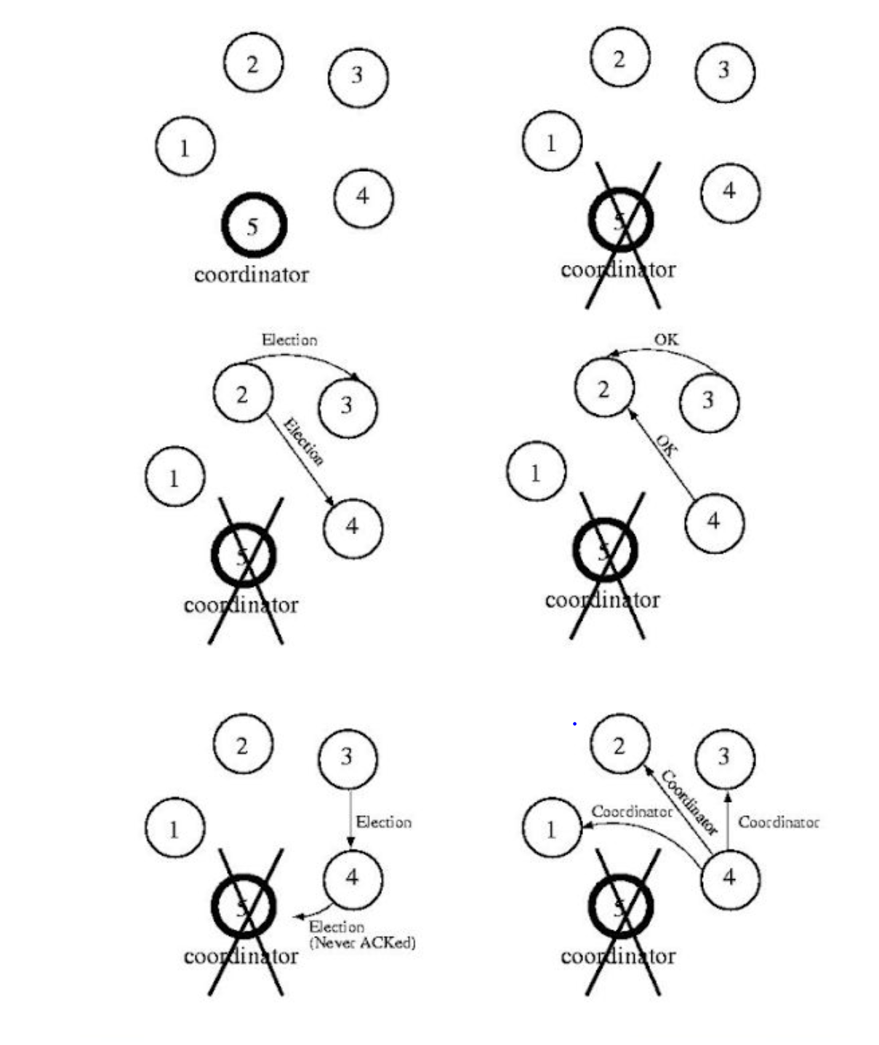

In this implementation, we have considered 5 processes with ID from 1 to 5.At every instance the non-faulty process with the highest process ID is selected as coordinator.

Source File:

import java.util.Scanner;
public class bully {
static boolean state[] = new boolean[5];
int coordinator;
public static void up(int up)
{
if(state[up-1]==true)
{
System.out.println("p"+up+" is already up");
System.out.println("Try some other proces");
}
else
{
state[up-1] = true;
System.out.println("*****ELECTION*****");
System.out.println("p"+up+" IS HOLDING A ELECTION");
for(int i=up;i<5;i++)
{
System.out.println("Election message: FROM p"+up+" TO p"+(i+1));
}
for(int i=up+1;i<=5;i++)
{
if(state[i-1]==true)
{
System.out.println("Alive message: FROM p"+i+" TO p"+up);
}
}
}
}
public static void down(int down)
{
if(state[down-1]==false)
{
System.out.println("p"+down+" is already down");
System.out.println("Try some other proces");
}
else
{
state[down-1] = false;

}
}

public static void mess(int mess)
{
if(state[mess-1]==true)
{
if(state[4]==true)
{
System.out.println("p5 is the COORDINATOR");
}
else
{
if(state[4]==false)
{
System.out.println("process "+mess+" election");
for(int i=mess;i<5;i++)
{
System.out.println("Election message: FROM p"+mess+" TO p"+(i+1));
}

for(int i=5;i>=mess;i--)
{
if(state[i-1]==true)
{
System.out.println("Coordinator message: FROM p"+i+" TO all");
break;
}
}
}
}
}
else
{
System.out.println("p"+mess+" is down");
System.out.println("Try some other proces");
}
}

public static void main(String[] args) {
// TODO code application logic here
Scanner sc = new Scanner(System.in);
int choice;
for(int i=0;i<5;i++)
{
state[i] = true;
}
System.out.println("THERE ARE CUURENTLY 5 ACTIVE PROCESSES");
System.out.println("Process ACTIVE :: p1 p2 p3 p4 p5");
System.out.println("CURRENT COORDINATOR: p5");

do
{
System.out.println("******************");
System.out.println("1. UP a process.");
System.out.println("2. DOWN a process");
System.out.println("3. HOLD Election");
System.out.println("4. EXIT");
System.out.println("******************");
choice = sc.nextInt();
switch(choice)
{
case 1:
{
System.out.println("ENTER PID: ");
int up = sc.nextInt();
if(up==5)
{
System.out.println("CURRENT COORDINATOR: p5");
state[4] = true;

}
else
{
up(up);
}
}
break;
case 2:
{
System.out.println("ENTER PID: ");
int down = sc.nextInt();
down(down);
}
break;
case 3:
{
System.out.println("WHO WANTS TO CONDUCT ELECTIONS: ");
int mess = sc.nextInt();
mess(mess);
}
break;

}

}
while(choice!=4);
}

}

Process Call Steps:

1.Enter the process ID which wants to conduct the election.
2.That process sends a message to all processes having IDs greater than its own.
3.The processes which are alive send an acknowledgement message ‘OK’ back.
4.The process with the largest ID and which is alive is selected as the coordinator

Test Procedure:

Case1:

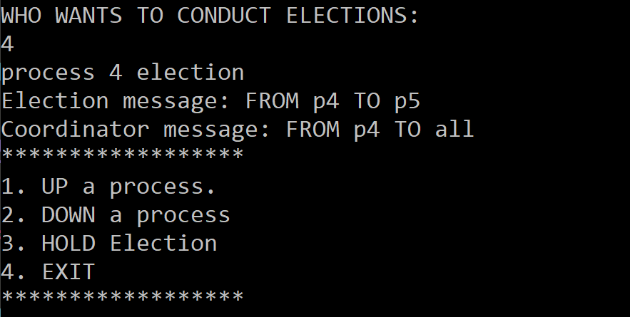

Process 5 has failed, and 4 conducts the election, sends a message to 5, and gets no response since the process is down. Hence, declares itself coordinator and sends a message to all.

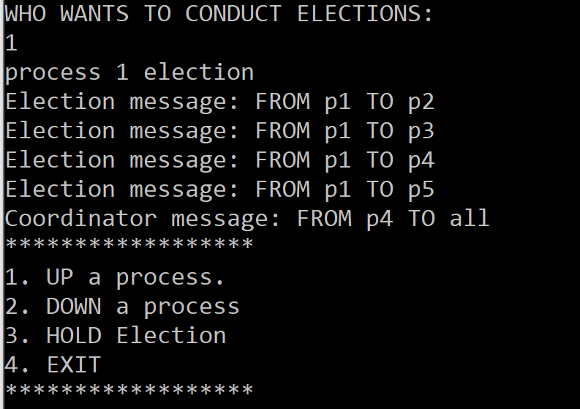

Here process 1 conducts the election, it has to ask all other processes for the response, after which process 4 is decided the leader.

Case 2:

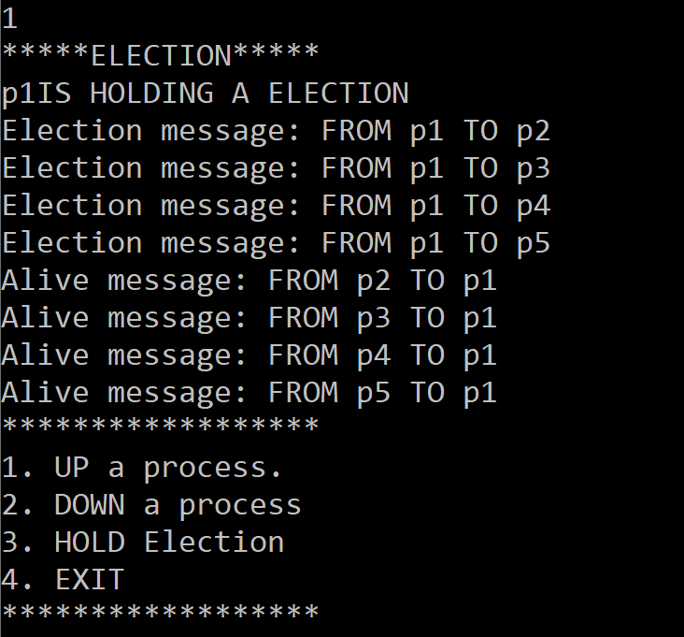

Here process 1 recovered from failure and conducts an election. it sends a message to every process with ID greater than its own, and then selects the one with the highest processID.

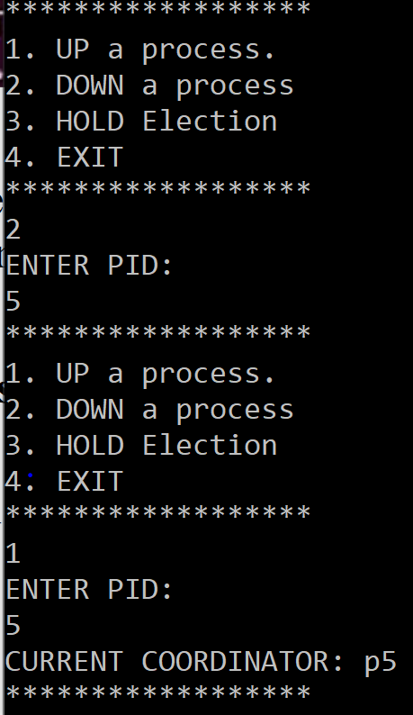

Here process 5 recovered from failure and conducted an election. since there is no process having process ID greater than its own, it declares itself as the coordinator.

1. Give a diagram and explain 3 messages - election, vote, and coordinator.

Election msg - Any process who wants to conduct an election, has to send an election message to all the processes having ID greater than its own and wait for response.
Vote message - The processes which receive the message, and are alive reply with OK, signifying acknowledgement.
Coordinator message - The process with the highest ID, sends message to all the processes present signifying it is the coordinator.

2. What happens if two processes notice at the same time, that a process has crashed?

In the case of two processes starting the bully algorithm simultaneously, if one of the nodes has the highest identifier of all nodes in the system then it will be chosen as the new coordinator, if not then other nodes with higher identifiers will run the algorithm.

Conclusion:

Implemented Bully Election algorithm using Java.

Evaluation
Grading is performed for this experiment.

Election Algo laboratory work grading details Points 5 + Instructor Signature | Requirements
5 | - Bully Algorithm implement (1M)  - Performance Analysis: Case 1 & 2 ( 2M)  - Documentation (2M)

Feedback | Yes/No
- Contents in this write up has been useful to perform experiment?
- Level of understanding DS has improved?

