VERA-TDMA — Complete Technical Workflow
VERA-TDMA is a centralized TDMA topology optimization and verification system designed to generate a minimum-length, conflict-free transmission schedule for a static wireless network. The system processes node coordinates from input data, constructs the communication topology, derives direct and two-hop interference constraints, generates an initial schedule using DSATUR graph colouring, attempts schedule reduction through optimization techniques, verifies optimality using an exact solver, and independently validates the final schedule before publication.
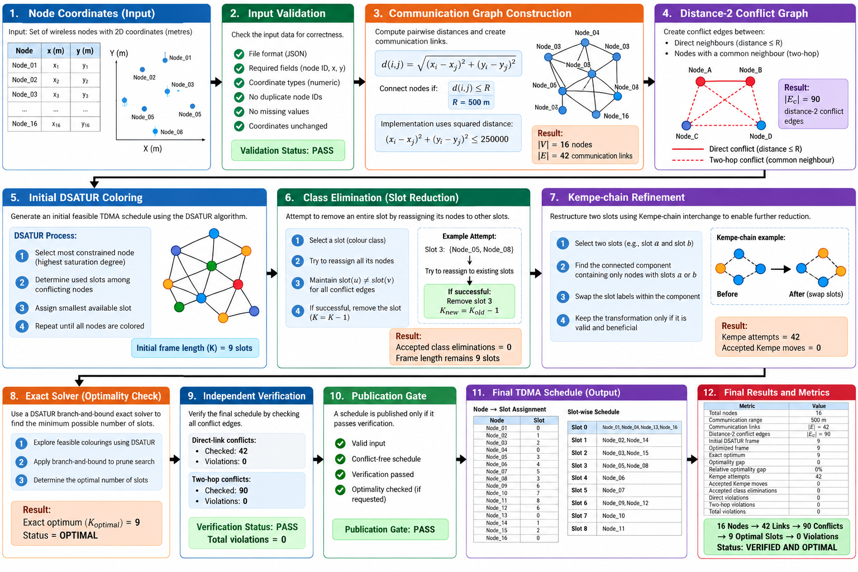
1. Input Node Coordinates
The workflow begins with a set of wireless nodes represented by Cartesian coordinates in metres. Each node is identified uniquely and associated with its position:
Node_i = (x_i, y_i)
For the demonstrated experiment, the input contains 16 nodes. The communication range is configured as:
R = 500 m
The input is validated before processing to ensure that node identifiers and coordinates are valid and that the topology can be constructed deterministically.
2. Communication Graph Construction
The system calculates the Euclidean distance between every relevant pair of nodes:
d(i,j) = sqrt((x_i - x_j)^2 + (y_i - y_j)^2)
Two nodes are considered directly connected when:
d(i,j) <= R
The implementation performs this comparison using squared distance:
(x_i - x_j)^2 + (y_i - y_j)^2 <= R^2
For the configured range:
R^2 = 500^2 = 250000
The resulting communication network is represented as:
G = (V, E)
where V is the set of wireless nodes and E is the set of direct communication links.
For the demonstrated topology:
|V| = 16
|E| = 42
Therefore, the system identifies 42 direct communication links.
3. Distance-2 Conflict Graph
Direct communication relationships alone are insufficient for TDMA scheduling because two nodes that are not directly connected may still interfere through a common neighbour.
For example:
A ---- B ---- C
A and C are two hops apart. Under the implemented Distance-2 model, they are treated as a scheduling conflict.
The communication graph is therefore converted into a conflict graph:
G_c = (V, E_c)
where E_c contains direct-link and two-hop conflict relationships.
For every conflict pair, the fundamental TDMA constraint is:
slot(u) != slot(v)
The demonstrated topology produces:
Direct communication links = 42
Distance-2 conflict edges = 90
The Distance-2 model is a protocol-level interference abstraction. It does not attempt to model physical RF effects such as SINR, antenna patterns, fading, capture effect, or cumulative interference.
4. Initial DSATUR Scheduling
The conflict graph is then passed to the DSATUR graph-colouring scheduler. Each graph colour represents one TDMA transmission slot.
The scheduler prioritizes nodes according to their saturation degree and assigns the smallest available slot that does not conflict with already-assigned nodes.
Conceptually:
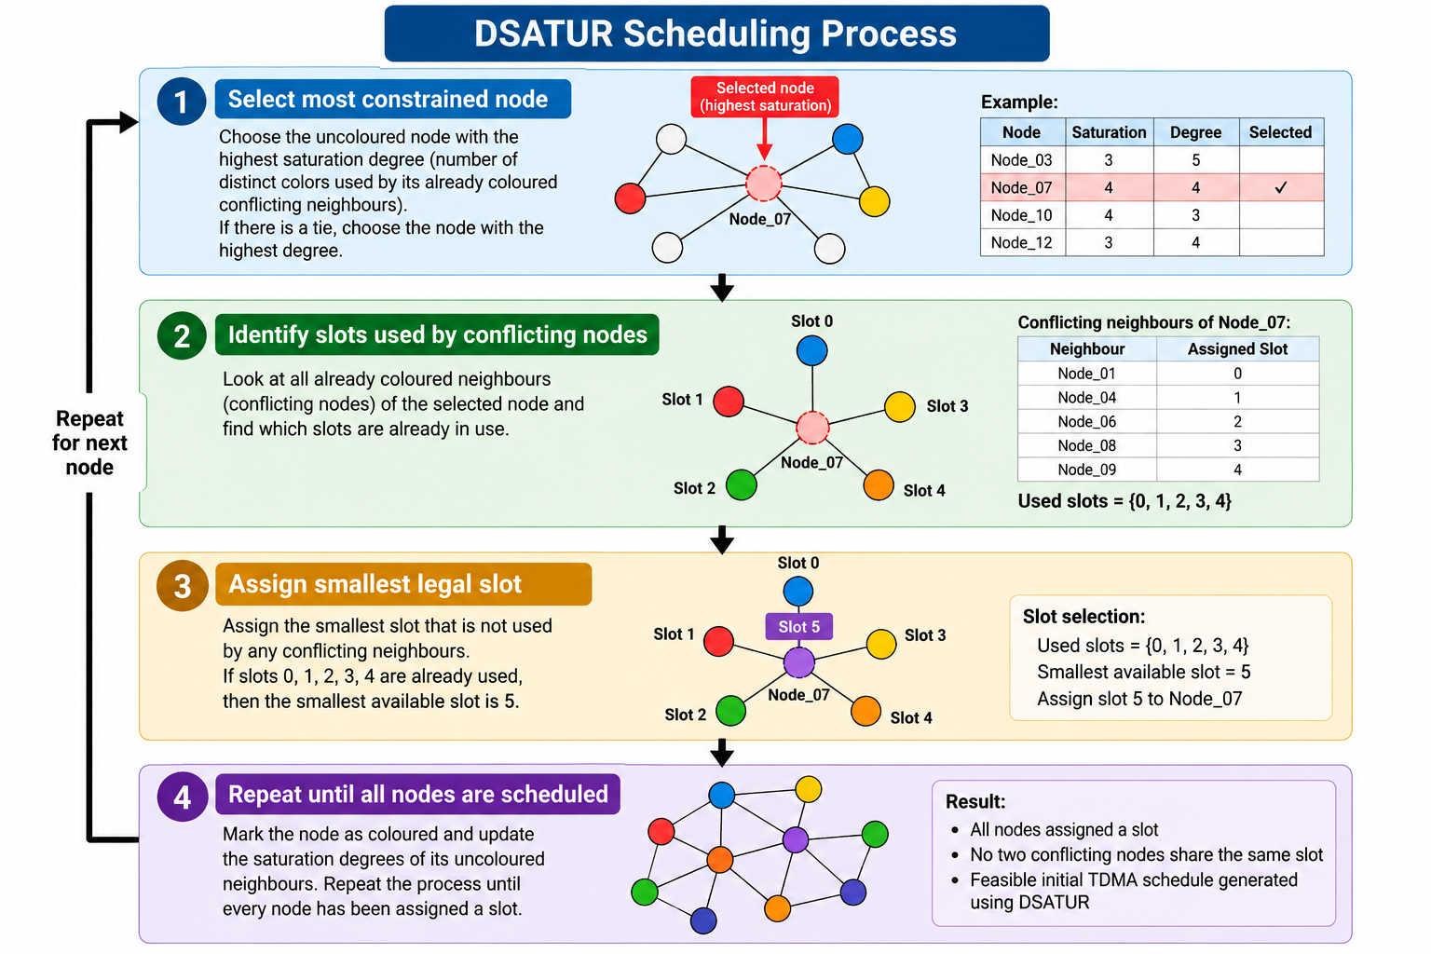
The number of unique slots is represented by K.
The optimization objective is:
minimize K
subject to:
slot(u) != slot(v) for every (u,v) in E_c
For the demonstrated topology, DSATUR produces an initial frame of:
Initial DSATUR frame = 9 slots
5. Class Elimination
The system then attempts to reduce the number of slots by eliminating complete colour classes.
A selected slot is targeted for removal, and its nodes are reassigned to other existing slots. A reassignment is accepted only when all conflict constraints remain satisfied.
If successful:
K_new = K_old - 1
For the demonstrated topology:
Accepted class eliminations = 0
Therefore, no slot could be removed through this optimization stage.
6. Kempe-Chain Refinement
The second optimization mechanism is Kempe-chain refinement. It attempts to restructure assignments involving two slots.
A valid two-colour connected component can have its two slot labels exchanged while preserving a proper colouring. The system tests such transformations and retains only valid and beneficial changes.
The demonstrated run performed:
Kempe attempts = 42
Accepted Kempe moves = 0
Since neither class elimination nor Kempe refinement reduced the schedule, the frame remained at 9 slots.
7. Exact Solver
A valid heuristic solution does not automatically prove optimality. Therefore, the system invokes an exact DSATUR branch-and-bound solver for the small demonstrated topology.
The exact solver searches for a solution using fewer slots and determines whether the 9-slot solution can be improved.
The results are:
Generated frame = 9
Exact optimum = 9
Solver status = OPTIMAL
The optimality gap is:
Optimality Gap = K_generated - K_optimal
= 9 - 9
= 0 slots
The relative gap is:
Relative Gap = (K_generated - K_optimal) / K_optimal
= (9 - 9) / 9
= 0%
Therefore, the generated 9-slot schedule is exactly optimal for this topology under the implemented Distance-2 model.
8. Final Schedule Generation
The optimized and verified Node-to-Slot mapping is:
Node_01 → Slot 0
Node_02 → Slot 1
Node_03 → Slot 2
Node_04 → Slot 0
Node_05 → Slot 3
Node_06 → Slot 4
Node_07 → Slot 5
Node_08 → Slot 3
Node_09 → Slot 6
Node_10 → Slot 7
Node_11 → Slot 8
Node_12 → Slot 6
Node_13 → Slot 0
Node_14 → Slot 1
Node_15 → Slot 2
Node_16 → Slot 0
Nodes can share a slot only when they are non-conflicting in the Distance-2 conflict graph. This enables spatial reuse while maintaining schedule validity.
9. Independent Verification
The final schedule is independently checked rather than being trusted solely because it was produced by the optimizer.
The verifier reconstructs the relevant conflict relationships and checks:
slot(u) != slot(v)
for every conflict edge.
The demonstrated verification checks:
Direct conflicts checked = 42
Direct violations = 0

Two-hop conflicts checked = 90
Two-hop violations = 0
Therefore:
Total conflict violations = 0
Verification Status = PASS
Only after this verification succeeds does the publication gate accept the schedule.
10. Final Result
The complete demonstrated pipeline is:
16 Nodes
→ 42 Communication Links
→ 90 Distance-2 Conflict Edges
→ 9-Slot DSATUR Schedule
→ Optimization
→ 9-Slot Final Schedule
→ Exact Optimum = 9
→ Optimality Gap = 0
→ 132 Conflict Checks
→ 0 Violations
→ Verification PASS
→ Publication Gate PASS
The final system therefore produces a 9-slot TDMA schedule that is conflict-free and exactly optimal for the tested 16-node topology under the implemented Distance-2 interference model. The result is reproducible through the project CLI and is accompanied by structured scheduling, optimization, verification, and integrity information.
RESEARCH AND REFERENCE :
- Ergen, S., & Varaiya, P. — “TDMA Scheduling Algorithms for Wireless Sensor Networks.” Wireless Networks, 2010.
- Kang, H., Zhao, Y., & Mei, F. — “A Graph Coloring Based TDMA Scheduling Algorithm for Wireless Sensor Networks.” Wireless Personal Communications, 2013.
- Ren, T. — “Graph Coloring Algorithms for TDMA Scheduling in Wireless Sensor Networks.” PhD Dissertation, University of Rhode Island, 2007.
- Kuhn, F. — “Local Multicoloring Algorithms: Computing a Nearly-Optimal TDMA Schedule in Constant Time.” STACS, 2009.
- Lakhlef, H., Jaber, G., Bouabdallah, A., D’Andreagiovanni, F., & Lounis, A. — “Distributed Time Slots Assignment Protocol in Dynamic Networks.” IEEE ISCC, 2020.
- Mahfoudh, S., Chalhoub, G., Minet, P., Misson, M., & Amdouni, I. — “Node Coloring and Color Conflict Detection in Wireless Sensor Networks.” Future Internet, 2010.
- Sgora, A., & Vergados, D. — “A Survey of TDMA Scheduling Schemes in Wireless Multihop Networks.” ACM Computing Surveys, 2015.
- Brélaz, D. — “New Methods to Color the Vertices of a Graph.” Communications of the ACM, 1979.
- Lloyd, E. L., & Ramanathan, S. — “On the Complexity of Distance-2 Coloring.” 1992.
- Amdouni, I., Adjih, C., & Minet, P. — “Joint Routing and STDMA-based Scheduling to Minimize Delays in Grid Wireless Sensor Networks.” 2014.
- Malaguti, E., & Toth, P. — “A Survey on Vertex Coloring Problems.” International Transactions in Operational Research, 2010.
- Herman, T., Pirwani, I., & Pemmaraju, S. — “Oriented Edge Colorings and Link Scheduling in Sensor Networks.”

