**Practical 1**

**Aim:**

**To study various machine learning libraries like - Scipy, Sklearn, Keras, Tensorflow with their usage**

**Description:**

**1. SciPy:**

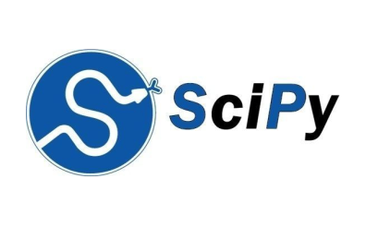

SciPy is a library of software for engineering and science. Again you need to understand the difference between SciPy Stack and SciPy Library. SciPy contains modules for linear algebra, optimization, integration, and statistics. The main functionality of SciPy library is built upon NumPy, and its arrays thus make substantial use of NumPy. It provides efficient numerical routines as numerical integration, optimization, and many others via its specific submodules. The functions in all submodules of SciPy are well documentedâ€Šâ€”â€Šanother coin in its pot.

**2. SciKit-Learn:**

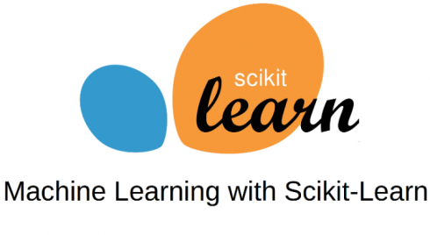

Scikits are additional packages of SciPy Stack designed for specific functionalities like image processing and machine learning facilitation. In the regard of the latter, one of the most prominent of these packages is scikit-learn. The package is built on the top of SciPy and makes heavy use of its math operations.

The scikit-learn exposes a concise and consistent interface to the common machine learning algorithms, making it simple to bring ML into production systems. The library combines quality code and good documentation, ease of use and high performance and is de-facto industry standard for machine learning with Python.

**3. Keras:**

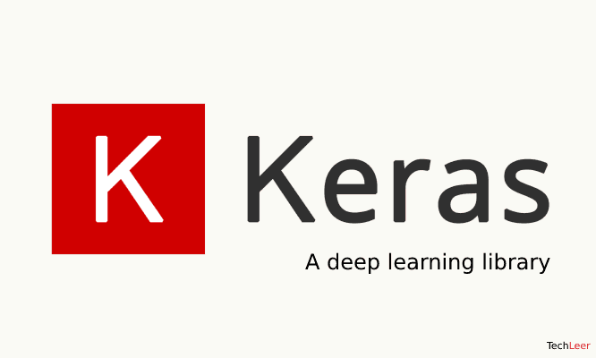

And finally, letâ€™s look at the Keras. It is an open-source library for building Neural Networks at a high-level of the interface, and it is written in Python. It is minimalistic and straightforward with high-level of extensibility. It uses Theano or TensorFlow as its backends, but Microsoft makes its efforts now to integrate CNTK (Microsoftâ€™s Cognitive Toolkit) as a new back-end.

The minimalistic approach in design aimed at fast and easy experimentation through the building of compact systems.

Keras is really eased to get started with and keep going with quick prototyping. It is written in pure Python and high-level in its nature. It is highly modular and extendable. Notwithstanding its ease, simplicity, and high-level orientation, Keras is still deep and powerful enough for serious modeling.

The general idea of Keras is based on layers, and everything else is built around them. Data is prepared in tensors, the first layer is responsible for input of tensors, the last layer is responsible for output, and the model is built in between.

**4. TensorFlow:**

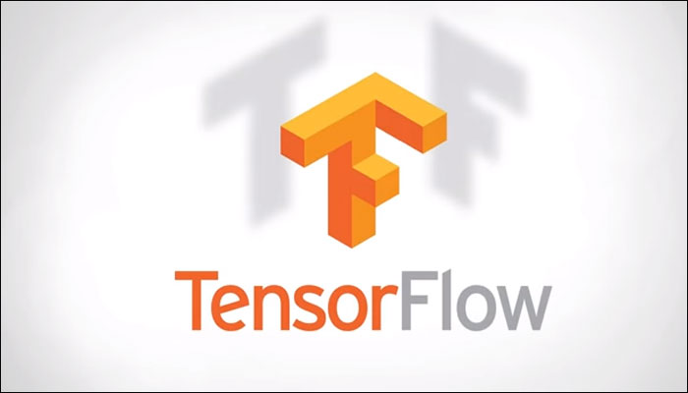

Coming from developers at Google, it is an open-source library of data flow graphs computations, which are sharpened for Machine Learning. It was designed to meet the high-demand requirements of Google environment for training Neural Networks and is a successor of DistBelief, a Machine Learning system, based on Neural Networks. However, TensorFlowisnâ€™t strictly for scientific use in borderâ€™s of Googleâ€Šâ€”â€Šit is general enough to use it in a variety of real-world application.

The key feature of TensorFlow is their multi-layered nodes system that enables quick training of artificial neural networks on large datasets. This powers Googleâ€™s voice recognition and object identification from pictures.