**Practical 2**

**Aim:**

**Write a python program to find the probability of given problem:**

1. **Find the probability of drawing two kings from a deck****.**
2. **A math teacher gave her class tow tests, 25 % of the class passed both tests and 42 % of the class passed the first test. Find the probability, number of students passed the second test.**

**Code:**

**a)**

total_cards = 52

no_of_king = int(input('Enter the number of kings: '))

def find_prob(no_of_king):

king, c, prob = 4, total_cards, 1

while(no_of_king > 0):

prob *= king/c

no_of_king -= 1

king -= 1

c -= 1

return prob

if(no_of_king > 0 and no_of_king <= 4):

prob = find_prob(no_of_king)

a = round(prob*100, 6)

print(

f'Probability of drawing {no_of_king} kings from the deck is {a}%')

else:

print(f'Enter valid number between 1-4')

**b)**

passed_in_both = int(input('Percentange of students passed in both test: '))

either_test = int(

input('Percentage of student passed in either of the test: '))

passed_in_remaining = passed_in_both / either_test

print(f'Students passed in first test is {round(passed_in_remaining*100,2)}%')

**Output:**

**a)**

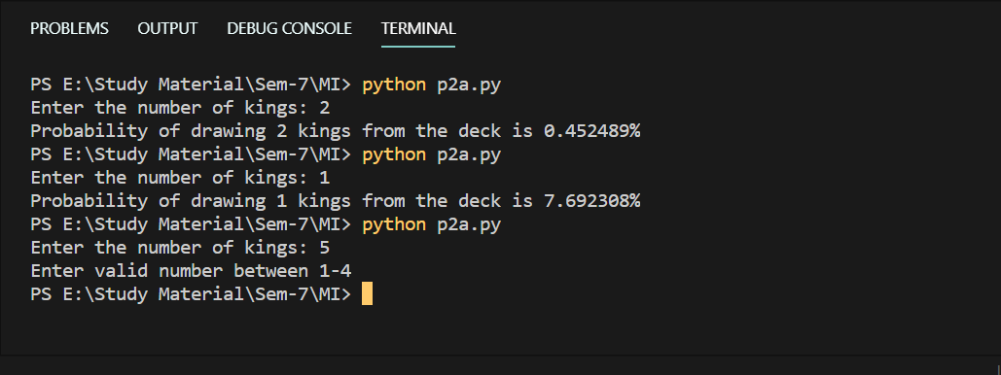

**b)**

