**PRACTICAL: 01**

**AIM:**

Practical Exercises in Email Writing

**QUESTION 01:**

You were unable to complete an assignment due to illness. Write an Email to your professor requesting an extension on the submission deadline.

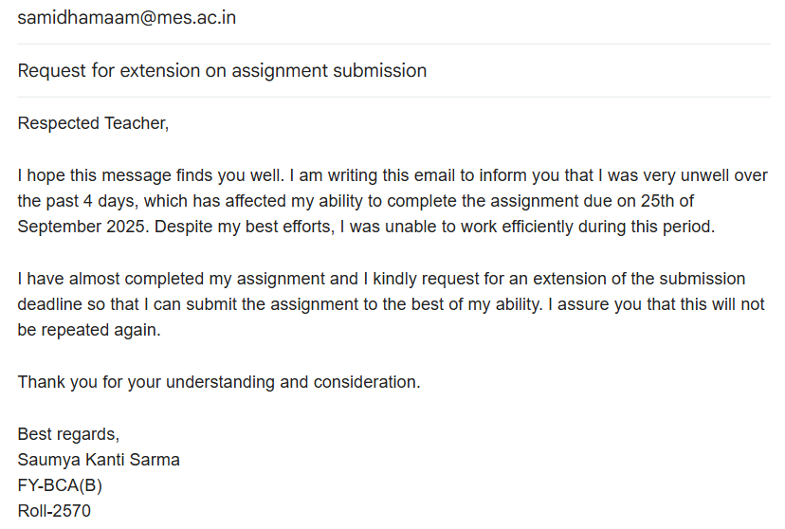

**QUESTION 02:**

Write an email accepting a job offer, confirming the joining date and expressing gratitude.

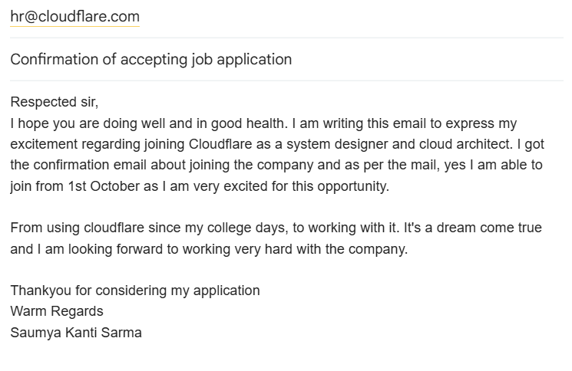

**CONCLUSION:**

Email writing performed successfully.