Practical 01: Basics of R

Q1) Assign the data in R .
1. 10.4, 5.6, 3.1, 6.4 , 21.7
2. 51 to 100
3. 0,5,10,......500
4. Round off the no 3.14159265359 into 4 decimal places.

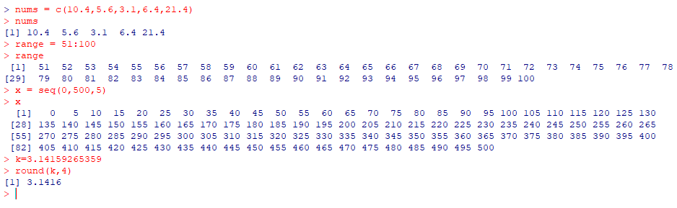

Q2) Find the mean, median, for the given data:
(i) 90, 94, 53, 68, 79, 94, 53, 65, 87, 90, 80, 69, 65, 89, 85, 53, 47, 61, 27, 80
(ii) 10 10 10 10 10 560 640 520 320 90 20 10

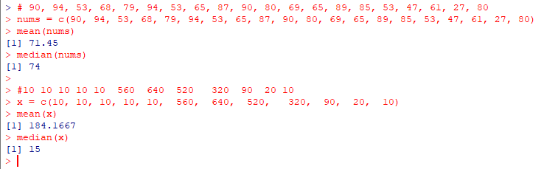

Q3) Find mode of
(i) 2,7,3,5,6,1,1
(ii) 73, 80, 73, 70, 73, 65, 63
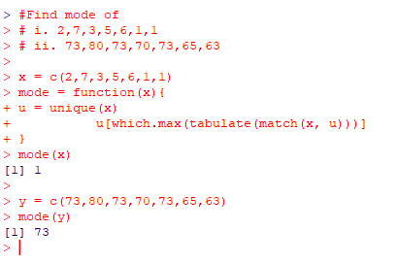
Q4) Find the following minimum, maximum, mean, median, SD, variance, length, summary, sort in decreasing , sort in ascending, sum, product,cumulative sum of the data
- 25, 29, 32, 35, 18, 19, 21, 12, 19, 87, 86
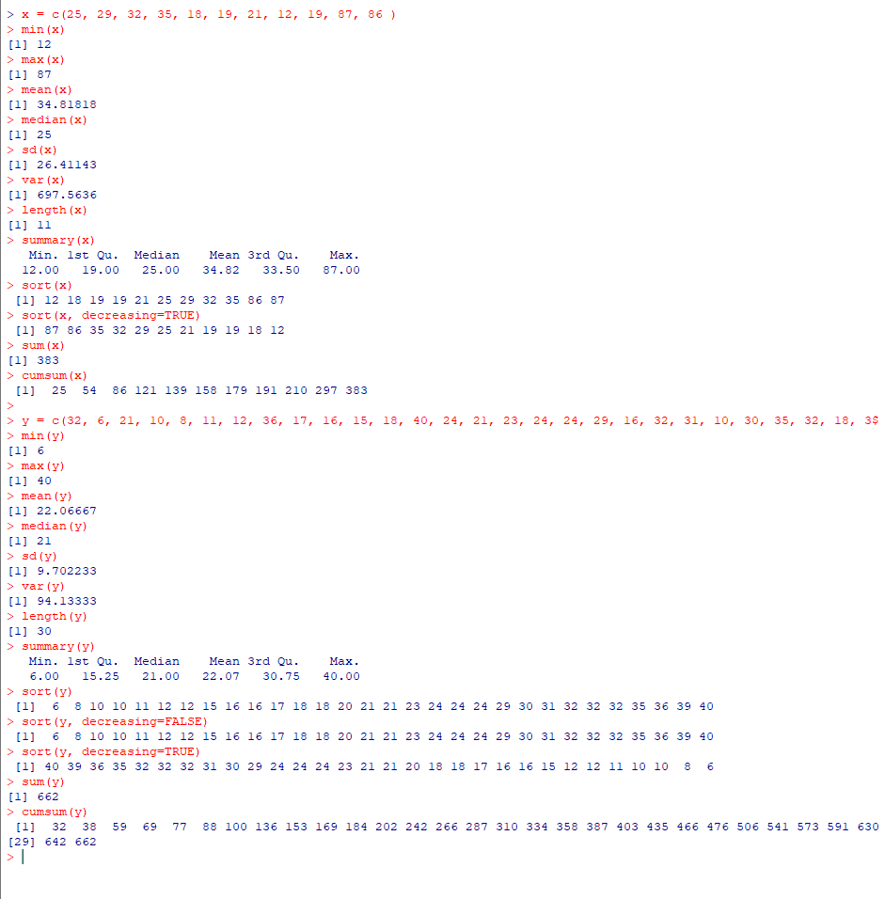

- 32, 6, 21, 10, 8, 11, 12, 36, 17, 16, 15, 18, 40, 24, 21, 23, 24, 24, 29, 16, 32, 31, 10, 30, 35, 32, 18,39, 12, 20

Q5) Prepare a table for the data
- x= 1,2,3……20 & y= 51,52,53……70
Where x is the serial no & y is the roll no.
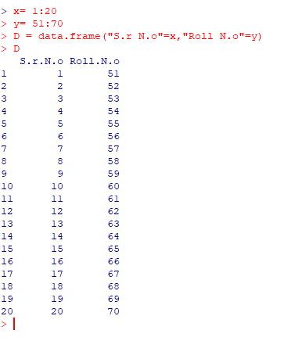

- Maths Stat
Ram 23 34
Raju 24 40
Meena 45 39
Mithu 15 40
Pooja 24 45
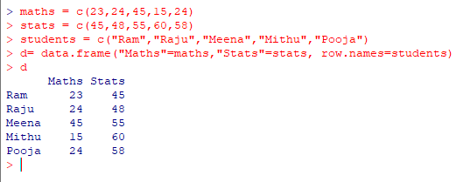

iii) Height weight
1201 135 45
1202 143 48
1203 157 55
1204 158 60
- 160 58

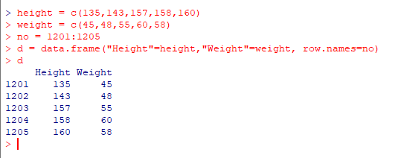

- Find the mode of the marks obtained by 10 students : 12,14,19,20,12,15,10,8,7,5,12,1,0,13,19

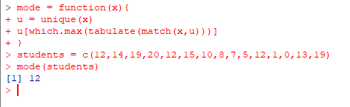

- Find mean,median,tamode
X 2, 3, 5, 8, 10
F 2 3 10 3 2
x=
f=
y=rep(x,f)
y
mean(y)
median(y)
mode(y)

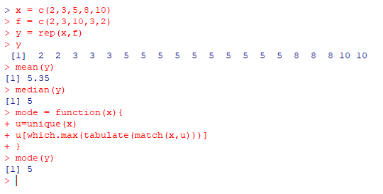
Q6)
X: 10 20 30 40 50
F;23 24 15 22 20

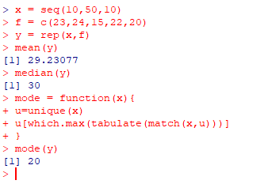

Practical 02: Graphs & diagrams
Bar Diagram:

- State: Punjab Haryana U.P. Gujarat Bihar Karnataka
Yield: 728 943 1469 2903 2153 2276

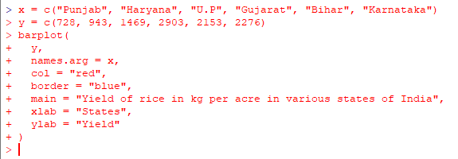
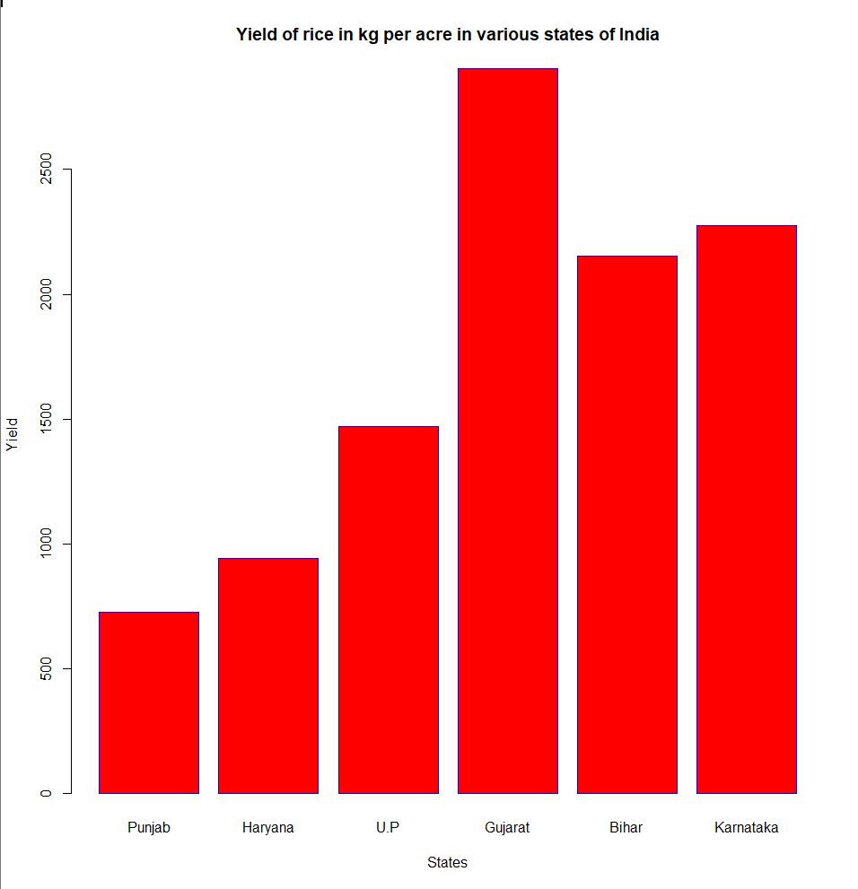

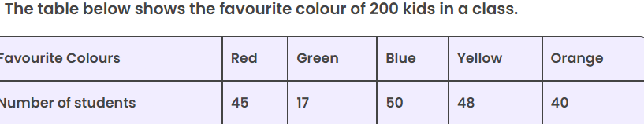

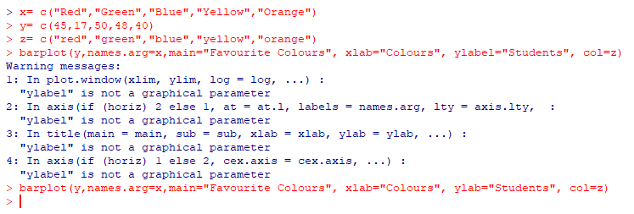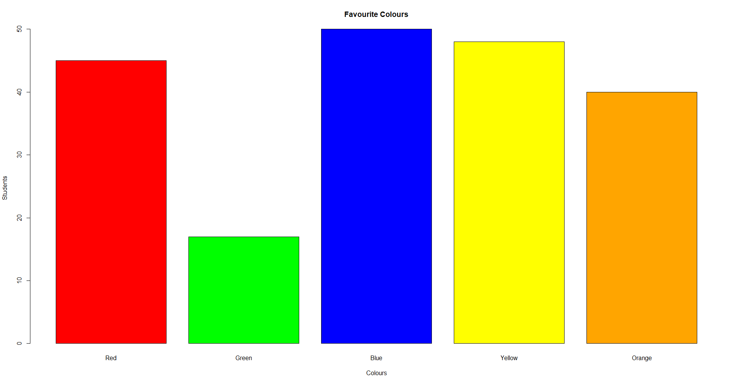

Multiple bar diagrams.

College Arts Science Commerce
A 1200 600 500
B 1000 800 650
C 1400 700 850
D 750 900 300

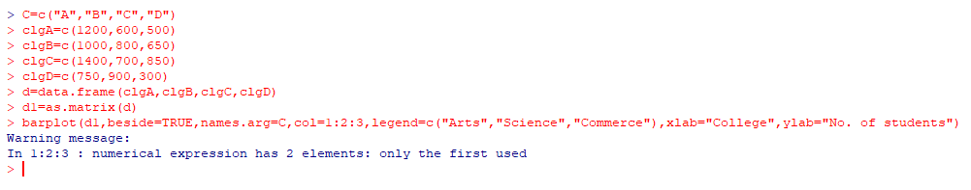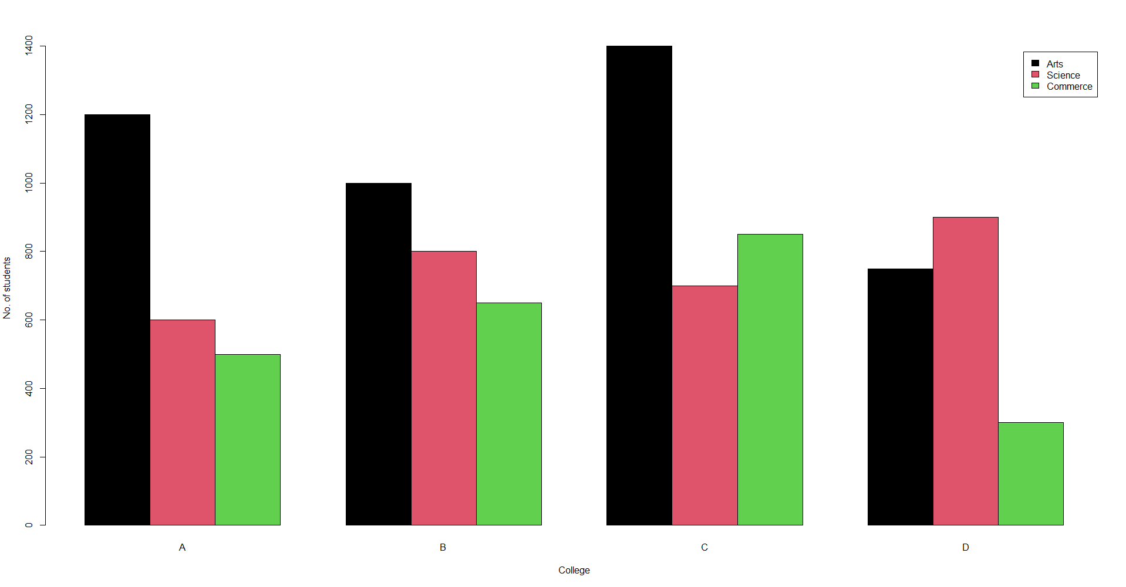

Faculty | Number of Students
Faculty | 2014-15 | 2015-16 | 2016-17
Arts  Science  Commerce | 600  400  200 | 550  500  250 | 500  600  300

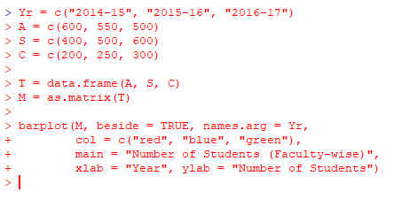
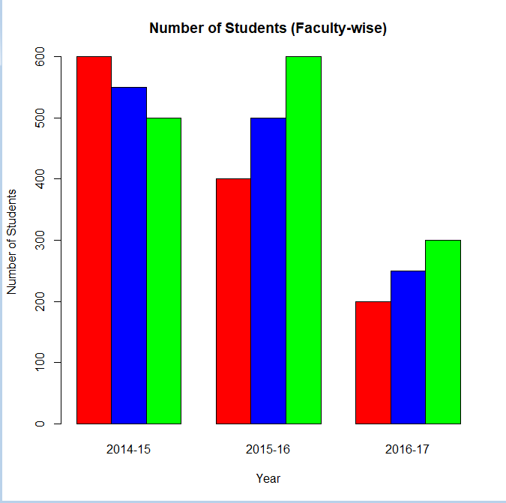

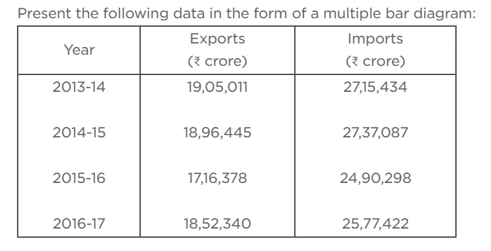

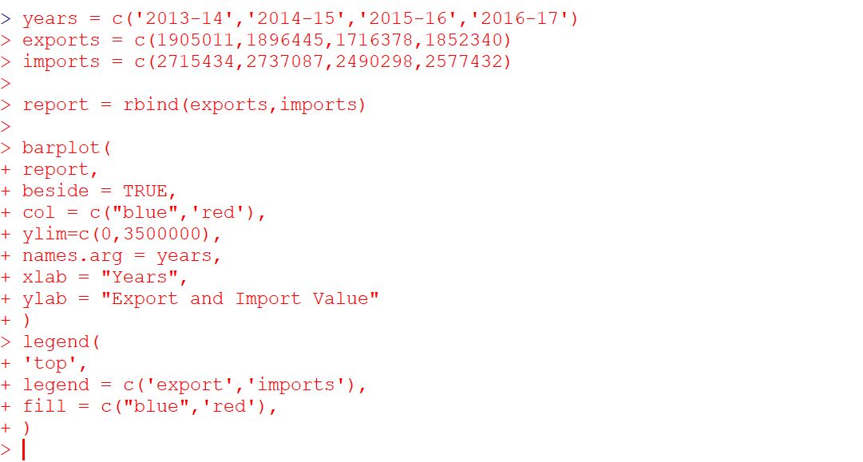
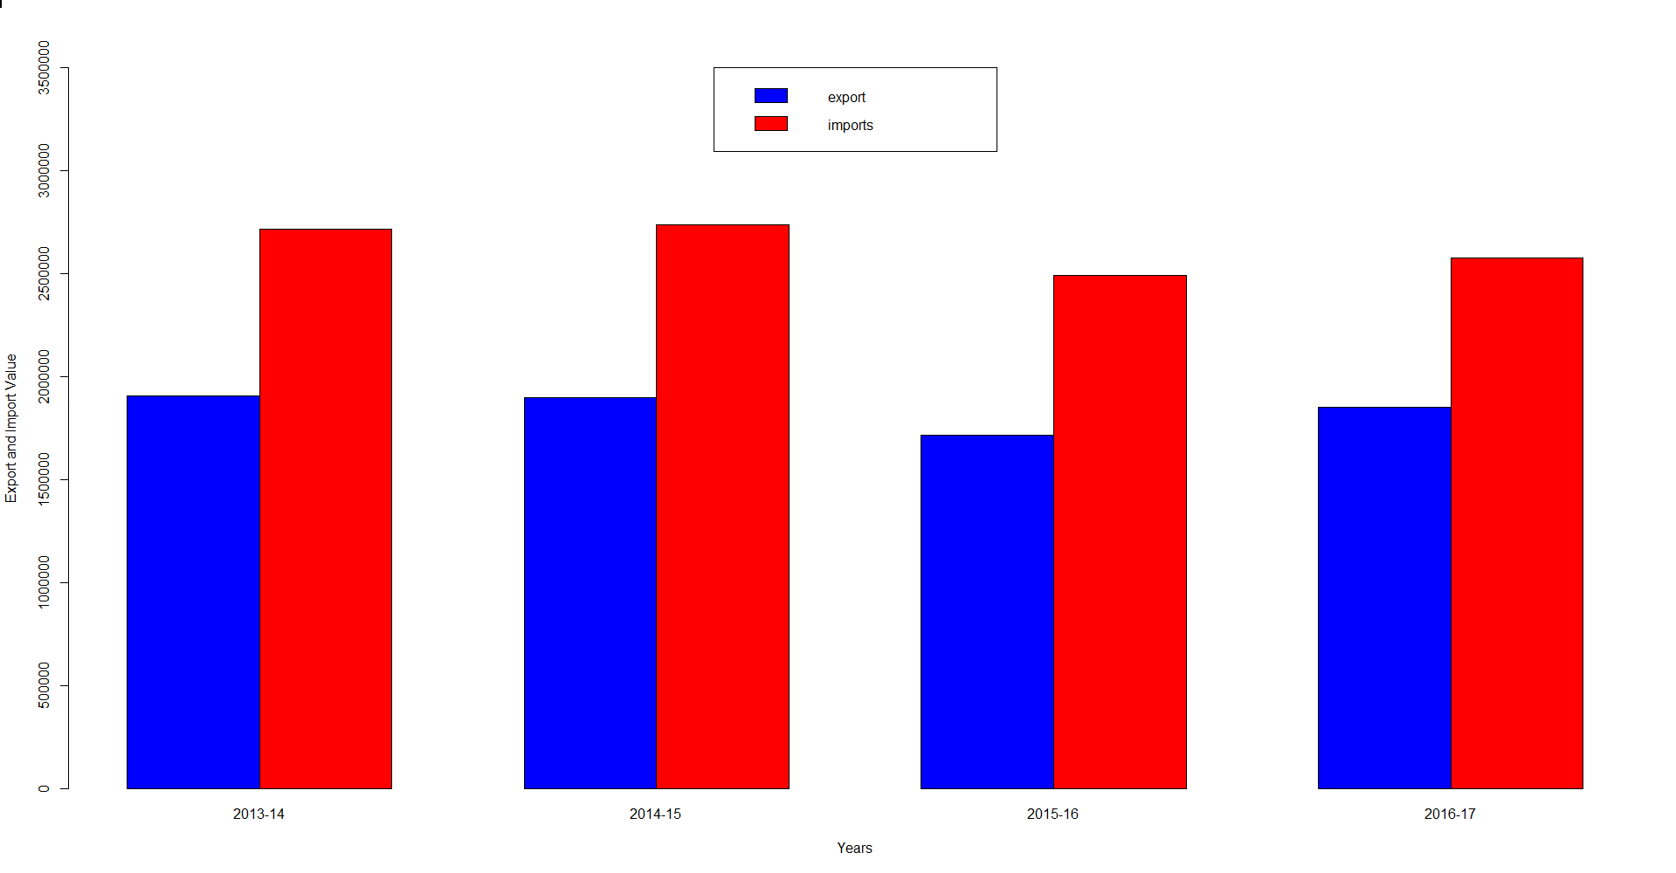

Subdivided bar diagram.
- create a subdivided graph:

Region | March | April | May | June | July
East | 2 | 9 | 3 | 11 | 9
West | 4 | 8 | 7 | 3 | 12
North | 5 | 2 | 8 | 10 | 11
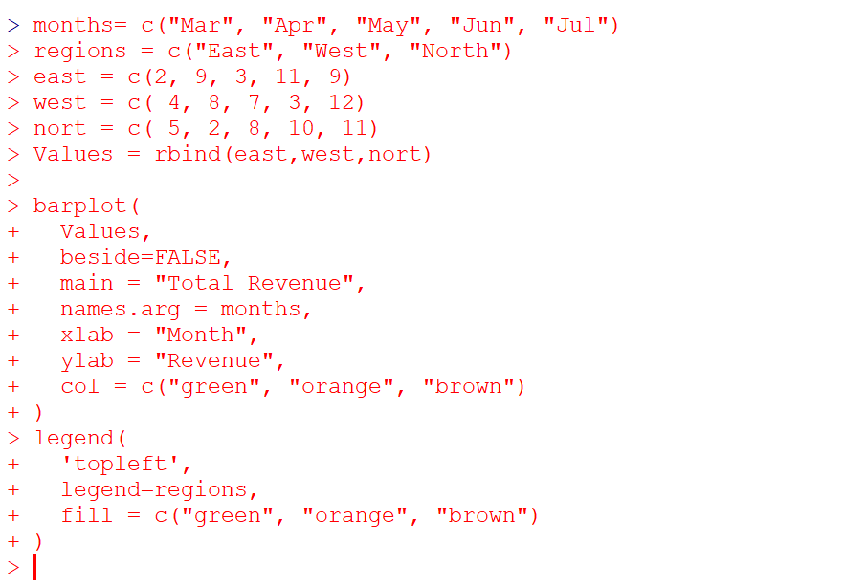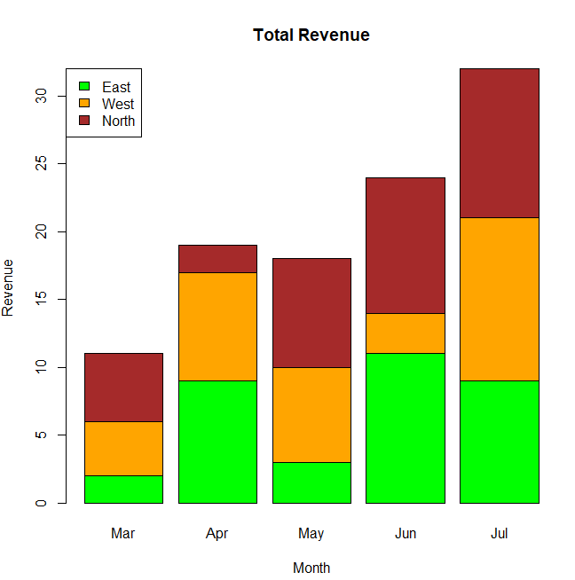

1st 2nd 3rd crew
Survived 122 167 528 673
Not survived 203 118 178 212
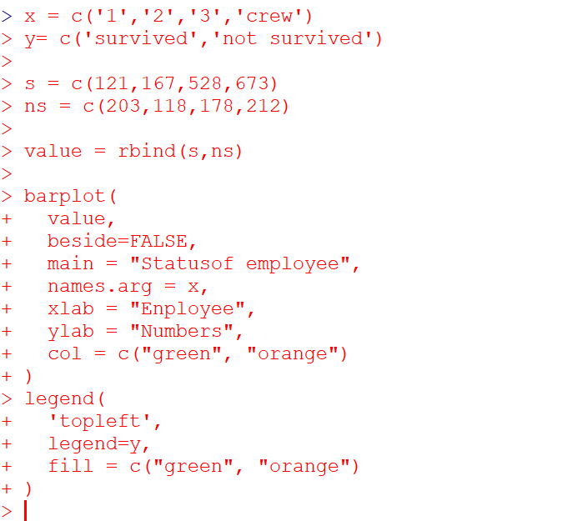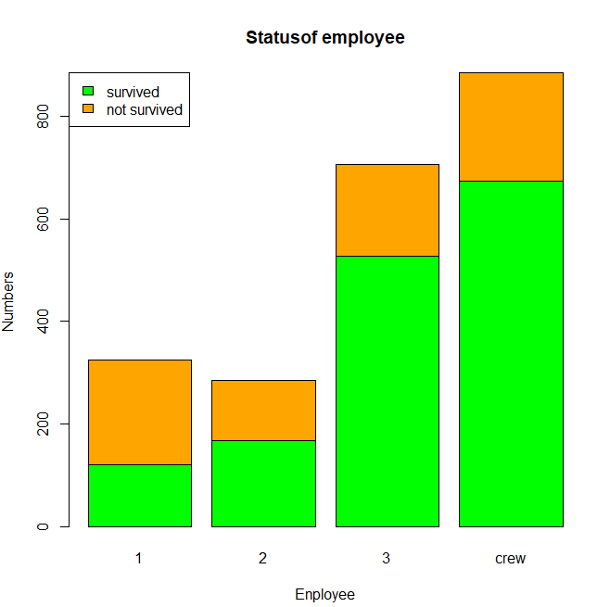

PIE DIAGRAM

- Construct a pie diagram for the given data of distance traveled by 6 travelers in a day.
Distance traveled in km Name of the person
210 A
450 B
250 C
100 D
50 E
90 F
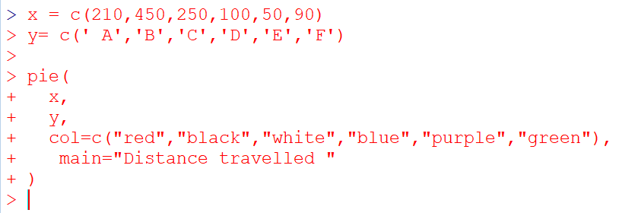
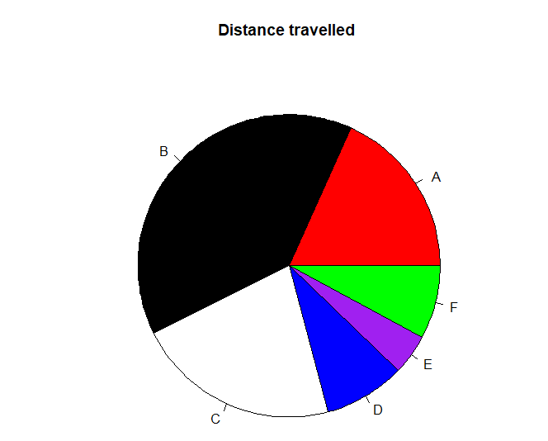
2. Make a pie diagram for the data
i)

Football | Hockey | Cricket | Basketball | Badminton
10 | 5 | 5 | 10 | 10
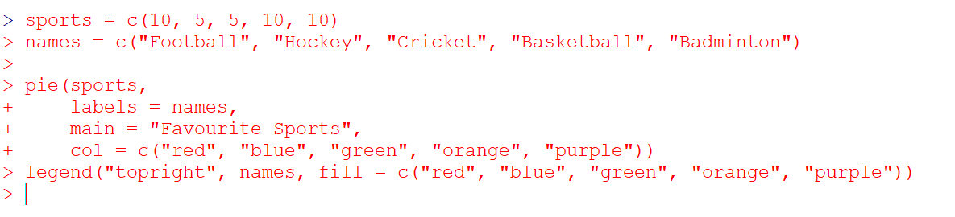
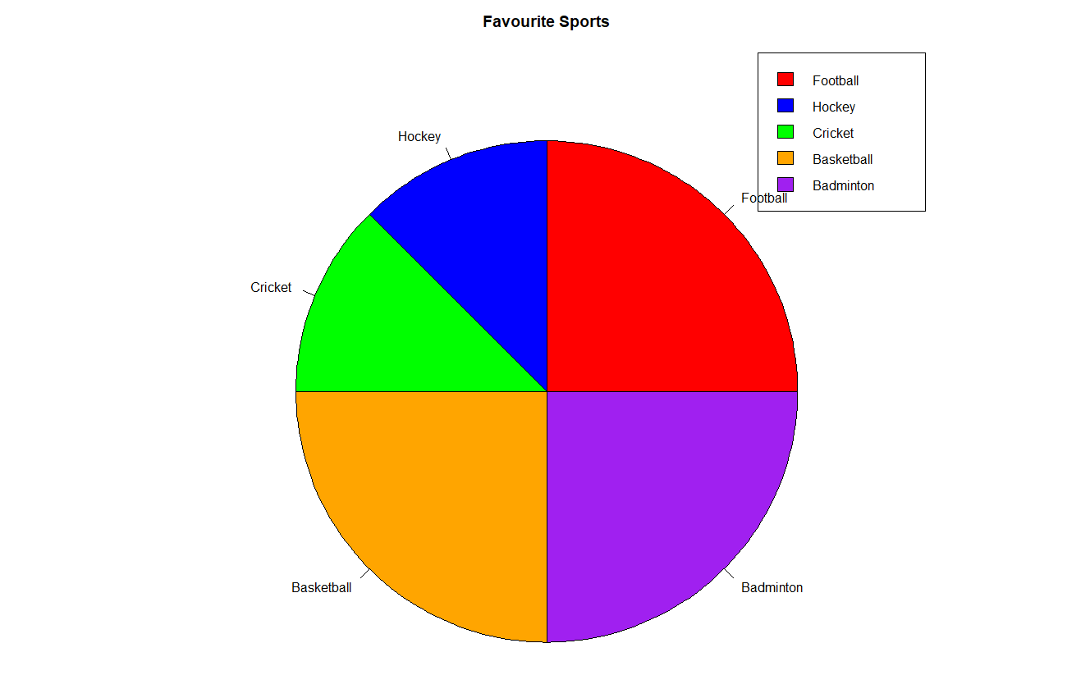

ii)
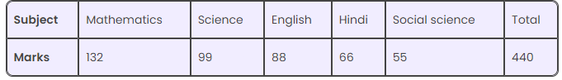
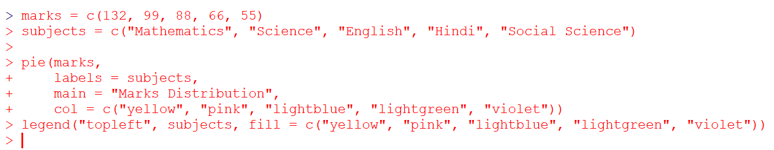
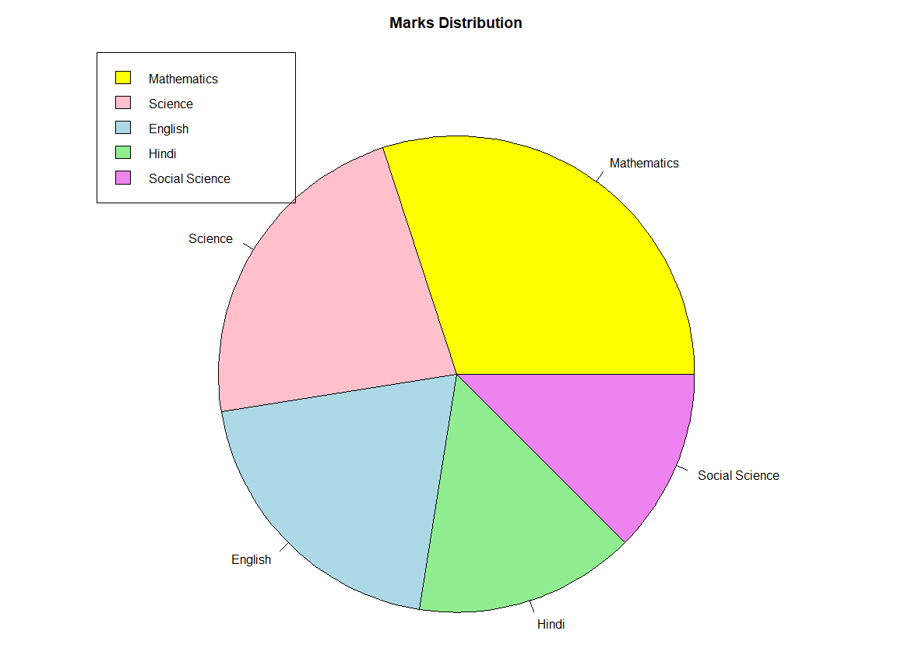

iii)
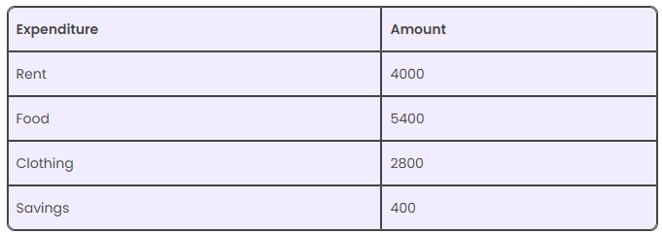
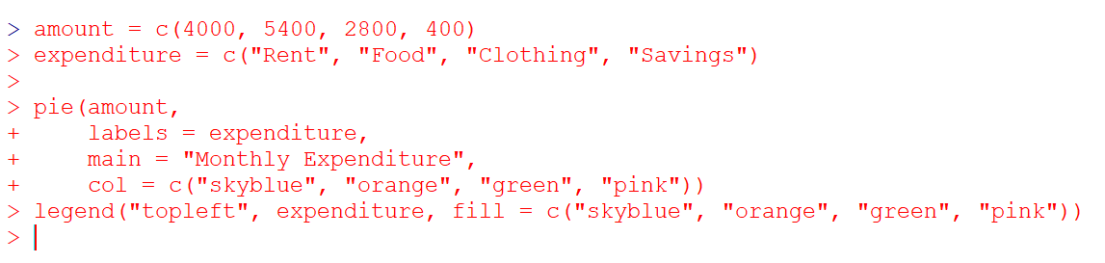
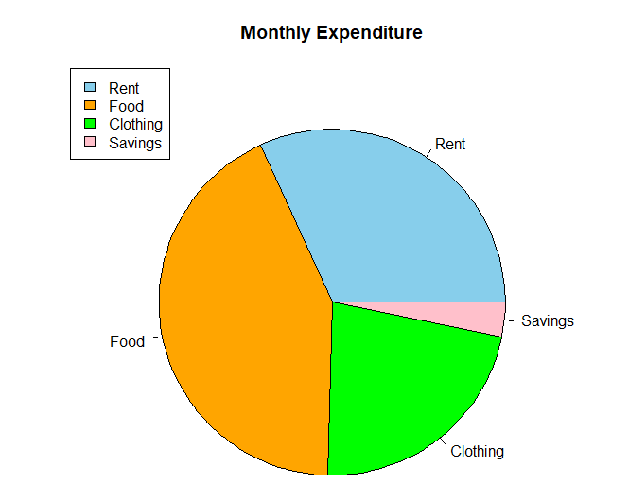
HISTOGRAM:

X: 5 10 15 20 25
F: 3 7 2 8 4
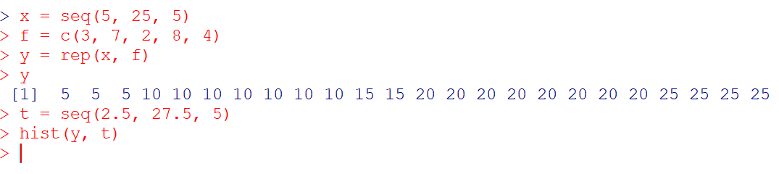
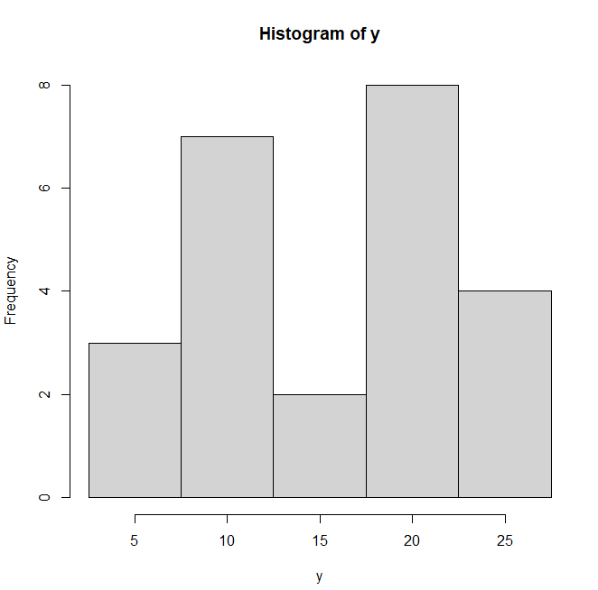

X: 0,10,20,30,40,50
F: 3,9,5,7,2,12
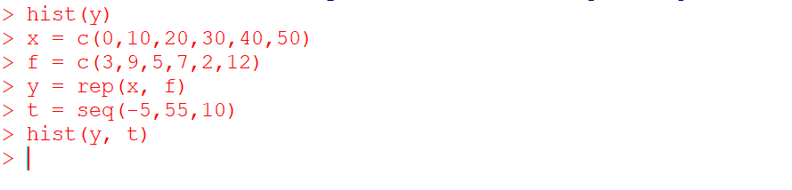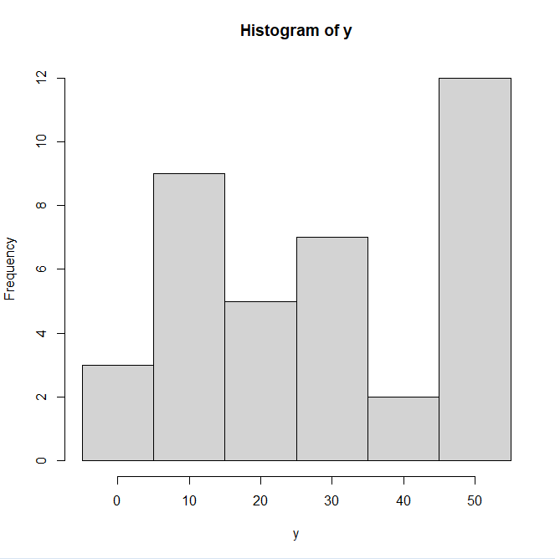

Histogram for grouped frequency data:

C.I. 0-25 25-50 50-75 75-100 100-125
f: 5 8 13 11 3
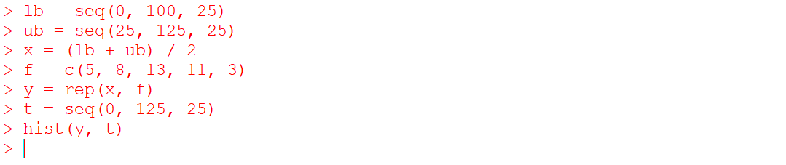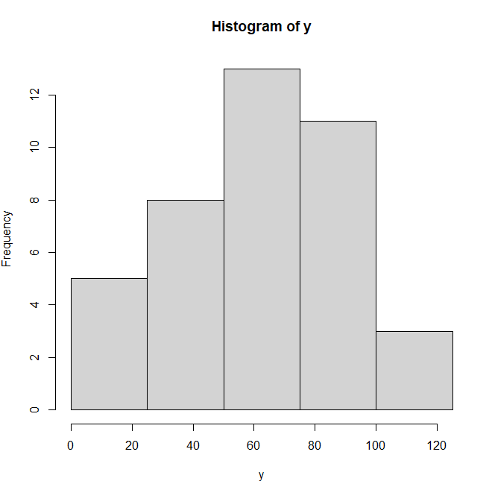

- Make a Histogram for the following data
CI : 10-15 15-20 20-25 25-30
F: 4 8 18 30
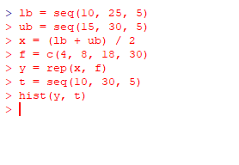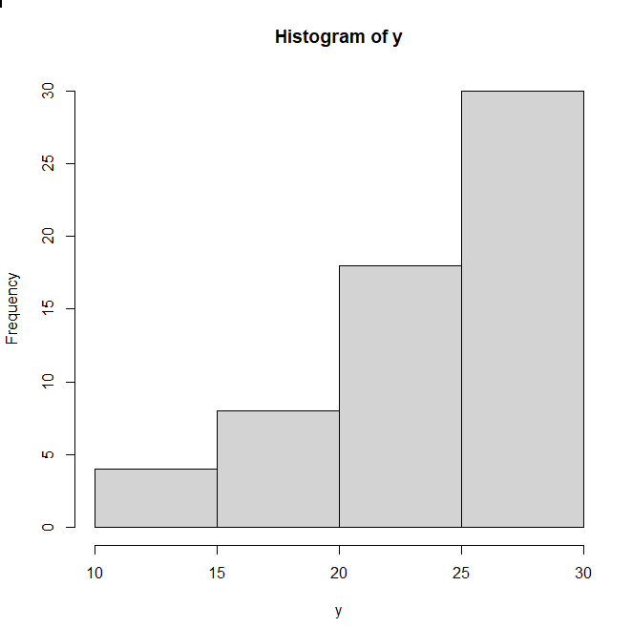

Frequency polygon:

C.I. 0-25 25-50 50-75 75-100 100-125
f: 5 8 13 11 3

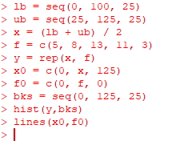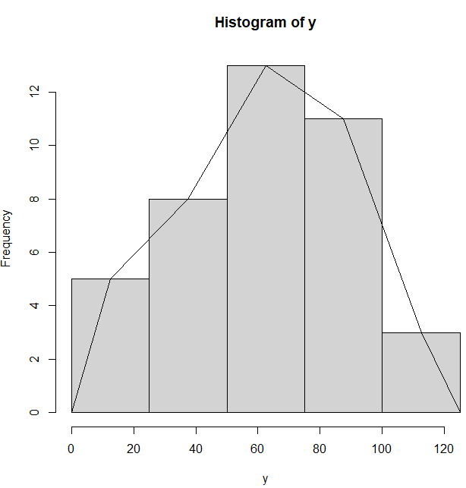

- Construct a frequency polygon for the given data.
Class Interval | 0 – 10 | 10 – 20 | 20 – 30 | 30 – 40 | 40 – 50 | 50 – 60 | 60 – 70
Frequency | 5 | 15 | 20 | 23 | 17 | 11 | 9
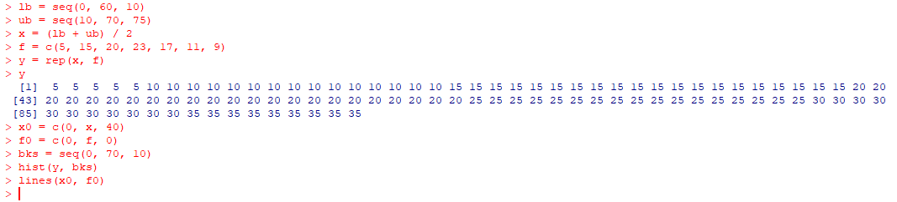
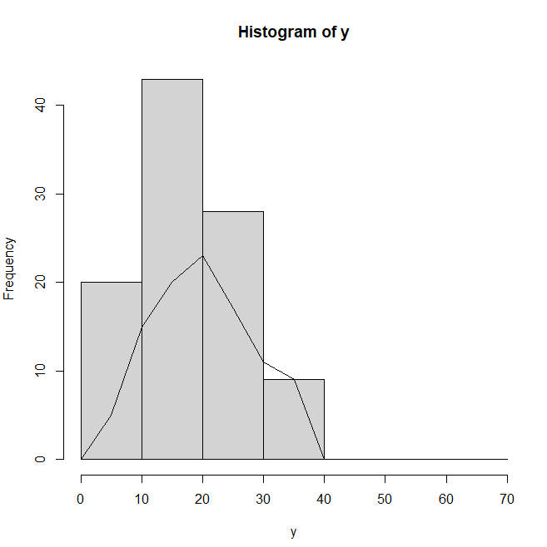

Ogivs:
- Construct ogives for the given data :
More than cumulative freq =
i=5 >=100 3
i=4 >=75 11+3=14
>= 50 27
>=25 35
>=0 40

C.I. 0-25 25-50 50-75 75-100 100-125
f: 5 8 13 11 3

- Construct an Ogive for the given data.
Score | 0-10 | 10-20 | 20-30 | 30-40 | 40-50 | 50-60 | 60-70 | 70-80
Frequency | 4 | 7 | 10 | 12 | 9 | 5 | 4 | 3

Scatter diagram :
plot (x,y )
