MAHATMA EDUCATION SOCIETY’S
PILLAI COLLEGE OF ARTS, COMMERCE & SCIENCE (Autonomous)

NEW PANVEL

PROJECT ON THE TOPIC: Employee Management System

BACHELOR OF COMPUTER APPLICATION (BCA)
3rd SEMESTER: 2026-2027

SUBJECT: FULL STACK DEVELOPMENT
TEACHER: MOHIT SIR

SUBMITTED BY: SAUMYA KANTI SARMA
ROLL NO: 4954
CLASS: SY-BCA-A

Introduction:
This project is a single page employee management application built with React 19 and Vite. It performs the four CRUD operations: create, read, update and delete. The whole interface lives in one component, App, inside App.jsx. It shows a form for adding or editing an employee and a table listing every employee, and it communicates with a backend REST API running at http://localhost:5000/employees

Concept Used:

1.Mapping (Rendering Lists)
Mapping means converting an array of data into an array of JSX elements. The table body calls employees.map() on the array held in state, and for every employee it returns one <tr> row. Each row receives a key prop set to employee.EMPLOYEE_ID, which lets React identify rows uniquely and update only the ones that change. Fields such as employee.NAME and employee.EMAIL are placed inside <td> cells with curly braces. Because the list is built from state, the table refreshes automatically whenever the array changes.

2. Conditional Rendering
Conditional rendering shows different output depending on a condition. This app uses two techniques. The first is the ternary operator, used for the submit button text: {editingId ? "Update Employee" : "Add Employee"}. The second is the logical AND operator, used so the Cancel button appears only while an employee is being edited: {editingId && (<button>Cancel</button>)}. Ordinary if statements are also used inside the functions,

3. Object Destructuring
Destructuring extracts values from arrays or objects into separate variables. The app uses array destructuring with hooks, as in const [employees, setEmployees] = useState([]), where the returned pair is unpacked into a value and a setter.

4. Type of CSS Used
The project uses external, plain CSS. Styles are written in App.css and imported into the component with import "./App.css", while index.css holds the global base styles. Elements are styled through class selectors applied with the className attribute, because class is a reserved word in JavaScript. The classes used include container, employee-form, cancel-button and delete-button. No inline styles, CSS modules or frameworks such as Bootstrap or Tailwind are used

5. Hooks
Hooks are special functions that let a function component use state and lifecycle features. This app uses two of them, both called at the top level of the component.
- useState stores data that changes over time. The app keeps three pieces of state: employees (the list, starting as an empty array), form (an object with name, email, department and salary) and editingId (starting as null). Calling a setter such as setEmployees re-renders the component with the new value.
- useEffect runs side effects. Here useEffect(() => { fetchEmployees(); }, []) has an empty dependency array, so it runs once after the first render and loads the employee list from the server.

6. Form Handling
The form uses controlled components. Every input has a name, a value bound to the form state and an onChange handler, so React state is always the single source of truth. One function, handleChange, serves all four inputs by using the computed property [e.target.name] to update the matching field. The form has onSubmit={handleSubmit}, and e.preventDefault() stops the browser from reloading the page. The salary string is converted with Number(form.salary) before sending, and the required attribute and type="email" give built in validation. After a successful submit the form is reset and editingId returns to null. Clicking Edit calls handleEdit, which fills the form with the chosen row, and cancelEdit clears it.

7. Fetch API
The Fetch API sends HTTP requests to the backend and is the hardest part of the app because it is asynchronous. All requests use async and await inside try and catch blocks, and the base address is stored in the constant API_URL. The app uses four request types:
- GET in fetchEmployees reads the list, converts it with response.json() and stores it using setEmployees.
- POST creates an employee, sending headers with Content-Type: application/json and a body made with JSON.stringify.
- PUT to ${API_URL}/${editingId} updates an existing employee.
- DELETE to ${API_URL}/${id} removes an employee after window.confirm asks for confirmation.
After each response, response.ok is checked and any error message from the server is shown in an alert. On success, fetchEmployees() is called again so the table always matches the database. Since the frontend and backend run on different ports, the backend must allow cross origin requests (CORS).
Code:
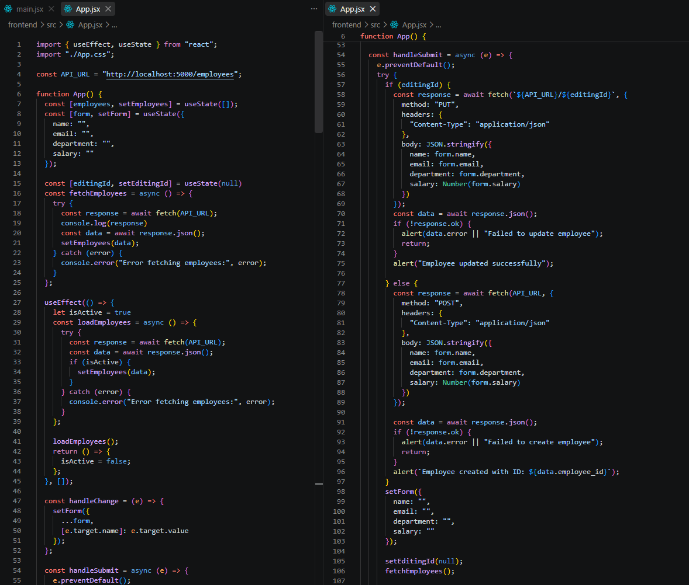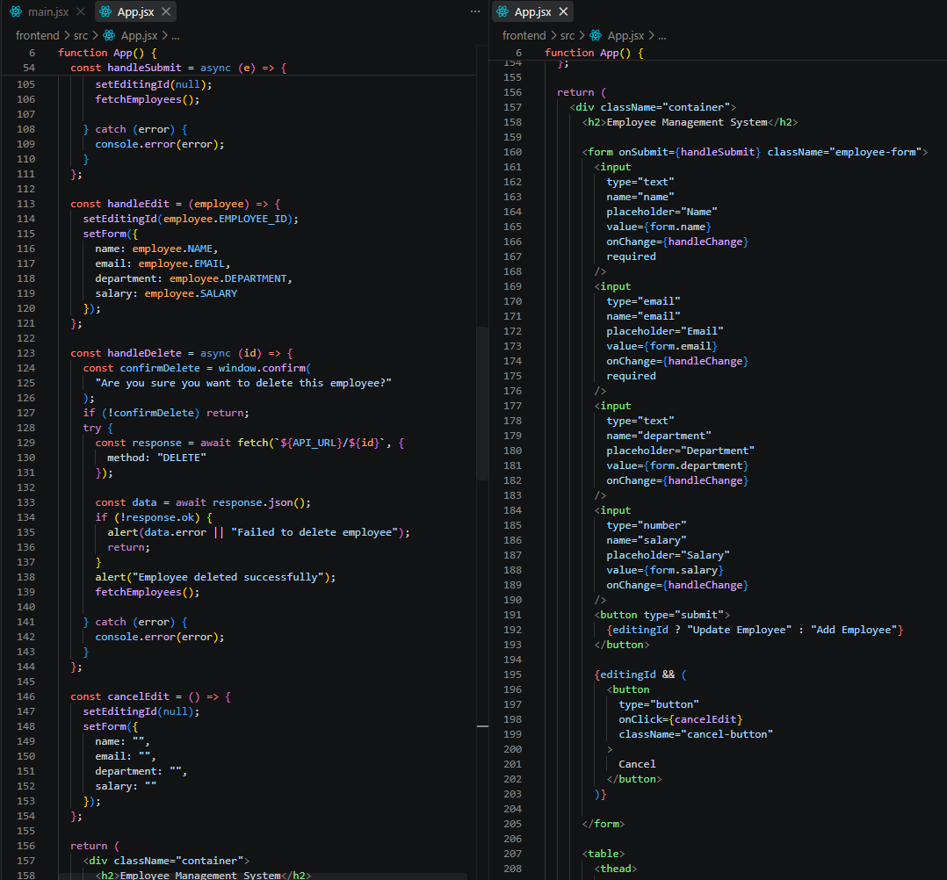

Output:
