ARDUINO BASED BLOOD GLUCOMETER FOR HIGH PRECISION VALUE

A PROJECT REPORT

Submitted in partial fulfillment for the award of the degree of

M.S
In
Software Engineering
By

L. ALICE AUXILIA
(13MSE0406)

Under the guidance of

Prof. M. Asha Jerlin



School of Information Technology and Engineering

November, 2016

DECLARATION BY THE CANDIDATE

I hereby declare that the project report entitled “ARDUINO BASED BLOOD GLUCOMETER FOR HIGH PRECISION” submitted by me to VIT University, Vellore in partial fulfillment of the requirement for the award of the degree of MS (Software Engineering) is a record of bonafide project work carried out by me under the guidance of Prof. M. Asha Jerlin. I further declare that the work reported in this project has not been submitted and will not be submitted, either in part or in full, for the award of any other degree or diploma in this institute or any other institute or university.

Place: Vellore Signature of the Candidate

Date: 09.11.16 L. Alice Auxilia

School of Information Technology & Engineering [SITE]

CERTIFICATE
This is to certify that the project report entitled “ARDUINO BASED BLOOD GLUCOMETER FOR HIGH PRECISION VALUE” submitted by L. ALICE AUXILIA (13MSE0406) to VIT University, Vellore, in partial fulfillment of the requirement for the award of the degree of M.S in Software Engineering is a record of bonafide work carried out by him/her under my guidance. The project fulfills the requirements as per the regulations of this Institute and in my opinion meets the necessary standards for submission. The contents of this report have not been submitted and will not be submitted either in part or in full, for the award of any other degree or diploma and the same is certified.

Prof. M. Asha Jerlin Dr. Valarmathi. B
Assistant Professor (Senior) Head of Department
INTERNAL GUIDE Department of Software and Systems Engineering

The project work is satisfactory / unsatisfactory

Prof. P.G. Shynu Prof. R. Seetha Prof. R. Vijay Anand

Internal Examiner 1 Internal Examiner 2 Internal Examiner 3

Acknowledgement

I wish to express our heartfelt gratitude to Dr. G. Viswanathan, Chancellor, VIT University, Vellore for providing facilities for the Final year project.
I am highly grateful to our Vice Presidents, Shri. Sankar Viswanathan, Dr. Sekar Viswanathan and Shri. G.V. Selvam, Vice Chancellor Dr. Anand A. Samuel, Pro-Vice Chancellors Dr. S. Narayanan and Dr. V. Raju for providing necessary resources.
My sincere gratitude to Dr. Aswani Kumar Cherukuri, Dean, School of Information Technology and Engineering for giving us the opportunity to undertake the project.
I wish to express my sincere gratitude to Dr. Valarmathi. B, Associate Professor, HOD of Software and Systems Engineering and the Project Coordinators Prof. Thilagavathi M and Prof. Magesh G, School of Information Technology and Engineering for providing me an opportunity to do my project work in VIT University.
I would like to express my special gratitude and thanks to my internal guide Prof. M. Asha Jerlin, Assistant Professor (Senior), School of Information Technology and Engineering whose esteemed guidance and immense support encouraged to complete the project successfully.
I thank the Management of VIT University for permitting me to use the library resources. I also thank all the faculty members of VIT University for giving me the courage and strength I needed to complete my goals. This acknowledgement would be incomplete without expressing my whole hearted thanks to my family and friends who motivated me during the course of the work.

Place: Vellore Signature of the Student

L. Alice Auxilia
Date:09.11.16

TABLE OF CONTENTS

Chapter No | Contents | Page No
 | Executive Summary | I
 | LIST OF FIGURES | II
 | LIST OF TABLES | III
 | LIST OF ACRONYMS | IV
1 | Introduction | 1
1.1 | Background | 1
1.2 | Problem Statement | 1
1.3 | Importance | 1
1.4 | Organization of Report | 2
2 | Overview and Planning | 2
2.1 | Proposed System Overview | 2
2.2 | Challenges | 3
2.3 | Assumptions | 4
2.4 | Architecture Specifications | 5
2.5 | Hardware Requirements | 6
2.6 | Software Requirements | 6
2.7 | Project Schedule (Gantt chart) | 7
2.8 | Work Breakdown Structure | 8
3 | Literature Survey and Review | 8
3.1 | Literature Survey | 9
3.2 | Literature Summary | 10
4 | System Design | 11
4.1 | High-Level Design | 12
4.2 | Low-Level Design | 15
4.3 | Codes and Standards | 19
4.4 | Constraints and Tradeoffs | 20
4.5 | Test Cases Generation | 20
5 | System Implementation | 21
5.1 | Code | 21
5.2 | Unit Testing | 30
5.3 | Integration Testing | 31
5.4 | Test Results | 31
6 | Results and Discussion | 32
6.1 | Output/Results | 32
6.2 | Results Analysis | 33
6.3 | Discussion | 34
7 | Conclusion and Future Work | 34
7.1 | Conclusion | 34
7.2 | Scope of Future Work | 35
8 | References | 35

EXECUTIVE SUMMARY

It is a worldwide problem that we face at any time, and that is checking our heartbeat rate, our body temperature and our glucose level. People become lazy nowadays to take care of their own health. In this project we proposed a system to check the above mentioned health checkups which is user friendly and less time consuming.
It is an advanced system of checking their own health checkups in an easy manner with less consumption of cost. This system is environment friendly with proper functions and functionalities. In existing system, the patient must be in hospital for continuous monitoring of his health. In this system the patient health can be monitored even though he is not in hospital and he can do his work normally.
Drawbacks in existing system are:
- Doctor Presence must be there.
- Consumes more time and more power.
- Difficult to monitor.
Advantages in the proposed system are:
- Even though doctor is absent health can be monitored.
- Extremely designed for low power.
- Easy monitoring system.

LIST OF TABLES

Table No Title Page No

2.3.1 Assumptions for the project
4.5.1 Test Cases

LIST OF FIGURES

Figure No Title Page No.

Fig. 2.4.1 System Architecture
Fig. 2.7.1 Gantt Chart
Fig.2.8.1 Work Breakdown Structure
Fig.4.2.1 Use Case Diagram
Fig.4.2.2 Class Diagram
Fig.4.2.3 Sequence Diagram
Fig.4.2.4 Activity Diagram
Fig.4.2.5 State Chart Diagram

LIST OF ACRONYMS

GSM - Global System for Mobile Communication.
DFD – Data Flow Diagram
UML – Unified Modelling Language

CHAPTER 1
INTRODUCTION

1.1 Background
This paper illustrates the design and implementation of an e-health monitoring networked system. The architecture for this system is based on smart devices and wireless sensor networks for real time analysis of various parameters of patients. This system is aimed at developing a set of modules which can facilitate the diagnosis for the doctors through Tele-monitoring of patients. It also facilitates continuous investigation of the patient for emergencies looked over by attendees and caregivers. A set of medical and environmental sensors are used to monitor the health as well as the surrounding of the patient. This sensor data is then relayed to the server using a smart device or a base station in close proximity. The doctors and caregivers monitor the patient in real time through the data received through the server

  - Problem Statement
The existing glucometer which is used for the diabetes patients to check the value of the sugar level in blood gives the incorrect values when it is compared with the laboratory value. People suffer a lot as well as they are less conscious about their sugar level which leads to more problems in the patient’s body and health due to belief of the incorrect values. Our project is to make an Arduino based blood glucometer which detects the patient’s high precision value of the glucose level. With this the precise value is directly generated to the patient’s doctor through a message to their mobile (either family doctor or the doctor to whom the patient checks regularly). Along with this we are going to check heart beat and the body temperature of the patient and it will be sent as a message to the doctor.

1.3 Importance
The roles and responsibilities of this system is giving exact value of the heartbeat, body temperature and the glucose level whether it is high or low. It is very useful to the patient as well as the doctor for the future use. Arduino UNO is a growing hardware which is used in many other projects. Arduino based blood glucometer which detects the patient’s high precision value of the glucose level, body temperature and heartbeat. With this, the precise value is directly generated to the patient’s doctor through a message to their mobile (either family doctor or the doctor to whom the patient checks regularly). This product is useful for detecting the sugar level in the blood and it helps the patient to know about their health condition. The benefits of this product are improved customer experience, focused marketing efforts. The objectives of this project are understand customer needs better, maintain long term customer relationships. The goals of this product are improved customer satisfaction, improve the efficiency of business, enhance the sales and support teams.

1.4 Organization of Report
This project highly deals with the heavy advantages in any type of organizations, hospitals and other sectors. This project deals with providing precision values using the Arduino. And consumes the less time for detecting the values of glucose, heartbeat and body temperature. The origin of this product is the approach of focusing on customer satisfaction and loyalty rather than focusing self-satisfaction and profit. The product perspectives are expansion of profitable, long lasting customer relationships, delivery of a consistent, relevant, high quality customer experience. Delivery of the right products and services tailored to meet customer’s needs. Increase customer equity. Having this product in any sector can relate customer satisfaction.

CHAPTER 2
OVERVIEW AND PLANNING
  - Proposed System Overview
To solve the problems identified in the existing system, we provide the Arduino based glucometer for high precision value to detect glucose level, body temperature and heartbeat. Another advantage is, we can use it wherever we are. In addition, an automated performance evaluation would provide more accurate and reliable results avoiding human error. In this work, we propose a system that detects the value of the glucose. Our system detects the value through given input. This project consists of the details of operating environment of our project. The faults that has been over came while implementing the project. The design convention (circuit diagram) of the modules used in system architecture. The UML diagrams of the implementation of the project for the better understanding. Images of the user interface designs. Here we use different sensors to detect the values of glucose level, body temperature and heartbeat.
- TEMPERATURE SENSOR: The temperature sensor functional module consists of two parts: the function module box and the probe head. The LM34 temperature sensor is mounted on the probe head. Be careful to make sure that the sensor is properly mounted on the probe head. By replacing the LM34 with another precision integrated-circuit temperature sensor LM35, we can easily get an output voltage proportional to the centigrade temperature. The LM35 sensor has a linear +10.0 mV/°C scale factor and a temperature range from -55°C to +150°C.In fact LM34 and LM35 are among the same series of temperature sensors so that they can be easily exchanged in different applications. The wiring for LM 35 is the same as that of LM34. Please refer to the datasheets of LM34 and LM35 for more detailed packaging and features information.

- PULSE OXIMETER SENSOR: In its most common (trans missive) application mode, a sensor device is placed on a thin part of the patient's body, usually a fingertip or earlobe, or in the case of an infant, across a foot. The device passes two wavelengths of light through the body part to a photo detector. It measures the changing absorbance at each of the wavelengths, allowing it to determine the absorbance’s due to the pulsing arterial blood alone, excluding venous blood, skin, bone, muscle, fat, and (in most cases) nail polish. This method does not require a thin section of the person's body and is therefore well suited to a universal application such as the feet, forehead, and chest, but it also has some limitations. Pulse oximeters are non-invasive devices used to measure a patient's blood-oxygen saturation level and pulse rate. Nonin Medical’s pulse oximeters and sensors provide proven accuracy in the widest range of patients, settings and conditions.

- MOISTURE SENSOR: The Moisture sensor is used to measure the water content (moisture) of soil. When the soil is having water shortage, the module output is at high level, else the output is at low level. This sensor reminds the user to water their plants and also monitors the moisture content of soil. It has been widely used in agriculture, land irrigation and botanical gardening.

2.2 Challenges
- Automatically provide values to the patient’s doctor through message.
- Advanced technology.
- Fast and readily available values with high resolution.
- It saves their time and efforts.
- The system is convenient and secure for the users.
- Environmental control systems.
- Augmentative communication devices.
- Emergency response systems.

2.3 Assumptions
Table 2.3.1 Assumptions for the project

S. No | category | Assumptions | Status | Actions
1 | Requirements gathering | Requirements of the project are analyzed and collected | open | met the project guide that the requirements are ready and working properly
2 | Analysis | The project working process, pros and cons are analyzed | open | Project team currently verifying the dimensions
3 | Design | Dimensions of the project significantly from existing product lines | open | Design team member is verifying the project
4 | Implementation | This done for each phase of the project | open | Some of the phases of implementation is shown during review2 and discussed with the project guide
5 | Testing | This is done after the project is complete and each phase is tested and modified | open | After the testing is completed successfully it is shown to the project guide and the documentation is prepared

2.4 Architecture Specifications

Moisture sensor
Arduino UNO
Pulse oximeter sensor

Message to doctor

DC power supply
Glucose sensor
GSM (wireless module)

Figure 2.4.1 system architecture

- ARDUINO
Arduino/Genuino Uno is a microcontroller board based on the ATmega328P. It has 14 digital input/output pins (of which 6 can be used as PWM outputs), 6 analog inputs, a 16 MHz quartz crystal, a USB connection, a power jack, an ICSP header and a reset button. It contains everything needed to support the microcontroller; simply connect it to a computer with a USB cable or power it with a AC-to- DC adapter or battery to get started. You can tinker with your UNO without worrying too much about doing something wrong, worst case scenario you can replace the chip for a few dollars and start over again. &quot; Uno&quot; means one in Italian and was chosen to mark the release of Arduino Software (IDE) 1.0. The Uno board and version 1.0 of Arduino Software (IDE) were the reference versions of Arduino, now evolved to newer releases. The Uno board is the first in a series of USB Arduino boards, and the reference model for the Arduino platform; for an extensive list of current, past or outdated boards see the Arduino index of boards.
- On the Software on the Arduino Forum
- On Projects on the Arduino Forum
- On the Product itself through our Customer Support

- GSM

Global system for mobile communication (GSM) is a globally accepted standard for digital cellular communication. GSM is the name of a standardization group established in 1982 to create a common European mobile telephone standard that would formulate specifications for a pan-European mobile cellular radio system operating at 900 MHz. A GSM modem is a wireless modem that works with a GSM wireless network. A wireless modem behaves like a dial-up modem. The main difference between them is that a dial-up modem sends and receives data through a fixed telephone line while a wireless modem sends and receives data through radio waves. The working of GSM modem is based on commands, the commands always start with AT (which means ATtention) and finish with a &lt;CR&gt; character. For example, the dialing command is ATD&lt; number&gt;; ATD3314629080; here the dialing command ends with semicolon.

- TEMPERATURE SENSOR

Temperature is the most-measured process variable in industrial automation. Most commonly, a temperature sensor is used to convert temperature value to an electrical value. Temperature Sensors are the key to read temperatures correctly and to control temperature in industrials applications. A large distinction can be made between temperature sensor types. Sensors differ a lot in properties such as contact-way, temperature range, calibrating method and sensing element. The temperature sensors contain a sensing element enclosed in housings of plastic or metal. With the help of conditioning circuits, the sensor will reflect the change of environmental temperature.

- PULSE OXIMETER SENSOR

Pulse oximeters are non-invasive devices used to measure a patient's blood- oxygen saturation level and pulse rate. Nonin Medical’s pulse oximeters and sensors provide proven accuracy in the widest range of patients, settings and conditions. Its reading of SpO2 (peripheral oxygen saturation) is not always identical to the reading of SaO2 (arterial oxygen saturation) from arterial blood gas analysis, but the two are correlated enough within an acceptable deviation such that the safe, convenient, noninvasive, inexpensive pulse oximeters method is valuable for measuring oxygen saturation in clinical use.

- MOISTURE SENSOR
The Moisture sensor is used to measure the water content (moisture) of soil. When the soil is having water shortage, the module output is at high level, else the output is at low level. This sensor reminds the user to water their plants and also monitors the moisture content of soil. It has been widely used in agriculture, land irrigation and botanical gardening.

2.5 Hardware Requirements
- ARDUINO and power supply
- Glucose level sensor
- Temperature sensor
- Pulse sensor
- GSM module

  - Software Requirements
- OS Name: Microsoft Windows 7 Professional.
- Processor: AMD E-300 APU with Radeon(tm) HD Graphics, 1300 Mhz, 2 Core(s), 2 Logical Processor(s).
- Installed Physical Memory (RAM): 3.00 GB.
- System Type: x64-based PC.
- Embedded C
- Arduino ide
2.7 Project Schedule (Gantt chart)
The project schedule plan involves the tasks performed to complete the overall project. This involves the functions and the representation tasks to complete the project within the time schedule, the start date of the tasks performed and the number of days to complete each and every segment and this is showed in the figure 2.7.1

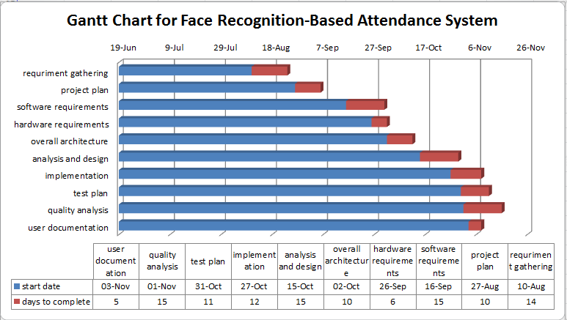
Figure 2.7.1 Gantt Chart for Arduino based blood glucometer for high precision value

2.8 Work Break Down Structure
Arduino Based Blood Glucometer For High Precision Value

Planning Design Implementation Documentation Testing
1.About 2. Connection 3.Arduino code 4.Survey Review
project Of the Process code SystemDiagram
components . 5.Test
Cases
Generation

Figure 2.8.1 8 Work Breakdown Structure

CHAPTER 3
LITERATURE SURVEY AND REVIEW

3.1 Literature Survey
[1] Ahmed S. Abd El-Hamid , Amani E. Fetohi , R.S. Amin , R.M. Abdel Hameed , Design of digital blood glucose meter based on Arduino UNO (August 8 , 2015).
In this study, the hardware and software features of Arduino UNO based system used to determine the approximate concentration of glucose in the blood is described. We used Bio sensor for monitoring blood glucose levels. The necessary software is developed in C, using Arduino 1.6.4 software. In the present paper, we used test strips, when a drop of blood is placed on the test strip it interacts with the elements on the strip that causes a reaction and an electric is generated. Voltage is sent to Arduino UNO for further processing and LCD to display which operated with less power and brighter. The accuracy of the system can be improved with a large set of data.

[2] Y. Lia , J. Fua , R. Chena, M. Huanga , B. Gaoa , K. Huoa , L. Wangb , P. K. Chuc , Sensors and Actuators B 192 (2014) 474– 479.
In this study, the hardware and software features of Microcontroller 8051 based system designed and developed to determine the approximate concentration of glucose level in the blood is described. The system is quite successful for the measurement of blood glucose with an accuracy of less than ± 3%. We used glucose test strip bio sensor designed for the Arkray Glucocard Vital Blood Glucose meter made by Arkray healthcare pvt.ltd. The necessary software is developed in C, using µVision IDE-Kiel. When a drop of blood is placed on the test strip it interacts with the enzymes on the strip that causes a reaction and an electric current is generated. The current is sensed by LF356 Op-Amp and convert to voltage.

[3] Q. Yang, P. Atanasov, E. Wilkins, Sensors and Actuators B 46 (1998) 249–256.
A biosensor towards the glucose detection is fabricated by immobilization of glucose oxidase onto the ZnO nanotubes via cross-linking method. The biosensor shows a fast response to glucose and has a quite wide linear range from 50 M to 12 mM as well as its experimental limit of detection can be achieved as low as 1 M. It also possesses good anti-interference ability and stability. All these advantageous features can make the designed biosensor applicable in medical, food or other areas. Moreover, the investigation also exhibits that the ZnO nanotubes may be applied as a potential novel immobilization material for a variety of biosensor designs.

[4] X-Z. Fu, Y. Liang, S-P.i Chen, J-D. Lin, D-W. Liao, Catalysis Communications, Volume 10, Issue 14, 25 August 2009, Pages 1893-1897
In this work a C-MnO₂ hybrid support was coated with platinum nanoparticles followed by a annealing at 600 °C, in order to promote the methanol oxidation reaction. However, its performance still falls short of the most commonly used commercial PtRu/C catalyst, due to the presence of some Pt agglomerates. The aspiration that this hybrid support can be optimized and then go on to replace the current PtRu based catalysts can be realized by understanding the real function of this kind of hybrid support and by reducing the presence of Pt agglomerates. All results suggested that the Pt/C-Mn_{x}O_{1+x} can act as promising catalysts for fuel cells.

[5] R.G. Jamkar and R.H. Chile “Microcontroller based Temperature Indicator and Controller”, Journal of Instrument. Society of India 34(3) pp.180-186, Sept-2004.
The objective of this work is to design & implement a low cost GSM enabled simulated biomedical parameters monitoring system using Atmel’s 89C51 microcontroller. The system is designed and developed successfully in the laboratory. The system has been designed using so many technologies such as sensors, data acquisition, biomedical instrumentation & GSM and we had to choose the suitable technology for the design. The developed system is simple, low cost and potable. The final goal of the work was to reduce the hospitalization and assistance cost and to increase patients and families quality of life. It is believed that, the other populations of patients such as elderly people may greatly be benefited by the creation of similar devices. The only disadvantage could be non-availability of GSM network. However, rarely the GSM connectivity may not be available. In such situation, the system cannot send information but the store-forward architectural feature of GSM enables the delivery of the SMS little late.

3.2 Literature Summary
In this study, the hardware and software features of Arduino UNO based system used to determine the approximate concentration of glucose in the blood is described. We used Bio sensor for monitoring blood glucose levels. The system has been designed using so many technologies such as sensors, data acquisition, biomedical instrumentation & GSM and we had to choose the suitable technology for the design. The developed system is simple, low cost and portable. The final goal of the work was to reduce the hospitalization and assistance cost and to increase patients and families quality of life. This system has functioned reliably and can be used by people suffering from variety of medical ailments. It is believed that, the other populations of patients such as elderly people may greatly be benefited by the creation of similar devices. The only disadvantage could be non-availability of GSM network. However, rarely the GSM connectivity may not be available. In such situation, the system cannot send information but the store-forward architectural feature of GSM enables the delivery of the SMS little late.

CHAPTER 4
SYSTEM DESIGN

The open-source Arduino Software (IDE) makes it easy to write code and upload it to the board. It runs on Windows, Mac OS X, and Linux. The environment is written in Java and based on Processing and other open-source software. This software can be used with any Arduino board.
The Arduino Integrated Development Environment - or Arduino Software (IDE) - contains a text editor for writing code, a message area, a text console, a toolbar with buttons for common functions and a series of menus. It connects to the Arduino and Genuino hardware to upload programs and communicate with them.

Library:
Libraries provide extra functionality for use in sketches, e.g. working with hardware or manipulating data. To use a library in a sketch, select it from the Sketch > Import Library menu. This will insert one or more #include statements at the top of the sketch and compile the library with your sketch. Because libraries are uploaded to the board with your sketch, they increase the amount of space it takes up. If a sketch no longer needs a library, simply delete its #include statements from the top of your code.

Serial Monitor:
Displays serial data being sent from the Arduino or Genuino board (USB or serial board). To send data to the board, enter text and click on the "send" button or press enter. Choose the baud rate from the drop-down that matches the rate passed to Serial.begin in your sketch. Note that on Windows, Mac or Linux, the Arduino or Genuino board will reset (rerun your sketch execution to the beginning) when you connect with the serial monitor.

4.1 High-Level Design

LEVEL 0:

Predict values

Sends messgage
Prediction of glucose level, body temperature and heartbeat value

Doctor

Arduino

LEVEL 1:

Serial Monitor
Raw data
Glucose level sensor
Gives input converts into values

Sends message

doctor

LEVEL 2:

Finger is placed as input

Raw data

Temperature sensor

Serial Monitor
values

Sends message

doctor

LEVEL 3:

Finger is placed values

Raw data

Pulse Oximeter

Serial Monitor

LEVEL 4:

Glucose sensor
Arduino

receives the value
Detects heartbeat rate

Order Id

Message details
INO details

Message details

GSM
Moisture sensor
Receives the message

Pulse oximeter sensor

doctor

4.2 Low-Level Design
UML diagrams.

Use Diagram:
Use case diagram for Arduino Based Blood Glucometer for High Precision Value
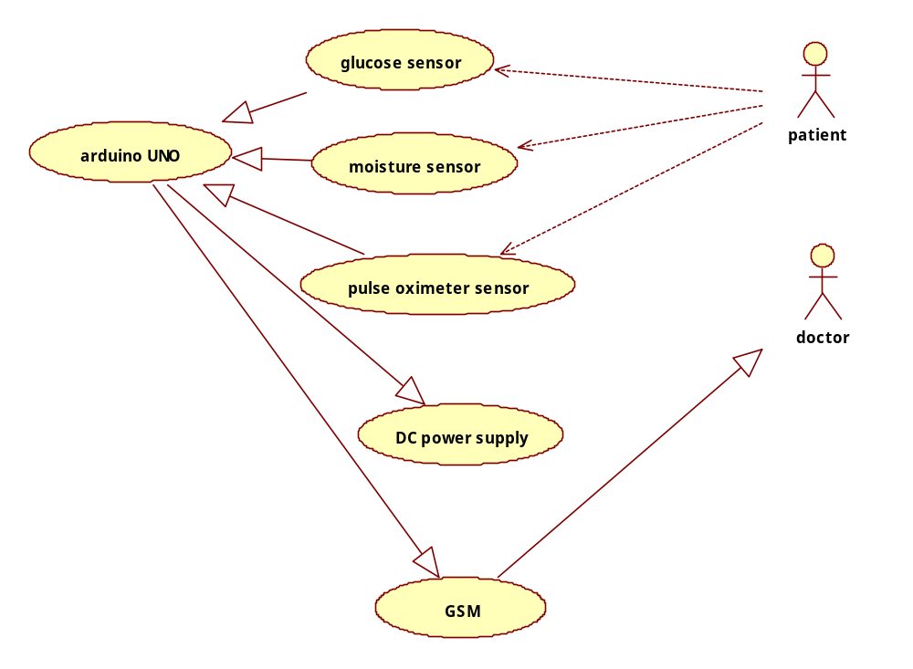

Figure 4.2.1 use case diagram for Arduino Based Blood Glucometer for High Precision Value

Class diagram:

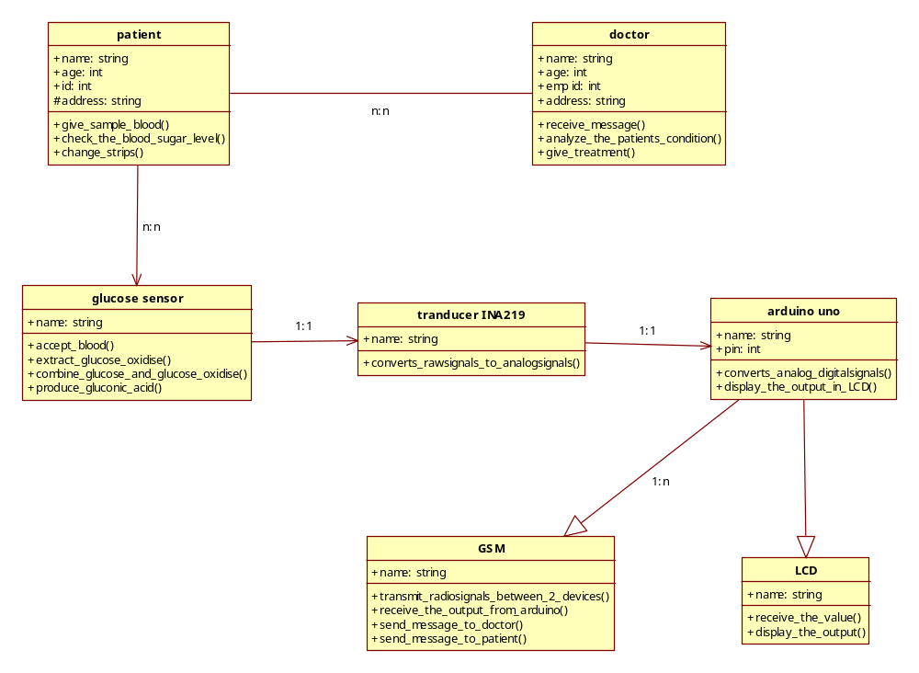

Figure 4.2.2 Class diagram for Arduino Based Blood Glucometer for High Precision Value

Sequence diagram:
Sequence diagram for overall system
GSM
arduino
Pulse oximeter sensor
glucose sensor
patient
doctor
1. give blood()
2. receive blood()
3. accept blood()
4. extract glucose oxidise()
5. combine glucose and glucose oxidise()
6. produce gluconic acid()
7. detect the pulse value
8. converts analog to digital signal()
9. display the output
10. send the output()
11. send the output as a message()
12. send the output as a message()
Figu

Figure 4.2.3 Sequence diagram for Arduino Based Blood Glucometer For High Precision Value

Activity diagram:

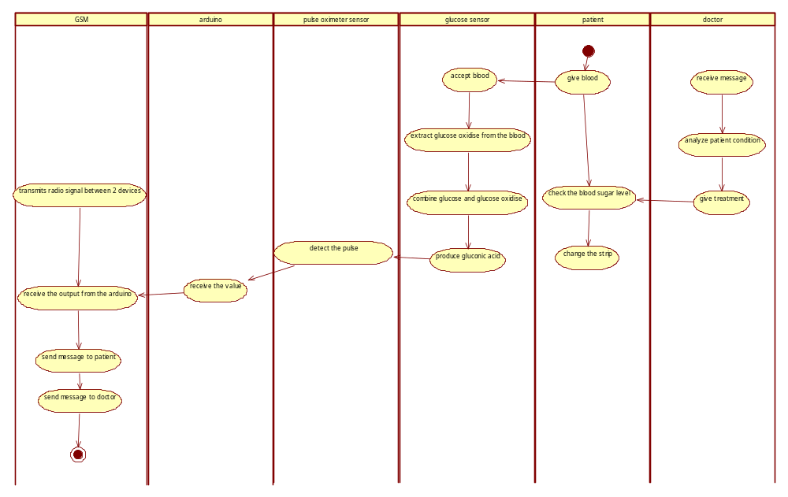
Figure 4.2.4 Activity diagram for the overall system

State chart diagram:
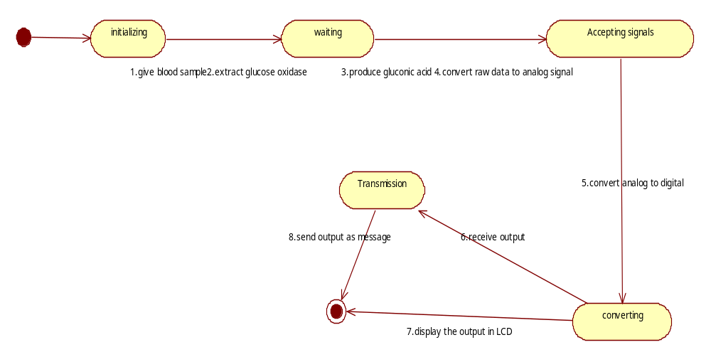
Figure 4.2.5 state chart for the overall system

4.3 Codes and Standards
4.3.1 ARDUINO
Arduino is an open-source project that created microcontroller -based kits for building digital devices and interactive objects that can sense and control physical devices. The Arduino Integrated Development Environment - or Arduino Software (IDE) - contains a text editor for writing code, a message area, a text console, a toolbar with buttons for common functions and a series of menus.

4.3.2 Processing (3.1.1)
Processing is an open source computer programming language and integrated development environment (IDE) built for the electronic arts, new media art, and visual design communities with the purpose of teaching the fundamentals of computer programming in a visual context, and to serve as the foundation for electronic sketchbooks.

4.3.3 C Language
C is a general-purpose, imperative computer programming language, supporting structured programming, lexical variable scope and recursion, while a static type system prevents many unintended operations. By design, C provides constructs that map efficiently to typical machine instructions, and therefore it has found lasting use in applications that had formerly been coded in assembly language, including operating systems, as well as various application software for computers ranging from supercomputers to embedded systems.

4.4 Constraints and Tradeoffs
Constraints:
- It will give accurate value.
- Shows fast response.
- We can check whenever we want.
- Easy to use.
- Compatibility and flexible.

Tradeoffs:
- Highly expensive.
- Non availability of GSM network
- Does not have wireless features.
- Chemical and physical characterization.
- It is a manual technique.

4.5 Test Cases Generation:
Features | Expected Input | Expected Output | Actual Output | Status
- Water | Normal Level | Normal Level | Normal Level | Pass
- Water | Normal Level | High Level | Normal Level | Fail
- Matchstick | High Temperature | High Temperature | High Temperature | Pass
- Message to doctor | Received Message | Received Message | Not Received | Fail
- Rate of Heartbeat | Graph Shown | Graph shown | Graph shown | Pass

Figure 4.5.1 Test Case for the overall system

CHAPTER 5
SYSTEM IMPLEMENTATION
5.1 Code
Code for implementing Glucose Level and Body Temperature:
#include <SoftwareSerial.h>
int tem=3;
int gul=3;
SoftwareSerial mySerial(9,10);
int c=1;
int e=1;
int f=1;
int g=1;
int p,r,s;
int se;
void setup() {
Serial.begin(9600);
mySerial.begin(9600);
pinMode(gul, INPUT);
pinMode(tem, INPUT);
}
void loop() {
p=digitalRead(gul);
r=analogRead(tem);
s=r*0.470;
se=(millis() / 1000);
if((p==1)&&(se>5))
{
if(c==1)
{
Serial.println("LOW GLUCOSE LEVEL");
Serial.println("");
mySerial.println("AT+CMGF=1"); //Sets the GSM Module in Text Mode
delay(1000); // Delay of 1000 milli seconds or 1 second
mySerial.println("AT+CMGS=\"+919445542772\"\r"); // Replace x with mobile number
delay(1000);
mySerial.print("LOW GLUCOSE LEVEL");
delay(1000);
mySerial.println((char)26);// ASCII code of CTRL+Z
delay(1000);
c=2;
}
}
else
{
if((p==0)&&(se>5))
{
if(g==1)
{
Serial.println("GLUCOSE LEVEL NORMAL");
Serial.println("");
mySerial.println("AT+CMGF=1"); //Sets the GSM Module in Text Mode
delay(1000); // Delay of 1000 milli seconds or 1 second
mySerial.println("AT+CMGS=\"+919445542772\"\r"); // Replace x with mobile number
delay(1000);
mySerial.print("GLUCOSE LEVEL NORMAL");
delay(1000);
mySerial.println((char)26);// ASCII code of CTRL+Z
delay(1000);
g=2;
}
}
}
if((s>40)&&(se>10))
{
if(e==1)
{
Serial.println("HIGH TEMPERATURE");
Serial.println("");
mySerial.println("AT+CMGF=1"); //Sets the GSM Module in Text Mode
delay(1000); // Delay of 1000 milli seconds or 1 second
mySerial.println("AT+CMGS=\"+919445542772\"\r"); // Replace x with mobile number
delay(1000);
mySerial.print("HIGH TEMPERATURE");
delay(1000);
mySerial.println((char)26);// ASCII code of CTRL+Z
delay(1000);
e=2;
}
}
else
{
if((s<40)&&(se>10))
{
if(f==1)
{
Serial.println("TEMPERATURE NORMAL");
Serial.println("");
mySerial.println("AT+CMGF=1"); //Sets the GSM Module in Text Mode
delay(1000); // Delay of 1000 milli seconds or 1 second
mySerial.println("AT+CMGS=\"+919445542772\"\r"); // Replace x with mobile number
delay(1000);
mySerial.print("TEMPERATURE NORMAL");
delay(1000);
mySerial.println((char)26);// ASCII code of CTRL+Z
delay(1000);
f=2;
}
}
}
}

Code for implementing the Heartbeat:
Arduino code for heartbeat:

int pulsePin = 0; // Pulse Sensor purple wire connected to analog pin 0
int blinkPin = 13; // pin to blink led at each beat
int fadePin = 5; // pin to do fancy classy fading blink at each beat
int fadeRate = 0; // used to fade LED on with PWM on fadePin

// these variables are volatile because they are used during the interrupt service routine!
volatile int BPM; // used to hold the pulse rate
volatile int Signal; // holds the incoming raw data
volatile int IBI = 600; // holds the time between beats, must be seeded!
volatile boolean Pulse = false; // true when pulse wave is high, false when it's low
volatile boolean QS = false; // becomes true when Arduoino finds a beat.

void setup(){
pinMode(blinkPin,OUTPUT); // pin that will blink to your heartbeat!
pinMode(fadePin,OUTPUT); // pin that will fade to your heartbeat!
Serial.begin(115200); // we agree to talk fast!
interruptSetup(); // sets up to read Pulse Sensor signal every 2mS
// UN-COMMENT THE NEXT LINE IF YOU ARE POWERING The Pulse Sensor AT LOW VOLTAGE,
// AND APPLY THAT VOLTAGE TO THE A-REF PIN
//analogReference(EXTERNAL);
}

void loop(){
sendDataToProcessing('S', Signal); // send Processing the raw Pulse Sensor data
if (QS == true){ // Quantified Self flag is true when arduino finds a heartbeat
fadeRate = 255; // Set 'fadeRate' Variable to 255 to fade LED with pulse
sendDataToProcessing('B',BPM); // send heart rate with a 'B' prefix
sendDataToProcessing('Q',IBI); // send time between beats with a 'Q' prefix
QS = false; // reset the Quantified Self flag for next time
}

ledFadeToBeat();

delay(20); // take a break
}

void ledFadeToBeat(){
fadeRate -= 15; // set LED fade value
fadeRate = constrain(fadeRate,0,255); // keep LED fade value from going into negative numbers!
analogWrite(fadePin,fadeRate); // fade LED
}

void sendDataToProcessing(char symbol, int data ){
Serial.print(symbol); // symbol prefix tells Processing what type of data is coming
Serial.println(data); // the data to send culminating in a carriage return
}

Processing code for heartbeat:

import processing.serial.*;
PFont font;
Scrollbar scaleBar;

Serial port;

int Sensor; // HOLDS PULSE SENSOR DATA FROM ARDUINO
int IBI; // HOLDS TIME BETWEN HEARTBEATS FROM ARDUINO
int BPM; // HOLDS HEART RATE VALUE FROM ARDUINO
int[] RawY; // HOLDS HEARTBEAT WAVEFORM DATA BEFORE SCALING
int[] ScaledY; // USED TO POSITION SCALED HEARTBEAT WAVEFORM
int[] rate; // USED TO POSITION BPM DATA WAVEFORM
float zoom; // USED WHEN SCALING PULSE WAVEFORM TO PULSE WINDOW
float offset; // USED WHEN SCALING PULSE WAVEFORM TO PULSE WINDOW
color eggshell = color(255, 253, 248);
int heart = 0; // This variable times the heart image 'pulse' on screen
// THESE VARIABLES DETERMINE THE SIZE OF THE DATA WINDOWS
int PulseWindowWidth = 490;
int PulseWindowHeight = 512;
int BPMWindowWidth = 180;
int BPMWindowHeight = 340;
boolean beat = false; // set when a heart beat is detected, then cleared when the BPM graph is advanced

void setup() {
size(700, 600); // Stage size
frameRate(100);
font = loadFont("Arial-BoldMT-24.vlw");
textFont(font);
textAlign(CENTER);
rectMode(CENTER);
ellipseMode(CENTER);
// Scrollbar constructor inputs: x,y,width,height,minVal,maxVal
scaleBar = new Scrollbar (400, 575, 180, 12, 0.5, 1.0); // set parameters for the scale bar
RawY = new int[PulseWindowWidth]; // initialize raw pulse waveform array
ScaledY = new int[PulseWindowWidth]; // initialize scaled pulse waveform array
rate = new int [BPMWindowWidth]; // initialize BPM waveform array
zoom = 0.75; // initialize scale of heartbeat window

// set the visualizer lines to 0
for (int i=0; i<rate.length; i++){
rate[i] = 555; // Place BPM graph line at bottom of BPM Window
}
for (int i=0; i<RawY.length; i++){
RawY[i] = height/2; // initialize the pulse window data line to V/2
}

// GO FIND THE ARDUINO
println(Serial.list()); // print a list of available serial ports
// choose the number between the [] that is connected to the Arduino
port = new Serial(this, Serial.list()[0], 115200); // make sure Arduino is talking serial at this baud rate
port.clear(); // flush buffer
port.bufferUntil('\n'); // set buffer full flag on receipt of carriage return
}

void draw() {
background(0);
noStroke();
// DRAW OUT THE PULSE WINDOW AND BPM WINDOW RECTANGLES
fill(eggshell); // color for the window background
rect(255,height/2,PulseWindowWidth,PulseWindowHeight);
rect(600,385,BPMWindowWidth,BPMWindowHeight);

// DRAW THE PULSE WAVEFORM
// prepare pulse data points
RawY[RawY.length-1] = (1023 - Sensor) - 212; // place the new raw datapoint at the end of the array
zoom = scaleBar.getPos(); // get current waveform scale value
offset = map(zoom,0.5,1,150,0); // calculate the offset needed at this scale
for (int i = 0; i < RawY.length-1; i++) { // move the pulse waveform by
RawY[i] = RawY[i+1]; // shifting all raw datapoints one pixel left
float dummy = RawY[i] * zoom + offset; // adjust the raw data to the selected scale
ScaledY[i] = constrain(int(dummy),44,556); // transfer the raw data array to the scaled array
}
stroke(250,0,0); // red is a good color for the pulse waveform
noFill();
beginShape(); // using beginShape() renders fast
for (int x = 1; x < ScaledY.length-1; x++) {
vertex(x+10, ScaledY[x]); //draw a line connecting the data points
}
endShape();

// DRAW THE BPM WAVE FORM
// first, shift the BPM waveform over to fit then next data point only when a beat is found
if (beat == true){ // move the heart rate line over one pixel every time the heart beats
beat = false; // clear beat flag (beat flag waset in serialEvent tab)
for (int i=0; i<rate.length-1; i++){
rate[i] = rate[i+1]; // shift the bpm Y coordinates over one pixel to the left
}
// then limit and scale the BPM value
BPM = min(BPM,200); // limit the highest BPM value to 200
float dummy = map(BPM,0,200,555,215); // map it to the heart rate window Y
rate[rate.length-1] = int(dummy); // set the rightmost pixel to the new data point value
}
// GRAPH THE HEART RATE WAVEFORM
stroke(250,0,0); // color of heart rate graph
strokeWeight(2); // thicker line is easier to read
noFill();
beginShape();
for (int i=0; i < rate.length-1; i++){ // variable 'i' will take the place of pixel x position
vertex(i+510, rate[i]); // display history of heart rate datapoints
}
endShape();

// DRAW THE HEART AND MAYBE MAKE IT BEAT
fill(250,0,0);
stroke(250,0,0);
// the 'heart' variable is set in serialEvent when arduino sees a beat happen
heart--; // heart is used to time how long the heart graphic swells when your heart beats
heart = max(heart,0); // don't let the heart variable go into negative numbers
if (heart > 0){ // if a beat happened recently,
strokeWeight(8); // make the heart big
}
smooth(); // draw the heart with two bezier curves
bezier(width-100,50, width-20,-20, width,140, width-100,150);
bezier(width-100,50, width-190,-20, width-200,140, width-100,150);
strokeWeight(1); // reset the strokeWeight for next time

// PRINT THE DATA AND VARIABLE VALUES
fill(eggshell); // get ready to print text
text("Pulse Sensor Amped Visualizer 1.1",245,30); // tell them what you are
text("IBI " + IBI + "mS",600,585); // print the time between heartbeats in mS
text(BPM + " BPM",600,200); // print the Beats Per Minute
text("Pulse Window Scale " + nf(zoom,1,2), 150, 585); // show the current scale of Pulse Window

// DO THE SCROLLBAR THINGS
scaleBar.update (mouseX, mouseY);
scaleBar.display();

//
} //end of draw loop

5.2 Unit Testing
Unit testing focuses verification effort on the smallest unit of software design- the software component or module. The unit test is white-box oriented. The unit testing implemented in every module of detecting the value of Glucose Level, Body Temperature, and heartbeat. By giving correct manual input to the system, the data’s are stored in database and retrieved. If you want required module to access input or gets the output from the End user.

5.3 Integration Testing
Integration testing is the phase in software testing in which individual software modules are combined and tested as a group. It is a black box testing. It occurs after unit testing and before validation testing. The purpose of integration testing is to verify functional, performance, and reliability requirements placed on major design items. In this project the design items that should be tested by integrating one or more modules is:
1. Detect the Glucose level.
2. Detect the Body Temperature and Heartbeat.
3. Sends the message to the Doctor.

5.4 Test Results
The results came out successfully. Arduino Based Glucometer Sensor, Moisture Sensor, Pulse Oximeter Sensor and GSM works out properly. Output of the test cases is shown in the serial monitor of the Arduino software and processing software.

CHAPTER 6
RESULTS AND DISCUSSION
6.1 Output/Results

Glucose Level Detection:

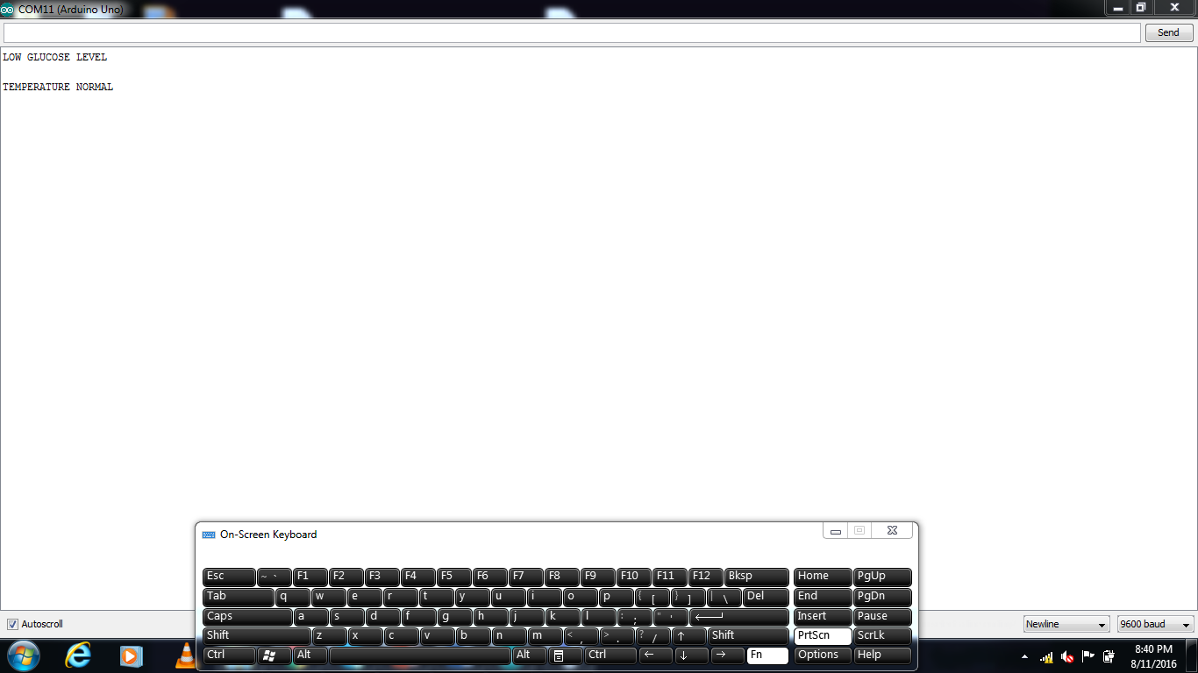

Heartbeat Rate Detection:

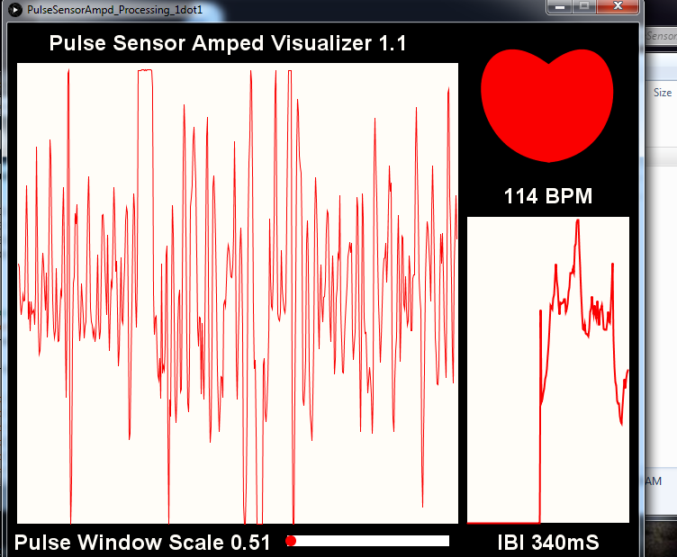

6.2 Results Analysis
The result from the test cases has been analyzed and the following results are shown:
- Glucose level is specified according to the amount of glucose present in the given solution.
- Body temperature is specified by giving various temperatures to the sensors with the help of temperature materials.
- Heartbeat rate is specified in the form of values as well as the cardiac graph.
- The values of the glucose level and the body temperature is sent as a message by using GSM.

6.3 Discussion
The current project is used to detect the following for various purposes:
- Glucose level sensor detects the level of glucose in the various solutions.
- Pulse oximeter sensor detects the rate of the heartbeat and gives the output in the form of both values and cardiac graph.
- Temperature sensor detects whether the human body is in normal state or with the high temperature state.

6.4 RESULTS
The results that are associated with this project analysis the various results like some the results may work correctly and some components may not work exactly with the specifications. Due to the high expenses of the blood sensor we cannot use it for the current result analysis. We cannot use the blood as a sample to detect the level of the blood in the glucose level sensor.

CHAPTER 7
CONCLUSION AND FUTURE WORK
7.1 Conclusion
In this project, we proposed the Arduino based glucometer for high precision value to detect the values and levels of glucose, body temperature and the rate of heartbeat. The system estimates the exact values of the glucose level, body temperature and heartbeat. The result of our preliminary experiment shows continuous observation improved the performance for estimation of the values. To conclude, Project works like a component which can access all the functions and functionalities. It overcomes the many limitations incorporated in the real time. And the result is sent as a message efficiently, Easy implementation environment, generate report flexibly, there is no duplication entry of data. The run time for the detection of values is also very less which is very efficient to use.

7.2 Scope of Future Work
The project has a very vast scope in future. Project can be updated in near future as and when requirement for the same arises, as it is very flexible in terms of expansion. In our future project, we are planning to detect the glucose level from the saliva as an input. In that we will try to detect the presence of glucose to get the exact precision of values with less difference of the percentage from the existing system.

CHAPTER 8
REFERENCES
REFERENCES
[1]. Q. Yang, P. Atanasov, E. Wilkins, Sensors and Actuators B 46 (1998) 249–256.

[2]. R.G. Jamkar and R.H. Chile “Microcontroller based Temperature Indicator and Controller”, Journal of Instrument. Society of India 34(3) pp.180-186, Sept-2004.

[3]. A.Rajendran and P. Neelamegam “Design of AT89C52 Microcontroller based system for the measurement of Temperature and control”, Journal of Instrument. Society of India 35(I) pp. 99-105, March-2005.

[4]. J.H. Yuan, K. Wang, X.H. Xia, Advanced Functional Materials 15 (2005)803–809.

[5]. X-Z. Fu, Y. Liang, S-P.i Chen, J-D. Lin, D-W. Liao, Catalysis Communications, Volume 10, Issue 14, 25August 2009, Pages 1893-1897.

[6]. F.Y. Xie, Z. Huang, C. Chen, Q.J. Xie, Y. Huang, C. Qin, Y. Liu, Z.H.Su, S.Z. Yao, Electrochemistry Communications 18 (2012)108–111.

[7]. N. Anju Latha1*, B. Rama Murthy1, U. Sunitha “ Design And Development Of A Microcontroller Based System For The Measurement Of Blood Glucose” International Journal of Engineering Research and Applications (IJERA) Vol. 2, Issue 5, September- October 2012, pp.1440-1444.

[8]. Q. Yuan, D. Duan, Y. Ma, G. Wei, Z. Zhang, X. Hao, S. Liu, Journal of Power Sources, Volume 245, 1 January 2014, Pages 886-891.

[9]. Y. Lia , J. Fua , R. Chena, M. Huanga , B. Gaoa , K. Huoa , L. Wangb , P. K. Chuc , Sensors and Actuators B 192 (2014) 474– 479.

[10]. Ahmed S. Abd El-Hamid , Amani E. Fetohi , R.S. Amin , R.M. Abdel Hameed , Design of digital blood glucose meter based on Arduino UNO (August 8 , 2015).

