Coding Practice on Hacker-rank
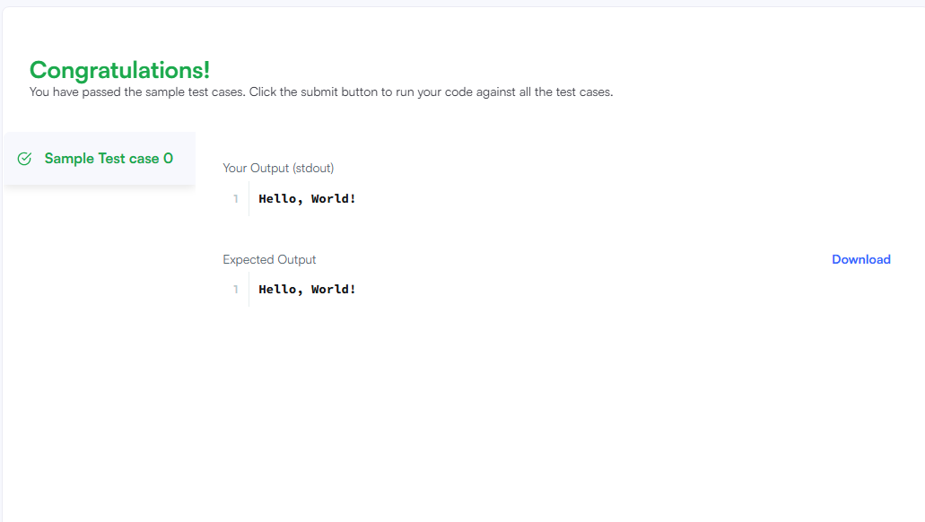
Google Workspace Collaboration
