Git Hub
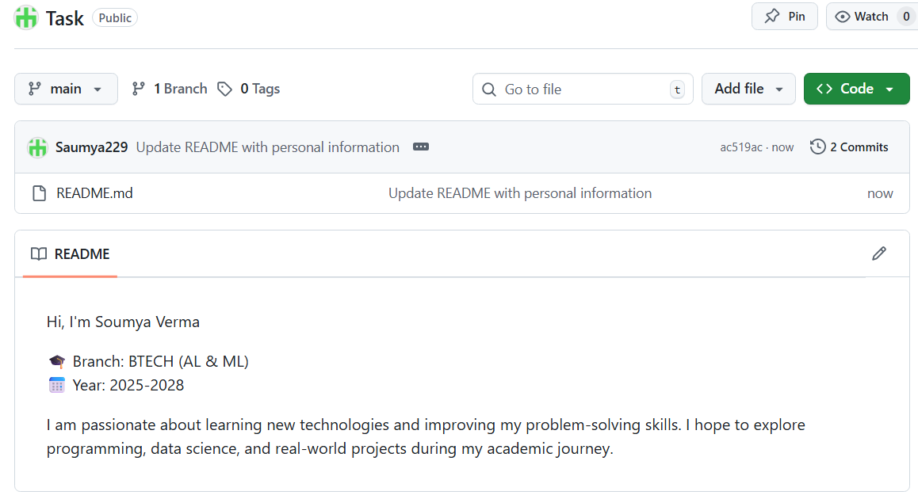

Linkedin
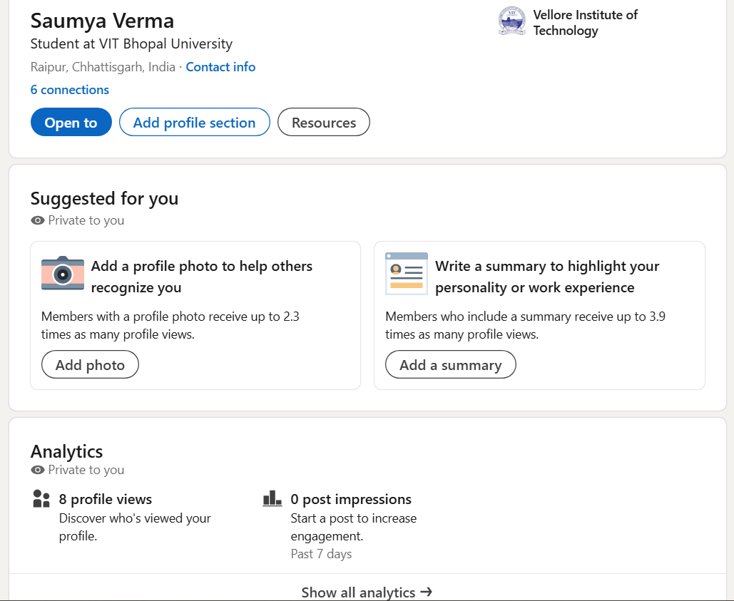
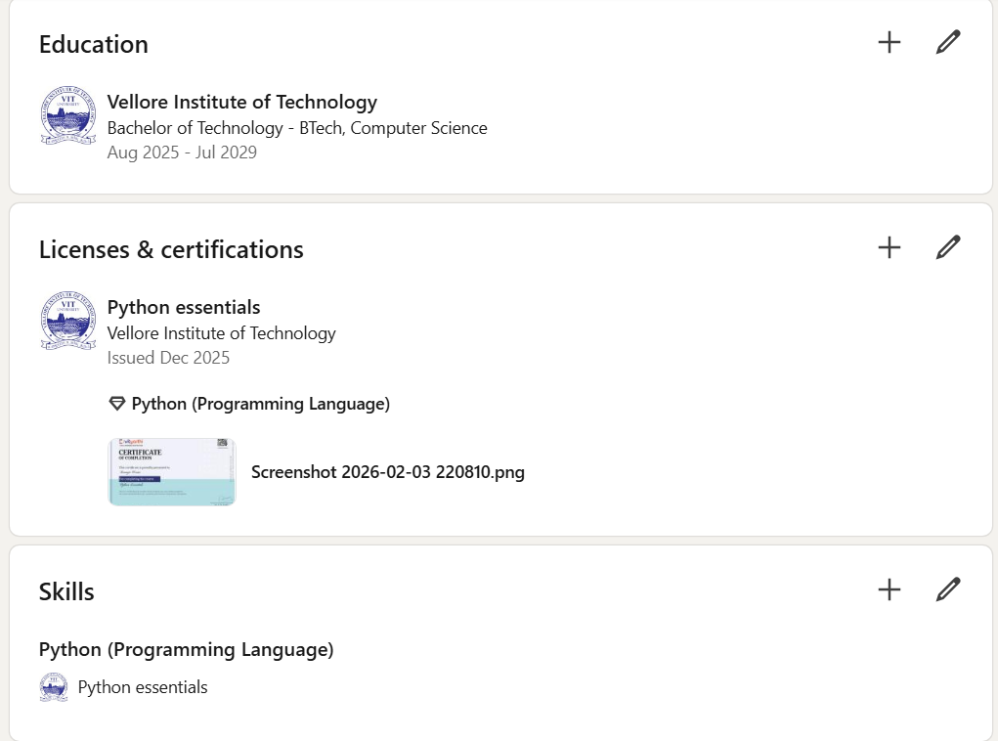
Soumya Verma is a Computer Science undergraduate student at Vellore Institute of Technology, currently pursuing a Bachelor of Technology (B.Tech) degree (2025–2029). Based in Raipur, India, Soumya is at the early stage of building a professional career in the field of technology and software development.
Soumya has demonstrated an interest in programming, particularly in Python, and has completed a certification in Python Essentials, strengthening foundational coding skills. This is further reflected in the listed technical skill of Python programming.
The profile indicates active academic engagement, with growing professional visibility and initial networking efforts. Although currently having limited connections and engagement metrics, the profile shows strong potential for development through enhanced participation, project work, and content sharing.
Overall, Soumya is an aspiring tech professional focused on developing programming expertise and building a solid foundation for future opportunities in the software and IT industry.

Kaggle
