

ONLINE WATCHES WEBSITE / WATCHSTORE
A Project Report Submitted in Partial Fulfillment of the Requirements
for the Degree of
Bachelor of Computer Applications (B.C.A.) Semester – V
Subject: 504 Web Framework & Services (WFS)
Academic Year: 2024 – 2025
Guided By:  Minal Desai  Assistant Professor,  Department of Computer Science | Submitted By:  Shubham Ashish Pancholi – Roll No. 3382  Saumya Chaudhari – Roll No. 3235  Vrushank Changawala – Roll No. 3234  Group No.: 129

INDEX
Sr. No. | Title | Page No.
1 | Introduction | 3
1.1 | Project Profile | 3
2 | Environment Description | 4
2.1 | Hardware & Software Requirements | 4
2.2 | Technology Used | 4
3 | System Requirement Specification | 6
3.1 | Data Dictionary | 6
3.2 | Feasibility Analysis | 9
3.2.1 | Economic Feasibility | 10
3.2.2 | Technical Feasibility | 10
3.2.3 | Behavioural Feasibility | 10
3.3 | E-R Diagram | 10
3.4 | UML Diagrams | 11
4 | Software Project Planning | 14
4.1 | Scope | 14
4.2 | Objectives | 14
4.3 | Expected Advantages | 14
5 | System Design | 15
5.1 | Input Design | 15
5.2 | Output Design | 19
6 | Software Testing | 25
6.1 | Introduction | 25
6.2 | Objectives of Testing | 25
6.3 | Levels of Testing | 25
6.4 | Test Cases | 25
7 | Limitation and System Enhancement | 28
7.1 | Limitation | 28
7.2 | System Enhancement | 28
8 | Bibliography | 29

1 Introduction
Online Watches Website (WatchStore) is a web-based e-commerce application developed as part of the BCA Semester 5 course in Web Framework & Services (WFS). The main goal of this project is to provide a clean and user-friendly online shopping platform where customers can browse authentic wristwatches from top brands such as Titan, Fossil, Citizen, Seiko, Samsung, Casio, and Timex.
Traditional watch shopping requires customers to physically visit multiple retail stores to compare designs, specifications, prices, and brand warranties. This project solves this problem by allowing users to explore different watch categories such as Luxury Watches, Chronograph Watches, Smart Watches, Casual & Minimalist, and Formal & Classic from the comfort of their home or mobile device.
The system is divided into two primary modules:
- Client / Customer Side: Allows users to register an account, securely log in, browse watches, filter by brand or category, search for specific models, save favorites in their wishlist, manage items in a shopping cart, proceed to checkout, make payments using Razorpay Test Mode, leave product reviews with star ratings, and submit general feedback.
- Admin Side: Provides store managers with a protected administrative portal to view store metrics, manage watch inventory (add, edit, delete products), manage watch brands with logos, and moderate customer reviews.
1.1 Project Profile
Project Title | Online Watches Website / WatchStore
Course / Subject | BCA Semester 5 – 504 Web Framework & Services (WFS)
Academic Year | 2024 – 2025
Developed By | Shubham Ashish Pancholi (3382), Saumya Chaudhari (3235), Vrushank Changawala (3234)
Project Guide | Minal Desai
Group Number | 129
Front-End | HTML5, CSS3, JavaScript
Server-Side | Core PHP 8.x
Database | MySQL / MariaDB (Database: watches_db)
Development Environment | XAMPP Server (Apache + MySQL), Visual Studio Code
Payment Gateway | Razorpay Standard Checkout (Test Mode)
Target Users | Online watch shoppers, watch enthusiasts, and store administrators

2 Environment Description
The environment description outlines the minimum hardware configurations and software packages required to develop, host, and execute the Online Watches Website.
2.1 Hardware & Software Requirements
2.1.1 Hardware Requirements
Development / Server Machine:
- Processor: Intel Core i3 / i5 or AMD Ryzen equivalent (2.0 GHz or higher)
- RAM: 4 GB minimum (8 GB recommended for smooth XAMPP and browser execution)
- Hard Disk Space: 500 MB free storage for project files, images, and database
- Input Devices: Standard Keyboard and Mouse / Touchpad
- Display: 1366 x 768 resolution or higher
Client / End-User Machine:
- Device: Desktop, Laptop, Tablet, or Smartphone
- RAM: 1 GB minimum
- Network: Active Internet or Local Area Network (LAN) connection
2.1.2 Software Requirements
Server Environment:
- Operating System: Windows 10 / Windows 11 (64-bit)
- Web Server: Apache HTTP Server 2.4 (included in XAMPP)
- Database Server: MySQL 5.7+ / MariaDB 10.4+
- Server-Side Scripting: PHP 8.1 / 8.2 with cURL and OpenSSL extensions enabled
Client Environment:
- Web Browser: Google Chrome, Microsoft Edge, Mozilla Firefox, or Safari
- JavaScript: Enabled in browser for client-side interactivity and Razorpay checkout
2.2 Technology Used
- PHP (Core PHP 8.x): Handles server-side business logic, session management, user authentication with password_hash() and password_verify(), SQL query preparation, and API communication with Razorpay via cURL.
- MySQL: Stores all persistent data including users, admins, watch products, brands, orders, order items, wishlist records, reviews, and feedback messages.
- HTML5: Provides clean and semantic markup for forms, navigation menus, product cards, tables, and modal dialogs.
- CSS3: Custom styling for modern aesthetics, responsive grid layouts, card designs, buttons, and badges without heavy third-party framework dependencies.
- JavaScript (Vanilla JS): Handles dynamic client-side interactions such as quantity changes, image switching, and launching the official Razorpay Standard Checkout popup.
- Razorpay Test Mode: Integrated using official Razorpay cURL APIs for server-side order generation and client-side checkout popup for testing online payments without real money.
- XAMPP: Provides an all-in-one local development stack containing Apache, MySQL, and PHP.

3 System Requirement Specification
3.1 Data Dictionary
The database for the project is named watches_db and contains 9 relational tables. Below is the complete data dictionary detailing the field names, data types, constraints, and descriptions for all tables.
Table: admins
Stores credentials for administrators who manage the store catalog and reviews.
Field Name | Data Type | Constraint | Description
admin_id | INT(11) | PRIMARY KEY, AUTO_INCREMENT | Unique identifier for administrator
username | VARCHAR(50) | NOT NULL, UNIQUE | Unique admin login username
email | VARCHAR(100) | NOT NULL, UNIQUE | Admin email address
password | VARCHAR(255) | NOT NULL | Bcrypt hashed admin password
created_at | TIMESTAMP | DEFAULT CURRENT_TIMESTAMP | Date and time admin was registered
Table: users
Stores customer profile and authentication information.
Field Name | Data Type | Constraint | Description
user_id | INT(11) | PRIMARY KEY, AUTO_INCREMENT | Unique customer identifier
full_name | VARCHAR(100) | NOT NULL | Customer full name
email | VARCHAR(100) | NOT NULL, UNIQUE | Customer email used for login
mobile | VARCHAR(15) | NOT NULL | 10-digit mobile contact number
password | VARCHAR(255) | NOT NULL | Encrypted password using Bcrypt
created_at | TIMESTAMP | DEFAULT CURRENT_TIMESTAMP | Account registration timestamp
Table: products
Stores the catalog of watches offered in the store.
Field Name | Data Type | Constraint | Description
id | INT(11) | PRIMARY KEY, AUTO_INCREMENT | Unique watch product ID
name | VARCHAR(150) | NOT NULL | Watch title / model name
brand | VARCHAR(100) | NOT NULL | Brand name (e.g. Titan, Fossil)
price | DECIMAL(10,2) | NOT NULL | Price of watch in INR (₹)
image | VARCHAR(255) | NOT NULL | Relative file path to product image
category | VARCHAR(100) | NOT NULL | Category (Luxury, Smart, etc.)
description | TEXT | NOT NULL | Detailed specifications & description
quantity | INT(11) | NOT NULL, DEFAULT 10 | Available stock inventory count
created_at | TIMESTAMP | DEFAULT CURRENT_TIMESTAMP | Product creation timestamp
Table: brands
Stores watch manufacturer brand names and logos.
Field Name | Data Type | Constraint | Description
id | INT(11) | PRIMARY KEY, AUTO_INCREMENT | Unique brand identifier
name | VARCHAR(100) | NOT NULL, UNIQUE | Brand name
logo | VARCHAR(255) | NOT NULL | Path to brand logo image
created_at | TIMESTAMP | DEFAULT CURRENT_TIMESTAMP | Brand record creation timestamp
Table: orders
Stores customer orders, delivery addresses, and payment transaction details.
Field Name | Data Type | Constraint | Description
id | INT(11) | PRIMARY KEY, AUTO_INCREMENT | Internal order ID
order_number | VARCHAR(30) | NOT NULL, UNIQUE | Generated order reference number
user_id | INT(11) | NULL | ID of user who placed order
customer_name | VARCHAR(100) | NOT NULL | Name of recipient
customer_email | VARCHAR(100) | NOT NULL | Email for order confirmation
customer_phone | VARCHAR(15) | NOT NULL | Phone number for delivery contact
shipping_address | TEXT | NOT NULL | Detailed street address
city | VARCHAR(50) | NOT NULL | Delivery city
pincode | VARCHAR(10) | NOT NULL | Postal PIN code
payment_method | VARCHAR(50) | NOT NULL | Method of payment
payment_status | VARCHAR(20) | NOT NULL | Status: Pending / Paid
total_amount | DECIMAL(10,2) | NOT NULL | Total order value in INR
order_status | VARCHAR(20) | NOT NULL | Status: Pending Payment / Placed
razorpay_order_id | VARCHAR(100) | NULL | Razorpay order reference ID
razorpay_payment_id | VARCHAR(100) | NULL | Razorpay transaction ID
razorpay_signature | VARCHAR(255) | NULL | HMAC SHA256 verified signature
created_at | TIMESTAMP | DEFAULT CURRENT_TIMESTAMP | Order placement timestamp
Table: order_items
Stores individual line items associated with each order.
Field Name | Data Type | Constraint | Description
id | INT(11) | PRIMARY KEY, AUTO_INCREMENT | Unique order item identifier
order_id | INT(11) | FOREIGN KEY | Associated parent order ID
product_id | INT(11) | NOT NULL | ID of ordered watch product
product_name | VARCHAR(150) | NOT NULL | Name of watch at time of purchase
price | DECIMAL(10,2) | NOT NULL | Unit price of watch
quantity | INT(11) | NOT NULL | Purchased quantity
subtotal | DECIMAL(10,2) | NOT NULL | Line item total (price * quantity)
Table: wishlist
Stores watches bookmarked by customers for future purchase.
Field Name | Data Type | Constraint | Description
id | INT(11) | PRIMARY KEY, AUTO_INCREMENT | Unique wishlist record ID
user_id | INT(11) | NULL | Customer user ID
product_id | INT(11) | FOREIGN KEY | Watch product ID
created_at | TIMESTAMP | DEFAULT CURRENT_TIMESTAMP | Date item added to wishlist
Table: reviews
Stores product-specific customer reviews and 1 to 5 star ratings.
Field Name | Data Type | Constraint | Description
id | INT(11) | PRIMARY KEY, AUTO_INCREMENT | Unique review identifier
product_id | INT(11) | FOREIGN KEY | ID of watch reviewed
user_id | INT(11) | FOREIGN KEY | ID of user who wrote review
rating | INT(1) | NOT NULL | Customer rating (1 to 5 stars)
comment | TEXT | NOT NULL | Written review feedback text
created_at | TIMESTAMP | DEFAULT CURRENT_TIMESTAMP | Review submission timestamp
Table: feedback
Stores general website and service feedback submitted by visitors.
Field Name | Data Type | Constraint | Description
id | INT(11) | PRIMARY KEY, AUTO_INCREMENT | Unique feedback ID
name | VARCHAR(100) | NOT NULL | Visitor / customer name
email | VARCHAR(100) | NOT NULL | Contact email address
rating | INT(1) | NOT NULL | Website rating (1 to 5)
message | TEXT | NOT NULL | Feedback comment message
created_at | TIMESTAMP | DEFAULT CURRENT_TIMESTAMP | Feedback submission timestamp
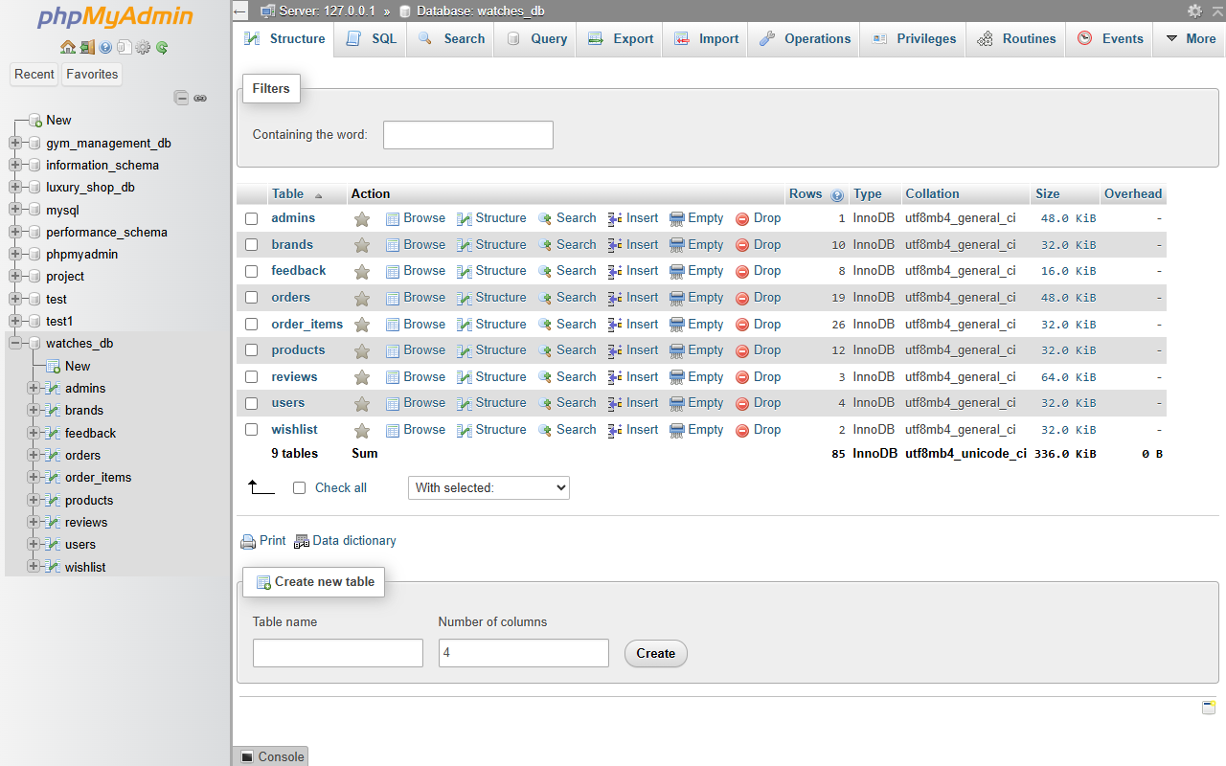
Figure 3.1: Actual phpMyAdmin View of watches_db Database Tables
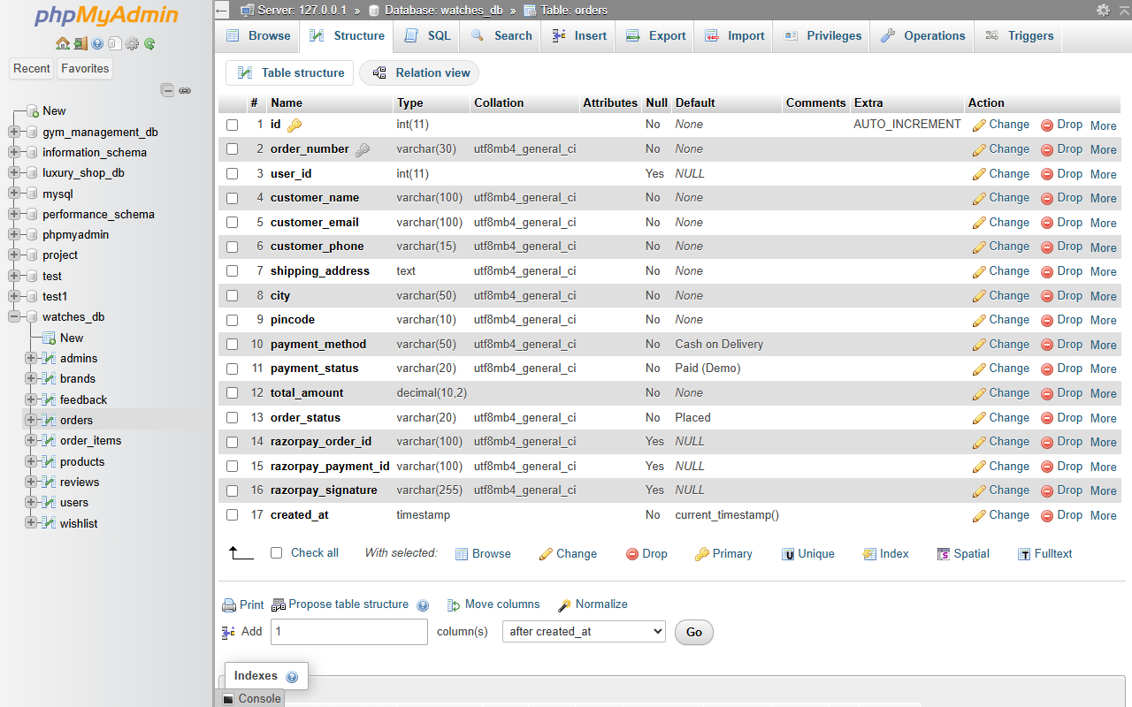
Figure 3.2: Actual MySQL Table Structure for orders Table
3.2 Feasibility Analysis
Before developing the software, a feasibility study was conducted to evaluate whether the proposed online watch store is viable from economic, technical, and operational perspectives.
3.2.1 Economic Feasibility
The project is highly feasible economically because it utilizes open-source technologies that do not incur any licensing or software acquisition costs. PHP, MySQL, Apache, XAMPP, and VS Code are completely free. Razorpay provides free sandbox credentials for test transactions without deductions.
3.2.2 Technical Feasibility
The technical requirements for this project are modest and fully supported by standard computer hardware available in college labs and homes. Core PHP 8, MySQL, and modern browsers handle all application features reliably.
3.2.3 Behavioural Feasibility
The system is designed with an intuitive interface that requires no prior training. Customers are familiar with standard e-commerce workflows, and administrators can easily manage products with simple web forms.
3.3 E-R Diagram
The Entity-Relationship (E-R) diagram represents the conceptual database structure of the Online Watches Website. It illustrates the primary entities, attributes, primary keys, and relationships.
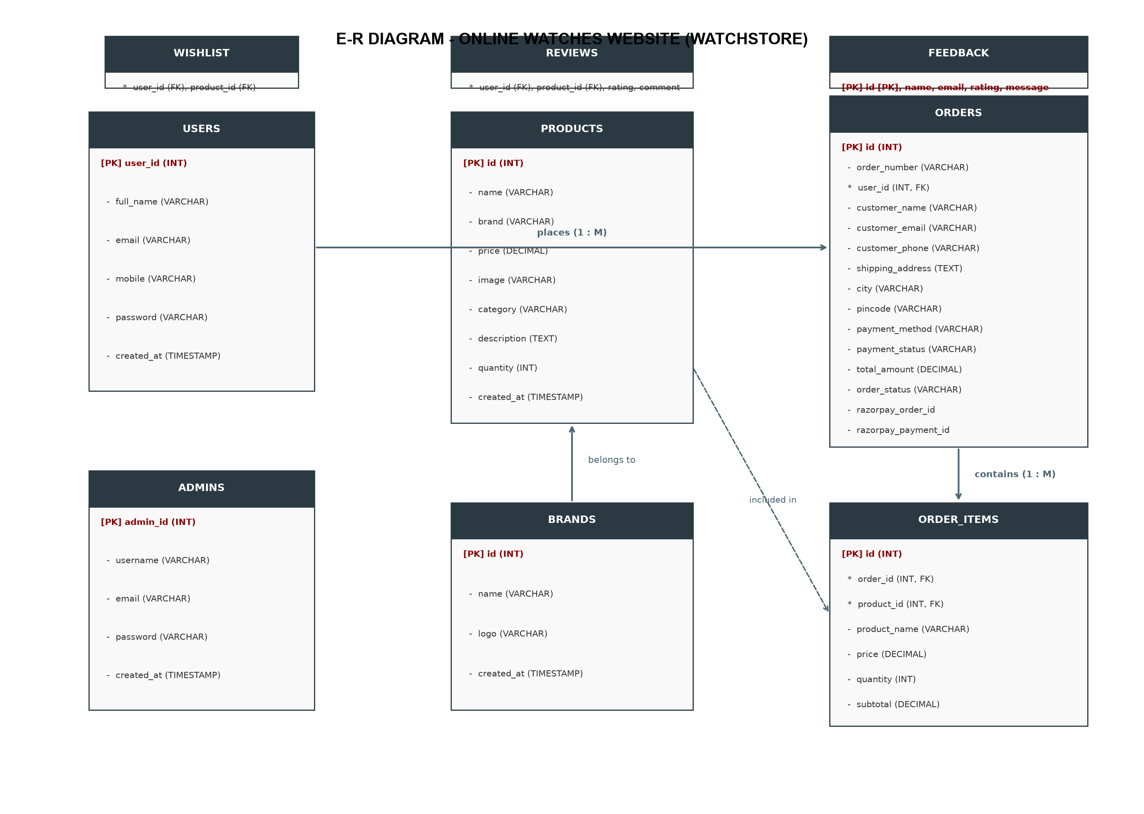
Figure 3.3: E-R Diagram for Online Watches Website
3.4 UML Diagrams
Unified Modeling Language (UML) diagrams provide visual blueprints of the system's actors, structural classes, and operational workflows.
3.4.1 Use Case Diagram
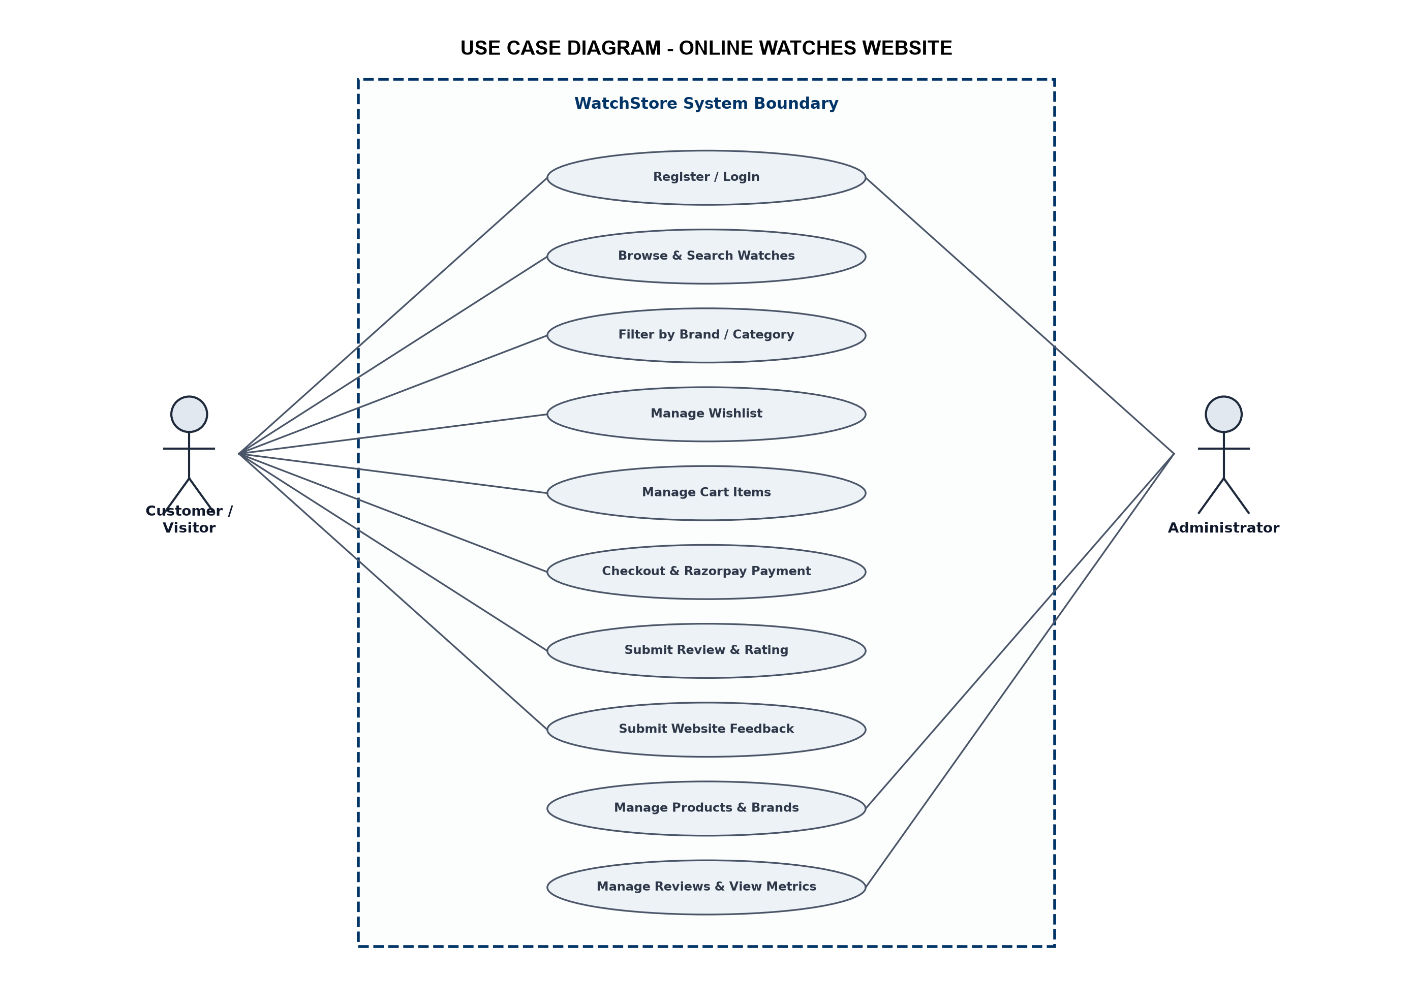
Figure 3.4: UML Use Case Diagram
3.4.2 Class Diagram
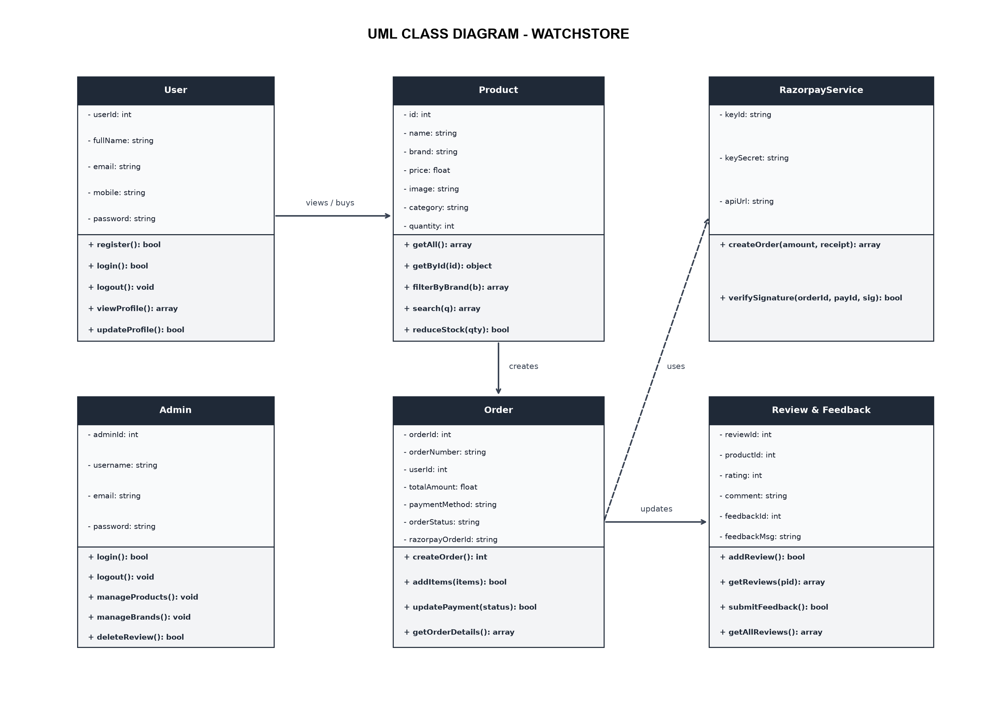
Figure 3.5: UML Class Diagram
3.4.3 Activity Diagram
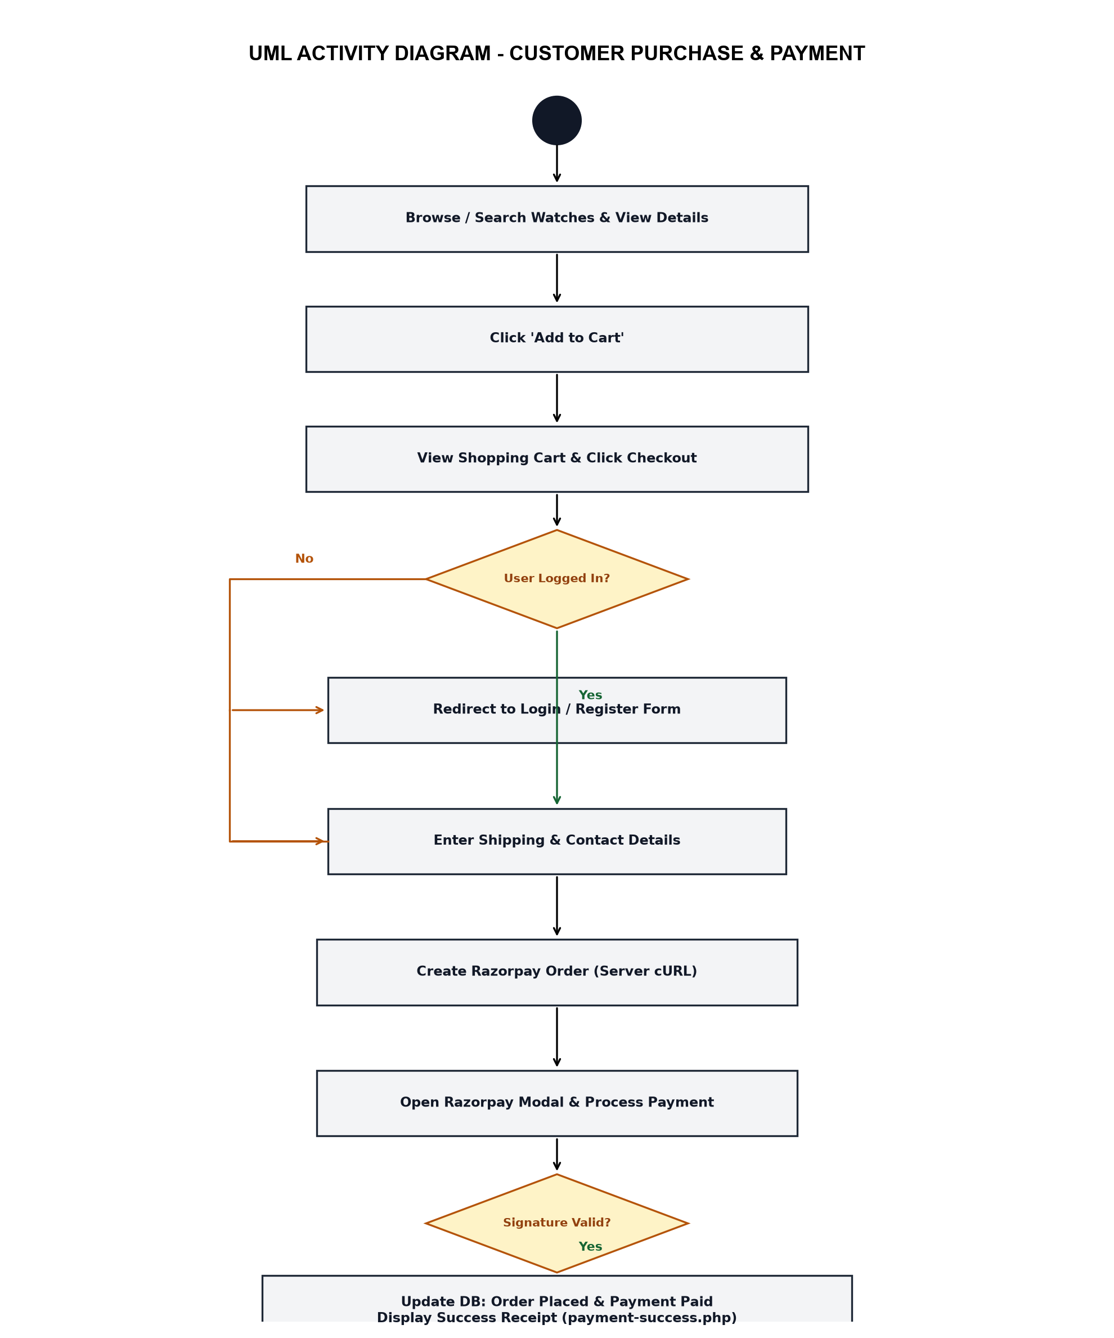
Figure 3.6: UML Activity Diagram for Customer Purchase & Payment
3.4.4 Sequence Diagram
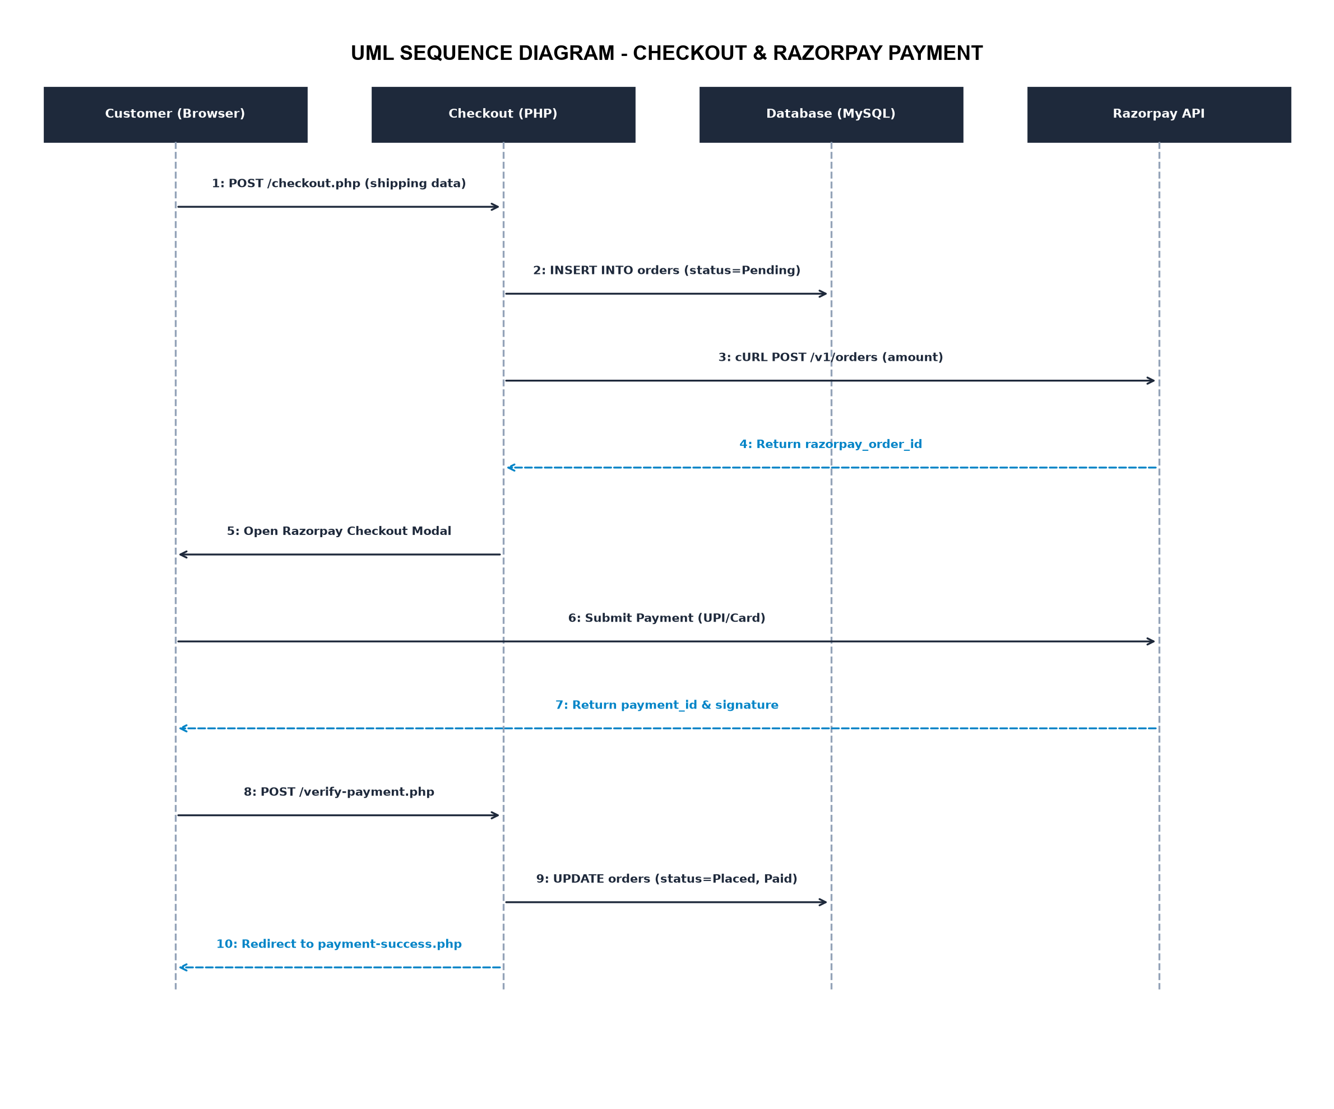
Figure 3.7: UML Sequence Diagram for Checkout & Razorpay Payment

4 Software Project Planning
4.1 Scope
The scope of the Online Watches Website project encompasses the design, development, and testing of a functional e-commerce prototype tailored for wristwatches:
- Developing a secure customer registration and login system with encrypted passwords.
- Creating an online watch catalog categorized into Luxury, Chronograph, Smart, Casual, and Formal watches.
- Enabling brand-based filtering for major brands such as Titan, Fossil, Citizen, Seiko, Samsung, ColorFit, Daniel Wellington, Timex, Casio, and Battuta.
- Implementing search functionality to quickly find watches by keywords.
- Providing an interactive shopping cart and wishlist system.
- Implementing a checkout form with shipping address collection and integration with Razorpay Test Mode for payment simulation.
- Enabling customer product reviews with 1 to 5 star ratings and a general website feedback form.
- Providing an administrative back-end to manage products, brands, and customer reviews.
4.2 Objectives
- To create an easy-to-use, responsive web interface for watch buyers.
- To replace manual in-store visits with 24/7 digital product browsing and order placement.
- To practice core web development concepts taught in BCA Semester 5 (Core PHP, MySQL relational design, session security).
- To understand how third-party payment gateways (Razorpay) integrate with PHP web applications using server-side cURL APIs.
- To maintain accurate inventory counts by automatically decrementing product stock when orders are successfully placed.
4.3 Expected Advantages
- Convenience: Users can browse specifications, high-quality images, and prices anytime without visiting physical showrooms.
- Transparent Information: Real-time pricing, stock availability, and genuine customer reviews help buyers make informed decisions.
- Simulated Online Payment: Demonstrates real-world e-commerce checkout flow using Razorpay Standard Checkout in test mode without financial risk.
- Centralized Store Management: Store administrators can easily update watch prices, add new arrivals, and manage brand partnerships through a single admin dashboard.

5 System Design
System design encompasses the input forms through which data enters the application and the output views through which information is presented to users and administrators.
5.1 Input Design
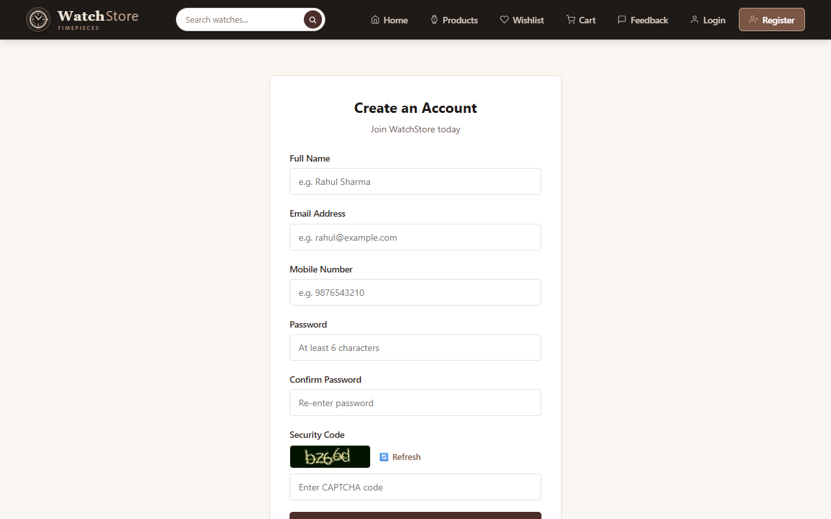
Figure 5.1: Customer Registration Page (register.php)
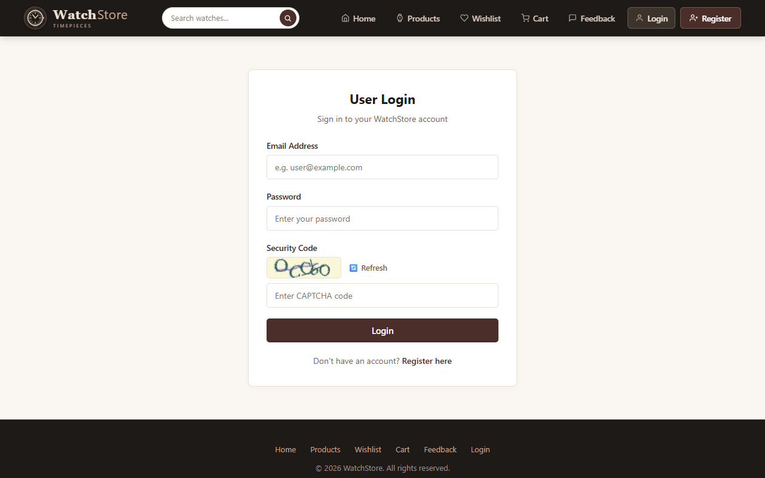
Figure 5.2: Customer Login Page (login.php)
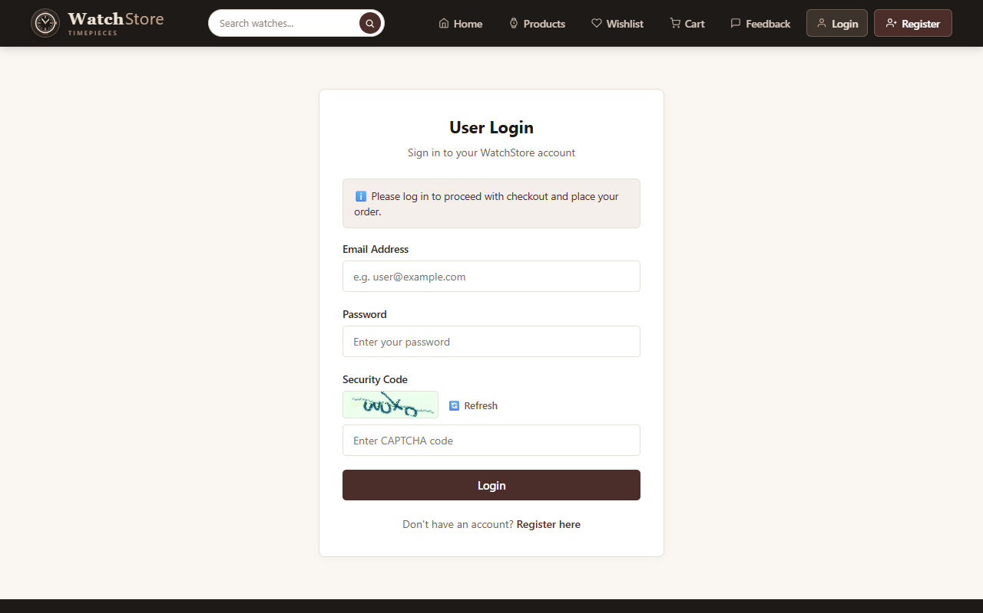
Figure 5.3: Checkout & Delivery Form (checkout.php)
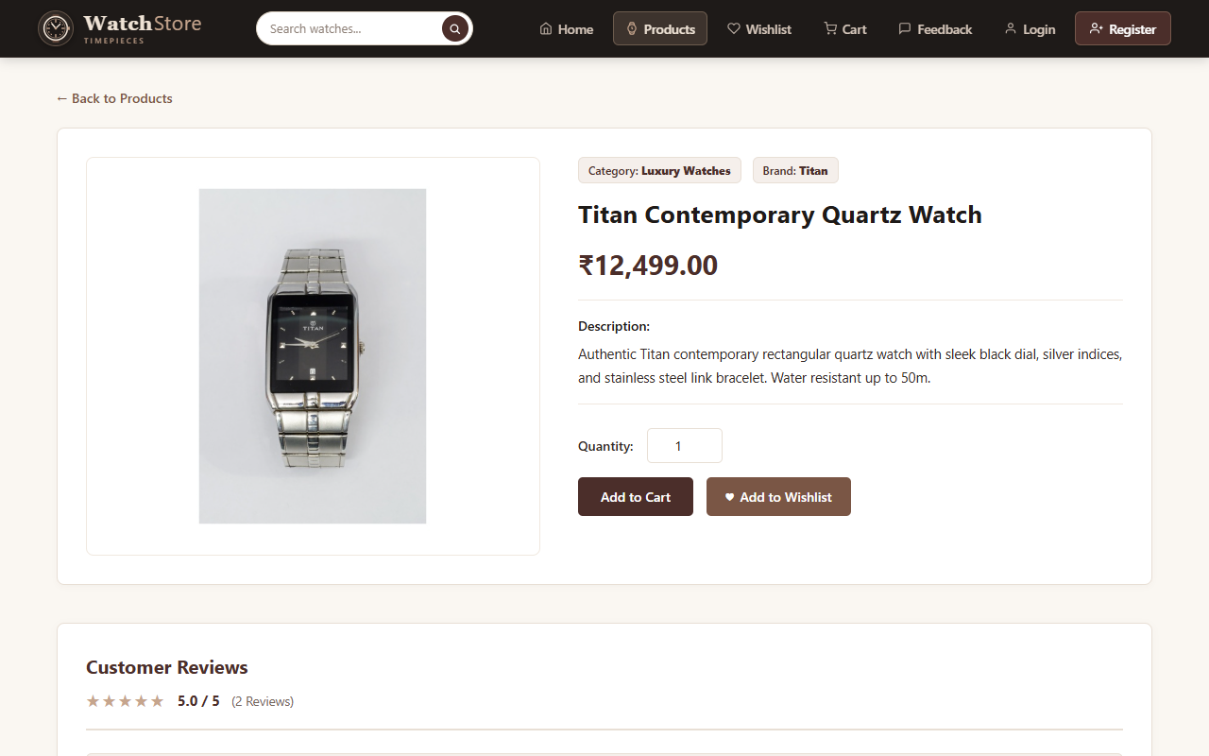
Figure 5.4: Product Details & Review Submission (product-details.php)
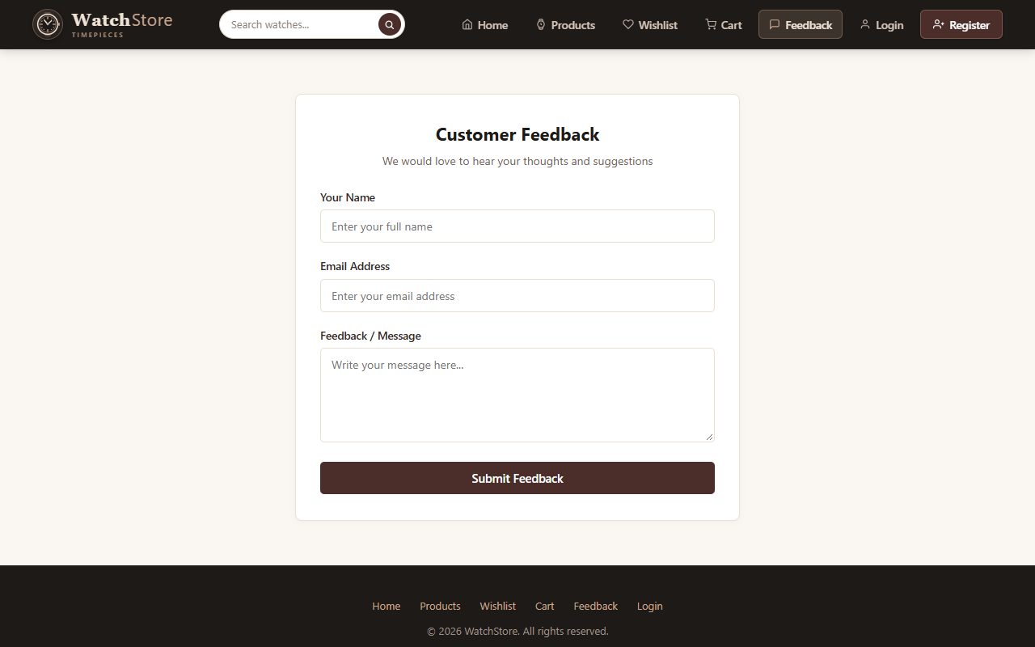
Figure 5.5: Website Feedback Page (feedback.php)
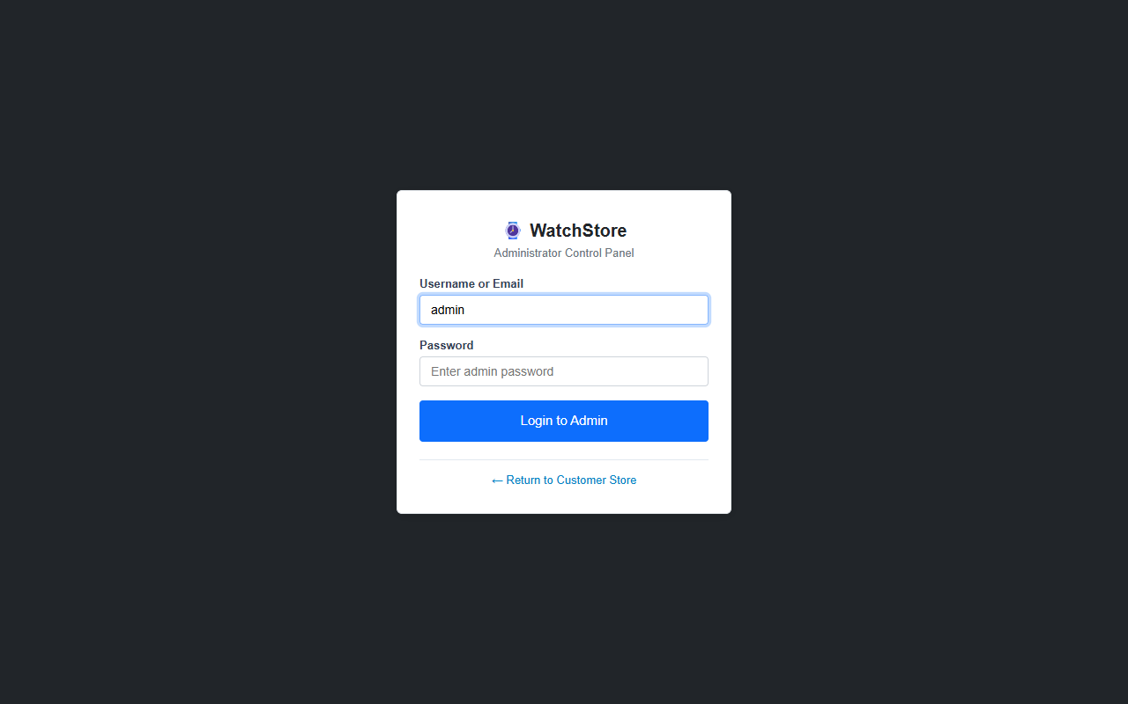
Figure 5.6: Admin Login Portal (admin/login.php)
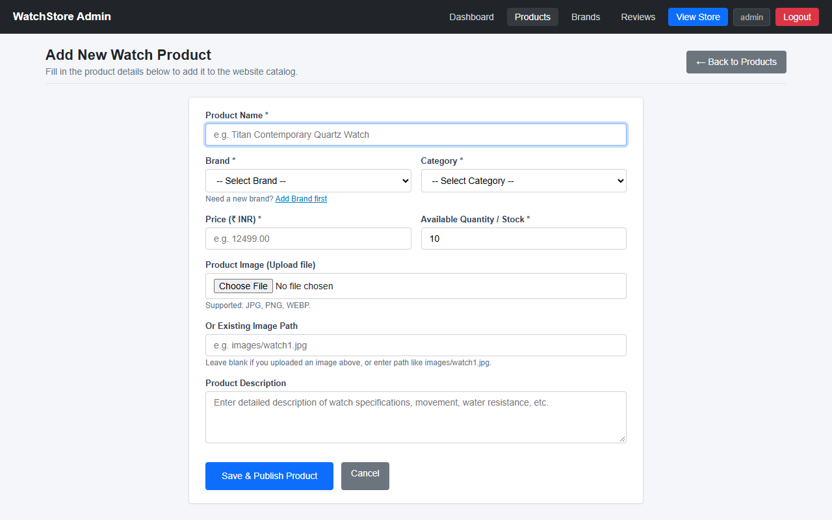
Figure 5.7: Admin Add Product Page (admin/product_add.php)
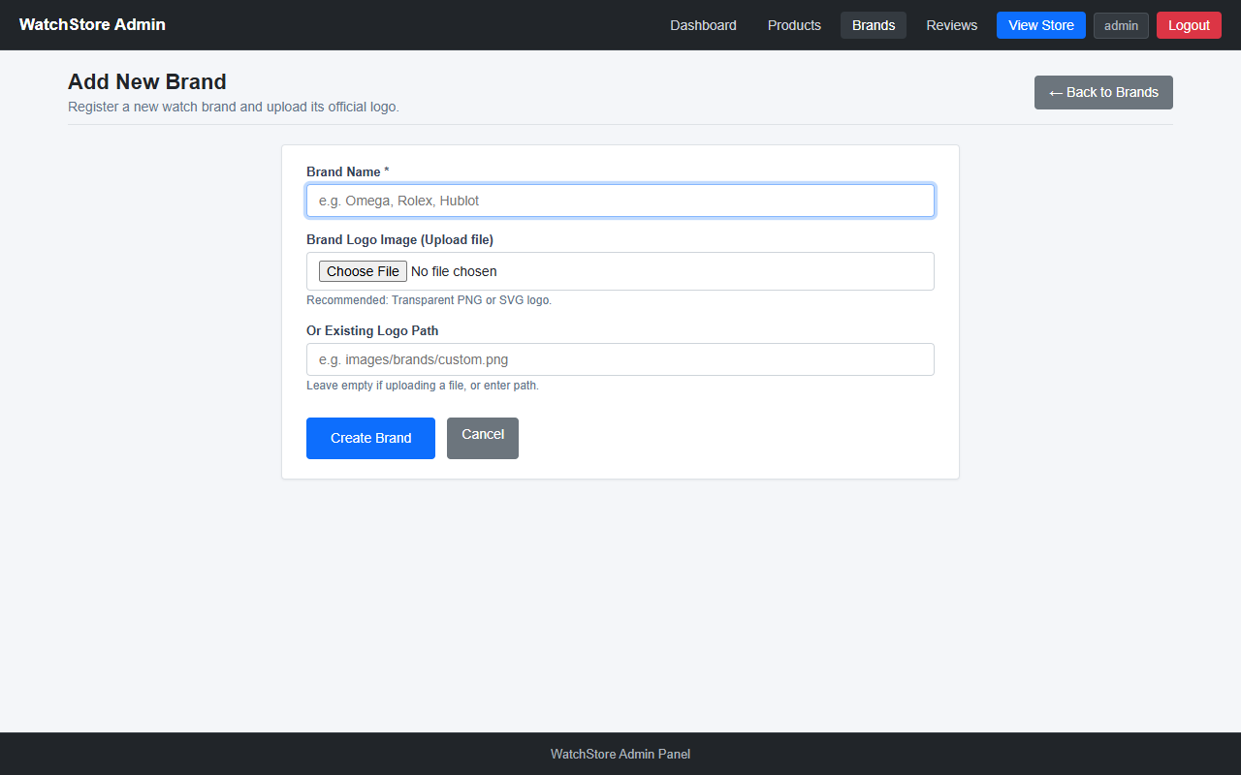
Figure 5.8: Admin Add Brand Page (admin/brand_add.php)
5.2 Output Design
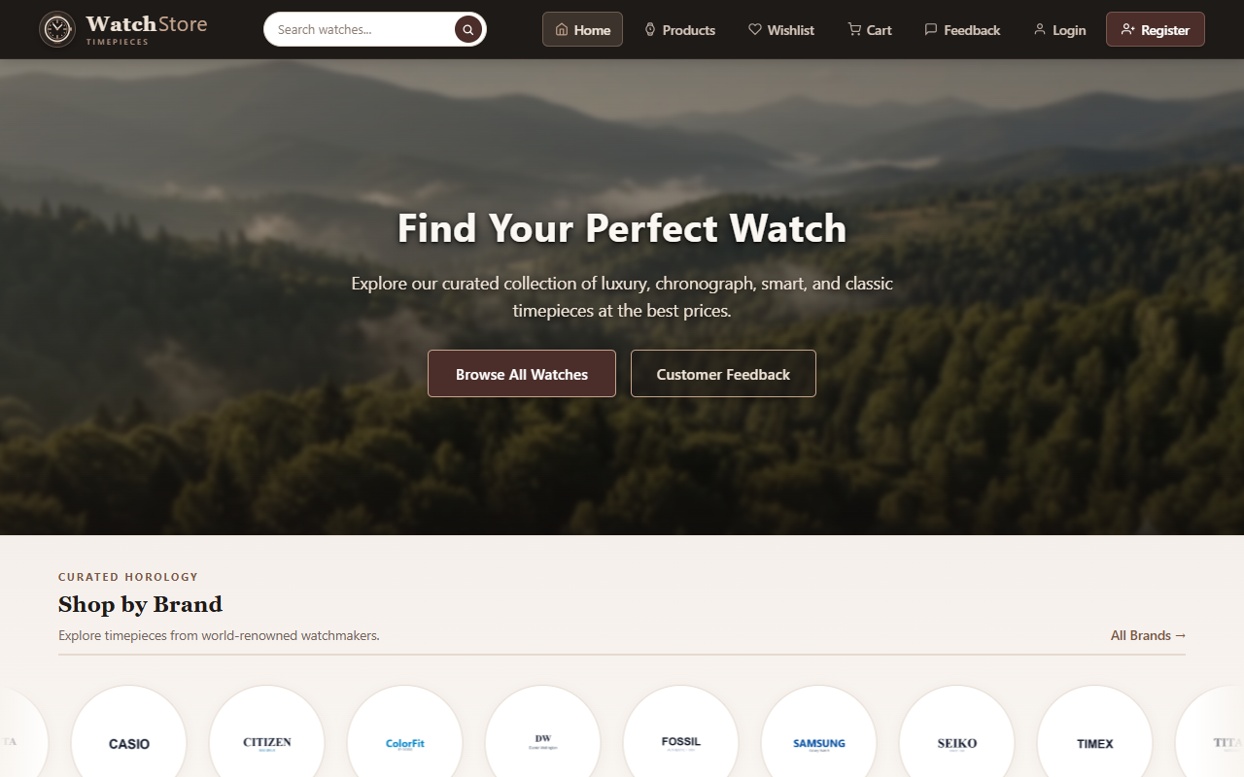
Figure 5.9: WatchStore Home Page (index.php)
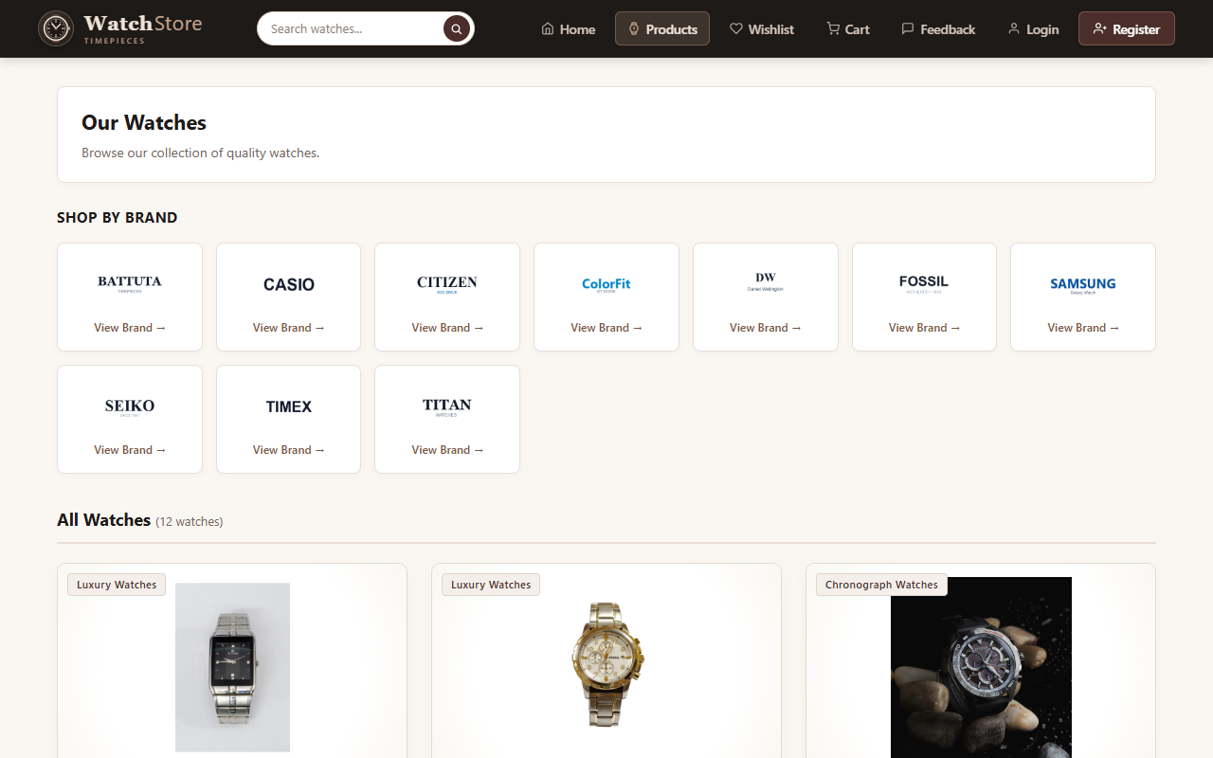
Figure 5.10: Watch Products Catalog (products.php)
Figure 5.11: Brand Specific Watch Filter (brand.php)
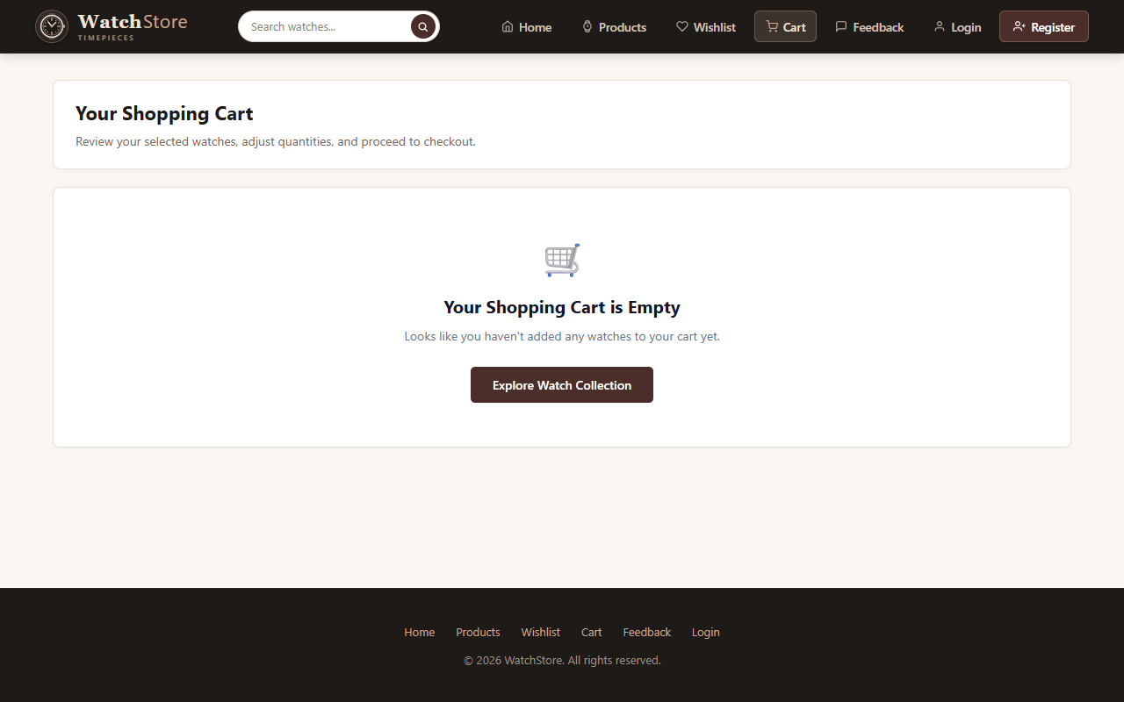
Figure 5.12: Shopping Cart Page (cart.php)
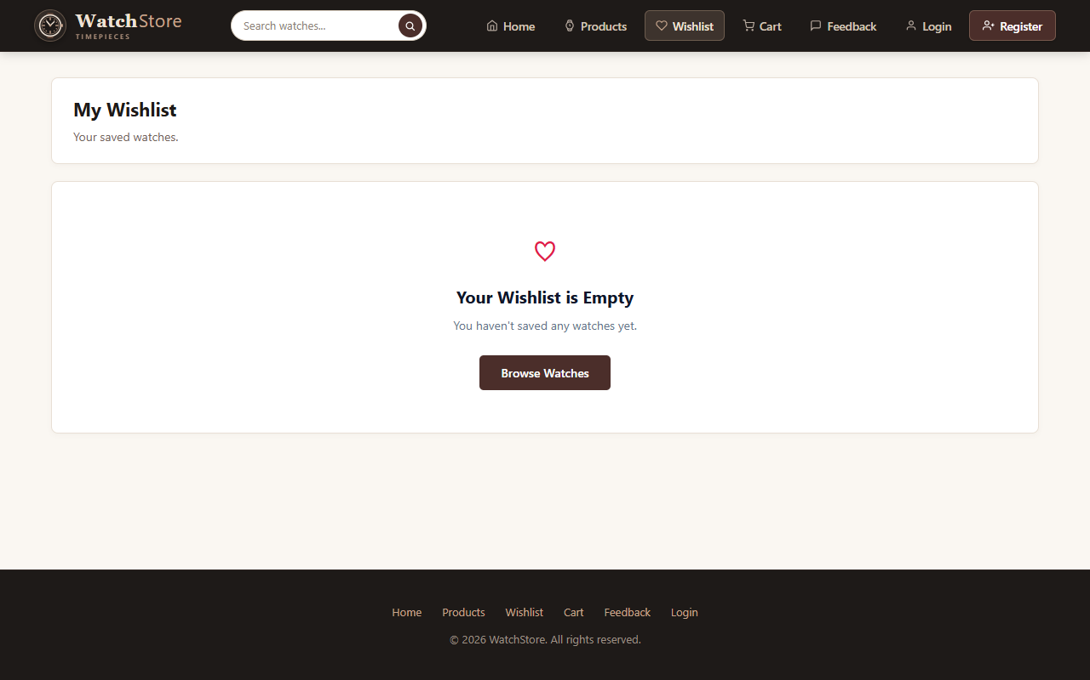
Figure 5.13: Customer Wishlist Page (wishlist.php)
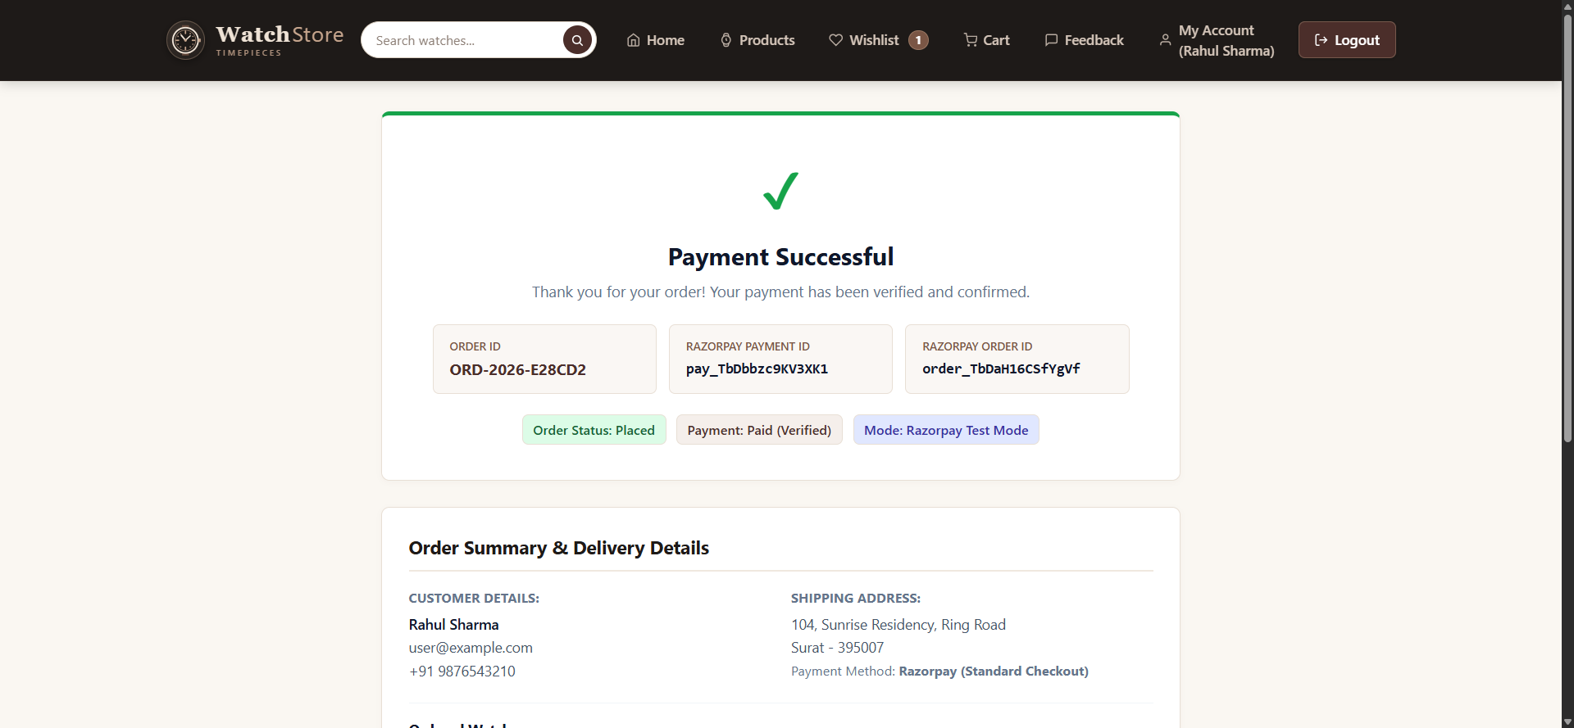
Figure 5.14: Order Confirmation & Payment Receipt (payment-success.php)
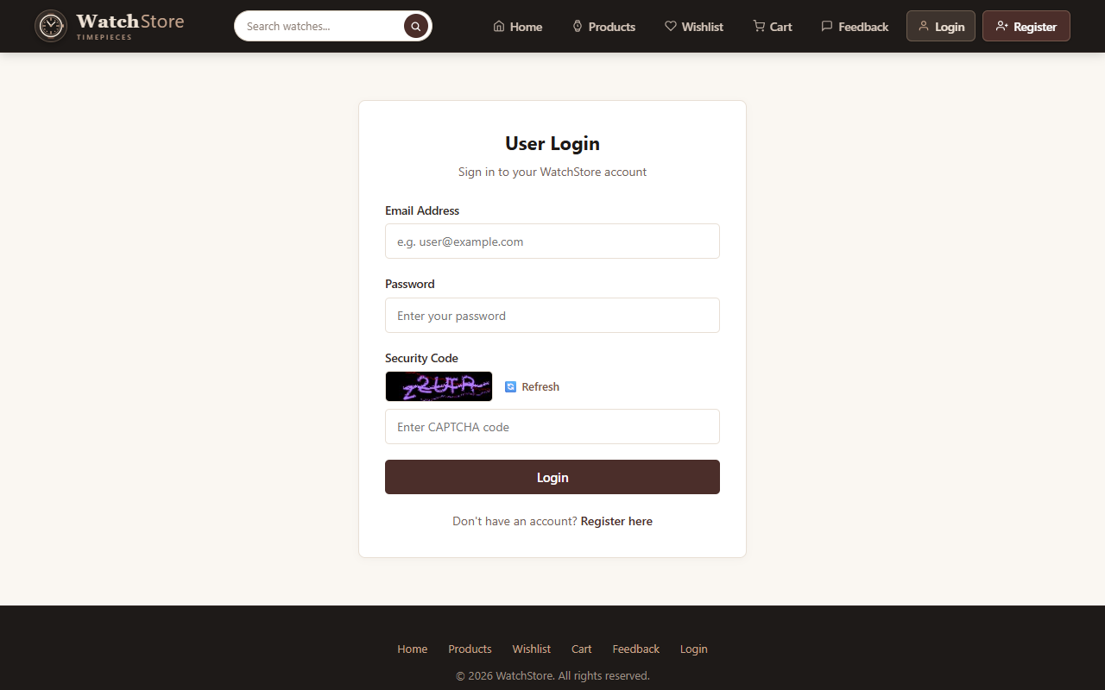
Figure 5.15: Customer Dashboard (dashboard.php)
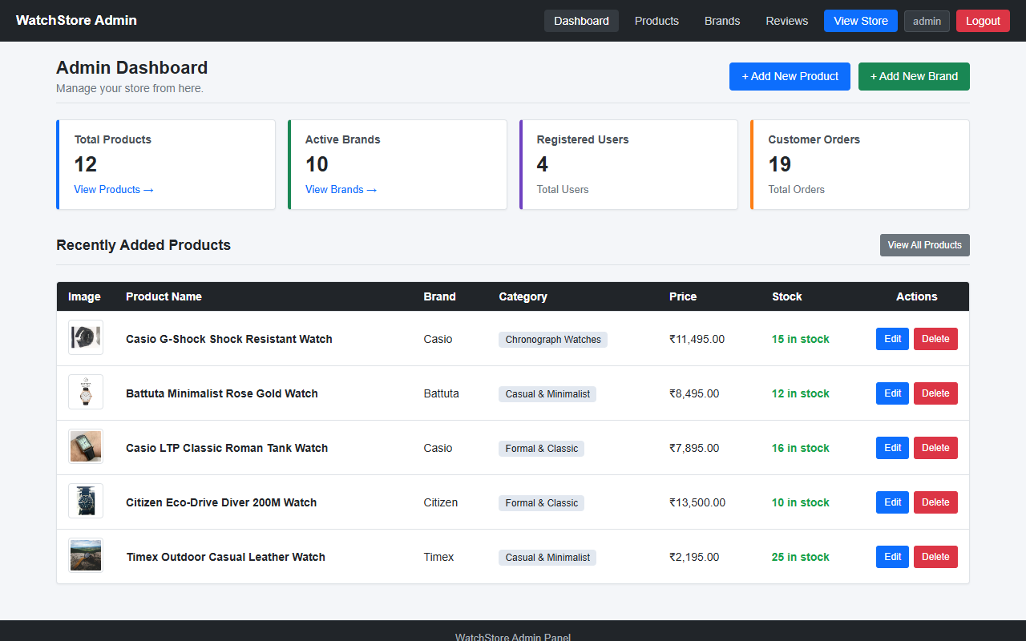
Figure 5.16: Admin Dashboard (admin/dashboard.php)
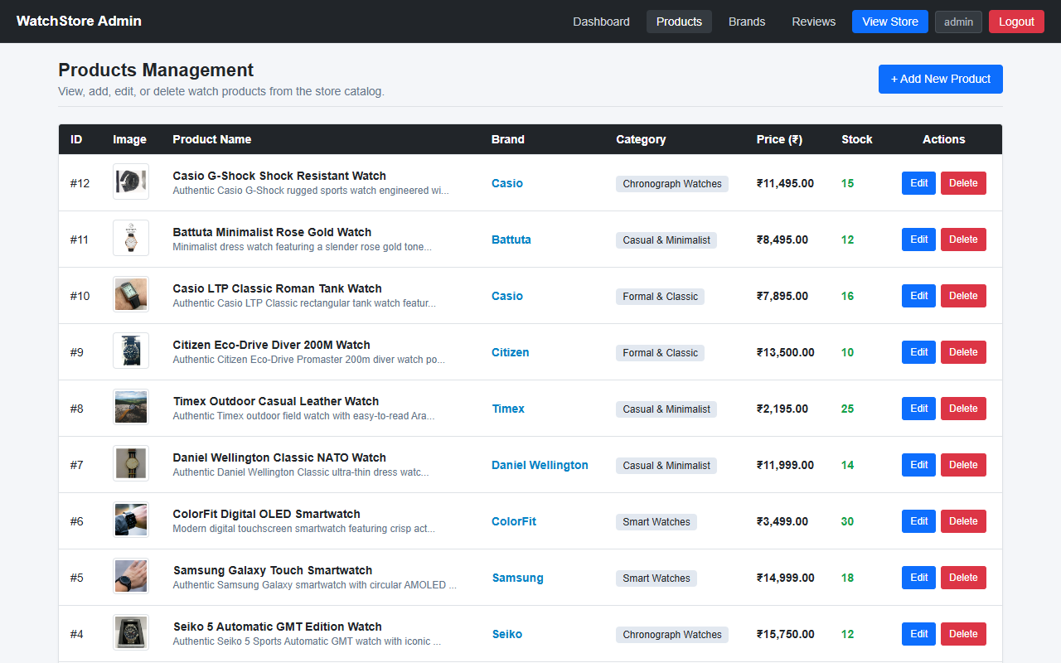
Figure 5.17: Admin Products Management (admin/products.php)
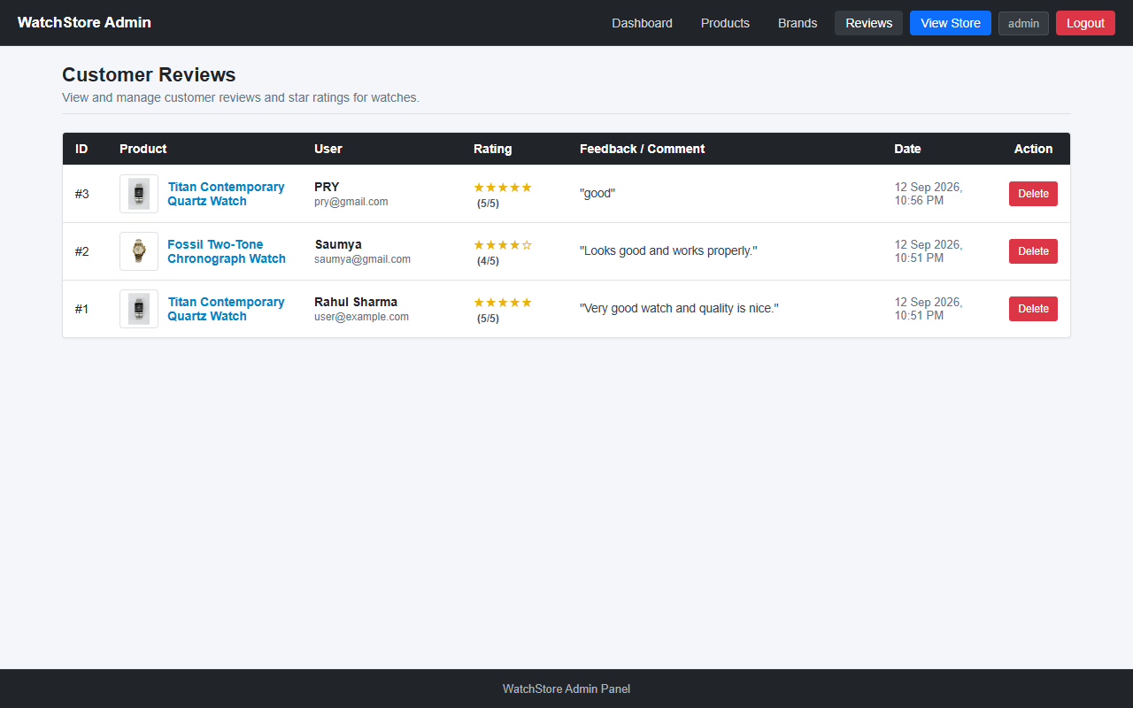
Figure 5.18: Admin Customer Reviews Moderation (admin/reviews.php)

6 Software Testing
6.1 Introduction
Software testing is the process of executing a program with the intent of finding errors, verifying that all system requirements are satisfied, and ensuring that user inputs produce expected outcomes under various conditions. For the Online Watches Website, testing was carried out at multiple levels to ensure reliability, data consistency, and proper integration with the database and payment gateway.
6.2 Objectives of Testing
- To verify that all customer registration and login validations work as intended.
- To ensure that product prices, item quantities, and order subtotals are calculated accurately without rounding errors.
- To verify that sessions prevent unauthorized access to customer dashboards and admin pages.
- To ensure that Razorpay test payments correctly create pending orders, verify cryptographic signatures, update order statuses, and decrement stock.
- To verify that product reviews and website feedback are stored properly in the database.
6.3 Levels of Testing
- Unit Testing: Tested individual PHP functions, database query scripts, and form input validators in isolation (e.g. email regex validation, password hash generation).
- Integration Testing: Tested the interaction between interconnected modules, such as adding a product to the cart, transferring session cart data to the checkout controller, creating the order in the database, and updating stock quantities upon payment verification.
- System Testing: Tested the complete end-to-end user journey across the entire application, from landing on the home page as an anonymous visitor to registering, browsing, purchasing via Razorpay test mode, and viewing the order confirmation receipt.
- Acceptance Testing: Verified that the system meets all the functional objectives defined for the BCA Semester 5 WFS project.
6.4 Test Cases
Test ID | Test Case Description | Input / Action | Expected Result | Actual Result | Status
TC-01 | User Registration with valid details | Name: Test User, Email: newuser@test.com, Mobile: 9876543210, Pass: pass123 | Account created, redirected to login with success message | Account created successfully and redirected | PASS
TC-02 | User Registration with existing email | Email: user@example.com (already in database) | Show error message 'Email already registered' | Error displayed, form not submitted | PASS
TC-03 | User Login with correct credentials | Email: user@example.com, Pass: user123 | Successful login, session created, redirect to dashboard | Logged in and redirected to dashboard | PASS
TC-04 | User Login with incorrect password | Email: user@example.com, Pass: wrongpass | Show error message 'Invalid email or password' | Error message displayed properly | PASS
TC-05 | Browse Product Catalog | Navigate to products.php | Display all watch cards with name, brand, price, and image | All watch cards displayed properly | PASS
TC-06 | Filter Products by Brand | Click 'Titan' brand link (brand.php?name=Titan) | Display only Titan brand watches | Only Titan watches displayed | PASS
TC-07 | View Watch Product Details | Click watch card on products.php (id=1) | Open product-details.php with full specs, price, and reviews | Product details page rendered correctly | PASS
TC-08 | Add Watch to Wishlist | Click Wishlist button on product card | Item added to wishlist table for logged-in user | Item saved to wishlist and badge updated | PASS
TC-09 | Add to Cart & Quantity Update | Click 'Add to Cart' and change quantity to 2 | Cart total updated to price * 2 | Cart subtotal calculated accurately | PASS
TC-10 | Checkout Form Validation | Submit checkout form with empty shipping address | Prevent submission and show 'Please fill in all shipping details' | Validation triggered and error shown | PASS
TC-11 | Razorpay Test Mode Order Creation | Submit valid checkout form | Server creates Razorpay order via cURL and launches checkout popup | Razorpay popup launched with correct amount | PASS
TC-12 | Payment Signature Verification | Complete payment in Razorpay test modal | verify-payment.php validates HMAC SHA256 signature and updates order status | Signature verified, order status updated to Placed | PASS
TC-13 | Display Order Success Receipt | Redirect to payment-success.php | Display order reference, payment ID, and ordered watch list | Receipt rendered with complete details | PASS
TC-14 | Submit Product Review & Rating | Select 5 stars and enter comment on product-details.php | Review inserted into reviews table and displayed on page | Review saved and rendered immediately | PASS
TC-15 | Submit Website Feedback | Fill feedback form with rating and message | Feedback record saved into feedback table | Feedback saved with success message | PASS
TC-16 | Admin Login & Dashboard Access | Enter admin / admin123 on admin/login.php | Access granted to admin dashboard and management menu | Admin dashboard loaded successfully | PASS
TC-17 | Admin Add New Watch Product | Fill product add form and upload image | New watch added to products table and visible in store catalog | Product saved and listed in catalog | PASS

7 Limitation and System Enhancement
7.1 Limitation
While the Online Watches Website successfully implements the core features of an e-commerce platform, there are several limitations inherent to a student-level project:
- Payment Gateway in Test Mode: The Razorpay integration is configured in Test Mode using sandbox credentials. Real monetary transactions cannot be processed.
- Local Server Hosting: The system is currently hosted locally using XAMPP on localhost. It is not deployed on a public web server with a custom domain name.
- Single Currency: All watch prices and transactions are strictly denominated in Indian Rupees (INR ₹). Multi-currency conversion is not supported.
- No Automated SMS Gateway: Order confirmations and OTP verifications are handled through email and screen prompts; SMS notifications are not integrated due to paid API constraints.
- Basic Inventory Management: Stock count decreases when an order is placed, but automated supplier re-ordering or low-stock email alerts are not implemented.
7.2 System Enhancement
The following enhancements can be implemented in future iterations to transform this student prototype into a commercial-grade e-commerce system:
- Live Payment Gateway Integration: Transitioning from Razorpay Test Mode to Live Mode with production merchant API keys and automated webhook handlers.
- Cloud Deployment with SSL: Hosting the website on a cloud hosting provider (such as AWS, DigitalOcean, or Hostinger) with an SSL/TLS certificate (HTTPS) for secure data transmission.
- SMS & WhatsApp Notifications: Integrating SMS gateway APIs (such as Twilio or Fast2SMS) to send instant order confirmations, tracking links, and delivery updates directly to customers' mobile phones.
- Discount Coupons & Promotional Offers: Adding a promotional code module where administrators can create percentage or flat discount vouchers for festive sales.
- Multi-Image Gallery & 360-Degree View: Enhancing the watch details page with multiple high-resolution photos, zoom capabilities, and 360-degree interactive product views.
- Automated Order Invoice PDF Generation: Providing downloadable PDF tax invoices for customers directly from their dashboard.

8 Bibliography
The following official documentation, textbooks, and online resources were referenced during the design, development, and documentation of the Online Watches Website project:
Books & Academic References:
- Luke Welling and Laura Thomson, PHP and MySQL Web Development, 5th Edition, Addison-Wesley Professional, 2016.
- Robin Nixon, Learning PHP, MySQL & JavaScript: With jQuery, CSS & HTML5, 5th Edition, O'Reilly Media, 2018.
- Jon Duckett, HTML and CSS: Design and Build Websites, John Wiley & Sons, 2011.
- Abraham Silberschatz, Henry F. Korth, and S. Sudarshan, Database System Concepts, 7th Edition, McGraw-Hill, 2019.
Official Documentation & Online Resources:
- PHP Official Documentation: https://www.php.net/docs.php
- MySQL Reference Manual: https://dev.mysql.com/doc/
- Razorpay Payment Gateway Documentation: https://razorpay.com/docs/payments/payment-gateway/web-integration/standard/
- Mozilla Developer Network (MDN Web Docs): https://developer.mozilla.org/
- W3Schools Web Tutorials: https://www.w3schools.com/

