**Name-Saumya Gaur**

**Roll Number-CH.EN.U4CYS21076**

**Output**

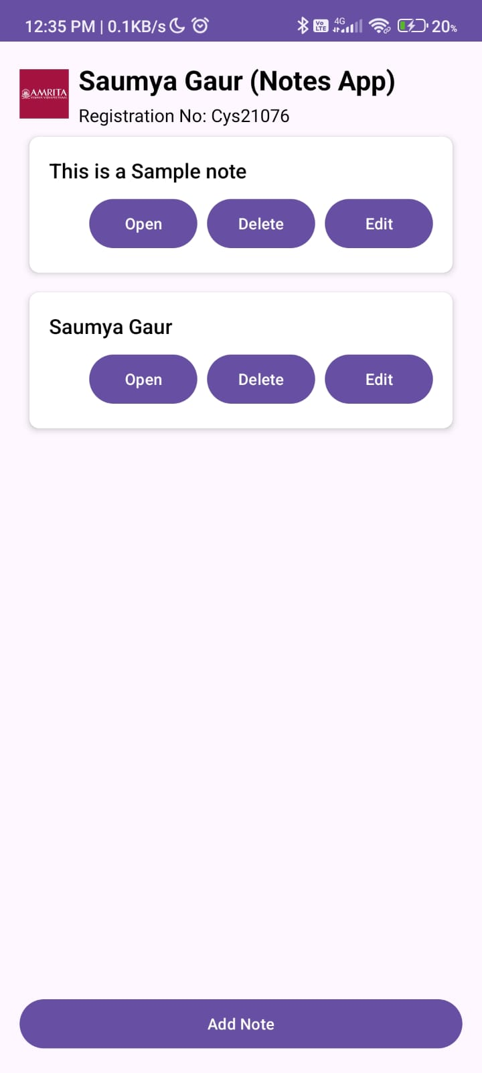

**After clicking on Add note**

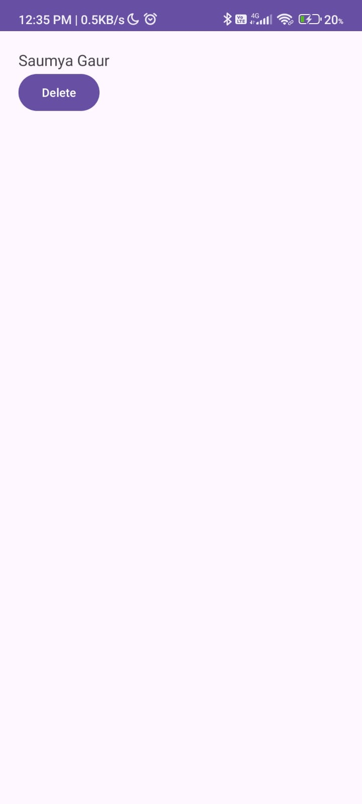

**After Clicking on Edit**

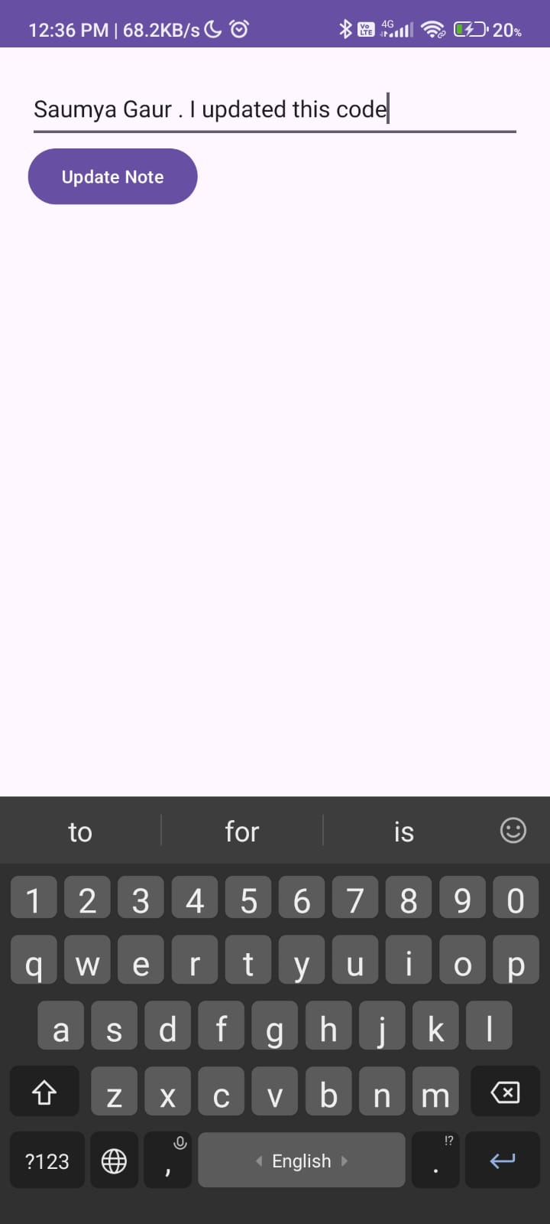

**After Delete and update**

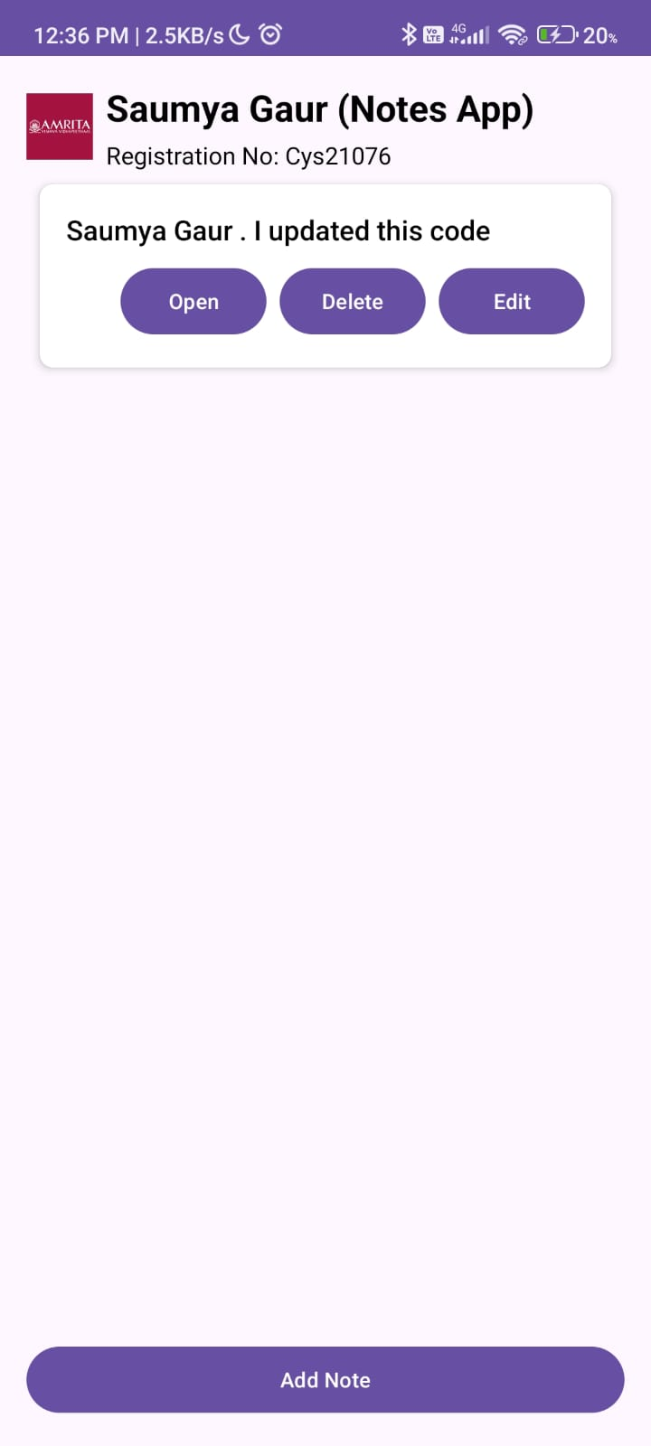

**Code**

MainActivity.java  
package com.example.mynote;  
  
import android.content.Intent;  
import android.os.Bundle;  
import android.view.View;  
import android.widget.Button;  
import androidx.appcompat.app.AppCompatActivity;  
import androidx.recyclerview.widget.LinearLayoutManager;  
import androidx.recyclerview.widget.RecyclerView;  
import java.util.ArrayList;  
import java.util.List;  
  
public class MainActivity extends AppCompatActivity {  
  
 public static final int *REQUEST_CODE_ADD_NOTE* = 1;  
 public static final int *REQUEST_CODE_UPDATE_NOTE* = 2;  
  
 private MyAdapter adapter;  
 private List<String> notes;  
  
 @Override  
 protected void onCreate(Bundle savedInstanceState) {  
 super.onCreate(savedInstanceState);  
 setContentView(R.layout.*activity_main*);  
  
 RecyclerView recyclerView = findViewById(R.id.*notes_recycler_view*);  
 Button addNoteButton = findViewById(R.id.*add_button*);  
  
 // Initialize notes list  
 notes = new ArrayList<>();  
 notes.add("Sample Note");  
  
 // Set up the adapter and layout manager  
 adapter = new MyAdapter(this, notes);  
 recyclerView.setAdapter(adapter);  
 recyclerView.setLayoutManager(new LinearLayoutManager(this));  
  
 addNoteButton.setOnClickListener(v -> {  
 Intent intent = new Intent(MainActivity.this, AddNoteActivity.class);  
 startActivityForResult(intent, *REQUEST_CODE_ADD_NOTE*);  
 });  
 }  
  
 @Override  
 protected void onActivityResult(int requestCode, int resultCode, Intent data) {  
 super.onActivityResult(requestCode, resultCode, data);  
  
 if (requestCode == *REQUEST_CODE_ADD_NOTE* && resultCode == *RESULT_OK*) {  
 String newNote = data.getStringExtra("NEW_NOTE");  
 if (newNote != null) {  
 notes.add(newNote);  
 adapter.notifyItemInserted(notes.size() - 1);  
 }  
 } else if (requestCode == *REQUEST_CODE_UPDATE_NOTE* && resultCode == *RESULT_OK*) {  
 String updatedNote = data.getStringExtra("UPDATED_NOTE");  
 int position = data.getIntExtra("NOTE_POSITION", -1);  
 if (updatedNote != null && position != -1) {  
 notes.set(position, updatedNote);  
 adapter.notifyItemChanged(position);  
 }  
 }  
 }  
}

MyAdapter.java  
package com.example.mynote;  
  
import android.content.Context;  
import android.content.Intent;  
import android.view.LayoutInflater;  
import android.view.View;  
import android.view.ViewGroup;  
import android.widget.Button;  
import android.widget.TextView;  
import androidx.annotation.NonNull;  
import androidx.recyclerview.widget.RecyclerView;  
import java.util.List;  
  
public class MyAdapter extends RecyclerView.Adapter<MyAdapter.NoteViewHolder> {  
  
 private final Context context;  
 private final List<String> notes;  
  
 public MyAdapter(Context context, List<String> notes) {  
 this.context = context;  
 this.notes = notes;  
 }  
  
 @NonNull  
 @Override  
 public NoteViewHolder onCreateViewHolder(@NonNull ViewGroup parent, int viewType) {  
 View view = LayoutInflater.*from*(context).inflate(R.layout.*list_item*, parent, false);  
 return new NoteViewHolder(view);  
 }  
  
 @Override  
 public void onBindViewHolder(@NonNull NoteViewHolder holder, int position) {  
 String note = notes.get(position);  
 holder.textView.setText(note);  
  
 holder.openButton.setOnClickListener(v -> {  
 Intent intent = new Intent(context, DetailActivity.class);  
 intent.putExtra("NOTE", note);  
 context.startActivity(intent);  
 });  
  
 holder.deleteButton.setOnClickListener(v -> {  
 // Implement delete logic here  
 notes.remove(position);  
 notifyItemRemoved(position);  
 notifyItemRangeChanged(position, notes.size());  
 });  
  
 holder.updateButton.setOnClickListener(v -> {  
 Intent intent = new Intent(context, UpdateNoteActivity.class);  
 intent.putExtra("NOTE", note);  
 intent.putExtra("NOTE_POSITION", position);  
 ((MainActivity) context).startActivityForResult(intent, MainActivity.*REQUEST_CODE_UPDATE_NOTE*);  
 });  
 }  
  
 @Override  
 public int getItemCount() {  
 return notes.size();  
 }  
  
 static class NoteViewHolder extends RecyclerView.ViewHolder {  
 TextView textView;  
 Button openButton;  
 Button deleteButton;  
 Button updateButton;  
  
 public NoteViewHolder(@NonNull View itemView) {  
 super(itemView);  
 textView = itemView.findViewById(R.id.*textView*);  
 openButton = itemView.findViewById(R.id.*open_button*);  
 deleteButton = itemView.findViewById(R.id.*delete_button*);  
 updateButton = itemView.findViewById(R.id.*update_button*);  
 }  
 }  
}

DetailActivity.java  
package com.example.mynote;  
  
import android.content.Intent;  
import android.os.Bundle;  
import android.view.View;  
import android.widget.Button;  
import android.widget.TextView;  
  
import androidx.appcompat.app.AppCompatActivity;  
  
public class DetailActivity extends AppCompatActivity {  
  
 @Override  
 protected void onCreate(Bundle savedInstanceState) {  
 super.onCreate(savedInstanceState);  
 setContentView(R.layout.*activity_detail*);  
  
 TextView detailTextView = findViewById(R.id.*Data_Notes*);  
 String note = getIntent().getStringExtra("NOTE");  
  
 detailTextView.setText(note);  
  
 Button deleteButton = findViewById(R.id.*delete_button*);  
 deleteButton.setOnClickListener(new View.OnClickListener() {  
 @Override  
 public void onClick(View v) {  
 // Handle delete action  
 // Use finish() to return to MainActivity with a result  
 Intent resultIntent = new Intent();  
 setResult(*RESULT_OK*, resultIntent);  
 finish();  
 }  
 });  
 }  
}

UpdateNoteActivity.java  
package com.example.mynote;  
  
import android.content.Intent;  
import android.os.Bundle;  
import android.view.View;  
import android.widget.Button;  
import android.widget.EditText;  
  
import androidx.appcompat.app.AppCompatActivity;  
  
public class UpdateNoteActivity extends AppCompatActivity {  
  
 @Override  
 protected void onCreate(Bundle savedInstanceState) {  
 super.onCreate(savedInstanceState);  
 setContentView(R.layout.*activity_update_note*);  
  
 EditText editTextNote = findViewById(R.id.*editTextUpdateNote*);  
 Button buttonUpdateNote = findViewById(R.id.*buttonUpdateNote*);  
  
 String note = getIntent().getStringExtra("NOTE");  
 editTextNote.setText(note); // Set the current note text  
  
 buttonUpdateNote.setOnClickListener(new View.OnClickListener() {  
 @Override  
 public void onClick(View v) {  
 String updatedNote = editTextNote.getText().toString();  
 Intent resultIntent = new Intent();  
 resultIntent.putExtra("UPDATED_NOTE", updatedNote);  
 resultIntent.putExtra("NOTE_POSITION", getIntent().getIntExtra("NOTE_POSITION", -1));  
 setResult(*RESULT_OK*, resultIntent);  
 finish();  
 }  
 });  
 }  
}

Activity_main.xml  
<?xml version="1.0" encoding="utf-8"?>  
<LinearLayout xmlns:android="http://schemas.android.com/apk/res/android"  
 android:layout_width="match_parent"  
 android:layout_height="match_parent"  
 android:orientation="vertical"  
 android:padding="16dp">  
  
 <LinearLayout  
 android:id="@+id/name_layout"  
 android:layout_width="match_parent"  
 android:layout_height="wrap_content"  
 android:orientation="vertical"  
 android:gravity="center">  
  
 <TextView  
 android:id="@+id/name_text"  
 android:layout_width="wrap_content"  
 android:layout_height="wrap_content"  
 android:text="Saumya Gaur (Notes App)"  
 android:textSize="24sp"  
 android:textStyle="bold"  
 android:textColor="@android:color/black"  
 android:layout_marginBottom="4dp"/>  
  
 <TextView  
 android:id="@+id/registration_text"  
 android:layout_width="wrap_content"  
 android:layout_height="wrap_content"  
 android:text="Registration No: Cys21076"  
 android:textSize="16sp"  
 android:textColor="@android:color/black" />  
 </LinearLayout>  
  
 <ImageView  
 android:id="@+id/logo_image"  
 android:layout_width="match_parent"  
 android:layout_height="wrap_content"  
 android:src="@drawable/logo"  
 android:contentDescription="@string/logo_desc"  
 android:layout_marginBottom="16dp" />  
  
 <androidx.recyclerview.widget.RecyclerView  
 android:id="@+id/notes_recycler_view"  
 android:layout_width="match_parent"  
 android:layout_height="0dp"  
 android:layout_weight="1"  
 android:clipToPadding="false" />  
  
 <Button  
 android:id="@+id/add_button"  
 android:layout_width="match_parent"  
 android:layout_height="wrap_content"  
 android:text="Add Note"  
 android:layout_marginTop="16dp" />  
  
</LinearLayout>

Activity_add_note.xml  
<?xml version="1.0" encoding="utf-8"?>  
<LinearLayout xmlns:android="http://schemas.android.com/apk/res/android"  
 android:layout_width="match_parent"  
 android:layout_height="match_parent"  
 android:orientation="vertical"  
 android:padding="20dp">  
  
 <EditText  
 android:id="@+id/editTextNote"  
 android:layout_width="match_parent"  
 android:layout_height="wrap_content"  
 android:hint="Enter your note"  
 android:minHeight="48dp" />  
  
 <Button  
 android:id="@+id/buttonAddNote"  
 android:layout_width="wrap_content"  
 android:layout_height="wrap_content"  
 android:text="Add Note" />  
</LinearLayout>

activity_update_note.xml  
<?xml version="1.0" encoding="utf-8"?>  
<LinearLayout xmlns:android="http://schemas.android.com/apk/res/android"  
 android:layout_width="match_parent"  
 android:layout_height="match_parent"  
 android:orientation="vertical"  
 android:padding="20dp">  
  
 <EditText  
 android:id="@+id/editTextUpdateNote"  
 android:layout_width="match_parent"  
 android:layout_height="wrap_content"  
 android:hint="Update your note"  
 android:minHeight="48dp" />  
  
 <Button  
 android:id="@+id/buttonUpdateNote"  
 android:layout_width="wrap_content"  
 android:layout_height="wrap_content"  
 android:text="Update Note" />  
</LinearLayout>

list_item.xml  
<?xml version="1.0" encoding="utf-8"?>  
<androidx.cardview.widget.CardView xmlns:android="http://schemas.android.com/apk/res/android"  
 xmlns:app="http://schemas.android.com/apk/res-auto"  
 android:layout_width="match_parent"  
 android:layout_height="wrap_content"  
 android:layout_margin="8dp"  
 app:cardElevation="4dp"  
 app:cardCornerRadius="8dp">  
  
 <LinearLayout  
 android:layout_width="match_parent"  
 android:layout_height="wrap_content"  
 android:orientation="vertical"  
 android:padding="16dp">  
  
 <TextView  
 android:id="@+id/textView"  
 android:layout_width="wrap_content"  
 android:layout_height="wrap_content"  
 android:textSize="18sp"  
 android:textColor="@android:color/black"  
 android:layout_marginBottom="8dp"  
 android:fontFamily="sans-serif-medium" />  
  
 <LinearLayout  
 android:layout_width="match_parent"  
 android:layout_height="wrap_content"  
 android:orientation="horizontal"  
 android:gravity="end">  
  
 <Button  
 android:id="@+id/open_button"  
 android:layout_width="wrap_content"  
 android:layout_height="wrap_content"  
 android:text="Open" />  
  
 <Button  
 android:id="@+id/delete_button"  
 android:layout_width="wrap_content"  
 android:layout_height="wrap_content"  
 android:text="Delete"  
 android:layout_marginStart="8dp" />  
  
 <Button  
 android:id="@+id/update_button"  
 android:layout_width="wrap_content"  
 android:layout_height="wrap_content"  
 android:text="Edit"  
 android:layout_marginStart="8dp" />  
 </LinearLayout>  
 </LinearLayout>  
</androidx.cardview.widget.CardView>