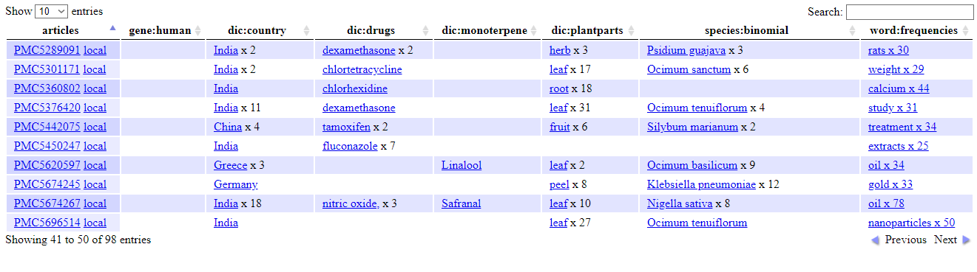

Fig - 01: commonestdataTable.html.png

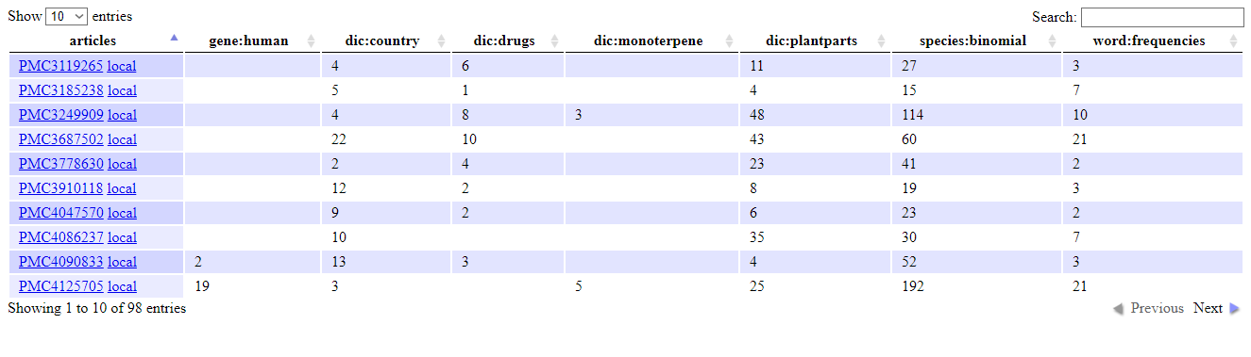

Fig - 02: count.dataTables.html.png

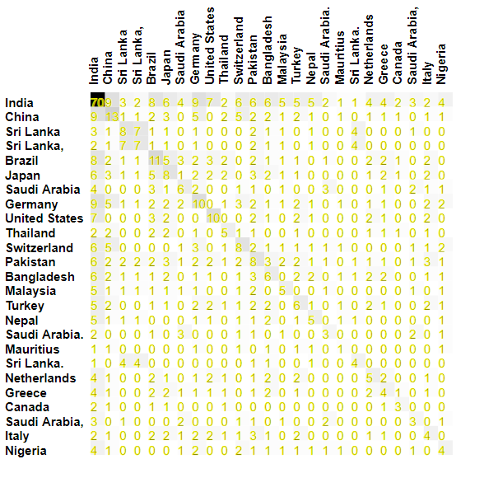

Fig - 03: country-country.cooccur.svg.png

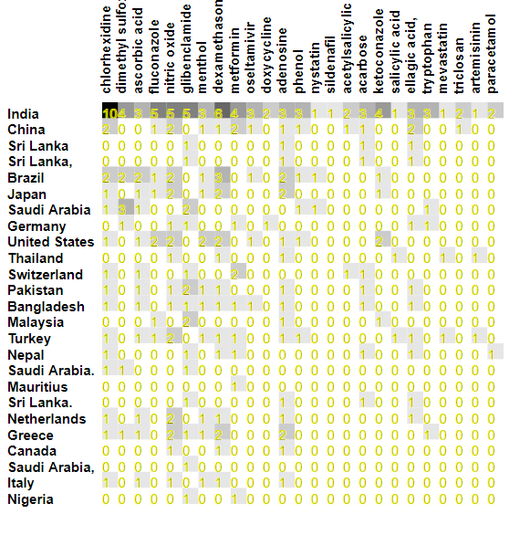

Fig - 04: country-drug.cooccur.svg.png

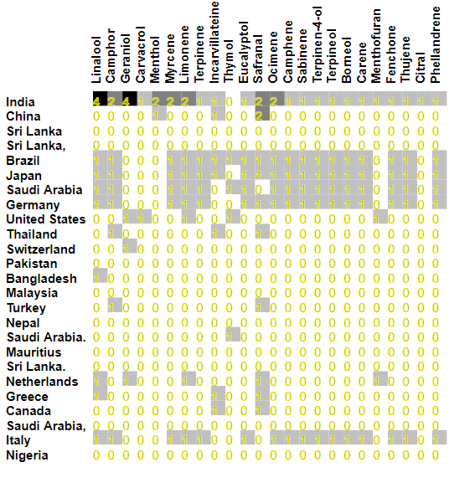

Fig-05: country-monoterpene.cooccur.svg.png

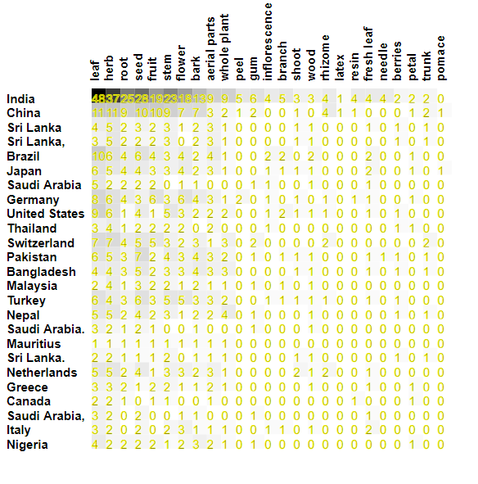

Fig - 06: country-plant-parts.cooccur.svg.png

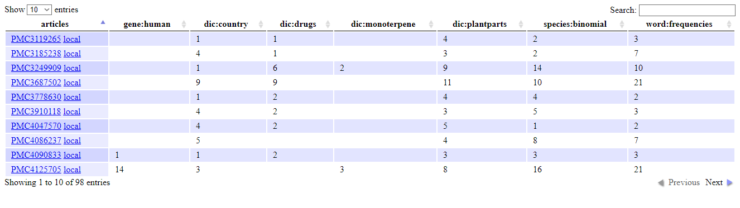

Fig - 07: entries.dataTables.html.png

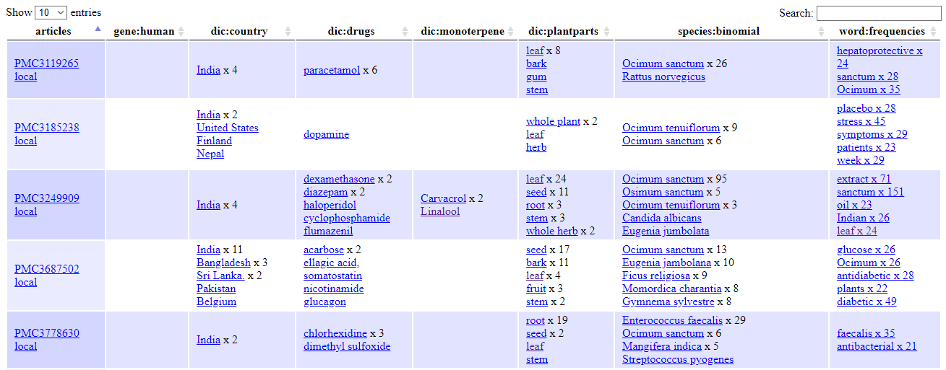

Fig -08: full.dataTables.html.png

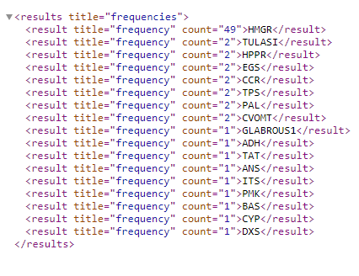

Fig - 09: gene.human.count.xml.png

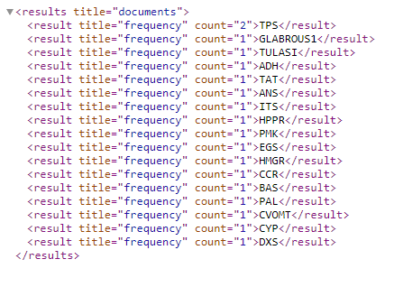

Fig - 10: gene.human.documents.xml.png

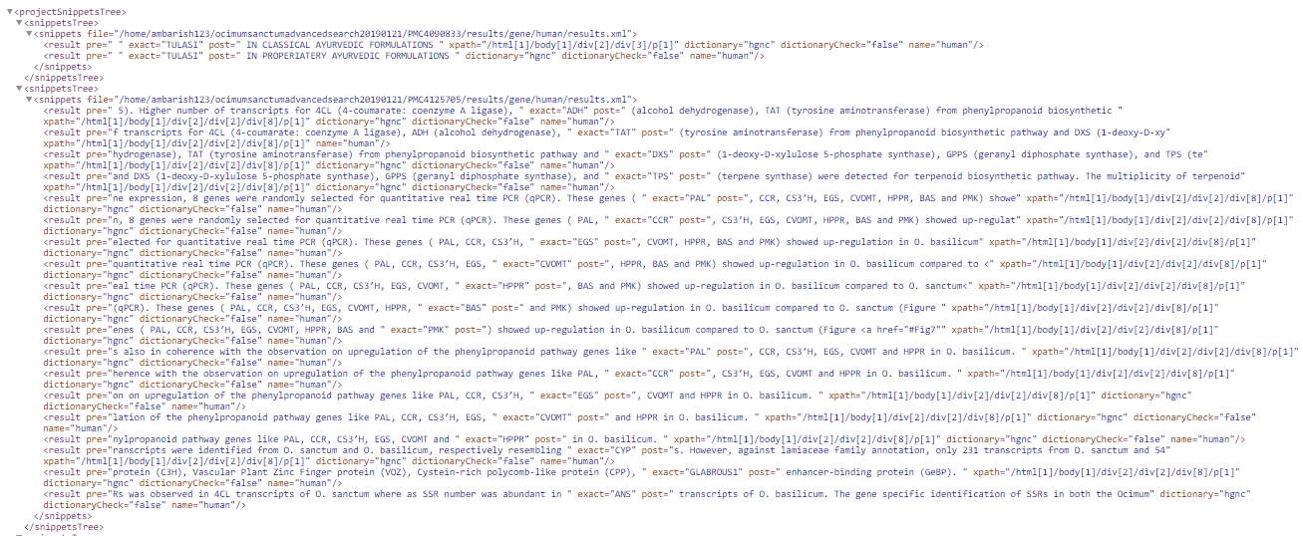

Fig - 11: gene.human.snippets.xml.png

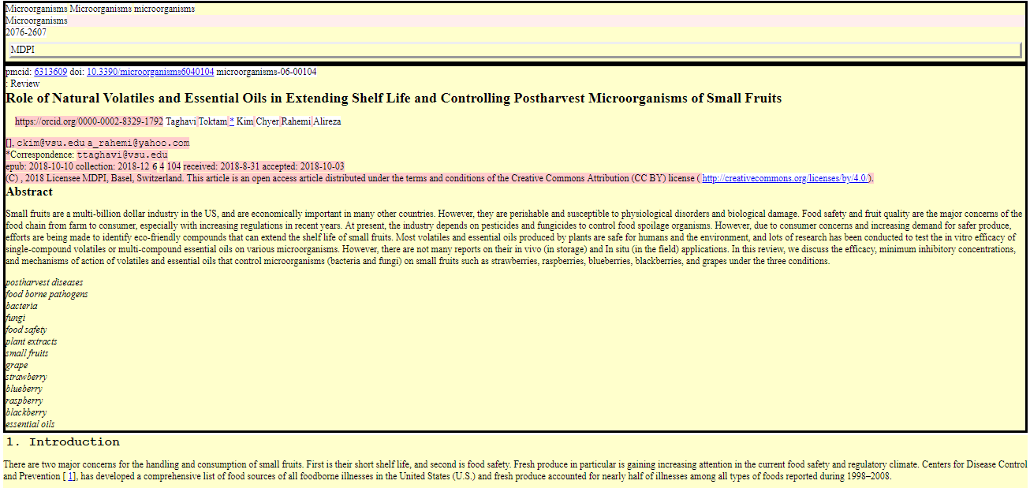

Fig - 12: scholarly.html.png

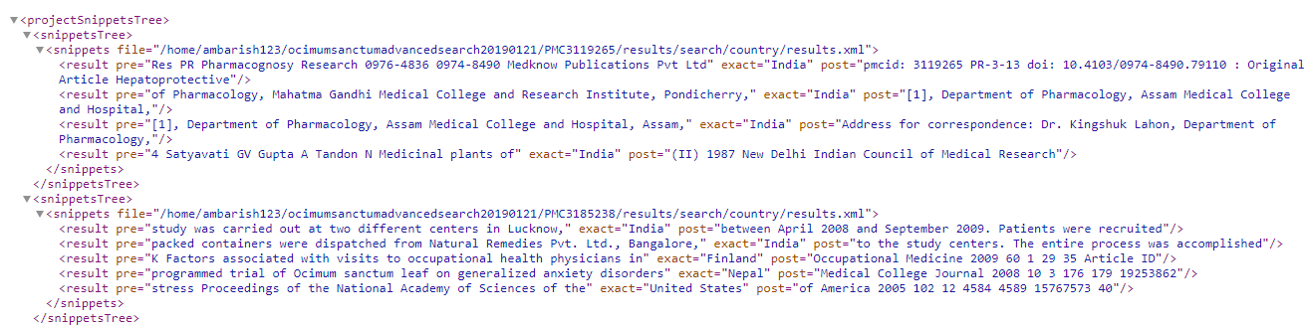

Fig - 13: search.country.snippets.xml.png

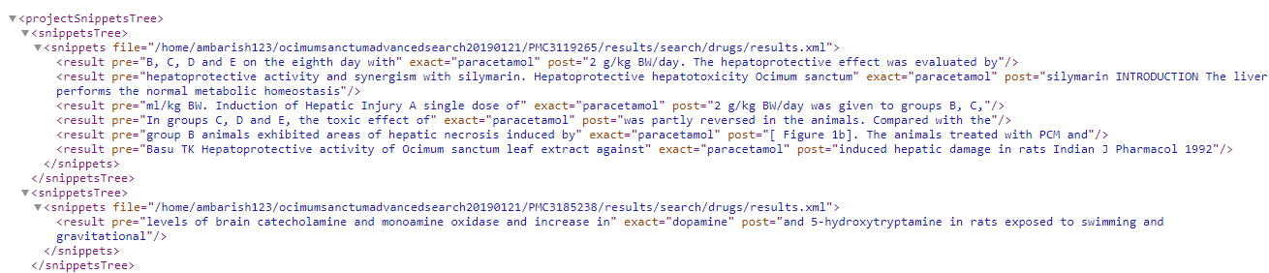

Fig - 14: search.drugs.snippets.xml.png

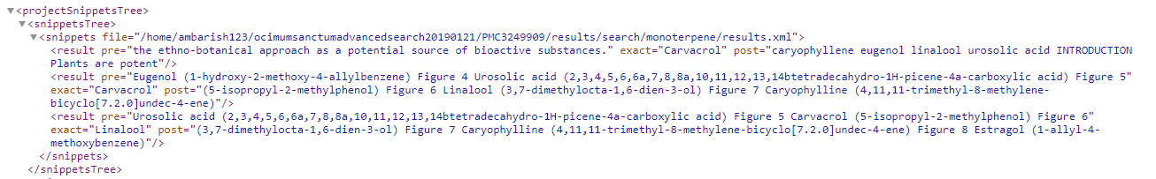

Fig - 15: search.monoterpene.snippets.xml.png

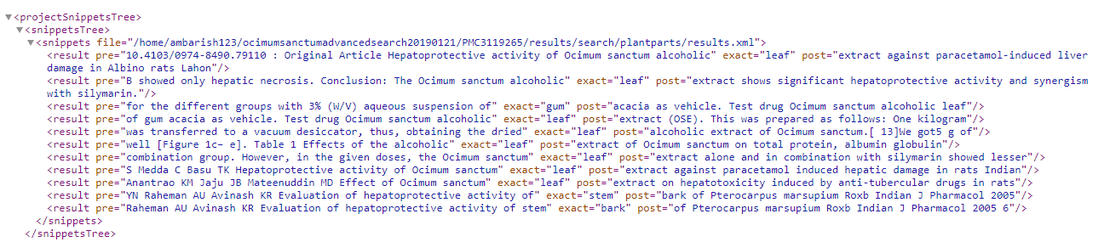

Fig - 16 : search.plantparts.snippets.xml.png

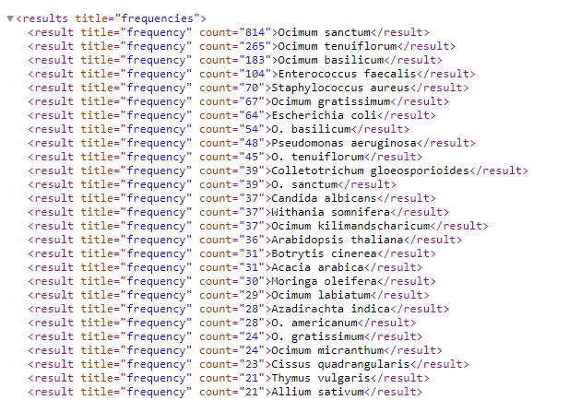

Fig - 17 : species.binomial.count.xml.png

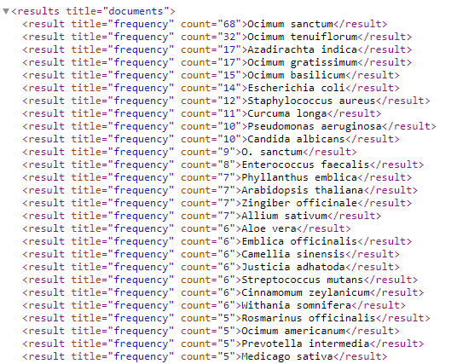

Fig - 18 : species.binomial.documents.xml.png

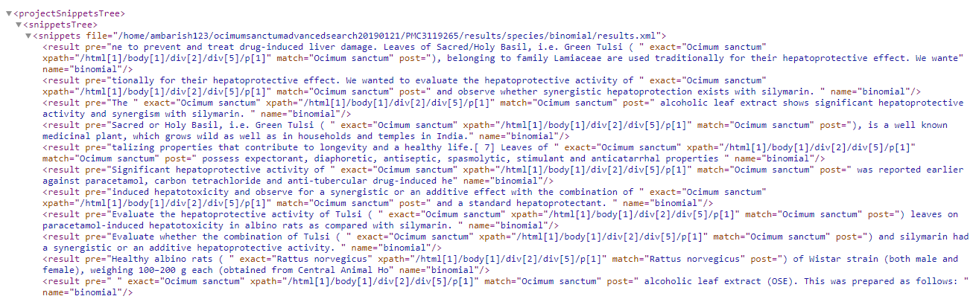

Fig - 19 : species.binomial.snippets.xml.png

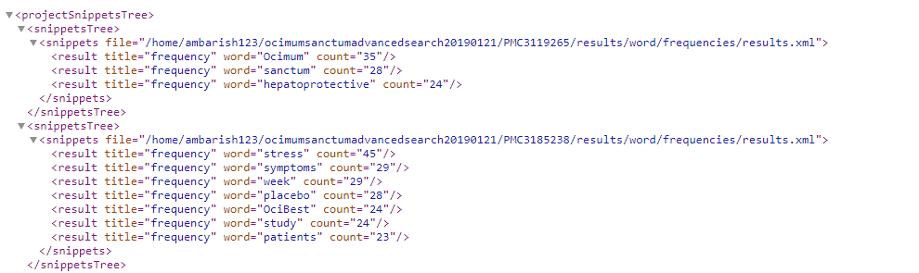

Fig - 20 : word.frequencies.snippets.xml.png