Game Design Document

Fill up the following document

1. Write the title of your project.

Zombie Persecuter

1. What is the goal of the game?

Relieving your stress and anxiety by killing zombies <3 . just some action game which can maybe take you away from reality .

1. Write a brief story of your game.

Cyrus with his 5 friends went to campaing in the forests . One day he

Woke up finding none of his friends their , he started to search for them .

He finally found them but they were in castle locked and there were many zombies protecting the castle . Now the only way for cyrus to save his friends is to kill the zombies and reach the castle .

1. Which are the playing characters of this game?

* Playing characters are the ones who respond to the user based on the input from the user.
* Cars, monkeys, dinos, wizards, etc., are the playing characters in the game.

|  |  |  |
| --- | --- | --- |
| Number | Character Name | What can this character do? |
| 1 | Cyrus (player) | Shooter |
| 2 |  |  |
| 3 |  |  |
| 4 |  |  |
| 5 |  |  |
| 6 |  |  |
| 7 |  |  |
| 8 |  |  |

1. Which are the Non-Playing Characters of this game?

* Non-Playing characters are the ones that don't have an action or behavior when the user interacts with the game.
* Hurdles, stones, bananas, coins, etc., are non-playing characters in the game.

|  |  |  |
| --- | --- | --- |
| Number | Character Name | What can this character do? |
| 1 | Zombie (obstacle) | Cannibals |
| 2 |  |  |
| 3 |  |  |
| 4 |  |  |
| 5 |  |  |
| 6 |  |  |
| 7 |  |  |
| 8 |  |  |

Draw your imagination of this game. What does this game look like?

* Draw the game either on your computer or on paper.
* Add images of the game scenes to show each of the playing and non-playing characters at least once.

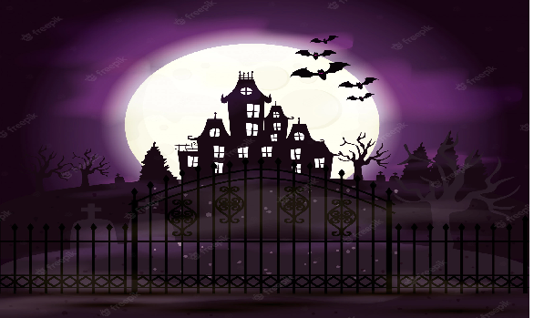

How do you plan to make your game engaging?