DIP Assignment 3 Report

201401110
Saumya Rawat

Problem 1 : Detect Players in a football field

Solved through a series of morphological transforms.

The steps of the method are :
1. Filter the gray scale input image with high boost filtering to enhance edges.
2. Then create a binary mask of image based on the property of fields being dominantly green
3. Compute gradient image and add to mask to preserve edges of non-uniform shapes of players.
4. Convert to binary image for morphological operations
5. Diagonal fill morphological operation to eliminate 8-connectivity of background using bwmorph.
6. Median filter image to remove salt and pepper noise
7. Close morphological transform to enhance only the players.
8. Remove crowd area of the image using connected components and removing the largest one.
9. Perform erosion morphological operation to remove ovals.
10. Remove the line as it's the last largest component left.
11. Dilate the image to furthur emphasise players left in the image.

Some of the results obtained using this method are :

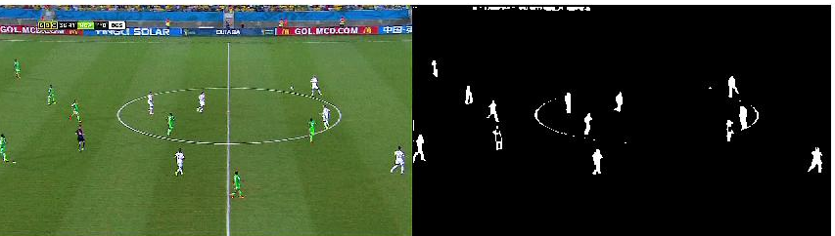
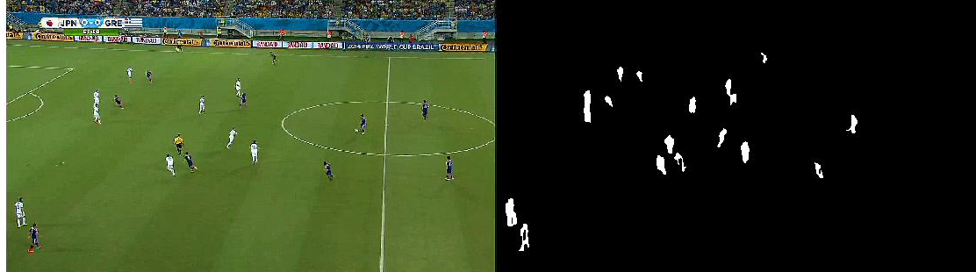
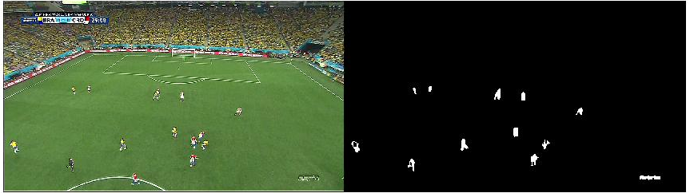

Problem 2 : Detect windows in facades

Solved using local adaptive histogram equalization technique and morphological transforms.

Assumptions : All input images have not been taken from lower angles.

1. Pre Processing :
The only pre processing involved is contrast stretching of input image and increasing it’s brightness so that the brightness values are spread out across the dymanic range, resulting in a more focused threshold value for the windows.

2. To obtain a sharp bw image that can easily distinguish windows, I use Adaptive Histogram Equalization and Osho’s Thresholding. This is based on the fact that all windows in the image have similar contrast and uniform colour distribution.

3. Dilate the horizontal and vertical gradient images with lines as SE at angles 90º and 0º, hence exploiting the fact that rectangular windows have 4 straight lines as contours. Median filter the Gx and Gy to remove salt and pepper noise and obtain the new gradient image using dilated Gx and Gy components.

4. To remove major parts of the building that have been falsely detected as regions, remove the largest connected component.

5. Median filter the final image to remove noise.

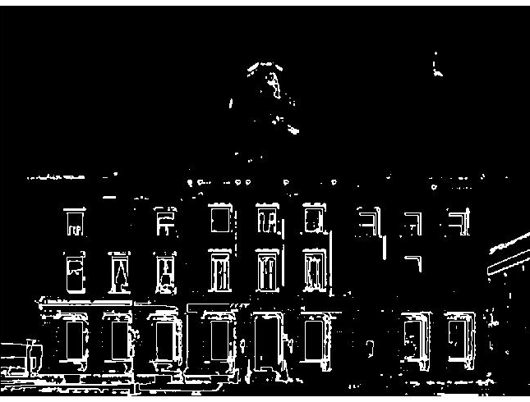
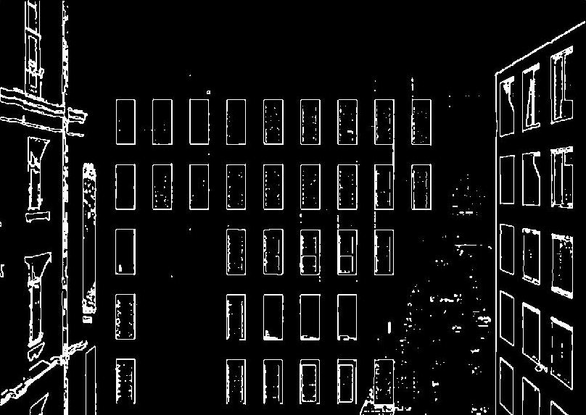
Results obtained from the above method are :

Method inspired from : DETECTION OF WINDOWS IN FACADES USING IMAGE PROCESSING ALGORITHMS by Milos Miljanovic,Thomas Eiter.

