Report : Naive Bayes Classifier

Solution 1: Naïve Bayes Classifier for UCI Census-Income (KDD) Data Set

Pre Processing of the data :
- The data contains 37 nominal features,used as categorical features for classification.
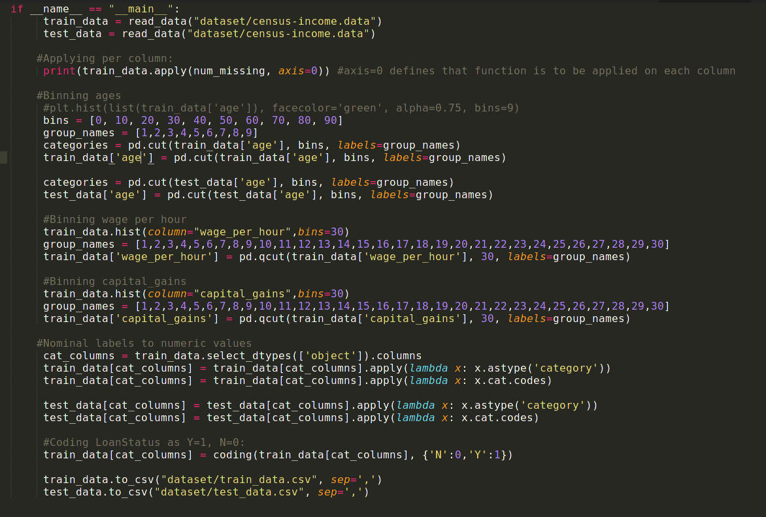
- There are 7 continous features, out of which age, wage per hour, capital gains were binned according to the histograms plotted.
- The missing data for categorical features was replaced with the mode of the feature as mean cannot be used and it was seen that one of the resulting values was dominant in the observations for the features.

Naive Bayes Classifier:

The Naive Bayes Classifier assumes that the presence of a particular feature in a class is unrelated to the presence of any other feature. It is easy to build and useful for large datasets.

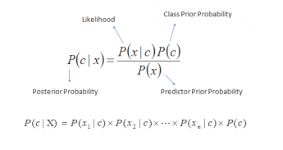

Pipeline of the classifier :
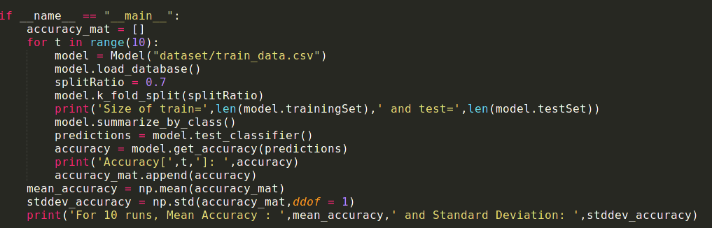

Test Runs:

- The data was sampled as 70% train and 30% test for 10 runs and the following accuracy and standard deviation was reported :
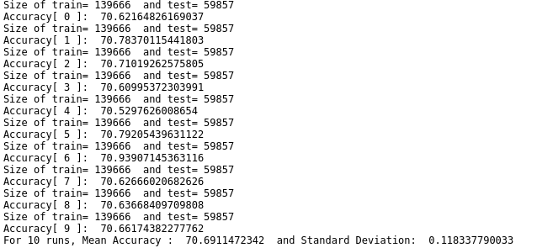

Solution 2: Derivations
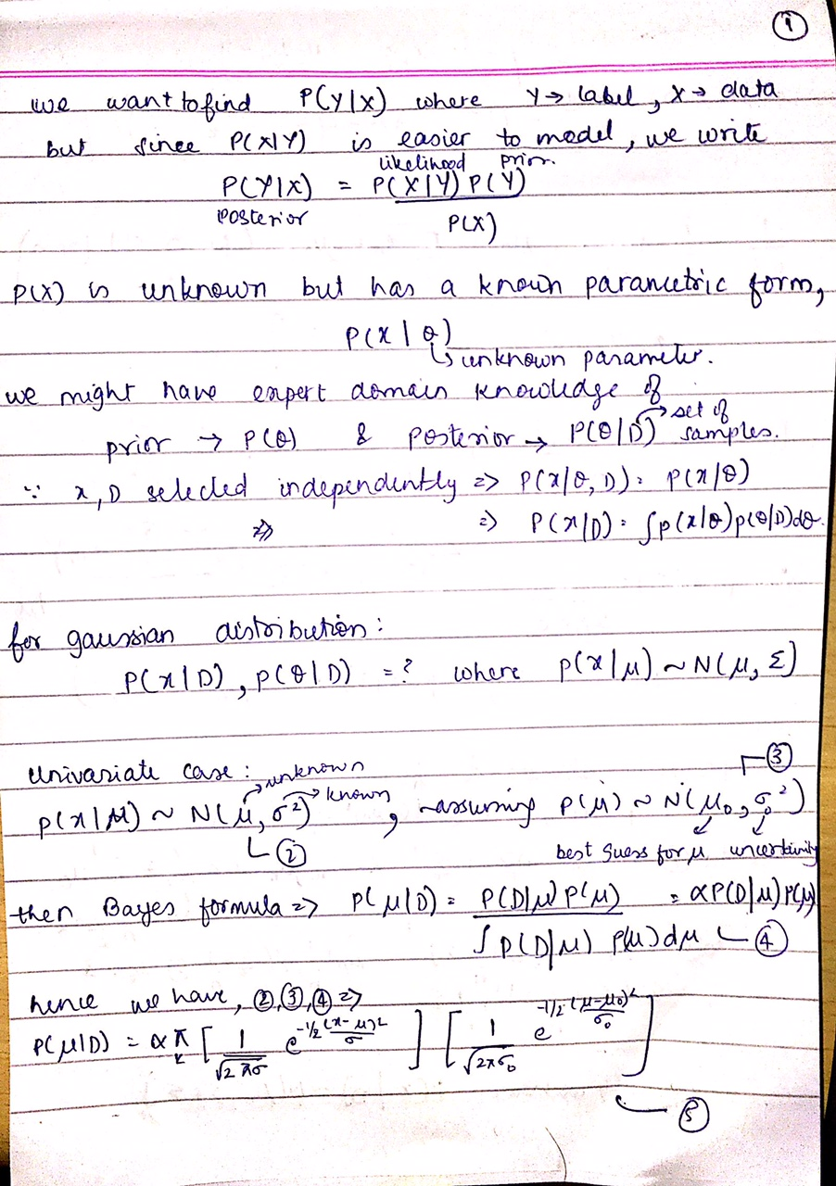
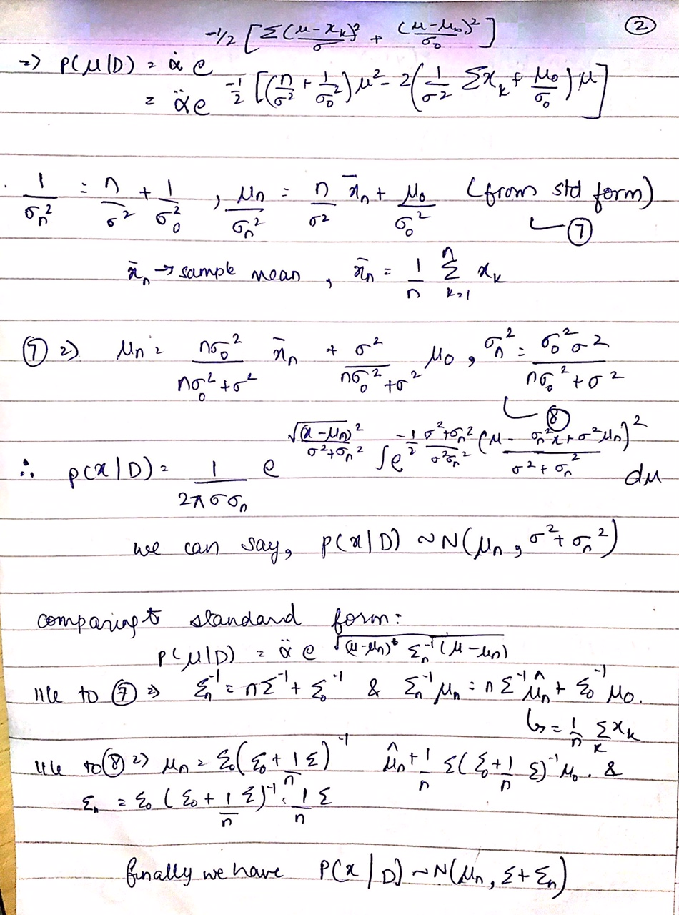
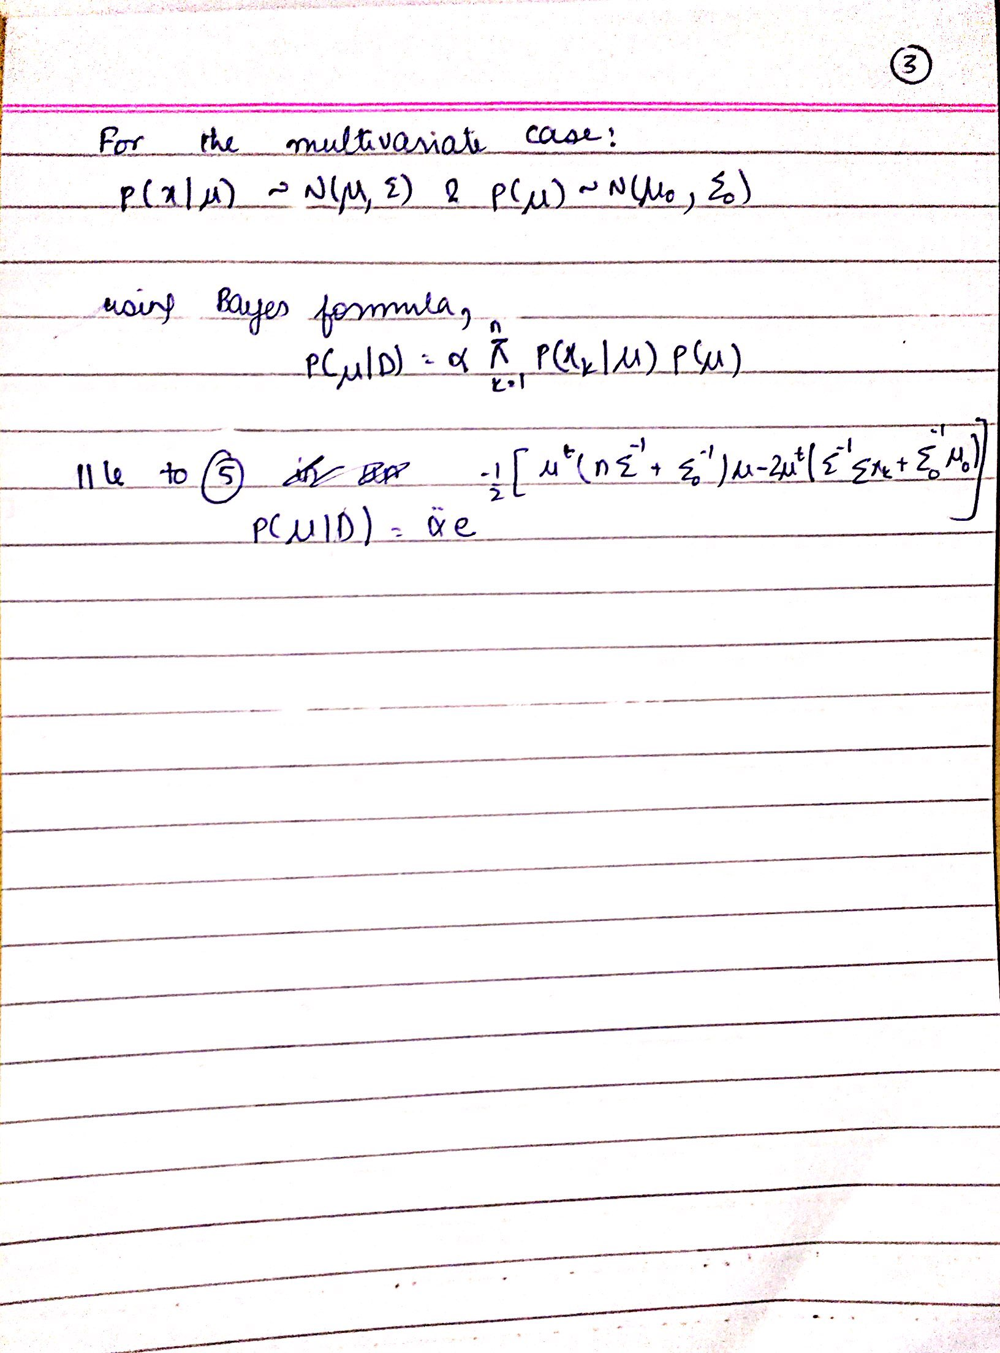
Solution 3: PCA, LDA and Gaussian Naive Bayes Classifier

PCA :
Principal component analysis is often used to reduce the dimensionality and bring out strong patterns in a dataset. The steps in PCA are :
- Centre the dataset, Compute the d-dimensional mean vector (i.e., the means for every dimension of the whole dataset)
- Compute the the covariance matrix of the whole data set
- Compute eigenvectors (e1,e2,...,ed) and corresponding eigenvalues (λ1,λ2,...,λd)
- Sort the eigenvectors by decreasing eigenvalues and choose k eigenvectors with the largest eigenvalues to form a d×k dimensional matrix W
- Use this d×k eigenvector matrix to transform the samples onto the new subspace. This can be summarized by the mathematical equation: y=W^{T}×x (where x is a d×1-dimensional vector representing one sample, and y is the transformed k×1-dimensional sample in the new subspace.)
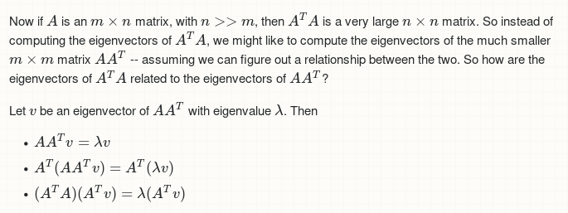
- Since in the particular dataset, d >> n, Kernel PCA was used.
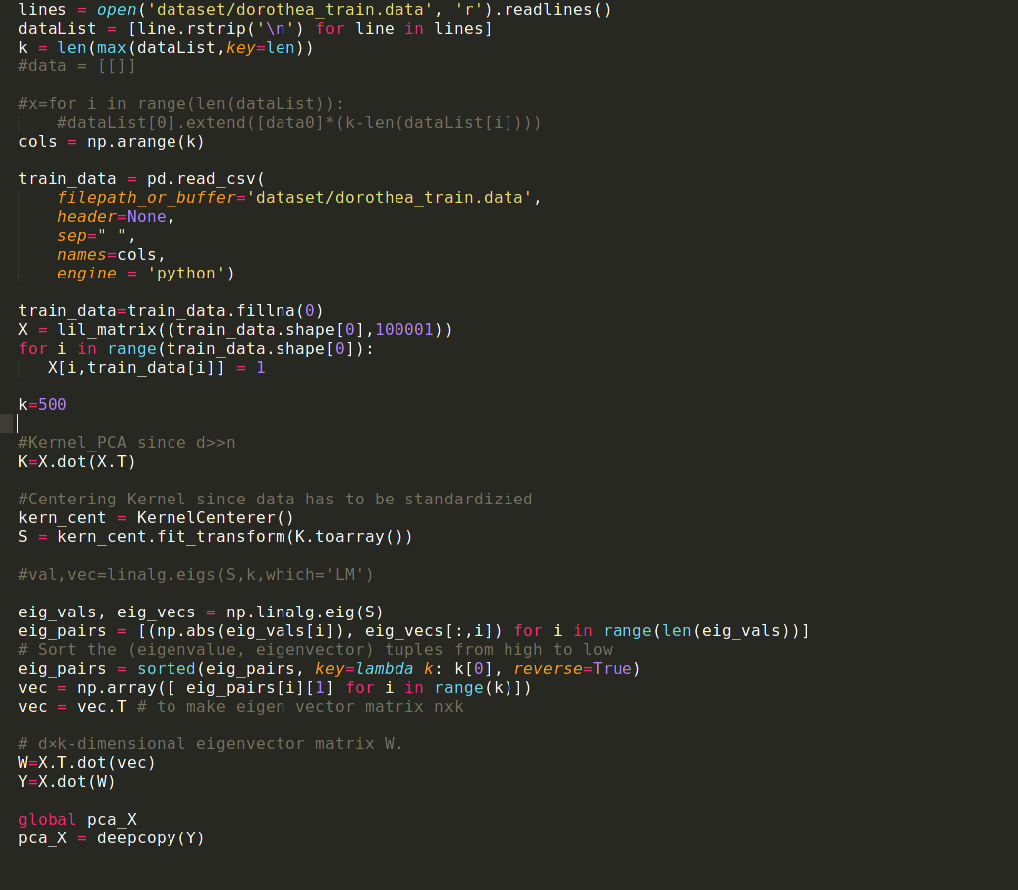
LDA :
- Computing the d-dimensional mean vectors
- Computing the Scatter Matrices
  - Within-class scatter matrix SW
  - Between-class scatter matrix SB
- Solving the generalized eigenvalue problem for the matrix S⁻¹W*SB
- Selecting linear discriminants for the new feature subspace
  - Choosing k eigenvectors with the largest eigenvalues
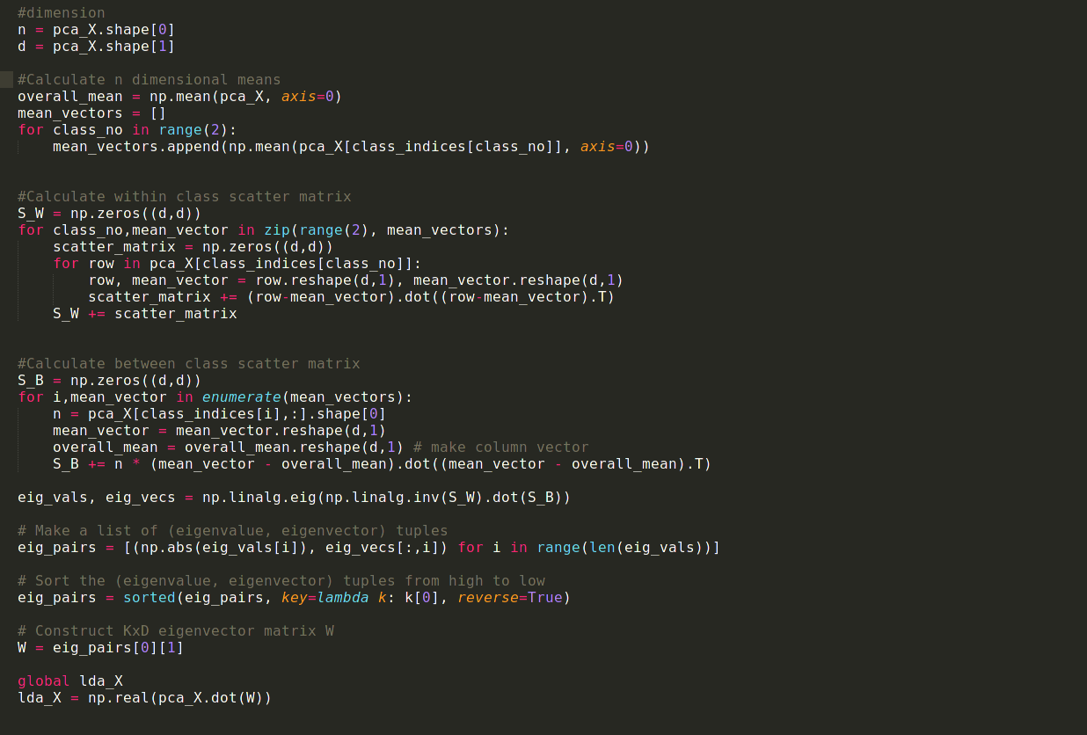
- Transforming the samples onto the new subspace
Gaussian Naive Bayes Classifier :

The Classifier model is defined as :
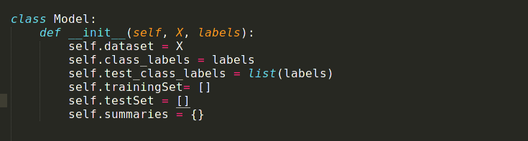
Here summaries is a dictionary object that holds mean and standard deviations for every class.

First the data is divided as test and train and also seperated on the basis of class labels :
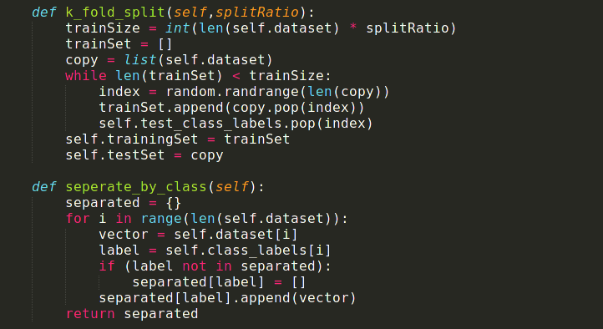
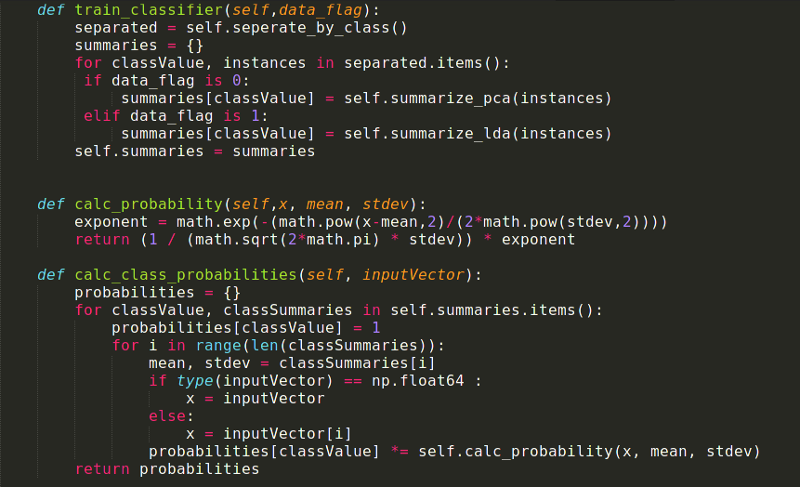
The classifier is then trained, calculation of summaries for each class.

Testing phase : For predicting values for the test set, probabilities are calculated using :-
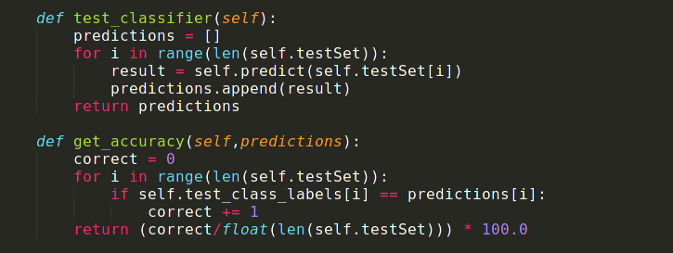
Results obtained are :
Split of train and test data = 70 % (train)
Test Run 1 :
K = 100
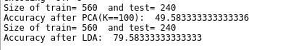
Test Run 2:
K = 100
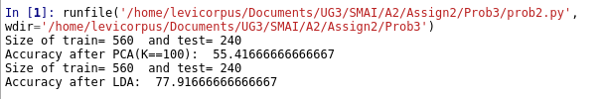
Test Run 1:
K = 500
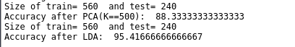
Test Run 2:
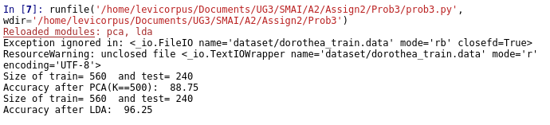
K = 500
Observations :

The accuracy for PCA is low, since it doesn’t take into consideration the classification of the data. However using LDA significantly increases accuracy since it considers maximises inter class distance and minimizes intra class distance.
Also as K increases, accuracy is increasing, since the number of dimensions retained for LDA is higher and hence more information is captured for classification.

On changing the split ratio for train vs test data, the accuracy does not significantly vary from previous results
