Assignment 3 : SVM and Kernel Methods

Problem 1:

In cases that Fisher Discriminant Analysis cannot even recognize the structure in the data and therefore gives us no guarantee that discriminative features are preserved. The idea of nonlinear discriminant analysis is to transform the input data non-linearly, before standard linear discriminant analysis is applied.

Kernel Fisher Discriminant Analysis implicitly maps the input data into a high dimensional space H, where it performs regular Fisher Discriminant Analysis.

Given two sets of labeled data, C₁ and C₂ , let the class means m₁ and m₂ be
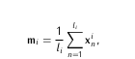
where l_{i} – # of instances of class C_{i} . LDA maximises the distance between two classes and minimizes intra class variance. This can be formulated as
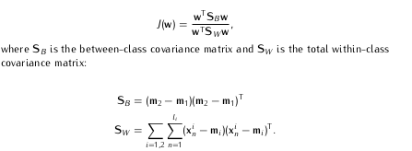
where S_{b} – between class scatter and S_{w} - within class scatter. These are individually formulated as :

To extend LDA to non linear space, the data can be mapped to a new space F via Ф. We now need to maximize :
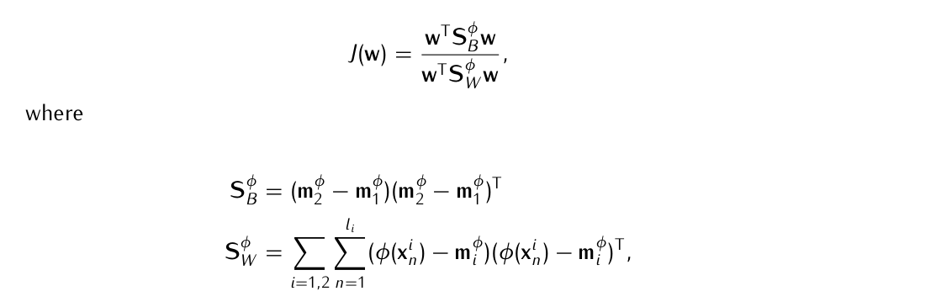
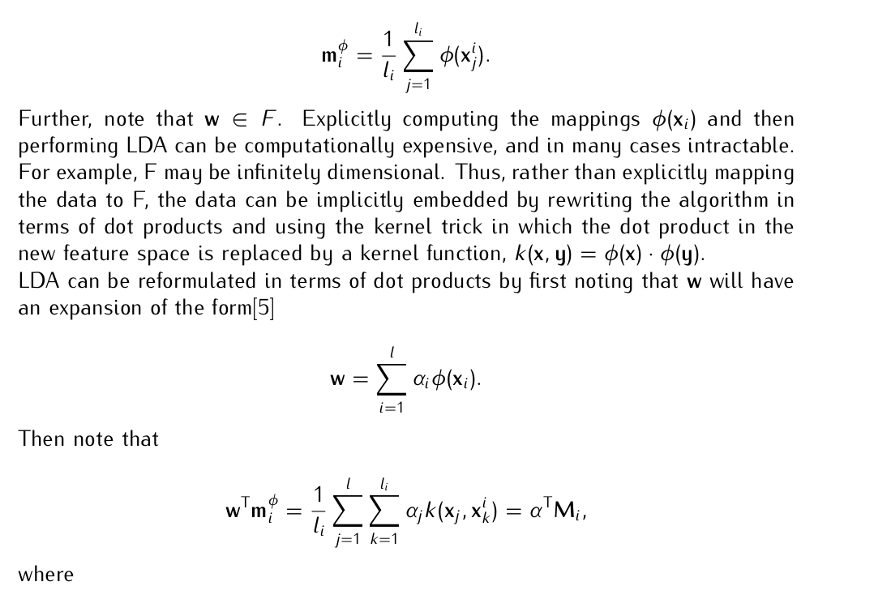

The kernel function can be given by
And w by,
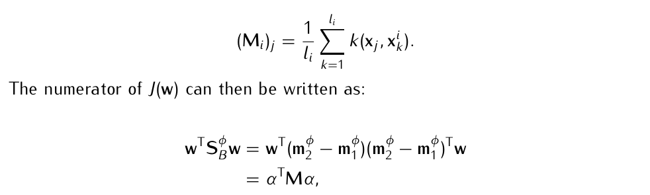

Also,
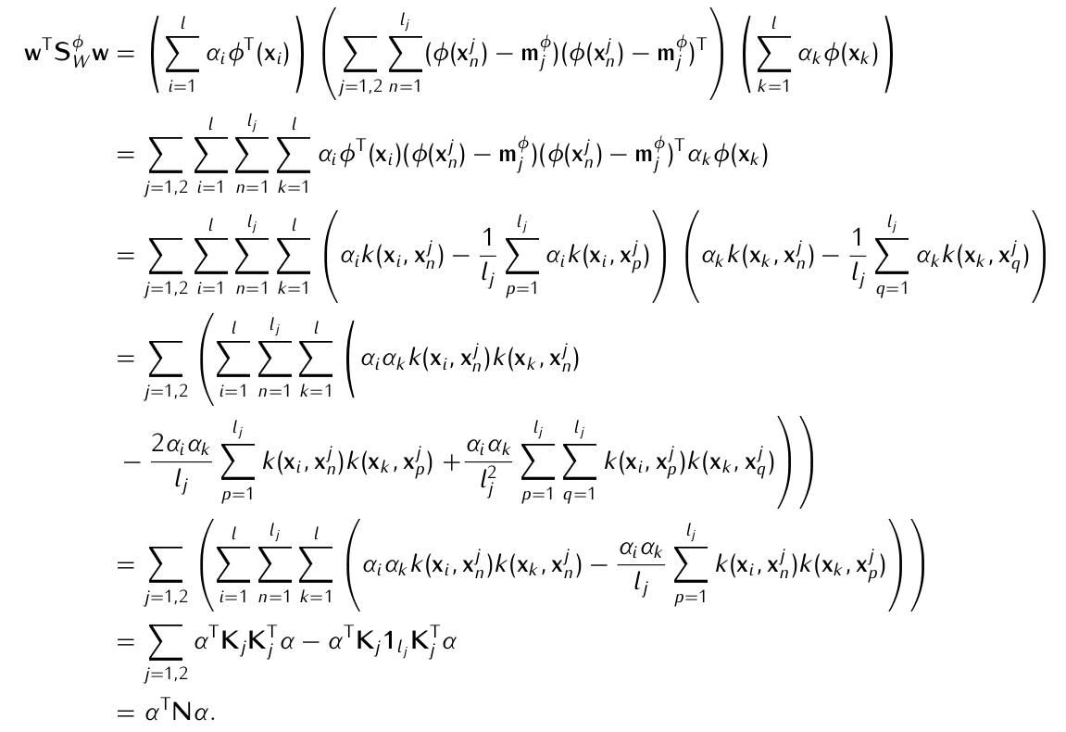
Hence we can write J(w) as :
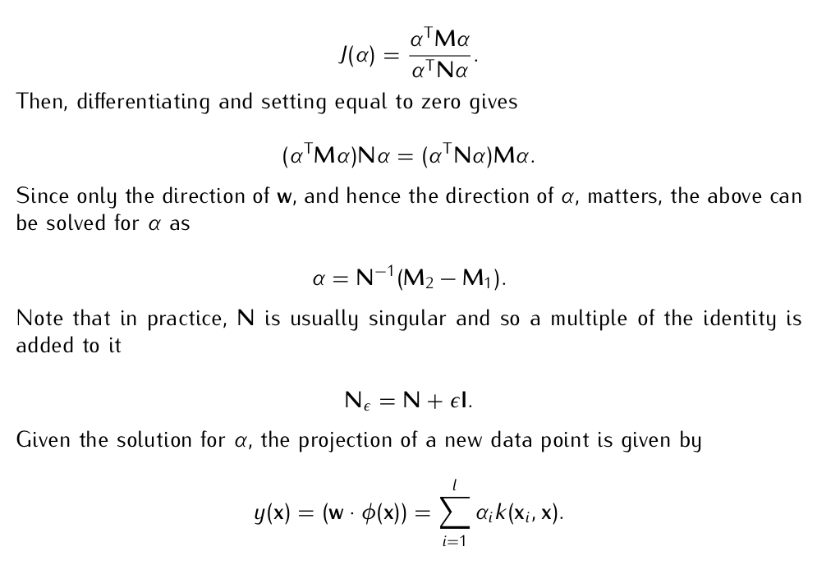
Differentiating and setting to 0,
Since N can be singular,
Hence the new set of data points can be given as ,
Problem 2:

Datasets used : Validation sets of UCI Arcene Dataset, UCI Dexter Dataset

UCI Dexter Dataset :
The task of DEXTER is to filter texts about "corporate acquisitions". This is a two-class classification problem with sparse continuous input variables. There are 10001 attributes in total

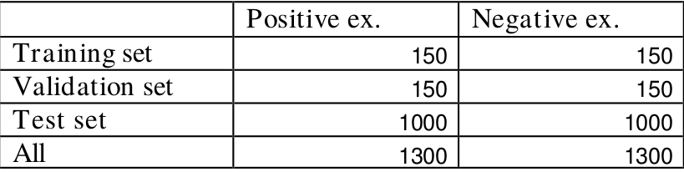
a) Kernel PCA
Kernel PCA is a nonlinear generalization of PCA. To get nonlinear forms of PCA, we simpy choose a nonlinear kernel. Kernel PCA has the main advantage that it is simple dot product linear algenra and no nonlinear optimization is involved. Compared to principal curves, kernel PCA is so far harder to interpret in input space however, at least for polynomial kernels, it has a very clear interpretation in terms of higher order features.

Psuedo Code :

- Compute Kernel
_dists = pdist(X, 'wminkowski')
sym_dists = squareform(_dists)
K = exp(-gamma * sym_dists)

- Center Kernel since data has to be standardizied
kern_cent = KernelCenterer()
K = kern_cent.fit_transform(K)

- Compute Eigen Values and Eigen Vectors of K
eig_vals, eig_vecs = np.linalg.eig(K)
eig_pairs = [(np.abs(eig_vals[i]), eig_vecs[:,i]) for i in range(len(eig_vals))]

- Sort the (eigenvalue, eigenvector) tuples from high to low and choose top k eigen vectors
eig_pairs = sorted(eig_pairs, key=lambda k: k[0], reverse=True)
vec = np.array([ eig_pairs[i][1] for i in range(k)])
vec = vec.T # to make eigen vector matrix

Results :

1. Arcene Dataset
k = 100
rbf kernel
1.1 Linear SVM : 55.56 % accuracy
1.2 RBF SVM : 52.22 % accuracy

k = 10
rbf kernel
1.1 Linear SVM : 54.34 % accuracy
1.2 RBF SVM : 51.56 % accuracy

2. Dexter Dataset
k = 100
rbf kernel
1.1 Linear SVM : 49.85 % accuracy
1.2 RBF SVM : 49.74 % accuracy

k = 10
rbf kernel
1.1 Linear SVM : 49.72 % accuracy
1.2 RBF SVM : 50.03 % accuracy

b) Kernel LDA

Pseudo Code :

def k_lda(X,y):
class_indices = []
class_indices.append(np.where(y==-1)) #at pos 0
class_indices.append(np.where(y==1)) #at pos 1

n = X.shape[0]
d = X.shape[1]

n1 = X[class_indices[0]].shape[0]
n2 = X[class_indices[1]].shape[0]
K = X.dot(X.T)

1. Calculate Kernel matrix K1 n1xn1
K1 = mlpy.kernel_gaussian(X, X[class_indices[0]], sigma=15)
K2 = mlpy.kernel_gaussian(X, X[class_indices[1]], sigma=15)

2. Calculate means
2.1 Calculate mean matrix M1
M1=np.zeros((n,1))
class_no = 0
for i,xi in enumerate(X):
M1[i] = np.sum([[xi.dot(xj.T)] for xj in X[class_indices[class_no]]])

2.2 Calculate mean matrix M2
M2=np.zeros((n,1))
class_no = 1
for i,xi in enumerate(X):
M2[i] = np.sum([[xi.dot(xj.T)] for xj in X[class_indices[class_no]]])

3. Calculate between class scatter matrix
M = (M2 - M1).dot((M2 - M1).T)

4. Calculate within class scatter matrix
N1 = (K1.dot(np.identity(n1) - (np.ones(n1)*n1))).dot(K1.T)
N2 = (K2.dot(np.identity(n2) - (np.ones(n2)*n2))).dot(K2.T)
N = N1 + N2;

eig_vals, eig_vecs = np.linalg.eig(np.linalg.inv(N).dot(M))

5. Make a list of (eigenvalue, eigenvector) tuples
eig_pairs = [(np.abs(eig_vals[i]), eig_vecs[:,i]) for i in range(len(eig_vals))]

6. Sort the (eigenvalue, eigenvector) tuples from high to low
eig_pairs = sorted(eig_pairs, key=lambda k: k[0], reverse=True)

7. Construct KxD eigenvector matrix W
W = eig_pairs[0][1]
ldaX = []
for j in range(len(X)):
ldaX.append( sum([W[i] * mlpy.kernel_gaussian(X[j], X[i], sigma=15) for i in range(n) ]))
return ldaX

Results :

1. Arcene Dataset
k = 100
rbf kernel
1.1 Linear SVM : 80.56 % accuracy
1.2 RBF SVM : 82.22 % accuracy

k = 10
rbf kernel
1.1 Linear SVM : 75.94 % accuracy
1.2 RBF SVM : 77.56 % accuracy

2. Dexter Dataset
k = 100
rbf kernel
1.1 Linear SVM : 69.06 % accuracy
1.2 RBF SVM : 89.74 % accuracy

k = 10
rbf kernel
1.1 Linear SVM : 79.72 % accuracy
1.2 RBF SVM : 80.03 % accuracy
Observations :
1. Variation of γ in RBF kernel doesn’t affect classification performance of SVM.
2. SVM with rbf kernel gives better results than linear SVM for these particular datasets.

