Game Design Document

Fill up the following document

1. Write the title of your project.

MUSIC TILE HOPE

1. What is the goal of the game?

You need to jump on the tile to play the music with out skipping or falling.

1. Write a brief story of your game.

There is no story the person who is playing the game need to make the stor

By his/her self. Basicaly you are going on a trip wile listen to your favourit

And you need to jusp to the tiles to get to your destination. This is my part

Of the story rest depends on the person playing.

1. Which are the playing characters of this game?

* Playing characters are the ones who respond to the user based on the input from the user.
* Cars, monkeys, dinos, wizards, etc., are the playing characters in the game.

|  |  |  |
| --- | --- | --- |
| Number | Character Name | What can this character do? |
| 1 | Ball | It need to be moved my the player to jump on the tiles. |
| 2 | - | - |
| 3 | - | - |
| 4 | - | - |
| 5 | - | - |
| 6 | - | - |
| 7 | - | - |
| 8 | - | - |

1. Which are the Non-Playing Characters of this game?

* Non-Playing characters are the ones that don't have an action or behavior when the user interacts with the game.
* Hurdles, stones, bananas, coins, etc., are non-playing characters in the game.

|  |  |  |
| --- | --- | --- |
| Number | Character Name | What can this character do? |
| 1 | Tiles | The tiles come endlessly untill you die/lose. Playes the song when jumped on. |
| 2 | Back ground | Gives an interisting look the game so the person playing doesn’t get bored. |
| 3 | - | - |
| 4 | - | - |
| 5 | - | - |
| 6 | - | - |
| 7 | - | - |
| 8 | - | - |

Draw your imagination of this game. What does this game look like?

* Draw the game either on your computer or on paper.
* Add images of the game scenes to show each of the playing and non-playing characters at least once.

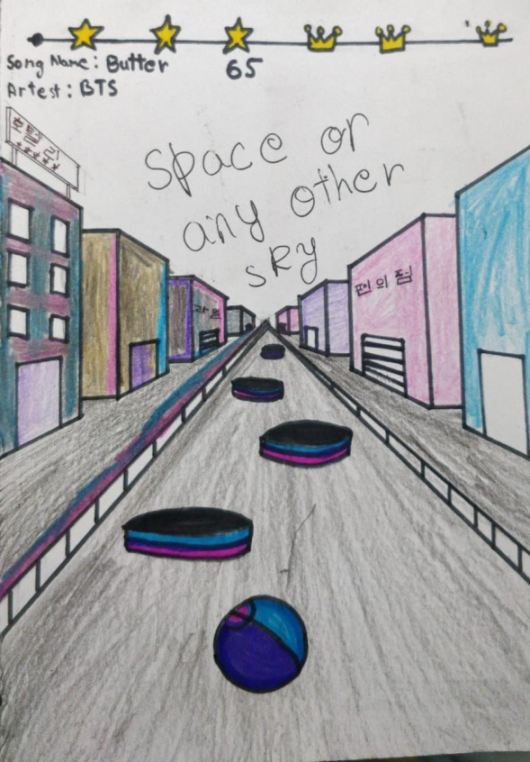

BALL(PLAYING) TILE(NON PLAYING)



BACK GROUND(NON PLAYING)

FINAL

How do you plan to make your game engaging?

BY ADDING MORE LEVELS AND SONG. AND MAKING IT CHALLANGELING.