Interim Evaluation Report: Student Struggle Classification (M1–M4)

Review 3 Benchmark Results

⚑ Executive Summary: Trajectory-based assessment (M2–M4) substantially outperforms single-attempt snapshot analysis (M1). The Refined Hybrid Model (M4) achieves top performance across Accuracy (67.42%), Balanced Accuracy (60.67%), Macro F1 (0.5814), and Productive F1 (0.7073).

1. Core Objectives
- Trajectory vs. Snapshot: Test if analyzing multi-attempt sequences (A₁ → At) improves accuracy over evaluating a single latest attempt (At).
- Hybrid Evidence Fusion: Test if combining rule-based behavioral features (M2) with LLM code-semantic reasoning (M3) yields superior struggle classification (M4).

2. Dataset & Benchmark Setup
Parameter | Value / Description
Total Evaluation Sample | 89 trajectory prefixes (derived from 15 validated multi-attempt sessions)
Prefix Definition (Pt) | Sequence of attempts [A1, …, At] up to step t (simulates real-time online hint timing)
Consensus Reference | Dual-annotator human consensus labels
Class Distribution | PRODUCTIVE: 40 (44.9%) | UNPRODUCTIVE: 42 (47.2%) | UNCERTAIN: 7 (7.9%)
Evaluation Scope | Interim pilot benchmark; prefixes from the same session share historical context

3. Method Taxonomy (M1–M4)
Method | Type | Input Scope | Core Mechanism
M1: Snapshot | Baseline | Latest Attempt (At) | Evaluates immediate pass/fail state in isolation (no temporal history).
M2: Rule-Based | Behavioral | Trajectory (A1 → At) | Deterministic heuristics on pass rate delta, stagnation length, and repeated executions.
M3: LLM Reasoning | Semantic | Trajectory (A1 → At) | llama-3.1-8b-instruct zero-shot reasoning over code diffs, errors, and transition metrics.
M4: Refined Hybrid | Fusion | Trajectory (A1 → At) | Evidence-weighted fusion combining M2 objective telemetry with M3 code diff reasoning.

4. Benchmark Performance Comparison
All metrics calculated on 89 prefixes against human consensus reference labels.
Method | Overall Acc | Bal. Acc | Macro Prec | Macro Rec | Macro F1 | Prod F1 | Unprod F1 | Uncert F1
M1: Snapshot | 26.97% | 43.57% | 30.26% | 43.57% | 0.2476 | 0.5806 | 0.0000 | 0.1622
M2: Rule-Based | 53.93% | 46.94% | 51.25% | 46.94% | 0.4634 | 0.6389 | 0.6301 | 0.1212
M3: LLM Reasoning | 66.29% | 59.76% | 56.90% | 59.76% | 0.5772 | 0.6667 | 0.7317 | 0.3333
M4: Refined Hybrid | 67.42% | 60.67% | 58.16% | 60.67% | 0.5814 | 0.7073 | 0.7368 | 0.3000

Bold values indicate best overall performance per metric.

5. Performance Visualizations
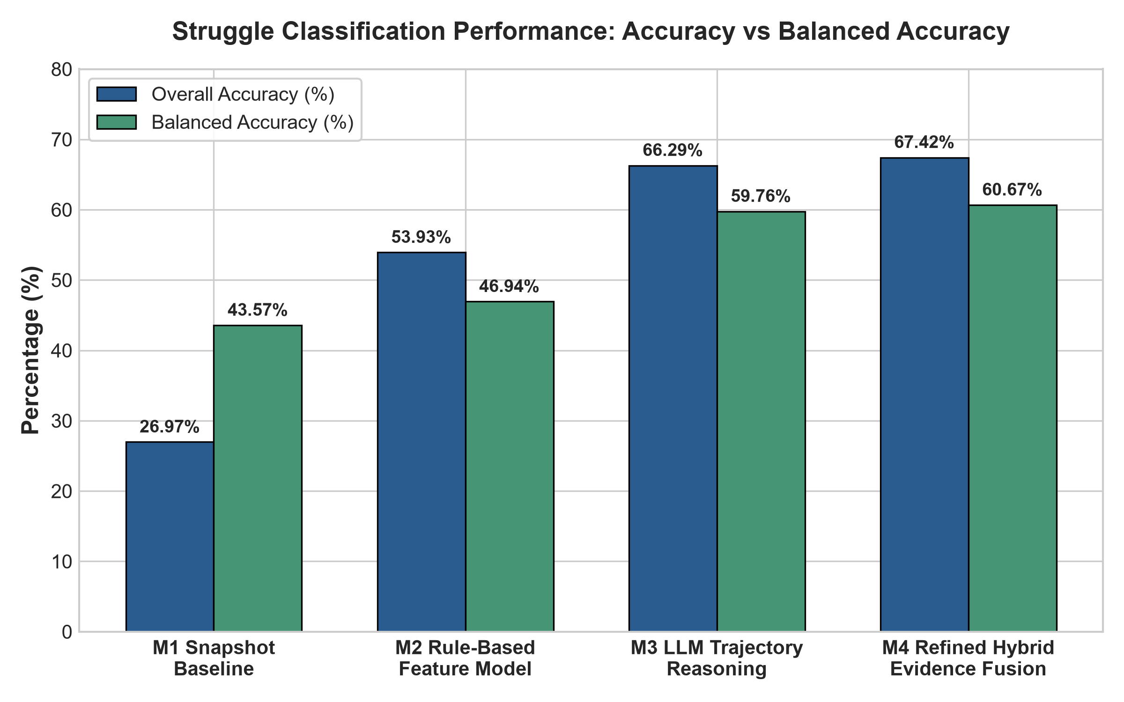
Figure 1 – Overall Accuracy & Balanced Accuracy across M1–M4

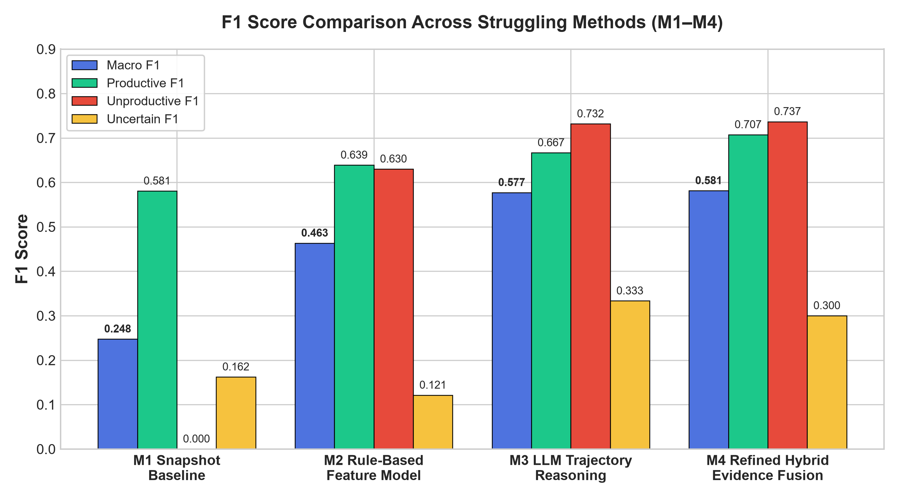
Figure 2 – Macro F1 & Per-Class F1 Scores across M1–M4

6. Confusion Matrices

M3: LLM Trajectory Reasoning
Reference \ Predicted | PRODUCTIVE | UNPRODUCTIVE | UNCERTAIN
PRODUCTIVE (40) | 26 | 8 | 6
UNPRODUCTIVE (42) | 10 | 30 | 2
UNCERTAIN (7) | 2 | 2 | 3

M4: Refined Hybrid Model
Reference \ Predicted | PRODUCTIVE | UNPRODUCTIVE | UNCERTAIN
PRODUCTIVE (40) | 29 | 4 | 7
UNPRODUCTIVE (42) | 11 | 28 | 3
UNCERTAIN (7) | 2 | 2 | 3

- Matrix Key Takeaways:
- Rows = Human Consensus Reference | Columns = System Predictions.
- M4 Correct Diagnoses: 29/40 Productive, 28/42 Unproductive, 3/7 Uncertain.
- M4 Misclassification Reduction: Productive → Unproductive errors reduced from 8 (M3) to 4 (M4).

7. Crisp Method Insights
- Why M1 Fails (26.97% Acc, 0.00 Unprod F1): Lacks temporal history; cannot distinguish initial exploration from persistent unproductive loops.
- Why M2 Improves (+26.96% Acc over M1): Uses multi-attempt transition features to detect repetition, stagnation, and pass-rate trends.
- Why M3 Outperforms M2 (+12.36% Acc over M2): Analyzes actual code AST diffs, recognizing syntax fixes vs. algorithm structural edits.
- Why M4 Refinement Wins (67.42% Acc, 0.5814 Macro F1): Fuses M2 objective test suite telemetry with M3 code reasoning using confidence dominance (Δ ≥ 0.15) and pass-rate precedence rules.
- Uncertain Class Challenge: UNCERTAIN remains the hardest class (~0.30 F1) due to noisy/boundary trajectory evidence.

8. Representative Technical Case Studies
Case ID | Trajectory State | Ref Label | M2 (Conf) | M3 (Conf) | M4 (Conf) | Fusion Decision Rationale
sess_36262904...p3 | 4 attempts, algorithm modified, pass rate increased | PRODUCTIVE | UNPRODUCTIVE (0.81) | PRODUCTIVE (0.85) | PRODUCTIVE (0.72) | M3 Confidence Dominance: M3 code diff overrode M2 repetition rule.
sess_3df5dfba...p7 | Error resolved, net pass rate +100% | PRODUCTIVE | PRODUCTIVE (0.95) | UNPRODUCTIVE (0.85) | PRODUCTIVE (0.60) | Objective Precedence: +100% pass rate overrode LLM misinterpretation.
sess_11ac3d64...p3 | Repeated identical failing code 3x | UNPRODUCTIVE | UNCERTAIN (0.35) | UNPRODUCTIVE (0.85) | UNPRODUCTIVE (0.72) | Partial Fusion: High-confidence M3 stagnation signal adopted over M2 uncertainty.

9. Key Takeaways
- Trajectory vs. Snapshot: Multi-attempt trajectory analysis (M2–M4) outperforms single-attempt snapshot analysis by +40.45% Accuracy.
- LLM Code Superiority: LLM semantic reasoning (M3) outperforms rigid heuristic rules (M2) by +12.36% Accuracy.
- Refined Hybrid Leadership: M4 Refined Hybrid achieves top overall performance across Accuracy (67.42%), Balanced Accuracy (60.67%), Macro F1 (0.5814), and Productive F1 (0.7073).
- Actionable Hint Timing: High F1 scores on PRODUCTIVE (0.7073) and UNPRODUCTIVE (0.7368) ensure reliable CONTINUE vs. INTERVENE hint timing decisions.
- Pilot Context: Benchmarked on 89 pilot trajectory prefixes; results establish strong preliminary validity for Review 3.

