**A PRELIMENERY REPORT ON**

**REAL TIME FACE RECOGNITION AUTOMATIC STUDENTS ATTENDENCE MANAGEMENT**

SUBMITTED TO THE UNIVERSITY NAME, CITY

IN THE PARTIAL FULFILLMENT OF THE REQUIREMENTS

FOR THE AWARD OF THE DEGREE OF

**BACHELOR OF ENGINEERING (COMPUTER ENGINEERING)**

**SUBMITTED BY**

1. Student1 Name and Seat Number
2. Student2 Name and Seat Number
3. Student3 Name and Seat Number
4. Student4 Name and Seat Number



Your college logo

**DEPARTMENT OF COMPUTER ENGINEERING**

**PUT HERE YOUR COLLEGE NAME**

College address

**UNIVERSITY NAME**

**2020-2021**



Your college logo

**CERTIFICATE**

This is to certify that the project report entitles

“ **REAL TIME FACE FACE RECOGNITION AUTOMATIC STUDENTS ATTENDENCE MANAGEMENT”**

**Submitted by**

1. Student1 Name and Seat Number
2. Student2 Name and Seat Number
3. Student3 Name and Seat Number
4. Student4 Name and Seat Number

**“REAL TIME FACE RECOGNITION AUTOMATIC STUDENTS ATTENDENCE**

**MANAGEMENT”** is a bonafide student of this institute and the work has been carried out by him/her under the supervision of **Prof. ABC** and it is approved for the partial fulfillment of the requirement of University Name, for the award of the degree of **Bachelor of Engineering** (Computer Engineering).

**(Dr. Guide name)**

**Guide**

Department of Computer Engineering

External Examinar **(principle name)**

Principal,

College name and address city

Place :

Date:

**ACKNOWLEDGEMENT**

We express our pleasure in submitting this project entitled

**“REAL TIME FACE RECOGNITION AUTOMATIC STUDENTS ATTENDENCE MANAGEMENT”** to

Put Here Your College Name

We express our deep sense of gratitude towards **Prof. ABC** for his valuable guidance and his interest; we are able to complete this project in scheduled time.

We are indebted to our honorable principle **Dr. xyz** who has been a constant source of motivation and co-operating in bringing this project in very short time.

Lastly we are thankful to all other staff members of **Put here your college name**

and our colleagues who have directly or indirectly helped us while completing this project report.

NAME OF THE STUDENTS

Student1 Name Student2 Name Student3 Name

Student 4 Name

**ABSTRACT**

In the era of modern technologies emerging at rapid pace there is no reason why a crucial event in educational sector such as attendance should be done in the old boring traditional way.

Attendance monitoring system will save a lot of time and energy for the both parties students as well as the class teachers. Attendance will be monitored by the face recognition algorithm by recognizing only the face of the students from the rest of the objects and then marking them as present. The system will be pre feed with the images of all the students and with the help of this pre feed data the algorithm will detect them who are present and match the features with the already saved images of them present in the database.

|  |  |
| --- | --- |
| **SR. NO** | **CHAPTERS** |
|  | **ABSTRACT** |
| **1** | **INTRODUCTION** |
| **2** | **LITERATURE SURVEY** |
| **3** | **SOFTWARE REQUIREMENTS SPECIFICATION** |
| **4** | **HAAR CASCADE ALGORITHM** |
| **5** | **LBPH ALGORITHM** |
| **6** | **OTHER SPECIFICATION** |
| **7** | **CONCLUSION AND FUTURE WORK** |

**INDEX**

**LIST OF FIGURES**

fig 1 .Flow chart ................................................................................................................................18

fig 2. haar cascade feature ............................................................................................. ………………21

fig 3. image detection using haar cascade .......................................................................................22

fig 4. image detection using haar cascade ........................................................................................26

fig 5. Radius of central pixel ..............................................................................................................28

fig 6.Histogram generation ................................................................................................................29

fig 7. face alignment and feature extraction ......................................................................................32

**LIST OF TABLES**

Table 1.LITERATURE SURVEY...................................................................................................... 12

**Chapter-1**

**INTRODUCTION**

**1. Introduction**

The purpose of the attendance monitoring system using face recognition is to ease the attendance process which consumes lot of time and efforts , it is a convenient and easy way for students and teacher. The system will capture the images of the students and using face recognition algorithm mark the attendance in the sheet. This way the class-teacher will get their attendance marked without actually spending time in traditional attendance marking.

The identification process to determine the presence of a person in a room or building is currently one of the routine security activities. Every person who will enter a room or building must go through several authentication processes first, that later these information’s can be used to monitor every single activity in the room for a security purpose. Authentication process that is being used to identify the presence of a person in a room or building still vary. The process varies from writing a name and signatures in the attendance list, using an identity card, or using biometric methods authentication as fingerprint or face scanner.

**1.1 MOTIVATION**

Nowadays many educational institutes are using a manual monitoring system and most of the time they accidentally loss their attendance sheet so that they cannot properly monitor the attendance of their students .Therefore it is important to design software which will help these institutes to mark the attendance of the students by face recognition which will save their time.

**1.2 PROBLEM DEFINITION**

**Automatic Face recognition attendance management using Machine Learning**

A real-world student attendance system which recognize face of student and attendance of the respective student will be marked automatically on excel sheet.

**Chapter-2**

**LITERATURE**

**SURVEY**

**2.LITERATURE SURVEY**

**Table 1.LITERATURE SURVEY**

|  |  |  |  |  |
| --- | --- | --- | --- | --- |
| **Sr.**  **No.** | **Paper**  **Name/Author** | **Publication Year** | **Methodology** | **Conclusion** |
| 1. | Monica.C, Nithya.R,  Prarthana.M,  Sonika.S.V,  Dr.M.Ramakrishna | 2017 | The design is expressed in sufficient detail so as to enable all the developers to  understand the  underlying architecture  of Attendance system. | The Existing system is a manual entry for the Admin and also  Faculty. Here the attendance will be  carried out in the hand written registers.  Maintaining the records for the  Faculty is a tedious job |
| 2. | Abdoulrahmaine  Mohammad, Mohammad Elmi  Hassan,  Muslim Musa | 2018 | In this we study it capable of eliminating time wasted during  manual collection of  attendance and for the educational  administration | The new system has been designed as per the user requirements so as to fulfill almost all them.  -User friendly  -Report Generation  -Less paper work |

**Chapter-3**

**SOFTWARE**

**REQUIRMENTS**

**SPECIFICATION**

**3.SOFTWARE REQUIREMENTS AND SPECIFICATION**

**3.1 INTRODUCTION**

**3.1.1 Project Scope**

The scope of the system is to reduce the time of the teacher as well as student which they wasted by doing traditional attendance.

**3.1.2 User Classes and Characteristics**

Identify the various user classes that you anticipate will use this product. User classes may be differentiated based on frequency of use, subset of product functions used, technical expertise, security or privilege levels, educational level, or experience. Describe the pertinent characteristics of each user class. Certain requirements may pertain only to certain user classes. Distinguish the most important user classes for this product from those who are less important to satisfy.

**3.1.3 Assumptions and Dependencies**

This document will provide a general description of our project, including user

requirements, product perspective, and overview of requirements, general constraints. In addition, it will also provide the specific requirements and functionality needed for this project such as interface, functional requirements and performance requirement

**FUNCTIONAL REQUIREMENTS**

Functional user requirements may be high-level statements of what the system should do but functional system requirements should also describe clearly about the system services in detail.

**3.2 EXTERNAL INTERFACE REQUIREMENTS**

**3.2.1 User Interfaces**

The user interface for the software shall be compatible to any Android version by which user can access to the system. The user interface shall be implemented using any tool or software package like Android Studio, MYSQL etc.

**3.2.2 Hardware Interfaces**

Since the application must run over the internet, the hardware shall require to connect internet to the hardware which is android device for the system.

**3.2.3 Software Interfaces**

This system is a Single-user, multi-tasking environment. It enables the user to interact with the server and attain interact with the server to show the animal information also leaves a record in the inbuilt database. It uses Java and android as the front end programming tool and MySQL as the back end application tool.

**3.2.4 Communication Interfaces**

The e-store system shall use the HTTP protocol for communication over the internet and for the intranet communication will be through TCP/IP protocol suite.

**NON FUNCTIONAL REQUIREMENTS:**

**3.2.5 Performance Requirements**

* System can produce results faster on 2GB/4GB of RAM.

* It may take LESS time for peak loads at main node.

* The system will be available 100% of the time. Once there is a fatal error, the system will provide understandable feedback to the user.

**3.2.6 Safety and Security Requirements**

* The system is designed in modules where errors can be detected and fixed easily.

**3.2.7 Software Quality Attributes**

* **Reliability:** The Client machine will change the status of data indicating successful data transmission.
* **Usability:** The application should be easy to use through interactive interface.

* **Maintainability:** The system will be developed using the standard software development conventions to help in easy review and redesigning of the system.
* **Support ability:** The system will be able to support to transfer different types of

SQL queries.

**Portability:** This software is portable to any system with the requirements specified. There must also be a server where the database can be set-up.

**SYSTEM REQUIREMENT**

**3.2.8 Software Requirements Platform :**

1. Operating System : Windows OS

1. Platform: Android Studio

1. Programming Language : PHYTON

**3.2.9 Hardware Requirements**

1. Processor: INTEL Pentium 4 Processor Core

1. 2. Hard Disk: 40 GB (min)

1. RAM: 256 MB or higher

**3.3 BASIC FLOWCHART DIAGRAM**

Save Data to CSV file

Add

students

information

and face in

database

Add

students

information

and face in

database

Add

students

information

and face in

database

Face

recognition

done

fig 1 .Flow chart

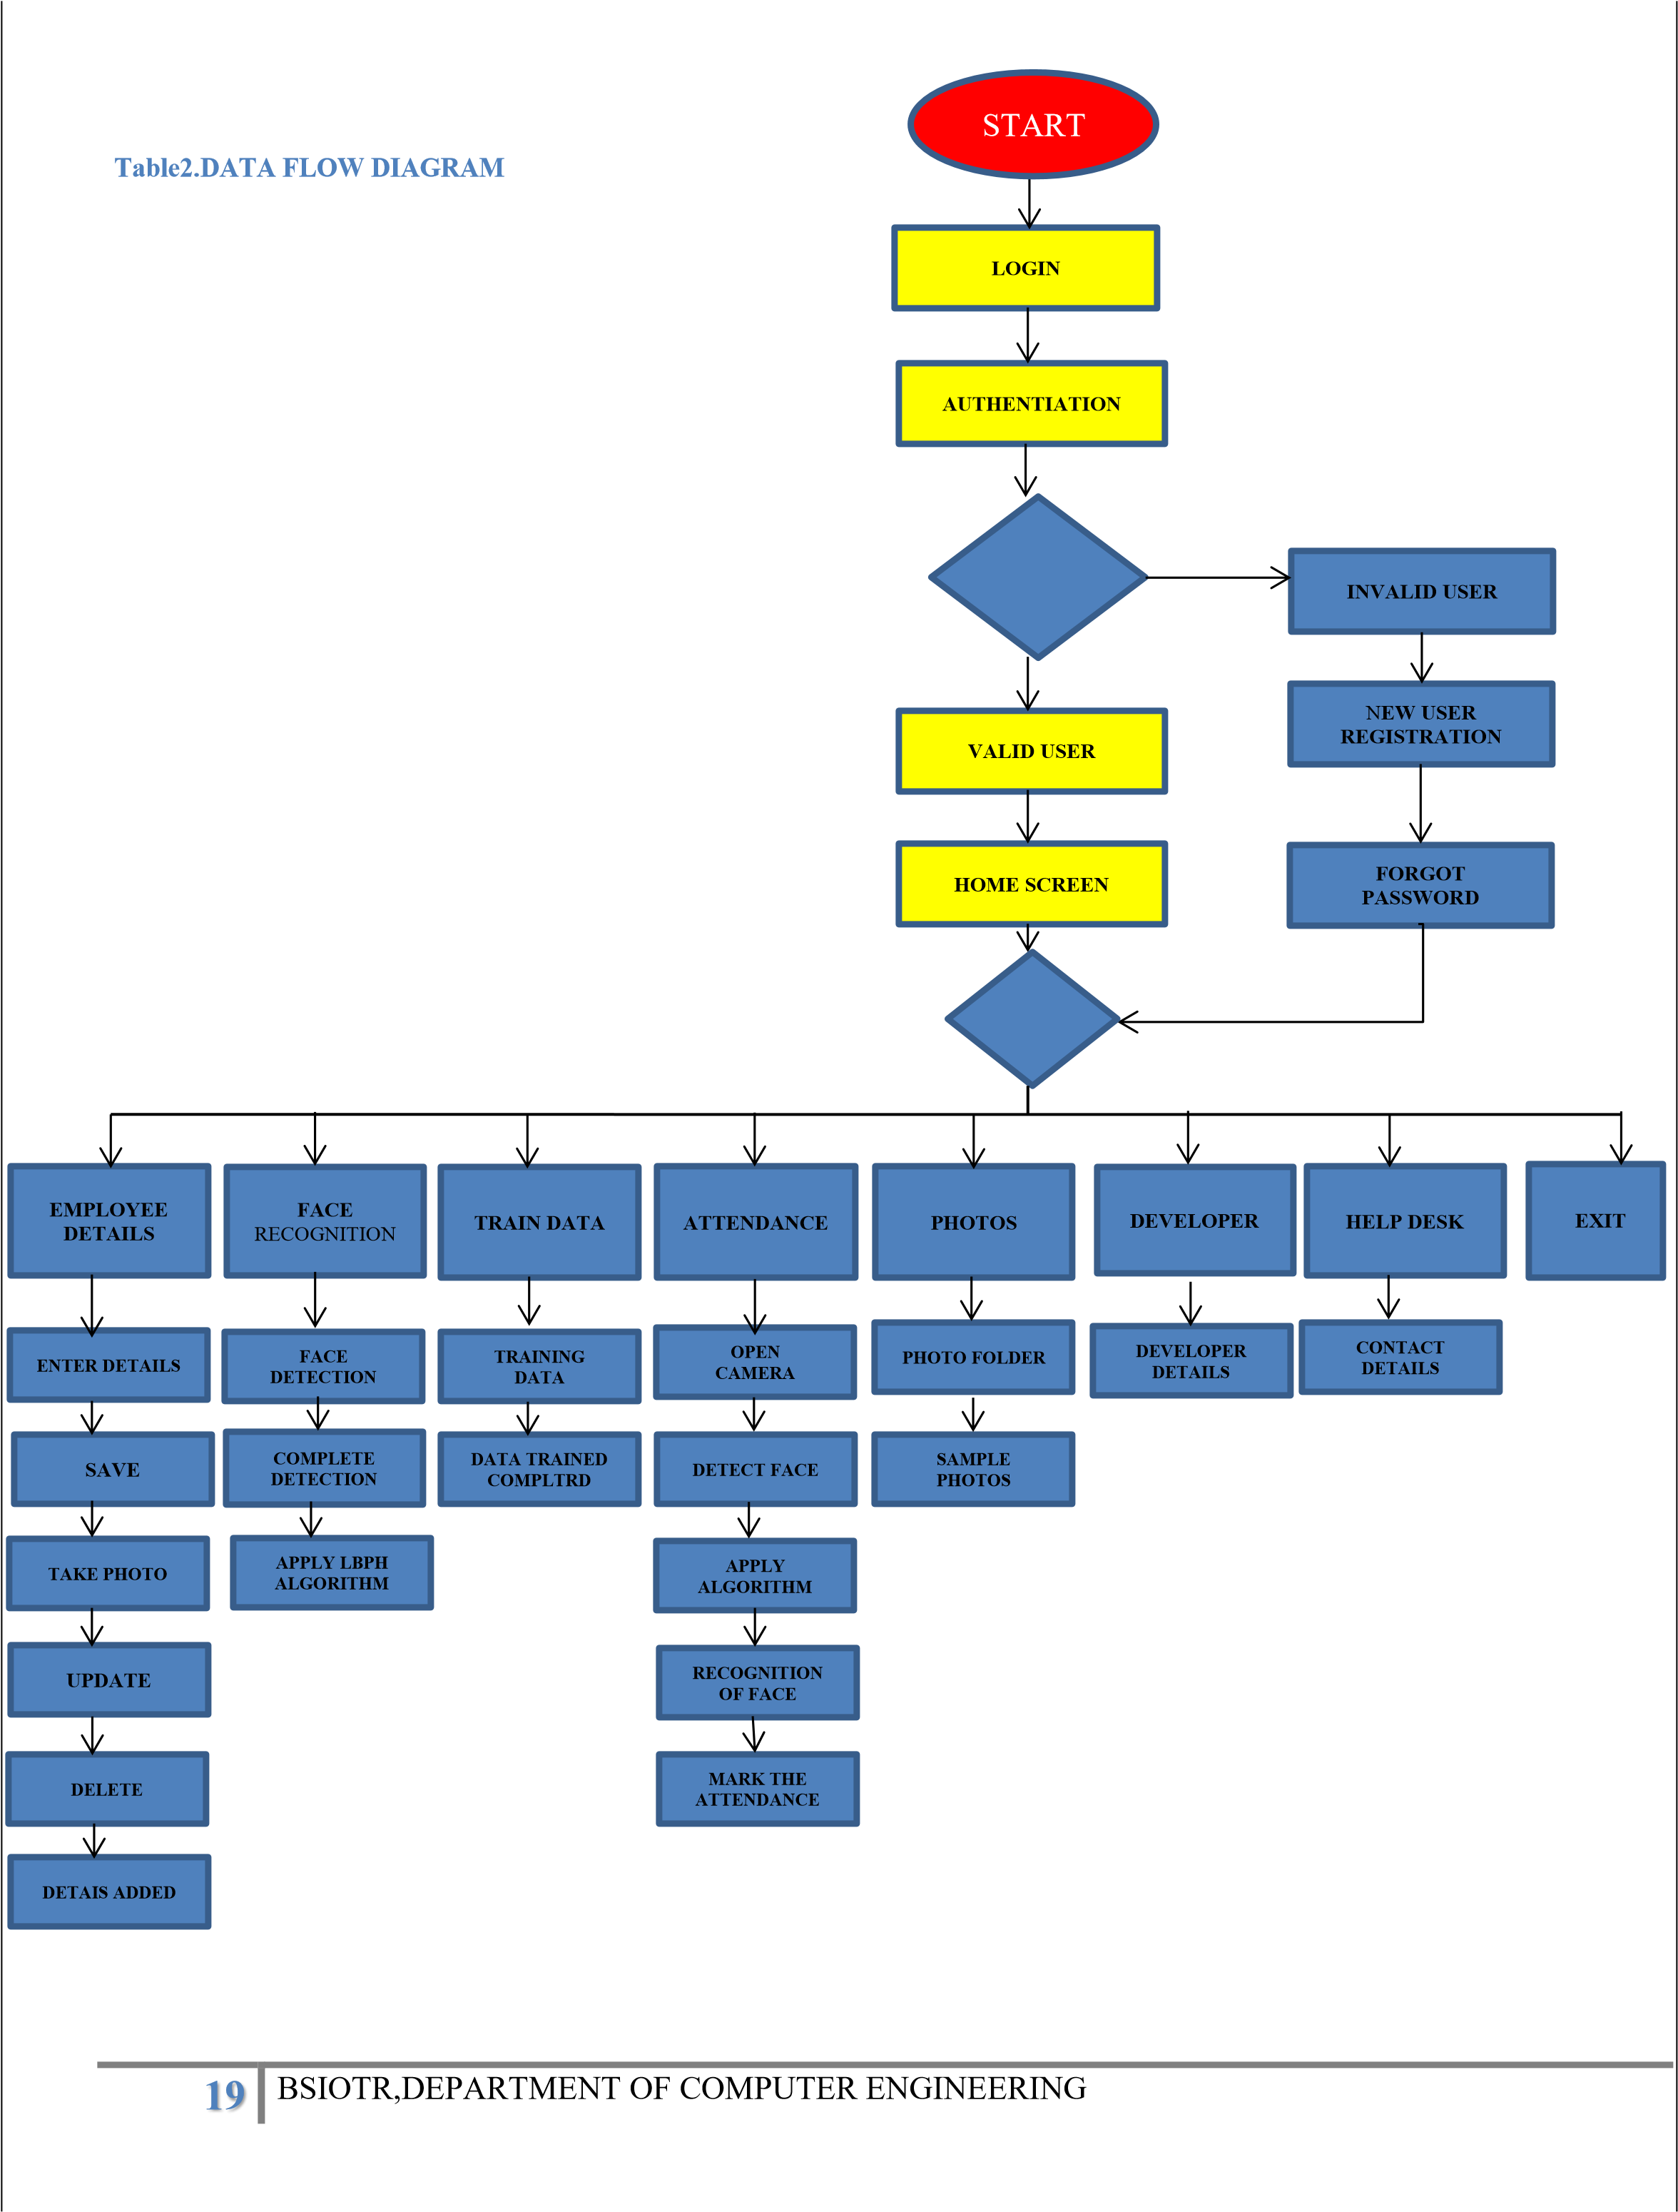

**Chapter-4**

**SYSTEM**

**DESIGN**

4. **HAAR CASCADE ALGORITHM**

The core basis for Haar classifier object detection is the Haar-like features. These features, rather than using the intensity values of a pixel, use the change in contrast values between adjacent rectangular groups of pixels. The contrast variances between the pixel groups are used to determine relative light and dark areas. Two or three adjacent groups with a relative contrast variance form a Haar-like feature. Haar-like features as shown in figure are used to detect an image. Haar features can easily be scaled by increasing or decreasing the size of the pixel group being examined. This allows features to be used to detect objects of various sizes. The cascading of the classifiers allows only the sub-images with the highest probability to be analyzed for all Haar-features that distinguish an object. It also allows one to vary the accuracy of a classifier. One can increase both the false alarm rate and positive hit rate by decreasing the number of stages. The inverse of this is also true. Viola and Jones were able to achieve a 90% accuracy rate for the detection of a human face using only 100 simple features. Detecting human facial features, such as the mouth, eyes, and nose require that Haar classifier cascades first are trained. In order to train the classifiers, this gentle AdaBoost algorithm and Haar feature algorithms must be implemented. Fortunately, Intel developed an open source library devoted to easing the implementation of computer vision related programs called Open Computer Vision Library (OpenCV). The OpenCV library is designed to be used in conjunction with applications that pertain to the field of HCI, robotics, biometrics, image processing, and other areas where visualization is important and includes an implementation of Haar classifier detection and training. Thus with help of this algorithm system will detect the person’s face in the video. Face of the person gets Green Square as an indication of detection process. As soon as the face gets detected user can paused the video and enters the data of detected person such as person’s name, address, profession, criminal record if any. If the detected person has criminal record then it can be defined as suspect. Check box option is given in the system where user can tick whether the person is suspect on not. This is the working of first module in which sample video is browsed and face is detected.

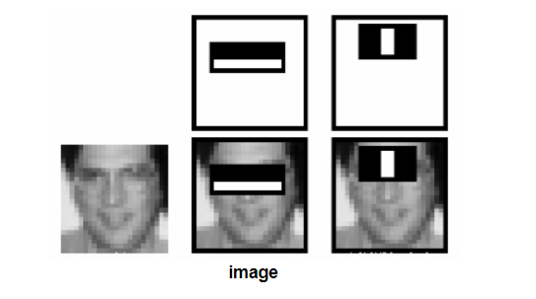

Fig 3. Haar Features

**5. Local Binary Pattern Histogram**(LBPH)**:**

**5.1.Introduction to LBPH algorithm**

**Local Binary Pattern**(LBP) is a simple yet very efficient texture operator which labels the pixels of an image by thresholding the neighborhood of each pixel and considers the result as a binary number.

The first computational step of the LBPH is to create an intermediate image that describes the original image in a better way, by highlighting the facial characteristics. To do so, the algorithm uses a concept of a sliding window, based on the parameters **radius** and **neighbors.**

**5.1 Applying the LBP operation**:

The first computational step of the LBPH is to create an intermediate image that describes the original image in a better way, by highlighting the facial characteristics. To do so, the algorithm uses a concept of a sliding window, based on the parameters **radius** and **neighbors**.

The image below shows this procedure:

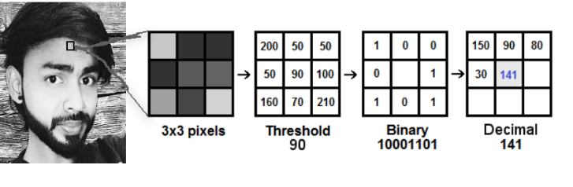

Fig 4. **Applying the LBP operation**

**5.2. Performing the face recognition:**

* In this step, the algorithm is already trained. Each histogram created is used to represent each image from the training dataset. So, given an input image, we perform the steps again for this new image and creates a histogram which represents the image.
* So to find the image that matches the input image we just need to compare two histograms and return the image with the closest histogram.
* We can use various approaches to compare the histograms (calculate the distance between two histograms), for example: Euclideandistance, chi**-**square, absolutevalue, etc. In this example, we can use the Euclidean distance (which is quite known) based on the following formula:

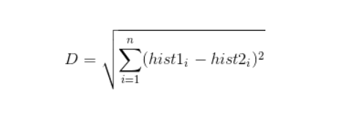

* So the algorithm output is the ID from the image with the closest histogram. The algorithm should also return the calculated distance, which can be used as a ‘**confidence**’ measurement. **Note**: don’t be fooled about the ‘confidence’ name, as lower confidences are better because it means the distance between the two histograms is closer.
* We can then use a threshold and the ‘confidence’ to automatically estimate if the algorithm has correctly recognized the image. We can assume that the algorithm has successfully recognized if the confidence is lower than the threshold defined.

**5.3 TRAINING THE ALGORITHM:**

First, we need to train the algorithm. To do so, we need to use a dataset with the facial images of the people we want to recognize. We need to also set an ID (it may be a number or the name of the person) for each image, so the algorithm will use this information to recognize an input image and give you an output.

Images of the same person must have the same ID. With the training set already constructed, let’s see the LBPH computational steps.

**5.4 APPLYING LBH OPERATIONS**

The first computational step of the LBPH is to create an intermediate image that describes the original image in a better way, by highlighting the facial characteristics. To do so, the algorithm uses a concept of a sliding window, based on the parameters **radius** and **neighbors**.

## IMPORTANT POINTS

* Suppose we have a facial image in grayscale.
* We can get part of this image as a window of 3x3 pixels.
* It can also be represented as a 3x3 matrix containing the intensity of each pixel (0~255).
* Then, we need to take the central value of the matrix to be used as the threshold.
* This value will be used to define the new values from the 8 neighbors.

For each neighbor of the central value (threshold), we set a new binary value. We set 1 for values equal or higher than the threshold and 0 for values lower than the threshold.

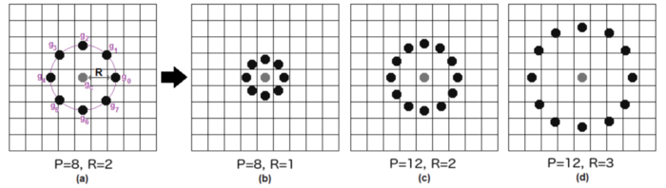

Fig.6 Radius of central pixel

**5.4 EXTRACTING THE HISTOGRAM**

Now, using the image generated in the last step, we can use the **Grid X** and **Grid Y** parameters to divide the image into multiple grids, as can be seen in the following image

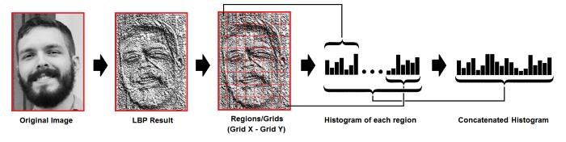

Based on the image above, we can extract the histogram of each region as follows:

* As we have an image in grayscale, each histogram (from each grid) will contain only 256 positions (0~255) representing the occurrences of each pixel intensity.

* Then, we need to concatenate each histogram to create a new and bigger histogram. Supposing we have 8x8 grids, we will have 8x8x256=16.384 positions in the final histogram. The final histogram represents the characteristics of the image original image.

No table of figures entries found.

In this step, the algorithm is already trained. Each histogram created is used to represent each image from the training dataset. So, given an input image, we perform the steps again for this new image and creates a histogram which represents the image.

So to find the image that matches the input image we just need to compare two histograms and return the image with the closest histogram.

We can use various approaches to compare the histograms (calculate the distance between two histograms), for example: **euclidean distance**, **chi-square**, **absolute value**, etc. In this example, we can use the Euclidean distance (which is quite known) based on the following formula:

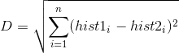

So the algorithm output is the ID from the image with the closest histogram. The algorithm should also return the calculated distance, which can be used as a ‘**confidence**’ measurement. **Note**: don’t be fooled

* ‘confidence’ name, as lower confidences are better because it means the distance between the two histograms is closer.
* We can then use a threshold and the ‘confidence’ to automatically estimate if the algorithm has correctly recognized the image. We can assume that the algorithm has successfully recognized if the confidence is lower than the threshold defined.

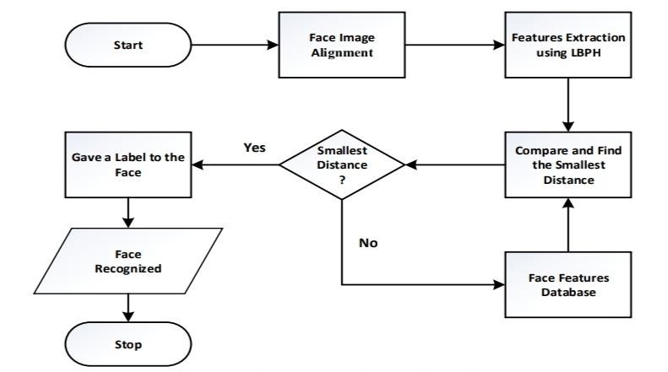

**fig 8. Face alignment and feature extraction**

**Chapter-6**

**OTHER**

**SPECIFICATONS**

**6.OTHER SPECIFICATIONS**

**6.1Advantages:**

1. It is trouble-free to use.
2. It is a relatively fast approach to enter attendance.
3. Is highly reliable, approximate result from user .
4. Best user Interface .
5. Can obtain accuracy upto 85 percent.

**6.2Limitations:**

1. While training there generates nearly 100 of copies of sample image.
2. While dealing with high volume of data system required the powerful processor which is more costly

**6.3Applications:**

1. It is very useful for educational institutes to get attendance easily.

We can get attendance of students as well as teachers without doing conventional attendance

Chapter-7

**CONCLUSION**

**AND**

**FUTURE**

**WORK**

**7.CONCLUSION AND FUTURE WORK**

**Conclusion:**

* The Attendance Management System is developed using Machine Learning meets the objectives of the system which it has been developed. The system has reached a steady state where all bugs have been eliminated. The system is operated at a high level of efficiency. The system solves the problem. It was intended to solve as requirement specification.
* The system can recognize and identify the face well with an accuracy of 85 %, at a face distance 40 cm from the camera with adequate lighting.

**Future Work:**

We have planned to create the application for multiple college campuses and for

the multiple schools.

**8.REFERENCES:**

* + 1. G.Satyanarayana Reddy,Rallabandi Srinivasu,Srikanth Reddy Rikkula,Vuda

Sreenivasa Rao,” Management Information System To Help Managers For Providing Decision Making In An Organization”, International Journal of Reviews in Computing.

* + 1. Learning OpenCV –Computer Vision with the OpenCV Library O’Reilly Publication
    2. [**http://www.wordpress.org/**](http://www.wordpress.org/)
    3. [**http://www.academia.edu/**](http://www.academia.edu/)
    4. [**http://www.stackoverflow.com/**](http://www.stackoverflow.com/)
    5. [**http://www.iproject.com**](http://www.iproject.com/)

**Paper Published:**