Machine Learning in Cyber
  - Section 1 Email Security and Phishing Detection
Module | COMP70049
Assessment | Machine Learning in Cyber Assignment
Student name | ____________________________
Student ID | ____________________________
Submission date | ____________________________

Report scope. This report evaluates a classical Logistic Regression pipeline and a neural LSTM pipeline for classifying the SpamAssassin corpus. It explains the dataset, preprocessing, models, performance, visual evidence, cybersecurity implications and future improvements.
Main finding. At the selected operating thresholds, Logistic Regression provides the stronger balance between detecting spam and limiting false alerts. The dataset contains spam and ham labels, so the result must not be presented as direct evidence of phishing-detection performance.

Contents
1 Cover page 1
2 Contents 2
3 Section 1 Email Security and Phishing Detection 3
3.1 Description of datasets used 3
3.2 Explanation of preprocessing techniques 4
3.3 Overview of implemented ML and deep learning models 5
3.4 Performance comparison of models 6
3.5 Visualizations 7
3.6 Discussion on findings and cybersecurity implications 9
3.7 Summary of key takeaways and potential improvements 10

3. Section-1 Email Security and Phishing Detection
This experiment compares two ways of classifying emails text. It uses the same stratified training, validation, and test split to have fair comparison. Firstly, the TF-IDF method used to represent important words and Logistic Regression to classify the emails. The second method uses learned word embeddings and an LSTM to identify patterns in the text. For each model, the decision threshold is selected from the validation results so only 1% of genuine emails will be incorrectly flagged as spam.

3.1 Description of datasets used
In section 1 two parts of the public Apache SpamAssassin dataset have been used. Those are the easy-ham archive and the spam archive. The original dataset has 3,000 email files. After the emails were parsed, normalized, checked for quality assurance, and removed when normalization revealed duplicates, 2,947 messages had remained. These included 2,471 legitimate emails, known as ham, and 476 spam emails. Therefore, the classes are distributed unevenly, because only 16.2% of the final dataset represents spam. [1] [2]

The shared stratified split contains 2,062 training messages, 442 validation messages and 443 test messages. The test partition contains 371 ham and 72 spam messages. Archive hashes, an extracted-file manifest hash and split membership are stored with the experiment outputs to make the fresh run auditable. [3]
A crucial limitation is the target label. The corpus distinguishes spam from ham; it does not verify whether each message is a phishing attempt. The experiment is relevant to email security, but its results should be reported as spam classification rather than direct phishing-detection performance.

3.2 Explanation of preprocessing techniques
Each email is read with the Python standard email parser. Attachments are excluded, the subject is combined with one preferred message body, and plain text is selected before falling back to HTML. When HTML is used, visible text is extracted with an HTML parser instead of deleting tags with a regular expression. The quality profile records 211 HTML fallbacks, three unknown-character-set fallbacks, one message without a text body and 3,701 decoding replacement characters. [4]
Normalization converts text to lowercase, replaces URLs and email addresses with the stable markers urltoken and emailtoken, extracts Unicode word tokens and applies English Snowball stemming. For the TF-IDF branch, a stemmed list of 297 English stopwords is removed while no, nor and not are protected because negation can change meaning. The LSTM branch keeps stopwords so that word order and local context remain available.
Normalized representations are deduplicated before splitting. No empty normalized messages or conflicting labels were found, and the overlap check reports zero exact normalized-text matches between every pair of train, validation and test partitions. This reduces direct representation leakage, although it cannot remove every near-duplicate campaign or shared template. [4] [5]
All fitted preprocessing is learned from training data. The TF-IDF vocabulary and document frequencies are not estimated from validation or test messages, and the LSTM vocabulary is also built from the training partition only. This separation protects the final evaluation from information that would not be available during model fitting.

3.3 Overview of implemented ML and deep learning models
Logistic Regression is the classical model. Its input is a TF-IDF matrix containing unigrams and bigrams. The vocabulary is capped at 20,000 features, ignores terms seen in fewer than two documents or more than 98 percent of documents, and uses sublinear term frequency. Balanced class weights increase the influence of the smaller spam class, and the optimizer is allowed up to 1,000 iterations. Validation scores select threshold 0.5463 by maximizing F1 among thresholds with a validation false-positive rate no greater than one percent. [2] [6]
The deep learning model uses a training-only vocabulary with padding and unknown tokens. Every message is truncated or padded to 300 tokens. Learned 128-dimensional embeddings feed a 128-unit LSTM, followed by dropout of 0.3 and a single output logit. Weighted binary cross-entropy addresses the class imbalance, and AdamW trains the model on the CPU for six epochs. The checkpoint with the lowest validation loss is restored, and validation scores select threshold 0.9772 under the same false-alert constraint. [2] [7] [8]
The models represent text differently. TF-IDF emphasizes discriminative words and adjacent word pairs but cannot model long message order. The LSTM learns embeddings and ordered context, but the available corpus may be too small to justify its greater capacity. The selected thresholds are operating points rather than calibrated deployment probabilities.

3.4 Performance comparison of models
The fresh test results favour Logistic Regression. It reaches F1 0.9504, compared with 0.7797 for the LSTM, and retains much more spam recall while producing only two false alerts. The LSTM achieves perfect observed precision because it produces no false positives, but it detects only 46 of 72 spam messages and misses 26. [6] [7]
Model | Accuracy | Precision | Recall | F1 | ROC AUC | Average precision
Logistic Regression | 0.9842 | 0.9710 | 0.9306 | 0.9504 | 0.9996 | 0.9977
LSTM | 0.9413 | 1.0000 | 0.6389 | 0.7797 | 0.9728 | 0.9444

Test confusion-matrix counts
Model | True negatives | False positives | False negatives | True positives
Logistic Regression | 369 | 2 | 5 | 67
LSTM | 371 | 0 | 26 | 46

Ranking metrics lead to the same overall conclusion. Logistic Regression obtains ROC AUC 0.9996 and average precision 0.9977, compared with 0.9728 and 0.9444 for the LSTM. The LSTM training loss continues to fall after epoch three while validation loss rises before partially recovering. Restoring the epoch-three checkpoint is therefore justified and suggests that later training increasingly fits the training sample rather than improving generalization. [6] [7] [8]

3.5 Visualizations
The figures below show the class and message-length distributions, test confusion matrices, ROC and precision-recall curves, and the LSTM learning history. Together they reveal both ranking quality and the operational effect of the selected thresholds.
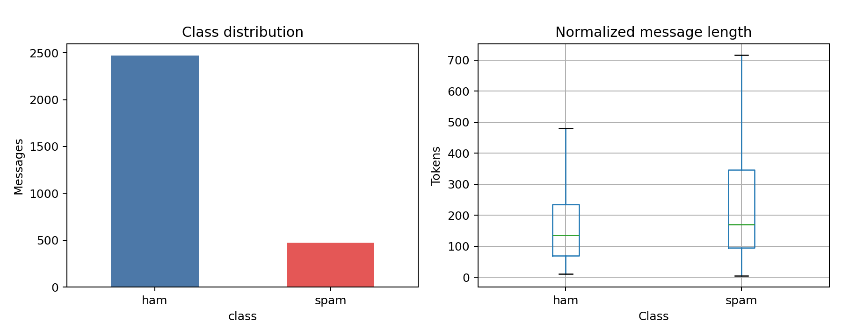
Figure 1. Class balance and normalized message-length distributions for the retained email corpus.
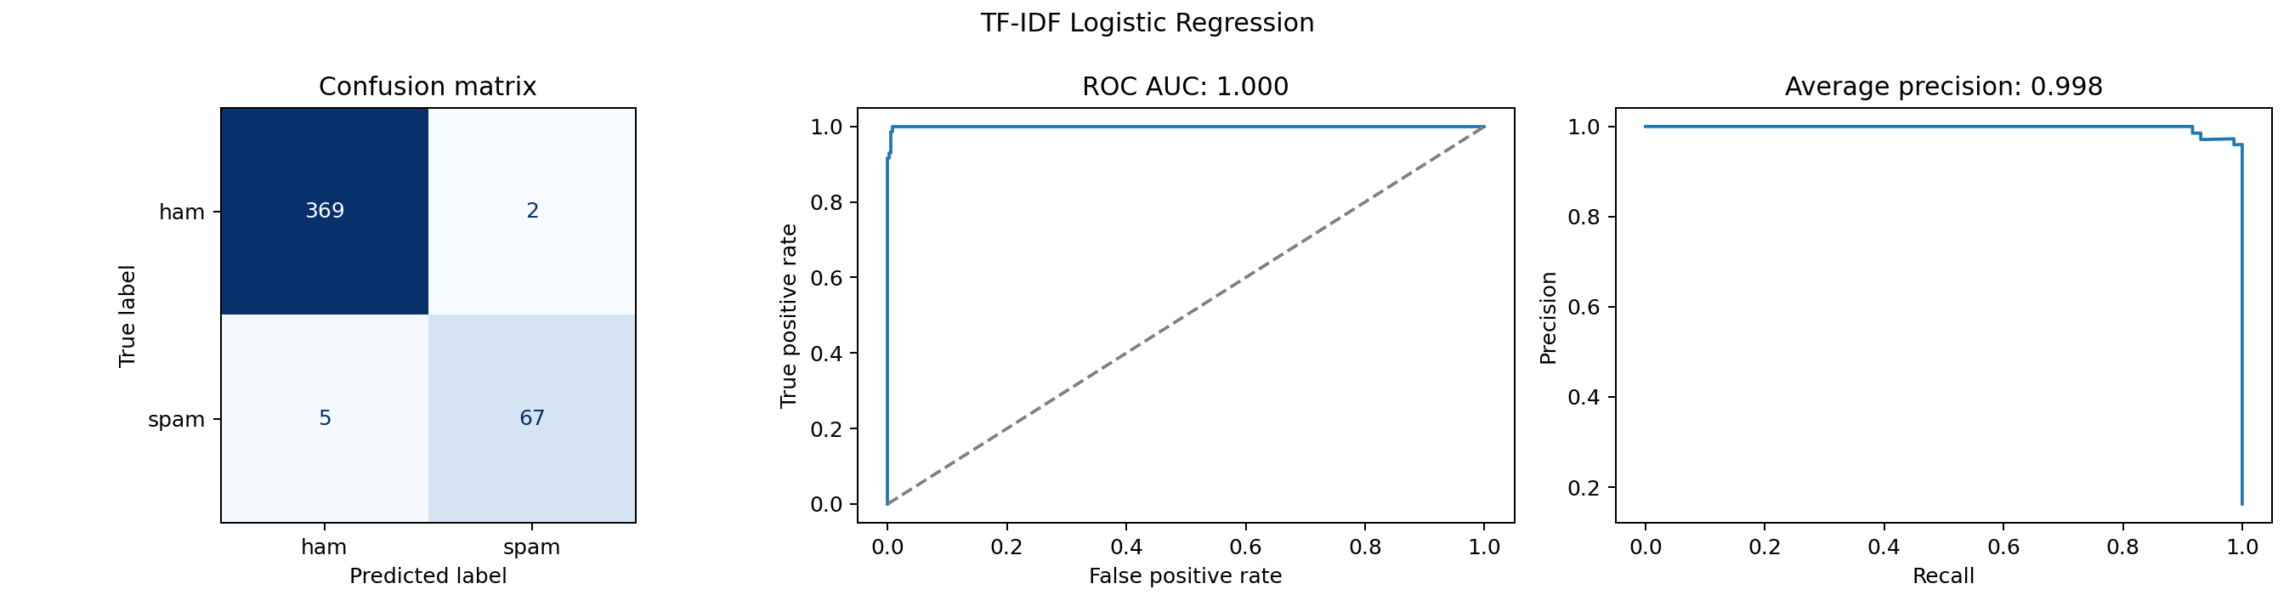
Figure 2. Logistic Regression confusion matrix, ROC curve and precision-recall curve on the test set.
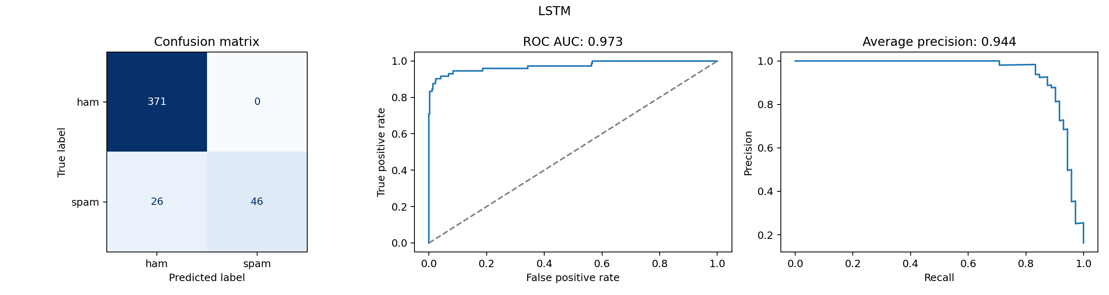
Figure 3. LSTM confusion matrix, ROC curve and precision-recall curve on the test set.
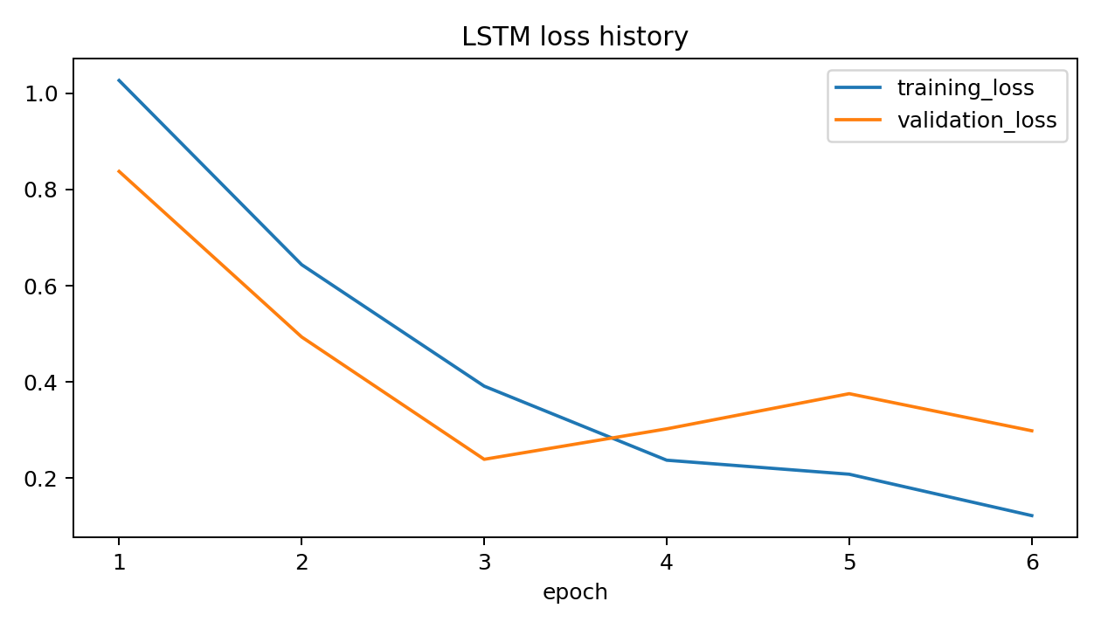
Figure 4. LSTM training and validation loss across six epochs.

3.6 Discussion on findings and cybersecurity implications
The comparison shows that the more complex neural architecture is not automatically the better security model. For this corpus and operating policy, the sparse linear representation separates the classes more effectively and provides a stronger balance between legitimate-email protection and spam detection. This is operationally important because false positives can hide or delay legitimate communication, while false negatives allow malicious or unwanted messages to reach users.
The LSTM's perfect observed precision must be interpreted with its low recall. It avoids false alerts by using a high threshold, but misses more than one third of the spam messages in the test set. A security team should therefore inspect precision, recall, confusion counts and threshold policy together instead of relying on accuracy or one headline metric.
The experiment also has limits that prevent deployment claims. The corpus is historical, the positive class is spam rather than verified phishing, and related campaigns may share templates even after exact normalized duplicates are removed. URL and email replacement can improve generalization but also removes identities and structures that may be useful indicators. Neither model has been evaluated against recent phishing techniques, adversarial wording, multilingual messages or a live organization's acceptable false-alert workload.

3.7 Summary of key takeaways and potential improvements
- Logistic Regression is the stronger model in the fresh run, with F1 0.9504 and only two false positives.
- The LSTM ranks messages well but its selected threshold sacrifices recall, missing 26 of 72 test spam messages.
- Training-only fitting and zero exact normalized-text overlap strengthen the evaluation design.
- The corpus supports spam classification claims, not direct claims about phishing detection or prevention.
- A focused error analysis should inspect the Logistic Regression false positives and false negatives and the LSTM false negatives using redacted examples.
- Future evaluation should use recent and independently labelled phishing data, grouped or time-based splits, repeated seeds and uncertainty intervals.
- Thresholds should be selected against an explicit operational false-positive budget, followed by an untouched final evaluation set.
- Further improvements could compare calibrated probabilities, stronger linear baselines, pretrained language models and ablations of stemming, stopwords, token replacement and sequence length.
Overall, the experiment demonstrates a clear and reproducible email text-classification workflow. Its strongest result is the classical TF-IDF and Logistic Regression pipeline, but the evidence remains an educational benchmark rather than proof of a production phishing-defence system.

Evidence sources
- [1] SpamAssassin corpus record
- [2] Section 1 notebook
- [3] Fresh run summary
- [4] Text quality profile
- [5] Representation overlap checks
- [6] Logistic Regression metrics
- [7] LSTM metrics
- [8] LSTM training history

4. Section 2 - Cyber Attack Detection

4.1 Description of datasets used
This experiment uses NSL-KDD, a well known benchmark dataset commonly used to study network intrusion detection. Each record represents 41 connection input features. From these, 38 are numerical fields and 3 are categorical fields which describe the protocol type network service and connection flag. The attack names are grouped into five classes. Those are normal traffic, denial of service (DoS), probing attacks, remote to local (R2L) and user to root attacks (U2R). The difficulty field and attack name are not used as predictors.
The official NSL-KDD training file has 125,973 records. A stratified 15% split provides 107,077 training records and 18,896 validation records, while the official 22,544-record test file is remains unchanged for final evaluation. The training partition is highly imbalanced. It contains 57,241 normal connections, 39,038 DoS attacks, 9,908 probe attacks, 846 R2L and only 44 U2R attacks. The saved data does not provide any missing values or complete duplicates records within any individual partitions. NSL-KDD is an older benchmark, so its traffic and attack patterns do not fully reflects the complexity of modern networks.

4.2 Explanation of preprocessing techniques
The numerical features are standardized so that variables with larger values do not unfairly dominate those measured on smaller scales. The protocol type, network service, and connection flag are converted into numerical columns using one hot encoding. If a category appears in the validation or test data but was not present during training, it is handled safely rather than causing the pipeline to fail. No missing value imputation is performed because the saved data profile confirms that none of the selected features contain missing values.
First, a variance filter removes any feature that has the same value across all training records, since a feature that never changes cannot help distinguishing between classes. ANOVA F-value selection is then used to retain the 64 features that show the strongest individual relationships with the five traffic classes. Every stage of this preprocessing process is fitted using the training partition only. The same fitted transformations and selected features are then applied to the validation and test data without modification, helping to prevent data leakage. However, using one shared set of 64 features may also remove combinations of weaker individual features that a Random Forest could potentially use together to identify more complex attack patterns.

4.3 Overview of implemented ML and deep learning models
The selected classical model is a Random Forest with 180 trees, maximum depth 28 and in each split, the model considers only the square root of the available features. This balanced the variation between the trees and supports to reduce the similarity. Balanced subsample weighting recalculates the class weights within every bootstrap sample, giving rare attack classes more influence during training. This is especially important for classes such as R2L and U2R, which have very few examples. The trained forest is saved together with its preprocessing pipeline, ensuring that any new network connection is transformed in exactly the same way before a prediction is made.

The selected deep learning model is a one dimensional CNN with convolutional layers of 32 and 64 channels, batch normalization, ReLU activation, adaptive maximum pooling, dropout of 0.3 and a five class output layer. Square root inverse frequency weights give rare attack categories more influence in the cross entropy loss. The Adam optimizer trains the model on the CPU for eight epochs, and the checkpoint with the highest validation macro F1 is restored. The best recorded validation macro F1 is 0.8097, reached at epoch six. The feature order is tabular rather than spatial or temporal, therefore CNN should be viewed as a neural network comparison, not as a model that learns directly from ordered network packets.

4.4 Performance comparison of models
The CNN leads the Random Forest on every reported aggregate test metric. Its macro F1 is 0.6036 compared with 0.4844 in random forest, while weighted F1 rises from 0.6955 to 0.7469 when moving from random forest to 1D-CNN. Macro measures are especially important here because they give the rare R2L and U2R classes equal influence instead of allowing normal and DoS records to dominate the result.
Model | Accuracy | Macro precision | Macro recall | Macro F1 | Weighted F1 | Macro AP
Random Forest | 0.7377 | 0.7850 | 0.4738 | 0.4844 | 0.6955 | 0.6813
1D CNN | 0.7644 | 0.8310 | 0.5784 | 0.6036 | 0.7469 | 0.6960

The class-level recall values show where the improvement occurs. The CNN detects substantially more probe, R2L and U2R records, but it performs a little worse on normal and DoS traffic. Rare-class recall remains low despite class weighting, particularly for U2R.
Class | Random Forest recall | 1D CNN recall
Normal | 0.9745 | 0.9229
DoS | 0.7591 | 0.7167
Probe | 0.5762 | 0.8794
R2L | 0.0392 | 0.2829
U2R | 0.0200 | 0.0900

4.5 Visualizations
The confusion matrices show exact class errors, the stronger classifications done by the random forest for normal and dos, and the improvements the CNN made over the rarer classes are clearly visible in it.
The precision-recall curves show how precision changes as recall increases for each class.
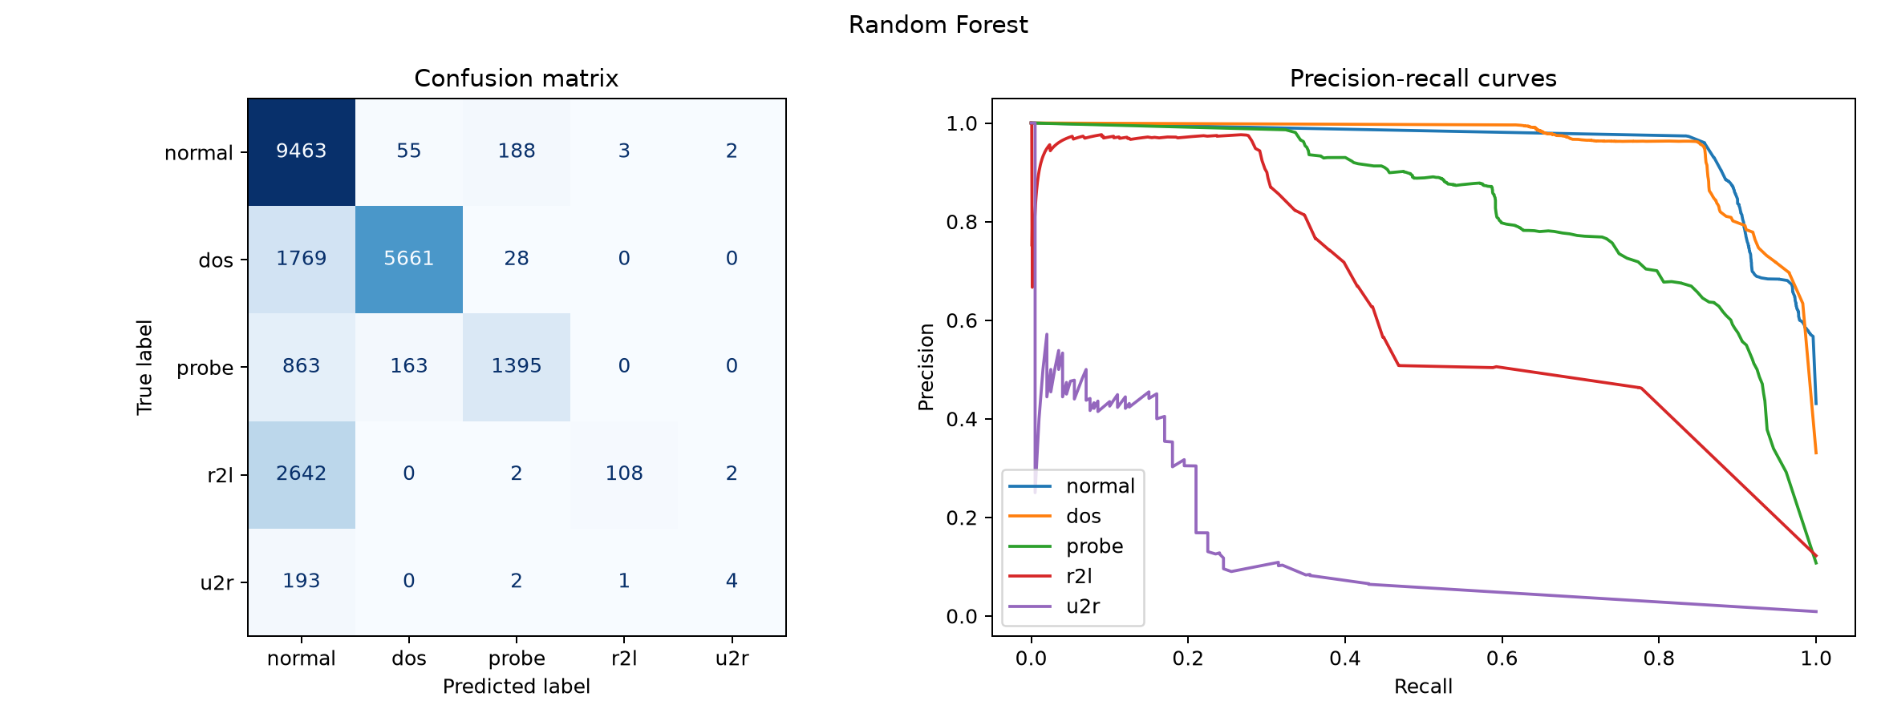
Figure 5. Random Forest confusion matrix and class-wise precision-recall curves.
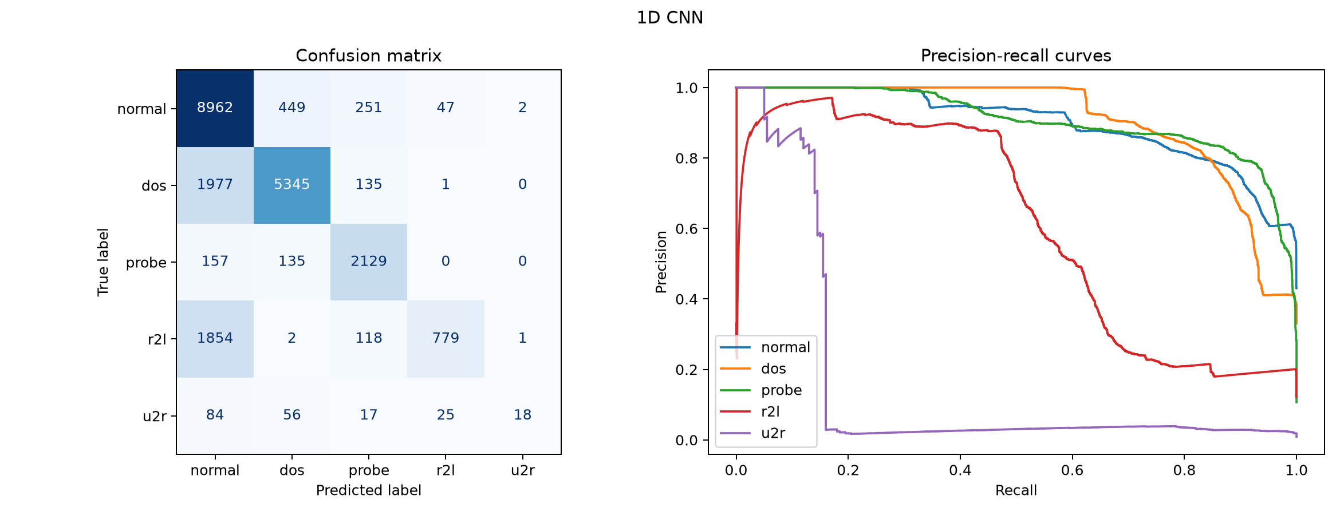
Figure 6. CNN confusion matrix and class-wise precision-recall curves.
The CNN history shows falling training loss and a validation macro-F1 peak at epoch six, which supports restoring that checkpoint rather than using the final epoch automatically.
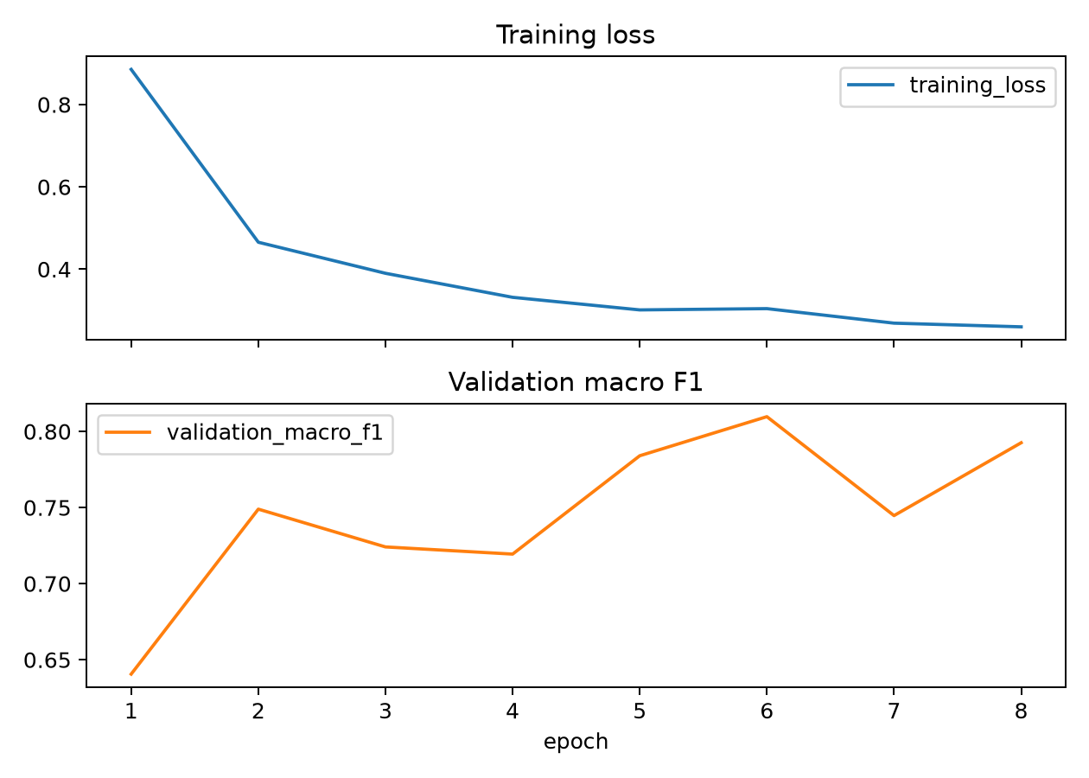
Figure 7. CNN training loss and validation macro F1 across eight epochs.

4.6 Discussion on findings and cybersecurity implications
The CNN provides the stronger overall result, but the confusion matrix prevents that conclusion from becoming a deployment claim. It correctly identifies 779 of 2,754 R2L records and 18 of 200 U2R records, compared with 108 and four for the forest. However, it still assigns 1,854 R2L and 84 U2R connections to the normal class. These are security-relevant misses because they may avoid investigation entirely.
The gain also increases benign misclassification. The CNN assigns 749 normal test records to an attack family, compared with 248 for the forest. In practice, this can create additional analyst work even while attack detection improves. The appropriate choice therefore depends on the cost of missed attacks, the cost of false alerts and whether family-level labels are needed. NSL-KDD's age and distribution shift between its official partitions further limit claims about current enterprise traffic.

4.7 Summary of key takeaways and potential improvements
The eight-epoch CNN is the better model in this recorded comparison because it improves accuracy, macro recall, macro F1 and average precision. The main weakness is still rare-attack coverage, especially U2R, and the stronger aggregate result comes with more benign records assigned to attack classes. The experiment therefore demonstrates a useful comparison, not a production-ready intrusion detector.
- Evaluate on newer and independently collected network traffic.
- Repeat training with several seeds and report uncertainty, not only one run.
- Compare training-only resampling, calibrated class weights and class-specific error costs.
- Test models designed for tabular data instead of assuming neighbouring features have spatial meaning.
- Measure binary attack-versus-normal performance, calibration, inference time and analyst alert load.

