Machine Learning in Cyber
  - Section 3 Anomaly Detection for Cyber Threats
Module | COMP70049
Assessment | Machine Learning in Cyber Assignment
Student name | ____________________________
Student ID | ____________________________
Submission date | ____________________________

Report scope. This report evaluates a classical Isolation Forest and a denoising Autoencoder for detecting anomalous network flows in the UNSW-NB15 dataset. It explains the dataset, preprocessing, model design, results, visual evidence, cybersecurity implications, and future improvements.
Main finding. The denoising Autoencoder is the stronger model. It detects 70.9% of attacks with a 14.2% false-positive rate and achieves ROC AUC 0.876. Both models exceed the required 50% attack-detection rate, but neither is ready for production deployment.

Contents
03. Section 3 Anomaly Detection for Cyber Threats 3
3.1 Description of datasets used 3
3.2 Explanation of preprocessing techniques 4
3.3 Overview of implemented ML and deep learning models 5
3.4 Performance comparison of models 6
3.5 Visualizations 7
3.6 Discussion on findings and cybersecurity implications 9
3.7 Summary of key takeaways and potential improvements 10

3. Section 3 - Anomaly Detection for Cyber Threats
This experiment tests whether models trained only on normal network behaviour can identify unusual traffic that may represent a cyberattack. A classical Isolation Forest is compared with a denoising Autoencoder. Attack labels are not used while either model learns its parameters; they are used only to select an operating threshold on validation data and to measure final test performance.

3.1 Description of datasets used
The experiment uses UNSW-NB15, a labelled network-flow benchmark containing normal traffic and nine attack families: Analysis, Backdoor, denial of service (DoS), Exploits, Fuzzers, Generic, Reconnaissance, Shellcode, and Worms. Each record describes a network flow using numerical traffic measurements and categorical protocol, service, and connection-state fields. The published development and test CSV files contain 175,341 and 82,332 records respectively, with 45 columns in each file. [1]
Exact duplicate feature rows were removed without using row identifiers. This removed 74,301 development records and 28,386 test records. A further 1,302 test rows were removed because the same feature representation appeared in the development data. The cleaned development and test partitions therefore contain 101,040 and 52,644 records. No missing values remained in the saved data-quality profile. [2] [3]
The final design uses 15,000 benign records for model training. Validation contains 24,000 records, balanced between 12,000 benign flows and 12,000 attacks. The cleaned official test partition is kept for final evaluation and contains 33,662 benign flows and 18,982 attacks. This split supports a realistic novelty-detection question while preserving an untouched test set. The benchmark was created in a controlled environment, so its results should not be treated as proof of performance on a current enterprise network.

3.2 Explanation of preprocessing techniques
The label, attack category, and row identifier are excluded from the predictors. Numerical variables are median-imputed as a safety step, transformed using a signed log1p function to reduce the influence of very large values, and robustly scaled using training medians and interquartile ranges. This scaling is less sensitive to extreme traffic values than ordinary mean and standard-deviation scaling.
The protocol, service, and connection-state fields are converted to one-hot encoded columns. Unknown categories are ignored safely when validation or test records contain a value not seen during fitting. Transformed columns with zero variance in benign training data are removed because they cannot help a model distinguish normal behaviour from an anomaly. The final representation contains 58 features. [2] [3]
Every imputation value, transformation, scale estimate, category vocabulary, and variance decision is learned from the 15,000 benign training records only. Validation and test records are transformed with the already fitted pipeline. This prevents information from the evaluation data leaking into model training.
For the Autoencoder, small random noise is added only to the model input during training while the target remains the clean benign vector. The reconstruction error for each feature is later divided by its typical benign error before errors are combined into one anomaly score. This prevents naturally difficult fields from dominating the score simply because they have larger reconstruction errors.
For both models, a higher score means that a flow appears more unusual. The threshold is selected using the validation set: among operating points that detect at least 60% of validation attacks, the method chooses the point with the lowest false-positive rate. The official test data are not used to select this threshold. [4] [5]

3.3 Overview of implemented ML and deep learning models
Isolation Forest is the traditional machine-learning model. It builds randomized decision trees that repeatedly split the feature space. Unusual records normally require fewer splits to isolate, so they receive higher anomaly scores. Six combinations of training sample size and feature proportion were compared on validation data using average precision, with ROC AUC as a secondary measure. The selected model uses 300 trees, all 15,000 benign training records, and all 58 transformed features. [2] [4]
The deep-learning model is a denoising Autoencoder. Its hidden layers reduce the 58-feature input through wider internal layers to a 16-value bottleneck and then reconstruct the original vector. The network uses layer normalization, ReLU activation, dropout, AdamW optimization, gradient clipping, and Smooth L1 reconstruction loss. It is trained on the CPU for 30 epochs, and the checkpoint with the lowest benign validation loss is retained. [2] [5] [7]
The two approaches learn normality in different ways. Isolation Forest finds regions that are easy to isolate with random partitions. The Autoencoder learns nonlinear relationships among benign features and flags flows that it cannot reconstruct accurately. Neither model learns named attack classes, so the output is an anomaly score rather than a prediction of a specific attack family.
Labels are used after model fitting to choose a useful threshold. This is a semi-supervised model-selection step, not supervised parameter training. It makes the operational goal explicit: detect at least 60% of validation attacks while producing as few benign alerts as possible. The same fixed threshold is then applied once to the cleaned official test partition.

3.4 Performance comparison of models
The denoising Autoencoder performs better on every reported test metric. It detects 70.9% of attacks, compared with 61.5% for Isolation Forest, while also reducing the false-positive rate from 20.6% to 14.2%. Its ROC AUC of 0.876 and average precision of 0.796 show that it also ranks attack flows above benign flows more reliably across possible thresholds. [4] [5]
Model | Accuracy | Attack recall | FPR | Precision | F1 | Average precision | ROC AUC
Isolation Forest | 0.729 | 0.615 | 0.206 | 0.627 | 0.621 | 0.672 | 0.763
Denoising Autoencoder | 0.805 | 0.709 | 0.142 | 0.739 | 0.724 | 0.796 | 0.876

Model | True negatives | False positives | False negatives | True positives
Isolation Forest | 26,723 | 6,939 | 7,316 | 11,666
Denoising Autoencoder | 28,896 | 4,766 | 5,517 | 13,465
Both models meet the specified requirement to categorize at least half of attacks as attacks. The Autoencoder identifies 1,799 more attacks and produces 2,173 fewer false alerts than Isolation Forest on the same test set. Performance is not uniform across attack families: the Autoencoder is strong on Analysis, Generic, Exploits, Worms, and DoS, but weaker on Fuzzers, Reconnaissance, and Shellcode. [6]
Attack family | Isolation Forest recall | Autoencoder recall
Analysis | 0.820 | 1.000
Generic | 0.946 | 0.949
Exploits | 0.744 | 0.859
DoS | 0.668 | 0.777
Fuzzers | 0.282 | 0.463
Reconnaissance | 0.321 | 0.357
Shellcode | 0.442 | 0.198

3.5 Visualizations
The evaluation figures combine the confusion matrix, ROC curve, precision-recall curve, and anomaly-score distribution for each model. They show both the exact effect of the selected threshold and the models' ranking quality across other possible thresholds.
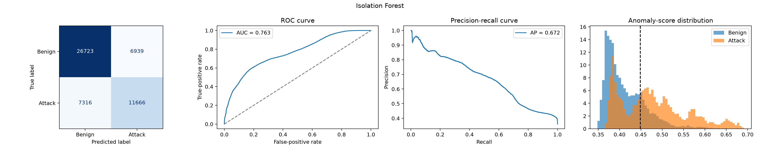
Figure 1. Isolation Forest confusion matrix, ROC curve, precision-recall curve, and anomaly-score distribution on the test set.
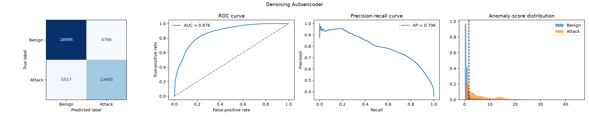
Figure 2. Denoising Autoencoder confusion matrix, ROC curve, precision-recall curve, and anomaly-score distribution on the test set.
The Autoencoder curves are consistently stronger. Its attack and benign score distributions also show clearer separation, which explains why it obtains higher attack recall while generating fewer false positives at the chosen operating point.

The learning history below shows a steady reduction in both training loss and benign validation loss. The best benign validation loss is 0.001345 at epoch 30, so the final checkpoint is retained. There is no late rise in validation loss in this run, although repeated runs are still needed before concluding that the model is stable. [7]
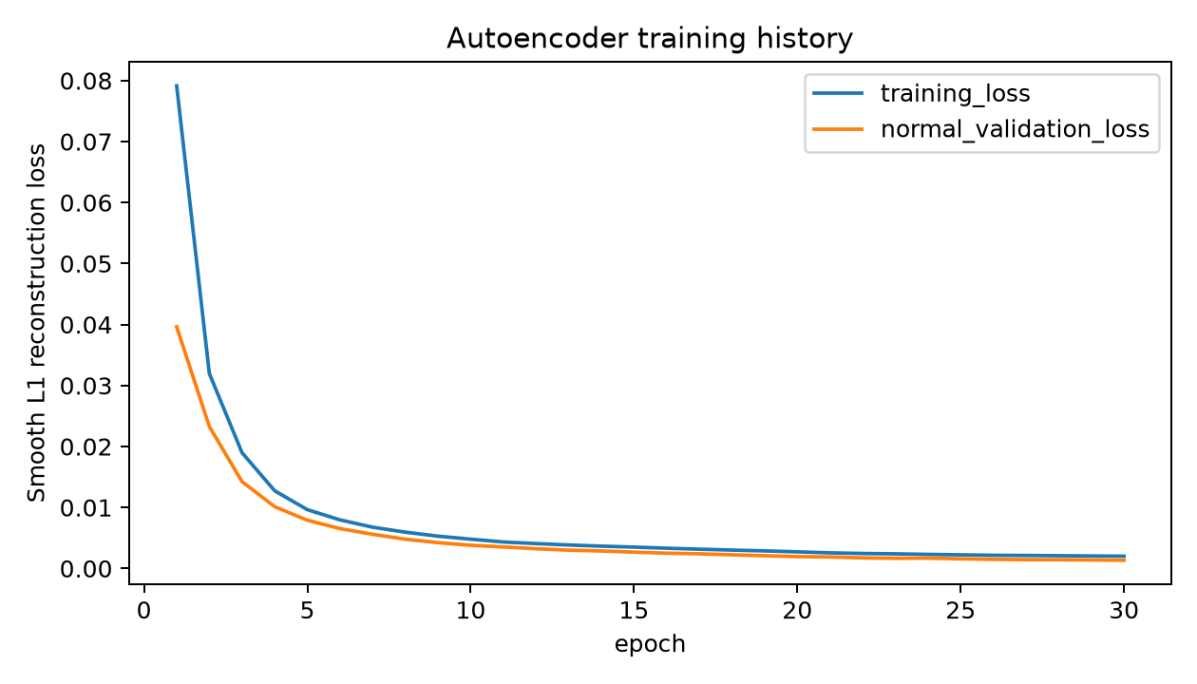
Figure 3. Autoencoder training loss and benign validation loss across 30 epochs.
A falling reconstruction loss does not by itself prove good attack detection because the Autoencoder is trained only to represent benign traffic. The separate ROC, precision-recall, recall, and false-positive results are therefore needed to judge whether the learned representation is useful for cybersecurity monitoring.

3.6 Discussion on findings and cybersecurity implications
The results show that both benign-only models learn useful anomaly scores, but the Autoencoder provides the stronger operational balance. Its nonlinear reconstruction boundary appears better suited to relationships among mixed network-flow features than random isolation. Denoising and per-feature error normalization also reduce simple copying and stop a few difficult fields from dominating the final score.
The selected threshold is deliberately recall-focused. Detecting 70.9% of attacks is useful, but a 14.2% false-positive rate would still create a large alert volume on a busy network. Isolation Forest is less suitable at its chosen threshold because it misses more attacks and flags more benign flows. A deployment threshold should therefore be selected using the organization's cost of missed incidents, available analyst capacity, and acceptable alert rate rather than one universal metric.
Overall recall also hides important weaknesses. The Autoencoder detects nearly all Generic attacks and all Analysis records in this test set, but only 46.3% of Fuzzers, 35.7% of Reconnaissance, and 19.8% of Shellcode records. These categories may resemble normal activity in the selected representation or may be poorly represented by a single global threshold. Analysts should review family-level errors and not assume that a good aggregate ROC AUC protects equally against every threat.
UNSW-NB15 is a benchmark rather than live organizational traffic. Removing exact duplicate and cross-split feature rows reduces direct leakage, but it cannot remove every related flow or experiment-specific pattern. Traffic behaviour, services, and attacker methods also change over time. The current results are therefore evidence of an educational anomaly-detection workflow, not proof that the models can prevent attacks or operate safely without human review.

3.7 Summary of key takeaways and potential improvements
- Both models exceed the required 50% attack recall: Isolation Forest reaches 61.5% and the Autoencoder reaches 70.9%.
- The denoising Autoencoder is the stronger model, with higher accuracy, precision, F1, average precision, and ROC AUC, plus a lower false-positive rate.
- Training uses benign records only; attack labels are used for validation threshold selection and final evaluation.
- Duplicate removal, cross-split overlap removal, training-only preprocessing, and an untouched official test partition make the comparison more reliable.
- The 60% validation-recall policy makes the detection goal explicit, but the resulting false-positive burden is still too high for an automatic blocking system.
- Future work should repeat the experiment with several seeds and report confidence intervals for metrics and attack-family recall.
- Thresholds should be recalibrated on recent local benign traffic and evaluated by alerts per hour or per million flows.
- Weak attack families should be investigated using feature-level error analysis, specialized detectors, and possibly separate thresholds.
- Further comparisons should include stronger tabular methods, compact feature subsets, temporal validation, and newer independently collected datasets.
Overall, the revised Section 3 experiment provides a credible anomaly-detection comparison and meets the requested attack-recall target. The Autoencoder is the preferred model for this dataset, but its remaining false alerts, missed attacks, and uneven family-level recall require further work before operational use.

Evidence sources
- [1] Official UNSW-NB15 dataset page
- [2] Section 3 anomaly-detection notebook
- [3] Fresh run summary and data-quality record
- [4] Isolation Forest metrics
- [5] Denoising Autoencoder metrics
- [6] Attack-family recall tables
- [7] Autoencoder training history

