**Experiment1.4**

# Student Name: Saumyamani Bhardwaz UID: 20BCS1682 Branch: CSE Section/Group: 701/A

**Semester: 6th Date of Performance: 29/2/23**

# Subject Name: IoT Lab Subject Code: 20CSP_358

1. **Aim:**

Program to interface the Arduino/Raspberry Pi with LED and blinking application.

# Objective:

1. Learn about interfacing.
2. Learn about IoT programming.

# Components Required:

1. Breadboard (1)
2. Arduino Uno R3 (1)
3. LED (1)
4. 330Ω Resistor (1)
5. Jumper (2)

# 4. Script and Output:

**Procedure**

LEDs are small, powerful lights that are used in many different applications. To start, we will work on blinking an LED, the Hello World of micro controllers. It is as simple as turning a light on and off. Establishing this important baseline will give you a solid foundation as we work

towards experiments that are more complex**.**

# Turn on LED programmatically via Pin 3

**Steps:**

Step 1: Start a new sketch in the Arduino IDE. Start a new sketch in the Arduino IDE: Step 2: Set the pinMode for Pin 3. ...

Step 3: Set Pin 3 HIGH. ...

Step 4: Compile the code. ...

Step 5: Upload the code to Arduino.

# Code:

**Simulation:**

Off LED

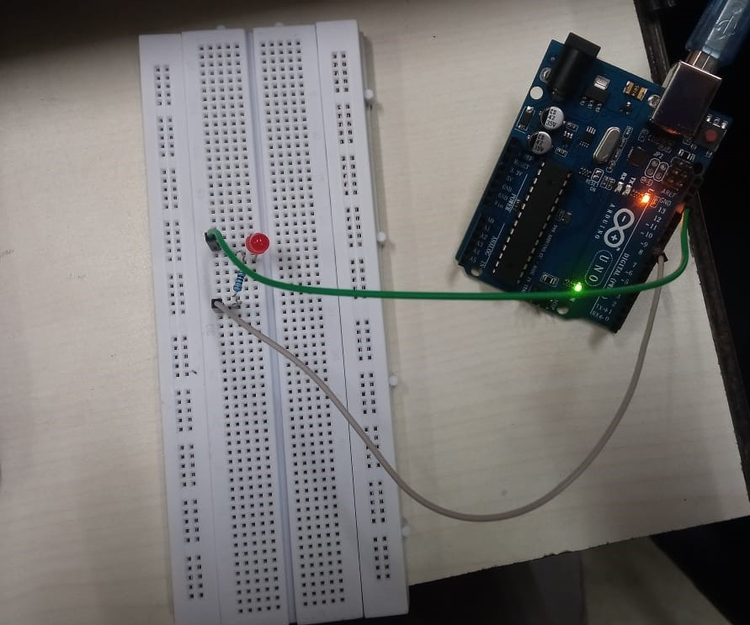

Blinking LED

