**Experiment 3.1**

# Student Name: Saumyamani Bhardwaz UID: 20BCS1682 Branch: BE CSE Section/Group: 701_A Semester: 6th Date of Performance:

**Subject Name: IoT Lab Subject Code: 20CSP-358**

## Aim: Interfacing Air Quality Sensor (MQ135), displays data on LCD

## Components Required:

* 1 × Breadboard
* 1 × Arduino Uno R3
* 1 × MQ 135 Air Quality Sensor Module
* 1 × LED
* 1 × LCD
* 1 × 330Ω Resistor
* 2 × Jumper

# Objective:

* To measure and display real-time air quality data using MQ135 sensor and LCD.
* To assess the feasibility of using MQ135 sensor for air quality monitoring via LCD interface.

# Script:

**Air Quality Sensor:**

MQ-135 sensor belongs to the MQ series that are used to detect different gasses present in the air. The MQ-135 sensor is used to detect gases such as NH3, NOx, alcohol, Benzene, smoke,CO2 ,etc. steel exoskeleton houses a sensing device within the gas sensor module.

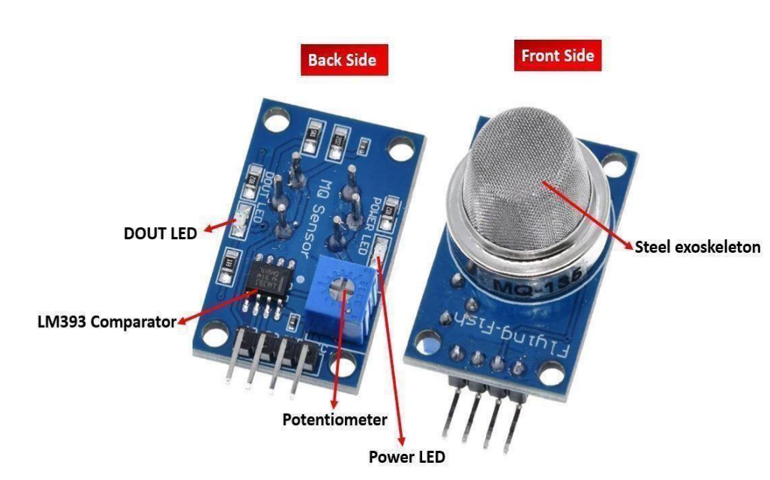

**The table below shows some key specifications of the MQ-135 sensor module:**

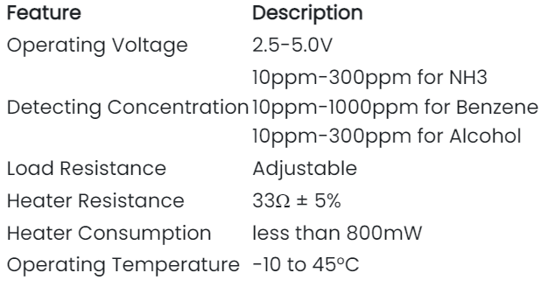

# 

**This sensor has 4 pins:**

1. 5V: Module power supply – 5 V
2. GND: Ground
3. DOUT: Digital output
4. AOUT: Analog output

**Circuit:**

* The following circuit shows how you should connect Arduino to MQ-135 module. Connect wires accordingly.
* The MQ-135 sensor module consists of four pins namely VCC, GND, DO, and DO. The table below gives a brief description of them.

| **Pin** | **Description** |
| --- | --- |
| **VCC** | Positive power supply pin that powers up the sensor module. |
| **GND** | Reference potential pin. |
| **AO** | Analog output pin. It generates a signal proportional to the concentration of gas vapors encountering the sensor. |
| **DO** | Digital Output pin. It also produces a digital signal whose limit can be set using the in-built potentiometer. |

# Code:

int sensorValue;

int digitalValue;

void setup() {

Serial.begin(9600); // sets the serial port to 9600

pinMode(13, OUTPUT) pinMode(2, INPUT);

}

void loop()

{

sensorValue = analogRead(0); // read analog input pin 0

digitalValue = digitalRead(2);

if (sensorValue > 400)

{

digitalWrite(13, HIGH);

}

else digital Write( 13, LOW);

Serial.println(sensorValue, DEC); // prints the value read

Serial.println(digitalValue, DEC);

delay(1000); // wait 100ms for next reading

}

# Figure/Screenshots:

# 

# Fig. 1: Working of gas sensor

# Result/Output:

The result of the experiment would be the measurement and display of air quality data on the LCD screen, based on the readings from the MQ135 sensor. This would provide valuable information on the levels of air pollutants such as carbon dioxide, ammonia, and nitrogen oxides in the surrounding environment. The accuracy of the readings would depend on the quality and calibration of the sensor used, as well as the effectiveness of the LCD interface in displaying the data in a user-friendly format. The results could be used to inform decisions on air pollution control measures and to raise public awareness of the importance of monitoring and improving air quality.

# Analysis of the experiment:

1. The analysis of the experiment would involve several aspects. Firstly, the accuracy and reliability of the air quality data measured by the MQ135 sensor would need to be evaluated. This could be done by comparing the sensor's readings to those obtained by more precise and calibrated instruments.
2. Secondly, the effectiveness of the LCD interface in displaying the air quality data would need to be assessed. This could be done by evaluating the clarity, readability, and ease of use of the interface, as well as its ability to provide meaningful insights into the air quality data.
3. Finally, the overall feasibility of using the MQ135 sensor and LCD interface for air quality monitoring would need to be evaluated. This would involve assessing the cost, maintenance requirements, and practicality of implementing such a system on a larger scale.
4. Overall, the analysis of the experiment would aim to determine the strengths and limitations of the MQ135 sensor and LCD interface for air quality monitoring, and to identify potential areas for improvement or further research.
5. Top of Form

Top of Form