**REST API (Django Rest Framework-DRF)**

**Session-1**

**Introduction:**

* API stands for Application Programming Interface.
* It is software that enables communication between the two or more applications.
* When you use an application on your mobile phone, the application connects to the Internet and sends data to a server.
* The server then retrieves that data, interprets it, performs the necessary actions and sends it back to your phone.
* The application then interprets that data and presents you with the information you wanted in a readable way.
* This is what an API is - all of this happens via API
* Django REST is a powerful Django-based framework that the developer uses to create the APIs.
* Django Rest Framework lets you create RESTful APIs: A way to transfer information between an interface and a database in a simple way**.**
* In Django REST, REST stands for **Representational State Transfer**. It is used for web-based architecture for data communication.
* REST is an architectural style, not a protocol.
* Django REST framework(DRF) is an open source, flexible and fully-featured library with modular and customizable architecture that aims at building web APIs and uses Python and Django.

**Advantages of DRF:**

* DRF allows the flexibility to extend and customize the framework’s tools according to programmer’s demands that greatly reduces development time.
* It also provides the support of testing, debugging and caching.
* Simplicity, flexibility, quality, and test coverage of source code.
* Powerful serialization engine compatible with both ORM and non-ORM data sources.
* Pluggable and easy to customize validators and authenticators.
* Generic classes for CRUD operations.
* Clean, simple, views for Resources, using Django's new class based views.

**API types:**

1. **Private :**It can be used within the organization
2. **Partner:** It can be used within business partners
3. **Public:** It can be used any third party developers

**How API works:**

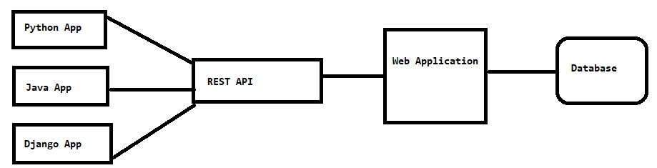

* Client sends HTTP request to API.
* API will interact with web application
* Web application will interact with database if it is required.
* Web application provides required data to API.
* API returns data to client.