**REST API (Django Rest Framework-DRF)**

**Session-12**

**Concrete View Classes:**

* [Concrete views](https://www.django-rest-framework.org/api-guide/generic-views/#concrete-view-classes) do most of the work that we need to do on our own when using APIView.
* They use mixins as their basic building blocks, combine the building blocks with GenericAPIView, and bind actions to the methods.
* The following are the concrete generic views.

1. ListAPIView
2. CreateAPIView
3. RetrieveAPIView
4. UpdateAPIView
5. DestroyAPIView
6. ListCreateAPIView
7. RetrieveUpdateAPIView
8. RetrieveDestroyAPIView
9. RetrieveUpdateDestroyAPIView

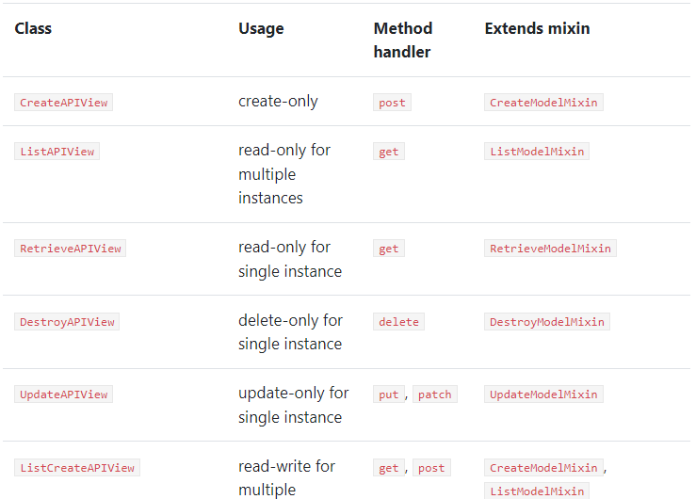

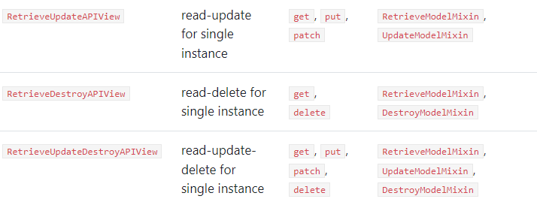

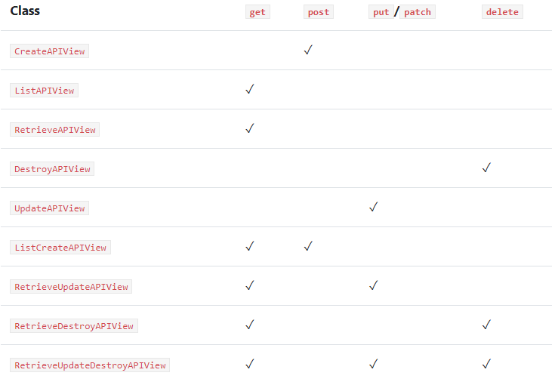

All classes that extend from a concrete view require:

* queryset
* serializer class

**Settings.py:**

INSTALLED_APPS = [  
 **'django.contrib.admin'**,  
 **'django.contrib.auth'**,  
 **'django.contrib.contenttypes'**,  
 **'django.contrib.sessions'**,  
 **'django.contrib.messages'**,  
 **'django.contrib.staticfiles'**,  
 **'myapp.apps.MyappConfig'**,  
 **'rest_framework'**,  
  
 **'myapp5'**,  
]

**Models.py:**

**from** django.db **import** models  
  
*# Create your models here.***class** Customer(models.Model):  
 name=models.CharField(max_length=20)  
 address=models.CharField(max_length=20)  
 mail = models.CharField(max_length=20)  
 age = models.IntegerField()

**admin.py:**

**from** django.contrib **import** admin  
**from** myapp5.models **import** Customer  
*# Register your models here.*@admin.register(Customer)  
**class** CustomerAdmin(admin.ModelAdmin):  
 list_display = [**'id'**,**'name'**,**'address'**,**'mail'**,**'age'**]

**Now go to terminal and then type the following commands**

* Python manage.py makemigrations
* Python manage.py migrate
* Python manage.py createsuperuser
* Now run server: python manage.py runserver
* Now go to browser: <http://127.0.0.1:8000/admin>
* Insert few records

Create a new python file with the name serializers.py.

**serializer.py:**

**from** rest_framework **import** serializers  
**from** myapp5.models **import** Customer  
  
**class** CustomerSerializer(serializers.ModelSerializer):  
 **class** Meta:  
 model=Customer  
 fields=[**'id'**,**'name'**,**'address'**,**'mail'**,**'age'**]

**views.py:**

**from** django.shortcuts **import** render  
**from** myapp5.models **import** Customer  
**from** myapp5.serializers **import** CustomerSerializer  
**from** rest_framework.generics **import** ListAPIView,  
 CreateAPIView,RetrieveAPIView,UpdateAPIView,DestroyAPIView,  
 ListCreateAPIView,RetrieveUpdateAPIView,RetrieveDestroyAPIView,RetrieveUpdateDestroyAPIView  
  
*# Create your views here.***class** CustomerList(ListAPIView):  
 queryset = Customer.objects.all()  
 serializer_class = CustomerSerializer  
  
**class** CustomerCreate(CreateAPIView):  
 queryset = Customer.objects.all()  
 serializer_class = CustomerSerializer  
  
**class** CustomerRetrieve(RetrieveAPIView):  
 queryset = Customer.objects.all()  
 serializer_class = CustomerSerializer  
  
**class** CustomerUpdate(UpdateAPIView):  
 queryset = Customer.objects.all()  
 serializer_class = CustomerSerializer  
  
**class** CustomerDestroy(DestroyAPIView):  
 queryset = Customer.objects.all()  
 serializer_class = CustomerSerializer  
  
**class** CustomerListCreate(ListCreateAPIView):  
 queryset = Customer.objects.all()  
 serializer_class = CustomerSerializer  
  
**class** CustomerRetrieveUpdate(RetrieveUpdateAPIView):  
 queryset = Customer.objects.all()  
 serializer_class = CustomerSerializer  
  
**class** CustomerRetrieveDestroy(RetrieveDestroyAPIView):  
 queryset = Customer.objects.all()  
 serializer_class = CustomerSerializer  
  
**class** CustomerRetrieveUpdateDestroy(RetrieveUpdateDestroyAPIView):  
 queryset = Customer.objects.all()  
 serializer_class = CustomerSerializer

**urls.py :**

**from** django.contrib **import** admin  
**from** django.urls **import** path  
**from** myapp5 **import** views  
  
urlpatterns = [  
 path(**'admin/'**, admin.site.urls),  
 path(**'customerlist/'**,views.CustomerList.as_view()),  
 path(**'customercreate/'**,views.CustomerCreate.as_view()),  
 path(**'customerretrieve/<int:pk>'**,views.CustomerRetrieve.as_view()),  
 path(**'customerupdate/<int:pk>'**,views.CustomerUpdate.as_view()),  
 path(**'customerdestroy/<int:pk>'**, views.CustomerDestroy.as_view()),  
  
  
 path(**'customerlistcreate/'**,views.CustomerListCreate.as_view()),  
 path(**'customerretrieveupdate/<int:pk>'**,views.CustomerRetrieveUpdate.as_view()),  
 path(**'customerretrievedestroy/<int:pk>'**, views.CustomerRetrieveDestroy.as_view()),  
 path(**'customerretrieveupdatedestroy/<int:pk>'**, views.CustomerRetrieveUpdateDestroy.as_view()),  
  
]