**REST API (Django Rest Framework-DRF)**

**Session-2**

**REST API:**

* REST API is an architectural style for an application programming interface (API) that uses HTTP request to access and use data.

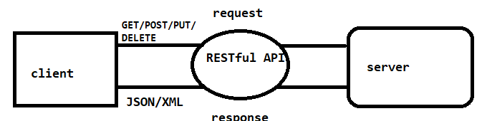

* When web services use REST architecture, they are called Restful APIs or REST APIs.
* A REST API is a set of web addresses that respond with pure information.
* API returns JSON or XML, which is common format.
* We can see all the information enclosed within {},[ ].

**JSON:**

* JSON is an open standard file format and data interchange format that uses human-readable text to store and transmit data objects consisting of attribute value pairs.
* JavaScript Object Notation (JSON) is a standard text-based format for representing structured data based on JavaScript object syntax. It is commonly used for transmitting data in web applications (e.g., sending some data from the server to the client, so it can be displayed on a web page.

**XML:**

* XML (Extensible Markup Language) is used to describe data. The XML standard is a flexible way to create information formats and electronically share structured data via the public internet, as well as via corporate networks.

**HTTP Methods :( GET, POST, PUT, PATCH, DELETE)**

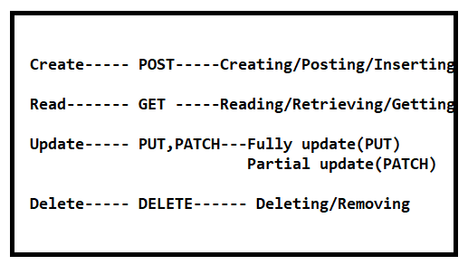

**API Resource:**

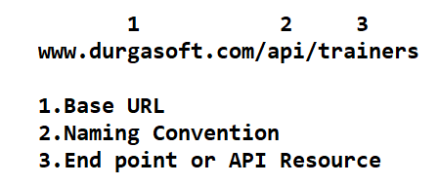

Note: Here api is not compulsory, but endpoint or resource is must.

**Installing DRF:**

* To install DRF first we have to install python and django framework.
* Install DRF using pip:

pip install djangorestframework

**Include DRF in django project:**

* INSTALLED_APPS=[

‘rest_framework’

]