**PROJECT DOCUMENTATION**

**AUDIBLE INSIGHT**

1.Project Overview

The goal of this project is to analyse Audible audiobook data to uncover insights into user preferences, popular genres, ratings distribution, and trends in audiobook consumption.

2. Tools Used

- Microsoft Excel

- Power BI

3. Dataset - Source

Audible sample data _uncleaned

Data contains:

- Book Title

-Author Name

-Narrator

- Ratings

- Languages

- Price

4. Steps Followed

Cleaned data in Excel Removed blanks, Removed Duplicates, formatted columns, Standardized Data (e.g. - trimmed spaces, fixed Capitalization) and used cleanup () to texts

Used text to columns to split columns

Used Excel formulas to convert total narration time into minutes. Performed basic data analysis to understand the key patterns

Then Imported cleaned data into Power BI - Built dashboards using charts, slicers, and KPIs.

5. Key Insights

1.Overall Ratings

-The audiobooks have a total of 398k ratings, showing a good amount of user engagement across the platform

2.Language Insight

- 36 different languages are represented in the Audible catalogue.

-English is the dominant language by a huge margin.

3. Top Languages by Ratings

-A pie chart shows that English alone accounts for most ratings’ other languages like German and Spanish have comparatively smaller shares.

4.Book counts

-There are approximately 82.67k audiobooks in the dataset.

5.Trends by Year

-The number of audiobooks published peaked around 2020, reaching nearly 24k books that year.

-There was a noticeable rise in audiobook release around 2019-2020

6.Total Revenue

-A pie chart shows clear picture about total revenue. Total revenue is heavily skewed towards English-language

7.Narrators

-The top 20 narrators have varying performance, with the leading narrator reaching 2.4k units sold

6. Screenshots

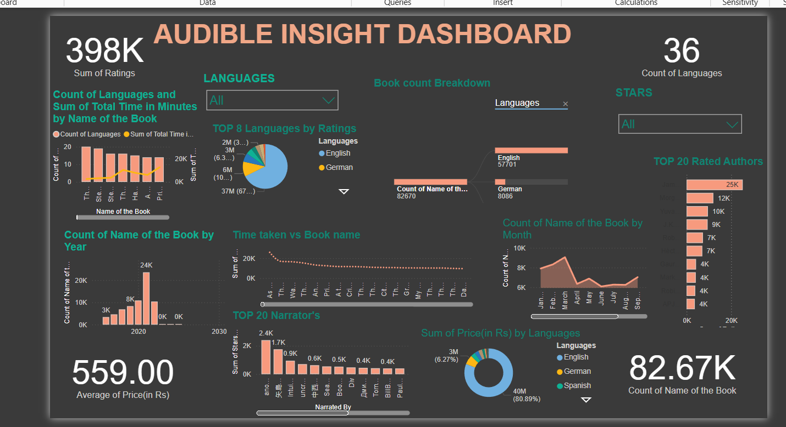

7. Files Included

- ‘Audibledataset.xlsx’ – Cleaned data and basic analysis

- ‘AUDIBLEDASHBOARD.pbix’ – Power BI dashboard

- ‘README.docx’ – Project description

8. How to Use

- Open `Audibledataset.xlsx` to view the cleaned data.

- Open `AUDIBLEDASHBOARD.pbix` in Power BI Desktop to explore the visuals.