***----------------MY SQL--------------***

* Download
  + <https://dev.mysql.com/downloads/installer/>

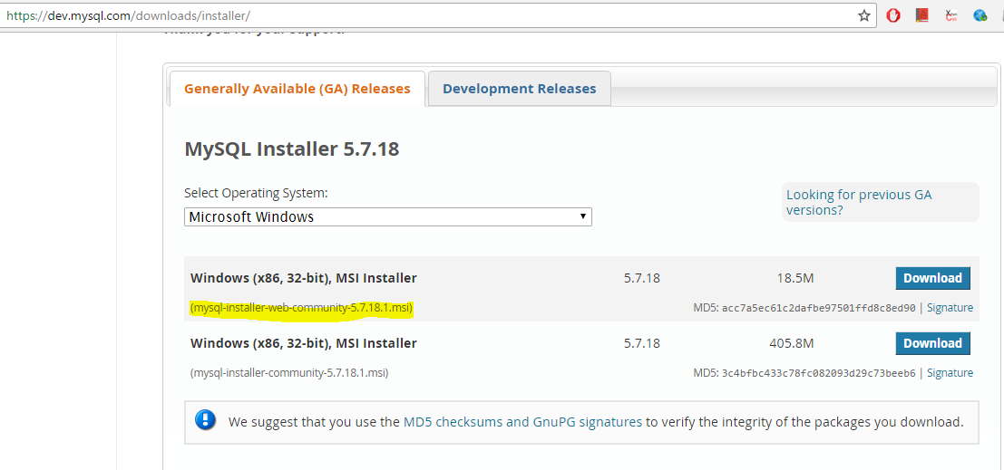

* Installation:
  + http://www.wikihow.com/Install-the-MySQL-Database-Server-on-Your-Windows-PC

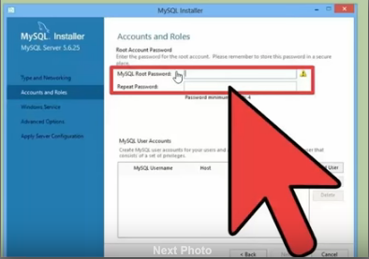

Remember the following:

* + port: 3306 username: root password: selenium
* Create new Database
* Import existing Database

***Create New Database----------------***

Open MySQL Command Line Client

* show databases;

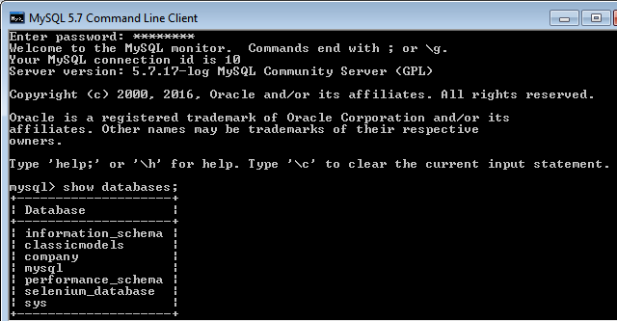

* + create database **selenium_database**;
  + use **selenium_database**
    - create table **webdriver** (name **varchar(20)**, email **varchar(30)**);
    - show tables;
    - desc **webdriver;**
      * insert into **webdriver**  value (“Saurab”,”saurab@gmail.com”);
      * insert into **webdriver** value (“Jeet”,”jeet@gmail.com”);

***Importing existing Database ----------------***

Get sample database from <http://www.mysqltutorial.org/mysql-sample-database.aspx>

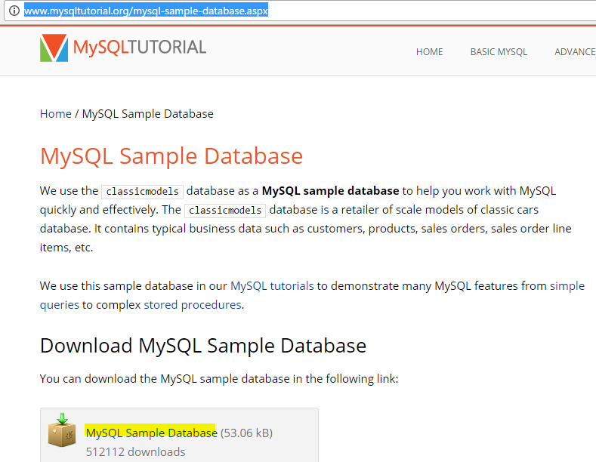

Open MySQL Workbench-> File-> Open SQL Script->Select the sample database as highlighted (http://www.mysqltutorial.org/how-to-load-sample-database-into-mysql-database-server.aspx)

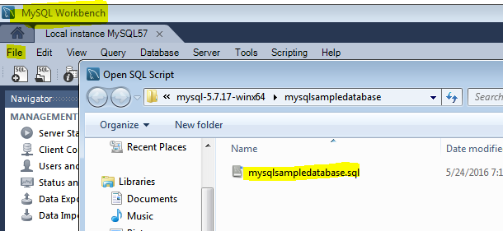

A script will open ->run **Execute Button**-> after running the script

* **classicmodels** database will get created and
* **customer**s table will get created under Schema

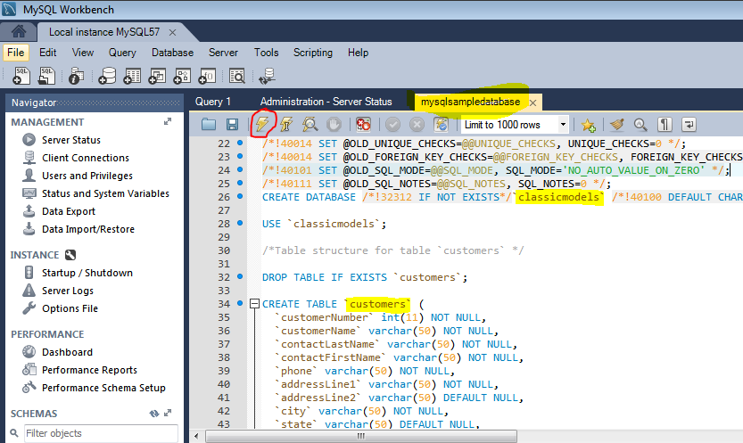 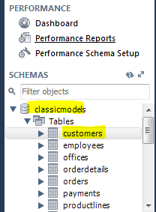

***Topics you should know (http://www.sqlcourse.com/)***

* ***select*** first, last, city from empinfo where first LIKE 'Er%';
* ***create*** table employee (first varchar(15),last varchar(20),age number(3), address varchar(30),city varchar(20), state varchar(20));

Here are the most common Data types:

|  |  |
| --- | --- |
| char(size) | Fixed-length character string. Size is specified in parenthesis. Max 255 bytes. |
| varchar(size) | Variable-length character string. Max size is specified in parenthesis. |
| number(size) | Number value with a max number of column digits specified in parenthesis. |
| date | Date value |
| number(size, d) | Number value with a maximum number of digits of "size" total, with a maximum number of "d" digits to the right of the decimal. |

* ***insert*** into employee (first, last, age, address, city, state)  
   values ('Luke', 'Duke', 45, '2130 Boars Nest', 'Hazard Co', 'Georgia');
* ***update*** phone_book set last_name = 'Smith', prefix=555, suffix=9292  
   where last_name = 'Jones';
* ***delete*** from employee;

**Note:** if you leave off the where clause, **all records will be deleted!**

delete from employee where lastname = 'May';

* ***drop*** table employees;

The **drop table** command is used to delete a table and all rows in the table

Deleting all of the records in the table leaves the table including column and constraint information.

Dropping the table removes the table definition as well as all of its rows.

-----Clauses-----

Groupby Clause

* ***select*** sum(amount), customerNumber from payments

group by customerNumber;

Having Clause

* ***select*** sum(amount), customerNumber from payments

group by customerNumber

having sum(amount)<=30000;

The HAVING clause allows you to specify conditions on the rows for each group - in other words, which rows should be selected will be based on the conditions you specify.

Constraints: "unique", "not null" "primary key"

Order by Clause

* SELECT employee_id, dept, name, age, salary  
  FROM employee_info  
  **ORDER BY** salary, age DESC;

All clauses

* select sum(amount), customerNumber from payments
* where customerNumber>200
* group by customerNumber
* having sum(amount)<=30000
* order by customerNumber desc;

***Rest can be learnt from*** [***http://www.sqlcourse2.com/***](http://www.sqlcourse2.com/)

Page 8 is to be read

***---------------------------------------Selenium Integration-------------------------***

* Get **mysql-connector-java-6.0.5.jar** in your project

<dependency>

<groupId>mysql</groupId>

<artifactId>mysql-connector-java</artifactId>

<version>6.0.6</version>

</dependency>

* Create a new class and write the following

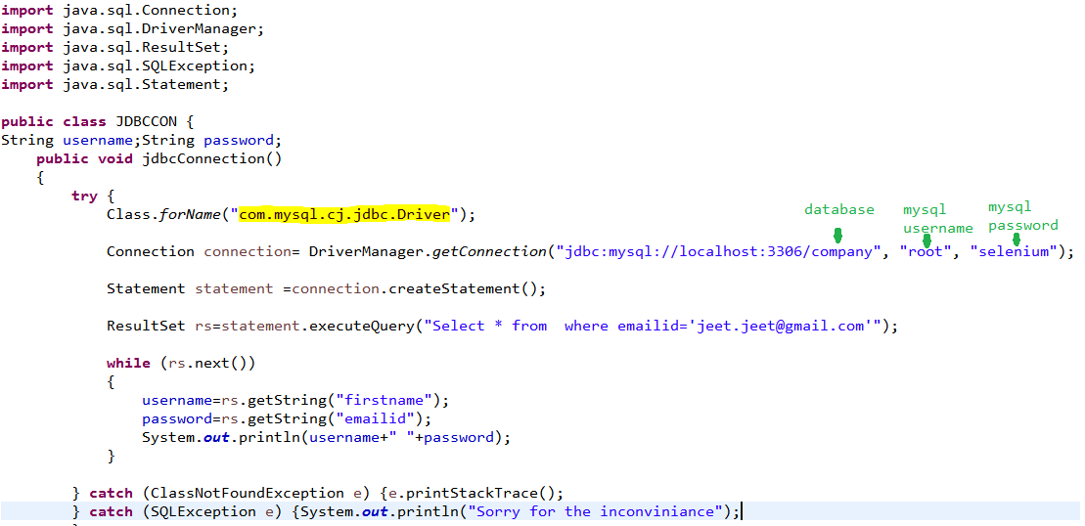

* Use the username and password in your Selenium Code ☺

***-------------------Additional good to know stuffs-----------------------------***

You can try:

* + Statement Interface
  + Prepared Statement Interface
  + Callable Statement Interface
    - Make Store Procedure

Check

* + - * DatabaseMetaData
      * ResultSetMetaData

In Work Bench we can also create SP

* Store Procedure

