EU AI Act RAG Assistant
Project walkthrough, methods, evaluation, and demonstration
A beginner-friendly explanation of what we built, why we built it, and how it works, with real application screenshots.
GitHub https://github.com/SaurabRauniyar/eu-ai-act-rag-assistant
Project format Python command-line RAG application
Document source Consolidated EU AI Act (EUR-Lex, 27 July 2026 version)

1. The question and the motivation
Main project question: Can a retrieval-augmented generation (RAG) assistant answer questions about the EU AI Act by first finding relevant legal Articles and then generating a grounded response?
The EU AI Act is a long regulatory document. Reading the entire text to locate one obligation can be time-consuming. A general-purpose language model can also give a confident answer without showing which Article supports it. We therefore built a system that retrieves the source text first and instructs the model to answer from that text.
Project in one sentence: This project demonstrates a practical, document-grounded question-answering workflow: prepare a complex document, compare embedding methods, retrieve relevant passages, generate a constrained answer, evaluate traceability, and handle real API limitations. It is a portfolio demonstration, not a legal advice system.

2. What is RAG?
RAG means Retrieval-Augmented Generation. “Retrieval” finds relevant passages in a document. “Generation” uses those passages as context for a language model to write an answer. In this project, the language model is not fine-tuned on the EU AI Act.
Stage | What it does | Technology
Document preparation | Extract, clean, and divide the Act into labelled passages | PyMuPDF + Python
Embeddings | Convert passages and questions into numeric vectors | Sentence Transformers (BGE)
Search | Find passages similar to the question | FAISS
Context construction | Include relevant Article sections and control input size | Section expansion + 12,000-character cap
Answer generation | Answer using retrieved context and cite relevant Articles | Groq / openai/gpt-oss-20b
Evaluation | Check whether expected Articles appear in context and answers | 12-question evaluation script

3. Questions the system is designed to answer
Examples from the project evaluation set:
- What accuracy, robustness and cybersecurity requirements apply to high-risk AI systems? (Expected: Article 15)
- What transparency obligations apply to AI systems that interact with people or generate synthetic content? (Expected: Article 50)
- What are the obligations for providers of general-purpose AI models? (Expected: Article 53)
- What are the requirements for post-market monitoring of high-risk AI systems? (Expected: Article 72)
The complete 12-question set is stored in evaluation/retrieval_questions.json. These four examples are confirmed from the recorded evaluation output; the full set is not reproduced here without the JSON file.

4. Step-by-step method
Step 1 — Collect the legal document
Download the consolidated EU AI Act PDF from EUR-Lex and store it in data/raw/. The consolidated text is useful for reference; official published acts remain the authentic legal sources.
Step 2 — Extract and clean text
Use PyMuPDF to extract text from the PDF, then clean formatting artefacts. Store extracted and cleaned versions in data/processed/.
Step 3 — Split into meaningful chunks
Identify Articles and Annexes, attach section metadata, and split very long sections into smaller overlapping chunks. The project produced 160 chunks.
Step 4 — Build vector representations
Encode the 160 chunks into 384-dimensional embeddings. Compare MiniLM (all-MiniLM-L6-v2) with BGE (bge-small-en-v1.5).
Step 5 — Create the FAISS index
Normalize embeddings and use FAISS similarity search to retrieve the top five matching chunks for a question.
Step 6 — Expand sections and manage context
Include all chunks for the top three unique retrieved sections where possible. Cap the assembled context at 12,000 characters to stay within API limits.
Step 7 — Generate an answer
Send the question and retrieved context to Groq’s openai/gpt-oss-20b model with instructions to answer from context, mention relevant Articles, and acknowledge missing evidence.
Step 8 — Evaluate and save progress
Run 12 curated questions. Save completed answers to a local progress file so rate limits or connection failures do not force every question to be repeated.

5. Architecture at a glance
Offline preparation | Online question-answering
EUR-Lex PDF → extract → clean | User question → BGE question embedding
Article/Annex chunking → 160 chunks | FAISS top-5 search → top 3 unique sections
BGE embeddings → FAISS index | Section expansion → 12k-character context limit
Saved files in data/processed/ | Groq LLM → answer with Article references

6. What did we measure?
Metric | MiniLM | BGE / RAG
Retrieval Hit@1 (12 curated questions) | 9/12 (75%) | 9/12 (75%)
Retrieval Hit@3 | 9/12 (75%) | 12/12 (100%)
Retrieval Hit@5 | 10/12 (83.3%) | 12/12 (100%)
Expected Article in LLM context | — | 12/12 (100%)
Expected Article mentioned in answer | — | 12/12 (100%)
Interpretation: BGE was selected because it placed the expected Article in the top three results for all 12 curated retrieval questions. In the end-to-end evaluation, all 12 expected Articles appeared in the context and were mentioned in the generated answers.
Important limitations: The 12-question set is small and manually curated. Article mention is not proof of factual correctness or legal completeness. The 12 end-to-end checks were completed using saved results across runs; questions 1–9 were saved before the later context-limit change. A consistent full rerun and manual answer-quality review would strengthen the evaluation.

7. Real question-and-answer screenshots
The following case studies show real command-line screenshots from the application: the question, retrieved Articles, section expansion, and generated answer. Article 53 remains to be added.

How to read the screenshots (beginner guide)
A “chunk” is a small piece of source text. Each chunk keeps a section label (for example, Article 15) and a chunk number. The question is converted into a vector, and FAISS compares it with the stored chunk vectors. The closest chunks appear in the SEMANTIC RETRIEVAL list.
A similarity score (for example, 0.8835) shows how close two vectors are in this search. Higher scores mean a stronger semantic match within this search; 0.8835 does NOT mean an 88.35% probability of a correct legal answer.
SECTION EXPANSION means the program takes the top three different Articles found and collects their associated chunks, subject to the context-size limit. RAG ANSWER is the language model’s generated explanation based on that selected source material.
Think of the pipeline as a librarian plus a writer: FAISS is the librarian that finds likely passages; the Groq model is the writer that explains them. The writer still needs checking against the original source.
Figure 1 — High-risk AI systems (Article 15)
Case study 1 — A real query from the working command-line application
Question: What accuracy, robustness and cybersecurity requirements apply to high-risk AI systems?
Figure 1a. The question and semantic retrieval. Article 15 ranked first among the five retrieved chunks (similarity 0.8835).
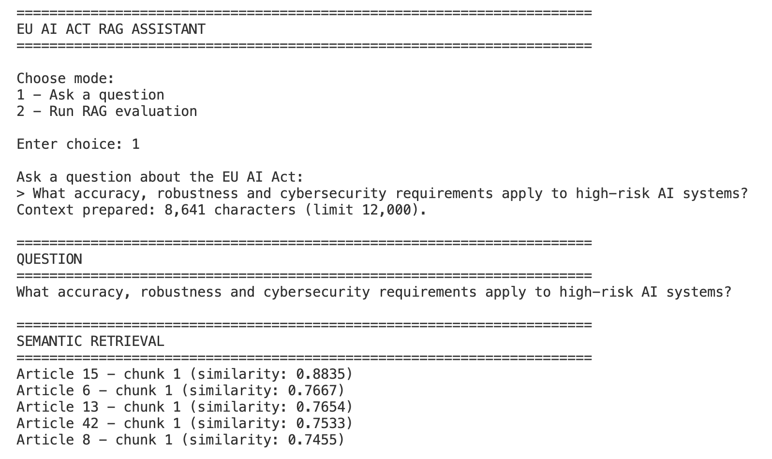
The search scores are similarity measures, not probabilities that an answer is correct.
Figure 1b. Section expansion and generated response. The selected context includes Articles 6, 13 and 15; the response focuses on Article 15.
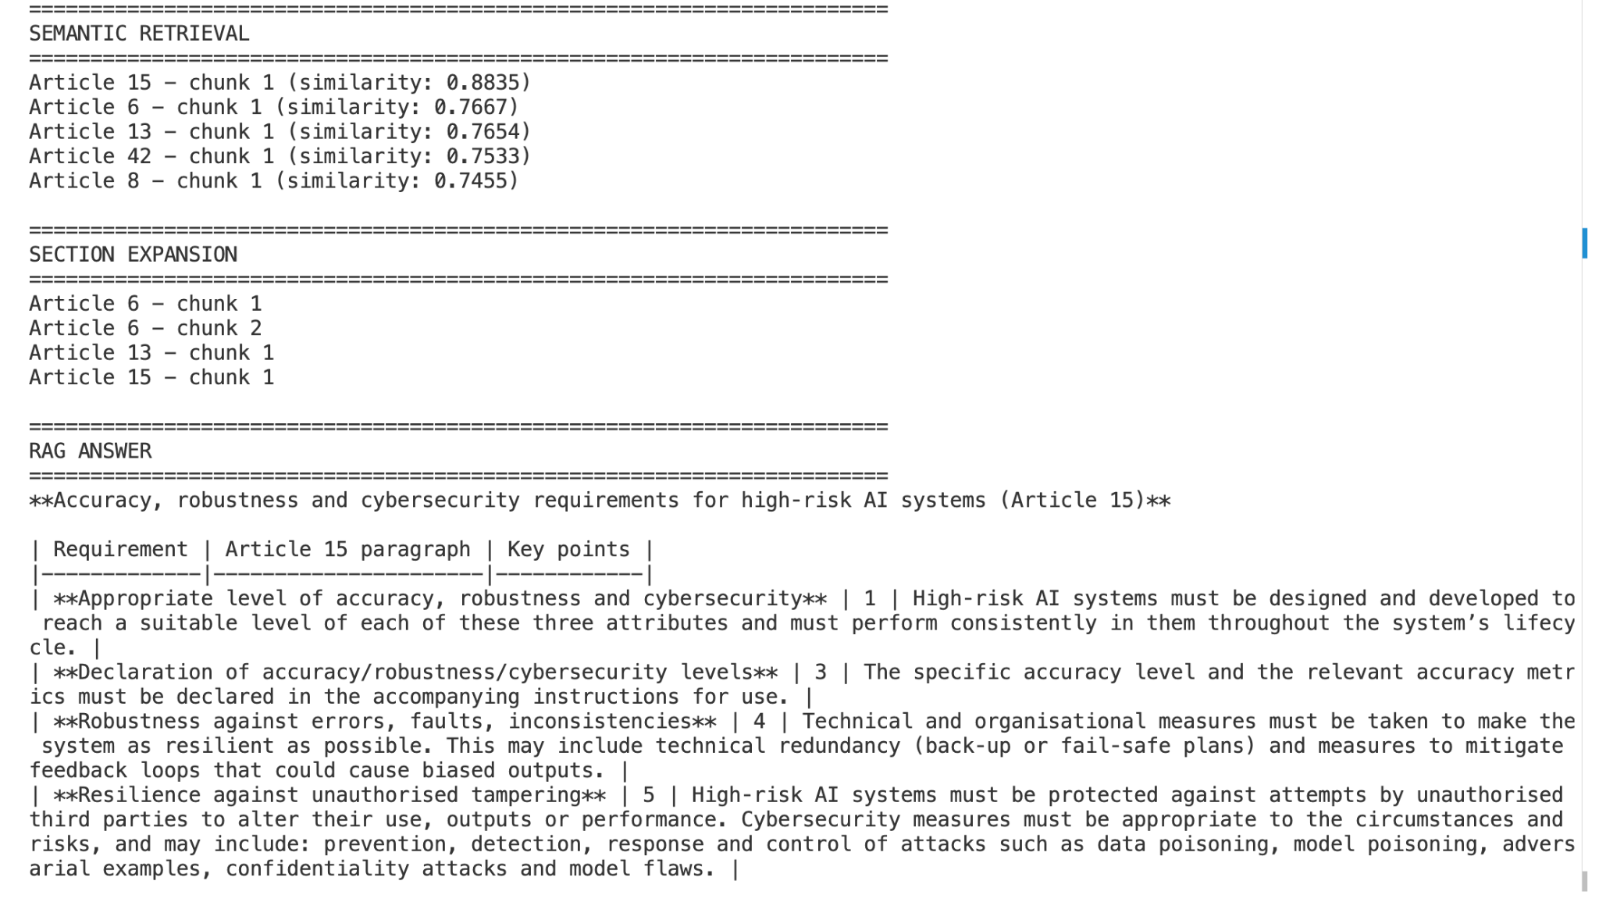
The terminal prints Markdown syntax literally, so the table borders and bold markers look less polished than they would in a rendered interface. The screenshot is kept as real application evidence.
Figure 1c. Closing summary of the same generated response.
Readable summary: Article 15 concerns maintaining suitable accuracy, robustness, and cybersecurity; documenting accuracy information; reducing errors and failures; and protecting systems from manipulation. This summarizes the generated output, not an independent legal verification.
What this demonstrates: a question is embedded, FAISS retrieves candidate sections, the context is expanded, and Groq generates an Article-referenced response. The screenshot alone does not establish legal or factual accuracy.

Case study 1 explained — From question to evidence to answer
1. What is the question asking? The reader wants to know how a high-risk AI system must perform reliably, withstand faults, and resist cybersecurity threats. It is not asking whether a particular AI product is compliant.
2. Which source chunks were most relevant? These are the five chunks shown by FAISS, ranked by semantic similarity:
Rank | Retrieved chunk | Similarity
1 | Article 15 — chunk 1 | 0.8835
2 | Article 6 — chunk 1 | 0.7667
3 | Article 13 — chunk 1 | 0.7654
4 | Article 42 — chunk 1 | 0.7533
5 | Article 8 — chunk 1 | 0.7455
3. What context reached the language model? The system selected the three highest-ranked unique Articles: Article 15, Article 6 and Article 13. It included Article 6 chunks 1–2, Article 13 chunk 1 and Article 15 chunk 1. The prepared context was 8,641 characters, below the 12,000-character cap.
4. Why is Article 15 the key evidence? It is the highest-ranked match and directly addresses accuracy, robustness and cybersecurity. Articles 6 and 13 are additional context, not substitutes for the primary source.
5. How do we read the generated answer? In plain English, the model described four themes: (a) appropriate accuracy, robustness and cybersecurity throughout the lifecycle; (b) accuracy information and metrics in instructions for use; (c) measures against faults, errors and problematic feedback loops; and (d) protection against unauthorized interference and AI-related attacks. These are a summary of the model’s displayed response, not a separate legal assessment.
6. What does the screenshot prove? It shows a reproducible chain from question → ranked chunks → expanded context → Article-referenced answer. It does not prove that every legal nuance was captured, or that the answer is independently correct.
Figure 2 — Transparency obligations (Article 50): real application demonstration
Case study 2 — A real transparency question
Question: What transparency obligations apply to AI systems that interact with people or generate synthetic content?
Figure 2a. Question, top-five semantic retrieval results and section expansion. Article 50 ranked first (similarity 0.8434). The selected context contains Articles 3, 13 and 50.
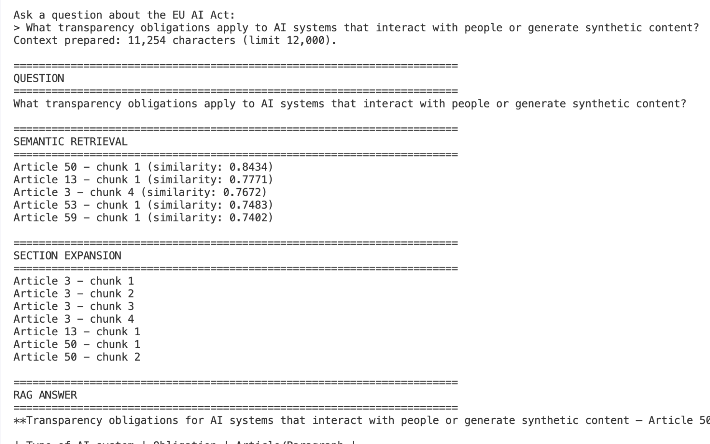
The system prepared 11,254 characters of context (below the 12,000-character limit). The similarity score measures embedding proximity; it is not a confidence probability.
Figure 2b. Generated answer for Article 50. The response distinguishes requirements for providers and deployers and identifies relevant paragraphs.
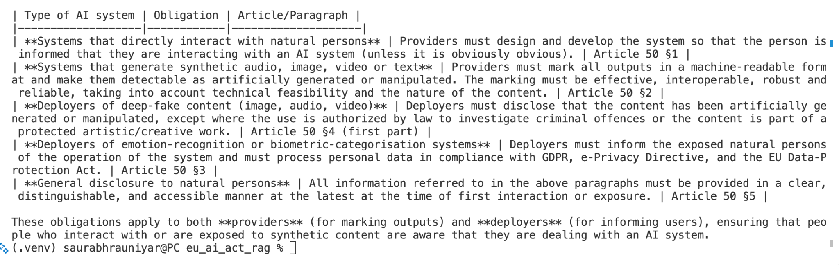
The screenshot preserves the raw terminal output, including visible Markdown table syntax. It illustrates the system’s answer generation, not an independent legal accuracy assessment.
Plain-English reading of this example: the search identifies Article 50 as the strongest match; the generated answer separates disclosure when people interact with AI, labelling of synthetic outputs, and disclosures by deployers. These are categories reported by the assistant, not an independent legal assessment.

Case study 2 explained — Why the retrieved data matters
1. What is the question asking? It asks what people should be told when interacting with AI, and what information should accompany AI-generated or manipulated content. The question combines several transparency scenarios.
2. Which chunks did the search return? The top-five FAISS matches were:
Rank | Retrieved chunk | Similarity
1 | Article 50 — chunk 1 | 0.8434
2 | Article 13 — chunk 1 | 0.7771
3 | Article 3 — chunk 4 | 0.7672
4 | Article 53 — chunk 1 | 0.7483
5 | Article 59 — chunk 1 | 0.7402
3. What did section expansion do? The three selected Articles were Article 50, Article 13 and Article 3. The system included Article 50 chunks 1–2, Article 13 chunk 1 and Article 3 chunks 1–4: seven chunks in total. It prepared 11,254 characters of context, under the 12,000-character cap.
4. Why is Article 50 important? It ranked first and directly addresses the transparency question. The screenshot also shows related Articles that help supply context, but their presence alone does not make them the correct legal basis for every obligation.
5. How do we understand the answer? The generated response separated several cases: informing people they are interacting with AI; marking synthetic audio, image, video or text outputs; disclosure relating to deepfakes; notices for emotion-recognition or biometric-categorisation systems; and clear, accessible disclosure. It also distinguished duties described for providers and deployers. The exact applicability and exceptions require checking the legal text.
6. What does this demonstrate? A broad question can retrieve several relevant chunks, and the model can organize the answer into understandable categories while referencing Article 50. Similarity scores are retrieval signals, not confidence scores or legal accuracy grades.
Figure 3 — General-purpose AI models (Article 53): real application demonstration

Case study 3 — What must providers of general-purpose AI models do?
Intended question: What are the obligations for providers of general-purpose AI models?
Screenshot note: The words “Copy question” were accidentally pasted after the question in the terminal. They are not part of the intended research question; the screenshot is retained unchanged as a real run.
Figure 3a. Real user query and top-five retrieval results. Article 53 is ranked first (similarity 0.8766); Article 54 and Article 55 follow.
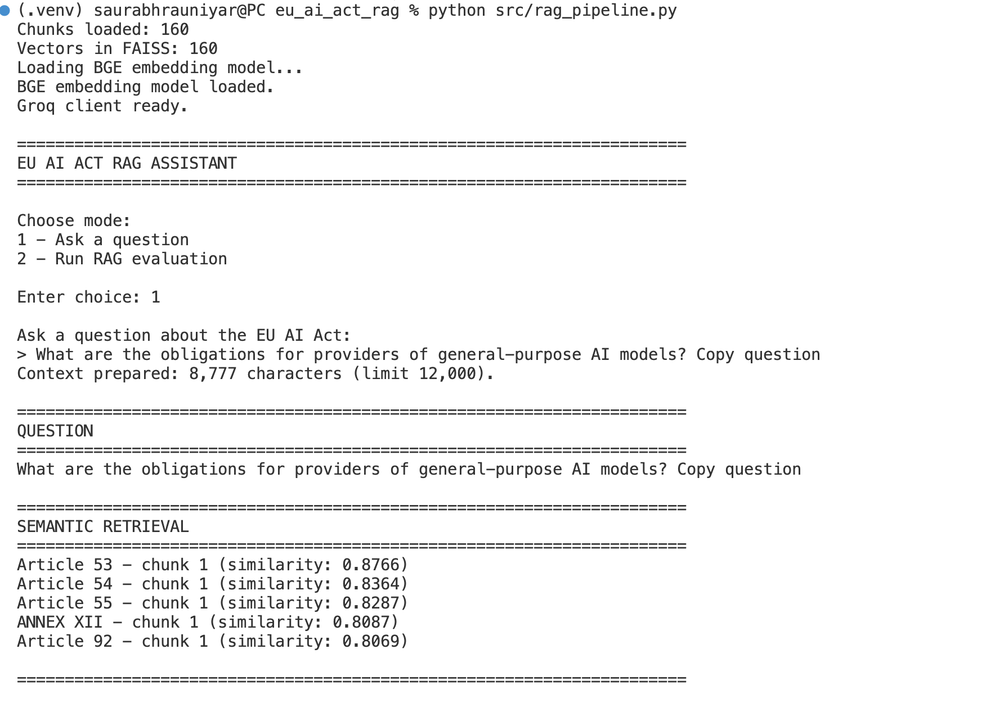
The model prepared 8,777 characters of context (below the 12,000-character limit). This demonstrates that context limiting can preserve the selected Articles without exceeding the configured character cap.
Figure 3b. The section-expansion stage selected Articles 53, 54 and 55. The generated answer describes general obligations for providers, including documentation, information sharing and copyright-related policies.
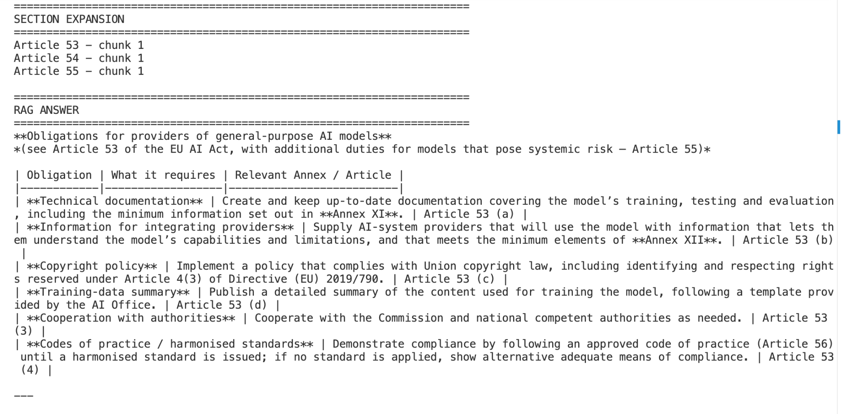
Figure 3c. The answer continues with additional obligations for models presenting systemic risk, referring to Article 55.
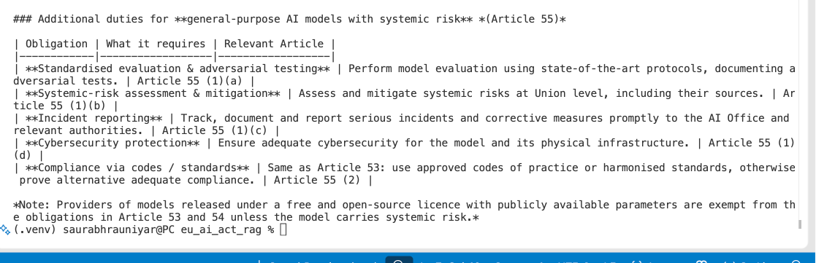

Case study 3 explained — From question to evidence to answer
1. What is the question asking? A “general-purpose AI model” can be adapted for many different tasks rather than only one narrow purpose. The reader wants to know what responsibilities the organisation providing such a model may have under the EU AI Act.
2. Which chunks did the search return? These are the five highest-ranked results from the real terminal run:
Rank | Retrieved chunk | Similarity score
1 | Article 53 — chunk 1 | 0.8766
2 | Article 54 — chunk 1 | 0.8364
3 | Article 55 — chunk 1 | 0.8287
4 | Annex XII — chunk 1 | 0.8087
5 | Article 92 — chunk 1 | 0.8069
3. Why are Articles 53, 54 and 55 important? Article 53 is the direct match for obligations on providers of general-purpose AI models. Article 54 concerns authorised representatives of certain providers established outside the Union. Article 55 concerns additional obligations for models with systemic risk. These distinctions help the model avoid treating all obligations as identical.
4. What does section expansion do here? FAISS returned five candidates, but the pipeline expanded only the top three unique sections: Articles 53, 54 and 55. Annex XII ranked fourth, so it was not one of the expanded sections. The generated answer can still mention Annex XII because the selected Article text refers to it. A mentioned Annex is not necessarily a directly retrieved Annex chunk.
5. What does the answer mean in simple English? The generated response groups general provider duties into technical documentation, information for organisations integrating the model, copyright-related policies, and a summary of training data. It then separates out further expectations for systemic-risk models, such as evaluation, risk assessment, incident reporting and cybersecurity. These are a plain-language interpretation of the output, not an independent legal verification.
6. What does the similarity score mean? The value 0.8766 measures semantic similarity between the question vector and Article 53’s chunk vector. It does not mean that the answer is 87.66% correct.
7. What does the example demonstrate? The system located Article 53 first, brought two related Articles into context, and generated a structured answer distinguishing general provider duties from systemic-risk duties. It shows evidence retrieval and source-referenced generation, but not that every legal qualification has been captured.
Reading caution: The screenshots show the model’s output, including simplified descriptions and Markdown table characters. Any compliance use would require checking the full, current legal text and the relevant exceptions and definitions.

8. How to run the demonstration
In VS Code Terminal, from the project folder:
cd ~/Desktop/eu_ai_act_rag
source .venv/bin/activate
python src/rag_pipeline.py
Select 1 to ask a question and display retrieval, section expansion, and the answer. Select 2 to run the 12-question evaluation. A GROQ_API_KEY is required in a local .env file; never include the key in screenshots or GitHub.

8.1 What do options 1 and 2 mean?
Think of this project as a library helper. You ask a question, it searches the EU AI Act for useful pages, and then it explains what those pages say. The menu lets you choose between asking ONE question and testing the helper with MANY questions.
Menu choice | Simple meaning | When to use it
1 - Ask a question | Ask the AI Act helper one question and see how it finds and explains an answer. | To show a friend how the assistant works.
2 - Run RAG evaluation | Give the helper 12 prepared questions and check whether it found and mentioned the expected Articles. | To test whether the system is finding the right sources.

8.2 Option 1 - Ask one question
Imagine asking a librarian: “Where can I read about safety rules for high-risk AI?” The librarian searches the book, finds the best pages, and explains them to you. That is what option 1 does.
Example question: What accuracy, robustness and cybersecurity requirements apply to high-risk AI systems?
What happens next?
- BGE changes the question into numbers (an embedding), so the computer can compare its meaning with document chunks.
- FAISS finds the five chunks most similar to the question. In our real example, Article 15, chunk 1 came first with a similarity score of 0.8835.
- The system collects related section text from Articles 15, 6 and 13. It keeps the context within a 12,000-character limit.
- Groq reads that context and writes an answer that refers to Article 15.
What the child-friendly answer means: A high-risk AI system should be accurate enough for its job, keep working reliably when problems happen, and be protected against harmful interference. The actual legal details are in Article 15; the assistant is a reading aid, not a lawyer.
Important: A similarity score of 0.8835 means the text looks relevant to the question. It does NOT mean the answer is 88.35% correct.

8.3 Option 2 - Test 12 questions automatically
Imagine a teacher gives the librarian 12 quiz questions. For every question, the teacher already knows which Article should be found. The teacher checks the librarian’s work. That is what option 2 does.
The 12 questions and their expected Articles are stored in evaluation/retrieval_questions.json. The program asks each question, retrieves context, generates an answer, and makes two checks:
Check | What the computer asks | Example for Article 50
Check A: Context | Did the expected Article reach the language model? | Was Article 50 included in the source text sent to Groq? YES.
Check B: Answer | Did the answer mention the expected Article? | Did the answer refer to Article 50? YES.
Our recorded result: 12 of 12 questions included the expected Article in context, and 12 of 12 answers mentioned the expected Article. That is 100% on these TWO checks, for this small set of questions.
But be careful: This does not prove that every sentence in every answer is correct. To measure factual accuracy, a person must read the answer and compare it carefully with the source. Also, the final 12-question result reused nine saved answers from before we added the context-length limit.
Why save results? Sometimes the Groq service is busy or a request is too large. The program saves finished questions locally, so we can restart without losing all earlier work.

8.4 How is this different from comparing MiniLM and BGE?
Embedding-model test | Full RAG test (menu option 2)
Checks how well MiniLM or BGE + FAISS FIND relevant Articles. | Checks whether expected Articles reach Groq AND are mentioned in the answers.
Uses Hit@1, Hit@3 and Hit@5: was the correct Article in the top 1, 3 or 5 results? | Uses expected-Article-in-context and expected-Article-mentioned-in-answer checks.
Does not need the Groq language model. | Calls Groq, unless a previous answer has already been saved.
Remember it like this: Option 1 = “Show me one answer.” Option 2 = “Give the assistant a 12-question quiz.”

9. Challenges and how we addressed them
Challenge | Solution
A long Article was only partially retrieved | Expanded all chunks for selected Article sections
A relevant Article ranked second, not first | Expanded the top three unique sections
Groq 429 rate limits and temporary connection failures | Added retries and saved completed evaluation results
Oversized prompt (HTTP 413) | Limited context to 12,000 characters
Article reference check missed Unicode whitespace | Normalized whitespace before matching

10. What would we improve next?
- Manually review generated answers for factual support and missing qualifications.
- Rerun all 12 questions with the final context-limit setting for consistent reporting.
- Evaluate more questions, including ambiguous and unanswerable ones.
- Add precise source quotations or section-level links for stronger traceability.
- Optionally build a small web interface after the command-line demo is stable.

11. Conclusion for readers
The three real demonstrations show how the assistant moves from a natural-language question to ranked evidence, expands the relevant Article context, and generates a structured answer. Article 15 illustrates technical requirements for high-risk AI systems; Article 50 illustrates transparency obligations; and Article 53 illustrates responsibilities of general-purpose AI model providers, with related systemic-risk duties in Article 55.
A useful way to read the results is to ask three questions: Did the search find the right Article? Did that Article reach the model as context? Does the final answer accurately reflect the relevant source text? This project measured the first two and Article mention, while full factual validation remains future work.

