How We Built the EU AI Act RAG Assistant
A visual, step-by-step guide for beginners
Think of this project as teaching a computer to find the right pages in a large rulebook before answering a question. The flowcharts show what happens before a question is asked and what happens after.

1. The complete project in one picture
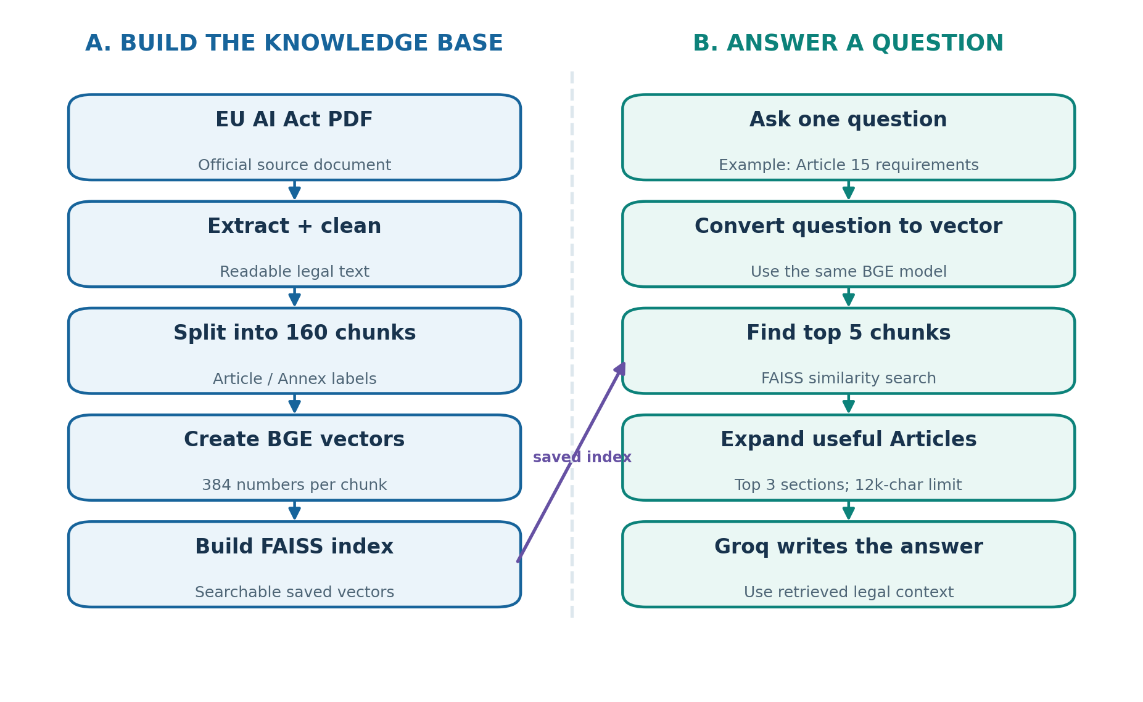
Figure 1. Left: prepare the document once. Right: use the prepared data to answer a new question.
The two sides work together. The left side creates a searchable collection of EU AI Act passages. The right side uses that collection to answer questions. This is called Retrieval-Augmented Generation (RAG).
Important: We did not fine-tune the language model. We retrieved useful text and supplied it as context when asking the model to answer.

2. How we prepared the EU AI Act document
This preparation is done before a person asks a question. Imagine making a book easier to search by cutting it into labelled pages and creating a smart index.
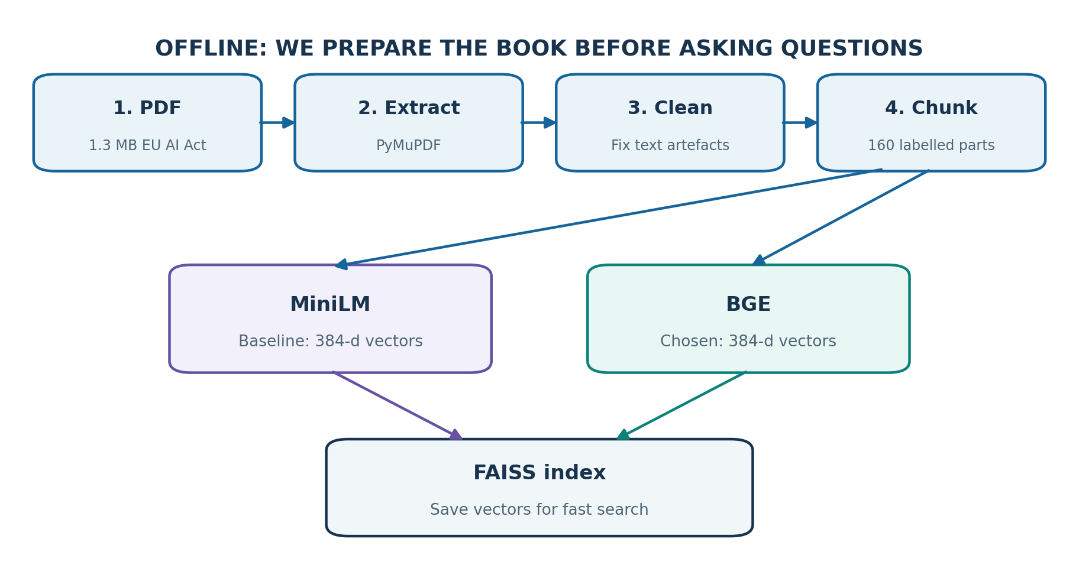
Figure 2. From the PDF to text chunks, embeddings, and a FAISS search index.
Step | What it means in simple English
1. Get the PDF | Use the consolidated EU AI Act document from EUR-Lex as the source.
2. Extract | PyMuPDF copies the text from the PDF into a text file.
3. Clean | Remove formatting problems so the text is easier for the computer to read.
4. Chunk | Split long Articles and Annexes into 160 labelled pieces. A chunk is simply a small part of the document.
5. Embed | Turn each chunk into a list of 384 numbers. Similar meanings produce vectors that are closer together.
6. Compare | Test MiniLM and BGE. BGE retrieved the expected Article in its top 3 for all 12 curated questions.
7. Index | Store the vectors in FAISS so similar passages can be found quickly.
Why keep Article labels? So the answer can point readers toward a relevant legal Article rather than giving an unsupported claim.

3. Option 1 — Ask one question
This mode is like asking a librarian one question. The computer looks up relevant pages, reads them, and gives a short explanation.
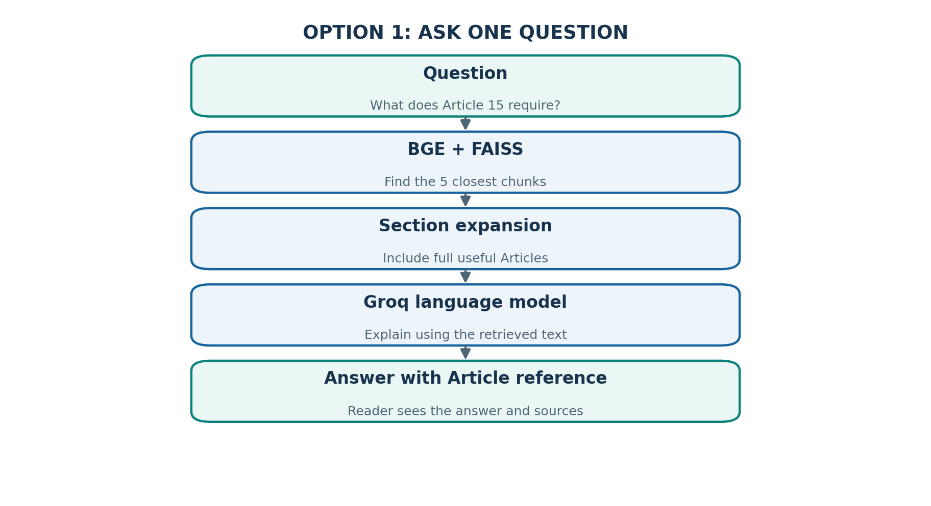
Figure 3. The path of one question from user input to a grounded answer.

Example: high-risk AI systems
Question: “What accuracy, robustness and cybersecurity requirements apply to high-risk AI systems?”
The system retrieved Article 15 as the highest-ranked chunk (similarity 0.8835). It also found Articles 6 and 13, which were included when building the context. Groq then generated an answer referring to Article 15.
A similarity score of 0.8835 means the question and chunk were close in the embedding search. It does NOT mean the answer is 88.35% correct.
The model sees at most 12,000 characters of prepared context in the current implementation, helping prevent requests from becoming too large.

4. Option 2 — Run RAG evaluation
This mode is like giving the librarian a 12-question quiz. Each question has a known expected Article. We test whether the assistant finds that Article and mentions it in the answer.
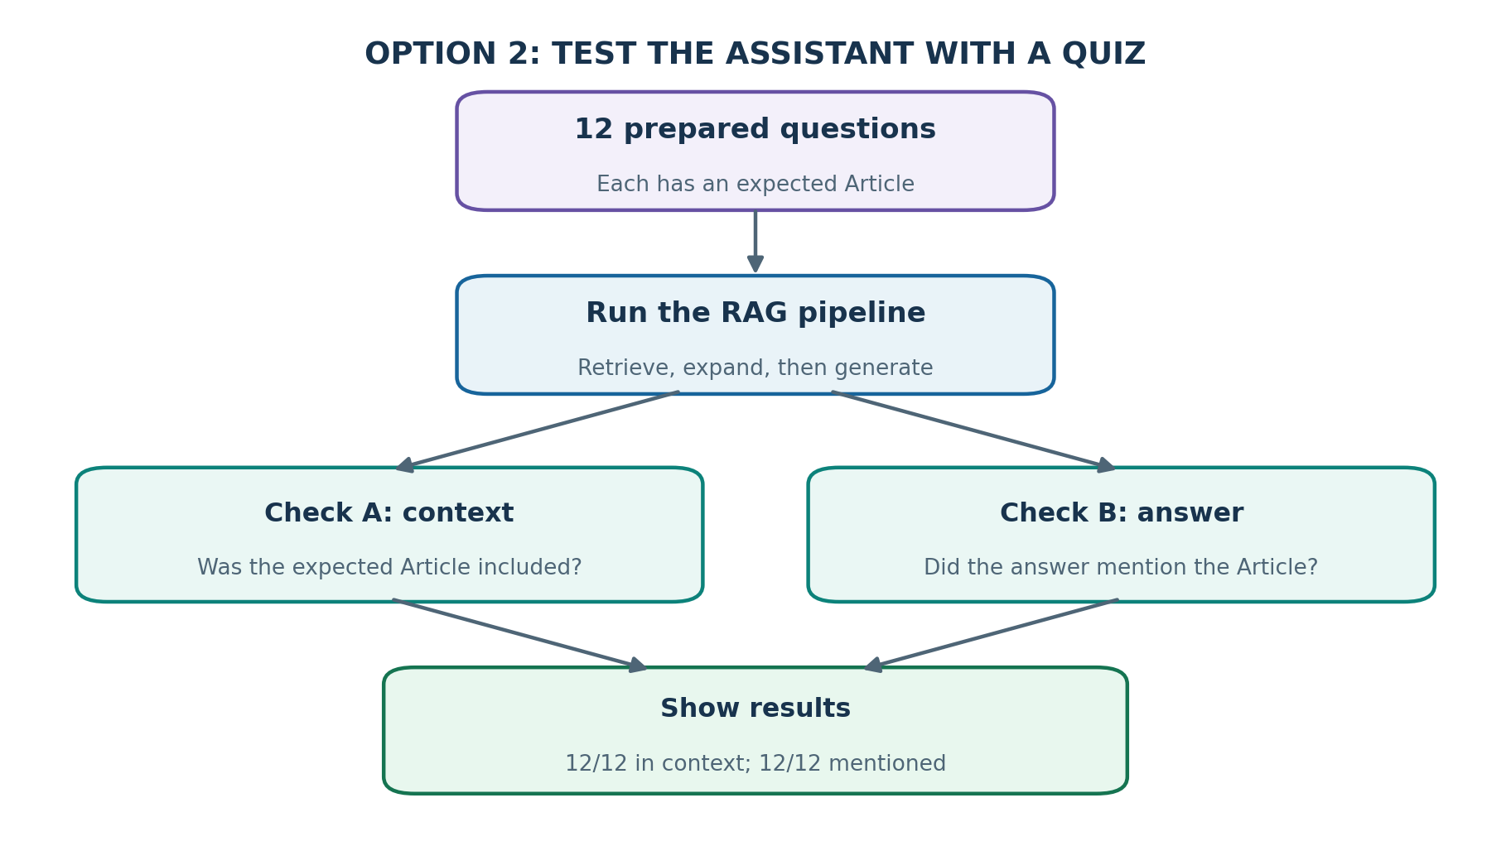
Figure 4. The 12-question evaluation repeats the pipeline and records two checks.

What do the results mean?
Step | What it means in simple English
12/12 in context | For all 12 questions, the expected Article was included in the information given to Groq.
12/12 mentioned | For all 12 questions, the generated answer mentioned the expected Article.
Not 100% accuracy | Mentioning an Article does not prove every sentence in the answer is correct.
Saved progress | Completed question results were saved so an API error did not require starting the entire quiz again.
Important detail: The completed evaluation reused earlier saved answers for some questions. A fresh full run using one final configuration would be a stronger test.

5. Two evaluations: why do we need both?
We asked two different questions about the system. The first checks how good our search is. The second checks whether the complete question-answering pipeline uses the expected Article.
Step | What it means in simple English
Retrieval evaluation | Test MiniLM versus BGE without asking Groq to write an answer. Hit@5 means the correct Article is among the five retrieved results.
Full RAG evaluation | Run the search and Groq answer generation, then check the expected Article in the context and the answer.

MiniLM versus BGE on 12 curated questions
Step | What it means in simple English
Hit@1 | MiniLM: 9/12 (75%) | BGE: 9/12 (75%)
Hit@3 | MiniLM: 9/12 (75%) | BGE: 12/12 (100%)
Hit@5 | MiniLM: 10/12 (83.3%) | BGE: 12/12 (100%)

6. Problems we solved along the way
Step | What it means in simple English
Only part of an Article appeared | We expanded retrieved sections to include their other chunks.
A relevant Article ranked second | We expanded the top three unique sections, not just the first one.
Groq rejected oversized requests | We capped the context at 12,000 characters.
API limits or connection errors | We used retries and saved evaluation progress.

7. Tiny dictionary
Chunk = a small labelled piece of text. Embedding = a list of numbers representing meaning. FAISS = a tool that finds nearby vectors quickly. Context = the source text sent to the language model. Groq = the service used to run the answer-generating model. RAG = search first, then answer using what was found.
Project repository: https://github.com/SaurabRauniyar/eu-ai-act-rag-assistant

