SAURABH CHAVAN

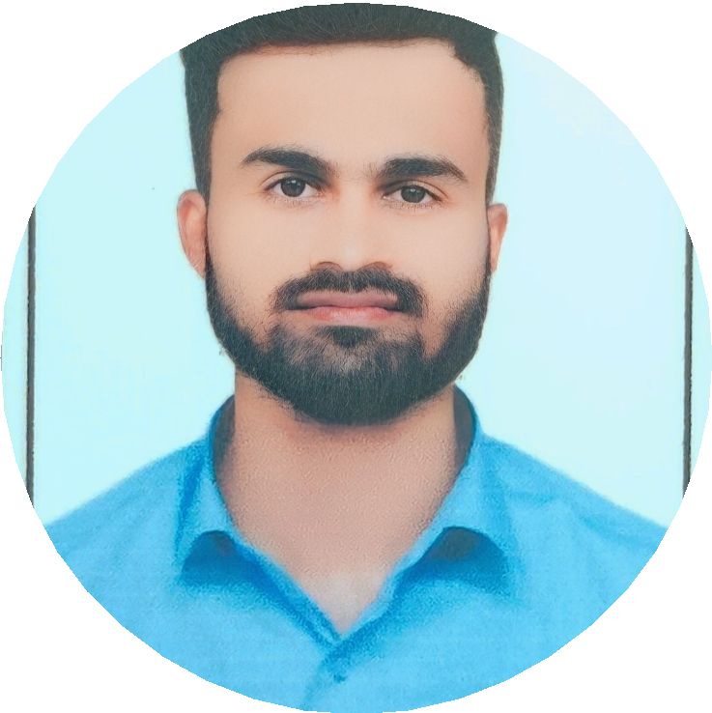

(Software Engineer - EY GDS)

 03/10/2001 (Maharashtra, India)

 Latur, Maharashtra - 413

 [saurabhchavan.official212@gmail.com](mailto:saurabhchavan.official212@gmail.com)

 https://saurabh-212800.github.io/Portfolio//  [www.linkedin.com/in/saurabh-cha212](http://www.linkedin.com/in/saurabh-cha212)

 https://github.com/Saurabh-212800

My name is Saurabh Chavan. I’m a versatile software engineer possessing a broad range of skills and a diverse skill set. I work best in dynamic contexts, whether I’m engaging with designers to improve user experience or embracing agile approaches to produce projects quickly and efficiently.

**EDUCATION**

**WORK EXPERIENCE**

# Bachelor of Engineering

(Electronics and Telecommunication Engineering)

*CGPA - 9.03*

Dr. DY. Patil Institute of Technology, Pune 

2019 – 2023 

# 12th High School Certificate

*PCM Grade - 70.00%*

Tripura Junior Science College 

2018 – 2019 

# 10th High School Certificate

*CGPA – 8.20*

Kendriya Vidyalaya No.1 AFS, Pune 

2016 – 2017 

# Full Stack Developer

Mostly playing with Mars rovers to search for the

 Exposys Data Labs

 November 2021 – January 22

# Personal portable heater

Hired on demand by those who happened to feel

 MDU. Shanti Solutions Pvt. Ltd.

 November 2021 – December 2021

**PROJECTS**

# Online Result Portal

# Tasks -

# 1] Developed an Website

# 2] Languages used- HTML, CSS & PHP

**CERTIFICATIONS**

**SKILLS & LANGUAGES**

# DevOps Engineer Expert (AZ-400)

Azure DevOps, Deployment, Security

# Azure Developer Associate (AZ-204)

Azure Cloud, Azure Vault, Azure Monitor

# Azure Cloud fundamentals (AZ-900)

Cloud Models, ARM, Cloud Services

# Google Data Analytics (Coursera)

Data Visualization, SQL, Critical Thinking

# 

# 

Java  Python  C++  JavaScript  HTML

 SQL  C#  CSS  React Native

**PERSONAL INTERESTS**



Athletics ( National ) Football

Badminton Watching Movies