ASSIGNMENT-8
A Job Ready Bootcamp in C++, DSA and IOT
Pattern Problems

NAME: KUMAR SAURABH
EMAIL: kumar.saurabh786@gmail.com
MOBILE: 7488540029

1) Write a program to draw the following patterns:
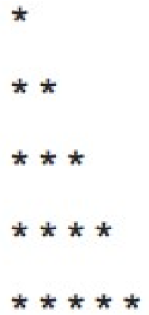
ANSWER:
#include<stdio.h>
int main()
{
int i, j ;
printf("Now Desired Shape:\n");
for(int i=1;i<=5;i++)
{
for(int j=1;j<=i;j++)
{
printf("* ");
}
printf("\n");
}
return 0;
}

/*OUTPUT:
Now Desired Shape:
*
**
***
****
***** */

2)
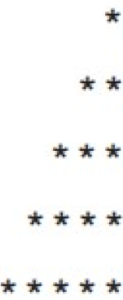

ANSWER:
#include <stdio.h>
int main()
{
int i, j;
printf("Now Desired Shape:\n");
for(i=1; i<=5; i++)
{
for(j=1; j<=5; j++)
{
if((i+j)<=5)
printf(" ");
else
printf("*");
}
printf("\n");
}
return 0;
}

/*OUTPUT:
Now Desired Shape:
*
**
***
****
***** */

3)
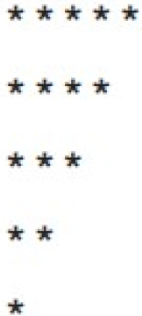

ANSWER:
#include <stdio.h>
int main()
{
int i, j;
printf("Now Desired Shape:\n");
for(i=1; i<=5; i++)
{
for(j=5; j>=i; j--)
{
printf("*");
}
printf("\n");
}
return 0;
}

/*OUTPUT:
Now Desired Shape:
*****
****
***
**
* */

4)
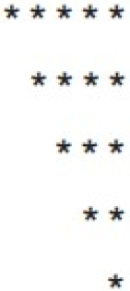

ANSWER:
#include <stdio.h>
int main()
{
int i, j;
printf("Now Desired Shape:\n");
for(i=1; i<=5; i++)
{
for(j=1; j<=5; j++)
{
if(j>=i)
printf("*");
else
printf(“ ”);
}
printf("\n");
}
return 0;
}

/*OUTPUT:
Now Desired Shape:
*****
****
***
**
* */

5)
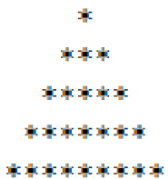

ANSWER:
#include <stdio.h>
int main()
{
int i, j,space;
printf("Now Desired Shape:\n");
for(i=1; i<=5; i++)
{
for(space=1; space<=(5-i); space++)
{
printf(" ");
}
for(j=1; j<=i; j++)
{
printf(“* ”);
}
printf("\n");
}
return 0;
}

/*OUTPUT:

Now Desired Shape:
*
* *
* * *
* * * *
* * * * * */

6)
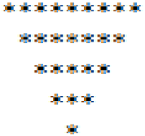

ANSWER:

#include <stdio.h>
int main()
{
int i, j,space;
printf("Now Desired Shape:\n");
for(i=5; i>=1; i--)
{
for(space=1; space<=(5-i); space++)
{
printf(" ");
}
for(j=1; j<=2*i-1; j++)
{
printf(“*”);
}
printf("\n");
}
return 0;
}

/*OUTPUT:

Now Desired Shape:
*********
*******
*****
***
*
7)
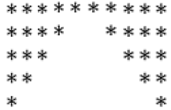
ANSWER:
#include <stdio.h>
int main()
{
int i, j;
printf("Now Desired Shape:\n");
for(i=1; i<=5; i++)
{
for(j=1; j<=10; j++)
{
if(j<=6-i || j>=5+i)
{
printf("*");
}
else
printf(" ");
}
printf("\n");
}
return 0;
}

/*OUTPUT:
Now Desired Shape:
**********
**** ****
*** ***
** **
* * */
8)
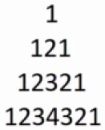

ANSWER:

int main()
{
int i, j;
printf("Now Desired Shape:\n");
for(i=1;i<=4;i++)
{
for(j=4; j>i; j--)
{
printf(" ");
}
for(j=1;j<=i;j++)
{
printf("%d ",j);
}
for(j=j-2;j>=1;j--)
{
printf("%d ",j);
}
printf("\n");
}
return 0;
}

/*OUTPUT:
Now Desired Shape:
1
1 2 1
1 2 3 2 1
1 2 3 4 3 2 1 */
9)
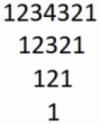

ANSWER:
#include <stdlib.h>
int main()
{
int i,j,space=0;
printf("Now Desired Shape:\n");
for(i=4; i>=1; i--)
{
for(j=1; j<=space; j++)
printf(" ");
for(j=1; j<=i; j++)
printf("%d",j);
for(j=i-1; j>=1; j--)
printf("%d",j);
printf("\n");
space++;
}
return 0;
}

/*OUTPUT:
Now Desired Shape:
1234321
12321
121
1 */

10)
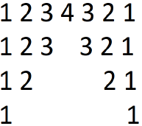

ANSWER:

#include<stdio.h>
int main()
{
int i, j, k, sp=-1;
printf("Now Desired Shape:\n");
for(i=4 ;i>=1; i--)
{
for(j=1; j<=i; j++)
{
printf("%d ",j);
}
for(j=1;j<=sp;j++)
{
printf(" ");
}
sp+=2;
if(i==4)
j= i-1;
else
j=i;
for(;j>=1;j--)
{
printf("%d ",j);
}
printf("\n");
}
return 0;
}

/*OUTPUT:
Now Desired Shape:

1 2 3 4 3 2 1
1 2 3 3 2 1
1 2 2 1
1 1 */

11)
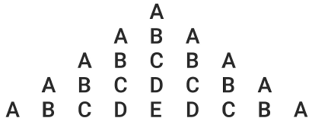

ANSWER:
#include<stdio.h>
int main()
{
int i,n,j;
printf("Now Desired Shape:\n");
for(i=1;i<=5;i++)
{
for(j=1;j<=5-i;j++)
{
printf(" ");
}
for(j=1;j<=i;j++)
{
printf("%c",(char)(j+64));
}
for(j=i-1;j>=1;j--)
{
printf("%c",(char)(j+64));
}
printf("\n");
}
return 0;
}

/*OUTPUT:
Now Desired Shape:
A
ABA
ABCBA
ABCDCBA
ABCDEDCBA */

12)
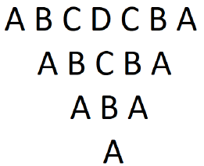
ANSWER:
#include<stdio.h>
int main()
{
int i,n,j;
printf("Now Desired Shape:\n");
for(i=4;i>=1;i--)
{
for(j=4;j>=1+i;j--)
{
printf(" ");
}
for(j=1;j<=i;j++)
{
printf("%c",(char)(j+64));
}
for(j=i-1;j>=1;j--)
{
printf("%c",(char)(j+64));
}
printf("\n");
}
return 0;
}

/*OUTPUT:
Now Desired Shape:
ABCDCBA
ABCBA
ABA
A */

13.
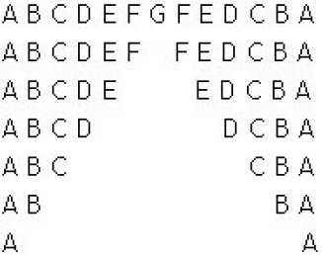

ANSWER:
#include <stdio.h>
int main()
{
int i, j, k, l;
printf("Now Desired Shape:\n");
for(i=0; i<=6; i++)
{
for(j=65; j<=71-i; j++)
{
printf("%c",j);
}
for(l=1; l<=i*2-1; l++)
{
printf(" ");
}
for(k=71-i; k>=65; k--)
{
if(k==71);
else
printf("%c", k);
}
printf("\n");
}
return 0;
}

/*OUTPUT:
Now Desired Shape:
ABCDEFGFEDCBA
ABCDEF FEDCBA
ABCDE EDCBA
ABCD DCBA
ABC CBA
AB BA
A A */

14)
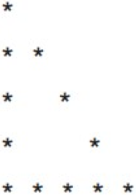

ANSWER:
#include <stdio.h>
int main()
{
int i, j;
printf("Now Desired Shape:\n");
for(i=1; i<=5; i++)
{
for(j=1; j<=i; j++)
{
if(j==1 || j==i || i==5)
{
printf("*");
}
else
{
printf(" ");
}
}
printf("\n");
}
return 0;
}

/*OUTPUT:
Now Desired Shape:
*
**
* *
* *
***** */

15)
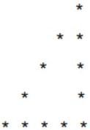

ANSWER:
#include<stdio.h>
int main()
{
int i, j;
printf("Now Desired Shape:\n");
for(i=1; i<=5; i++)
{
for(j=i; j<5; j++)
{
printf(" ");
}
for(j=1 ; j<=i; j++)
{
if(i==5 || j==1 || j==i)
{
printf("*");
}
else
{
printf(" ");
}
}
printf("\n");
}
return 0;
}

/*OUTPUT:
Now Desired Shape:
*
**
* *
* *
***** */

16)
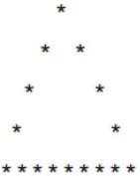

ANSWER:
#include <stdio.h>
int main()
{
int i, j;
printf("Now Desired Shape:\n");
for(i=1; i<=5; i++)
{
for(j=i; j<5; j++)
{
printf(" ");
}
for(j=1; j<=(2*i-1); j++)
{
if(i==5 || j==1 || j==(2*i-1))
{
printf("*");
}
else
{
printf(" ");
}
}
printf("\n");
}
return 0;
}

/*OUTPUT:
Now Desired Shape:
*
* *
* *
* *
********* */

17)
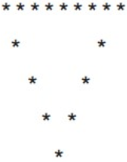

ANSWER:
#include <stdio.h>
int main()
{
int i, j;
printf("Now Desired Shape:\n");
for(i=5; i>=1; i--)
{
for(j=i; j<5; j++)
{
printf(" ");
}
for(j=1; j<=(2*i-1); j++)
{
if(i==5 || j==1 || j==(2*i-1))
{
printf("*");
}
else
{
printf(" ");
}
}

printf("\n");
}

return 0;
}

/*OUTPUT:
Now Desired Shape:
*********
* *
* *
* *
* */
18)
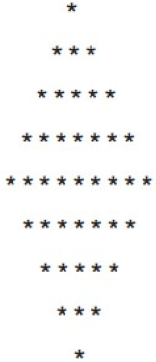

ANSWER:
#include <stdio.h>
int main()
{
int i, j;
printf("Now Desired Shape:\n");
for(i=1; i<=5; i++)
{
for(j=i; j<5; j++)
{
printf(" ");
}
for(j=1; j<=(2*i-1); j++)
{
printf("*");
}
printf("\n");
}
for(i=5; i>=1; i--)
{
for(j=i; j<=5; j++)
{
printf(" ");
}
for(j=2; j<(2*i-1); j++)
{
printf("*");
}
printf("\n");
}
return 0;
}

/*OUTPUT:
Now Desired Shape:
*
***
*****
*******
*********
*******
*****
***
* */

19)
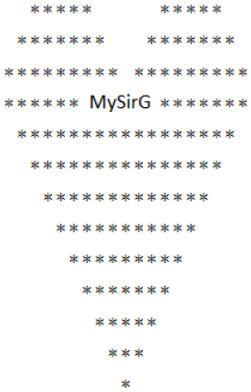
ANSWER:
#include <string.h>
int main()
{
int i, j, n=10;
char name[50]="MySirG";
int len;
printf("Now Desired Shape:\n");
len = strlen(name);
for(i=n/2; i<=n; i+=2)
{
for(j=1; j<n-i; j+=2)
{
printf(" ");
}
for(j=1; j<=i; j++)
{
printf("*");
}
for(j=1; j<=n-i; j++)
{
printf(" ");
}
for(j=1; j<=i; j++)
{
printf("*");
}

printf("\n");
}
for(i=n; i>=1; i--)
{
for(j=i; j<n; j++)
{
printf(" ");
}
if(i == n)
{
for(j=1; j<=(n * 2-len)/2; j++)
{
printf("*");
}
printf("%s", name);
for(j=1; j<(n*2-len)/2; j++)
{
printf("*");
}
}
else
{
for(j=1; j<=(i*2)-1; j++)
{
printf("*");
}
}

printf("\n");
}

return 0;
}

/*OUTPUT:
Now Desired Shape:
***** *****
******* *******
********* *********
*******MySirG******
*****************
***************
*************
***********
*********
*******
*****
***
*

