**HW #1 Ansible**

1. **Screenshots of vms and their ip**

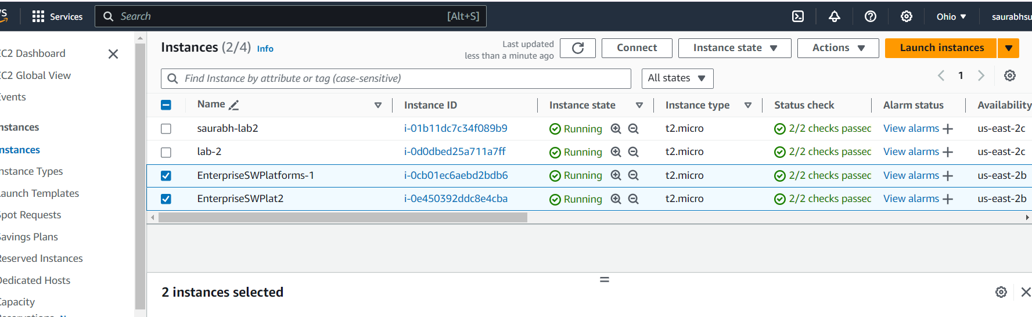

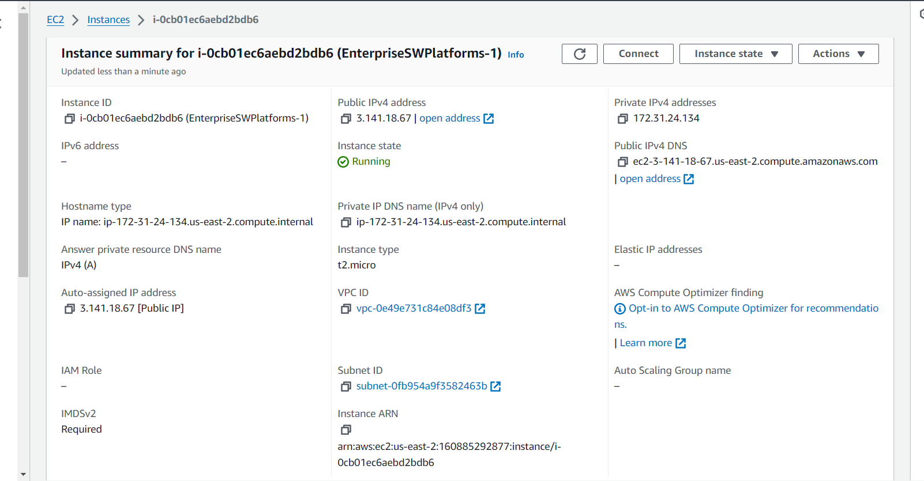

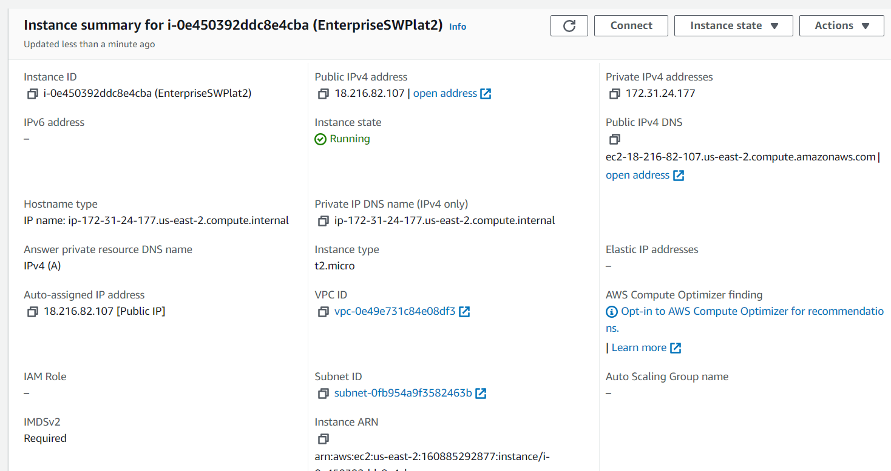

1. **Ansible deploy**

Command used -> ansible-playbook -i hosts.ini playbook.yml -e deploy_webserver=true

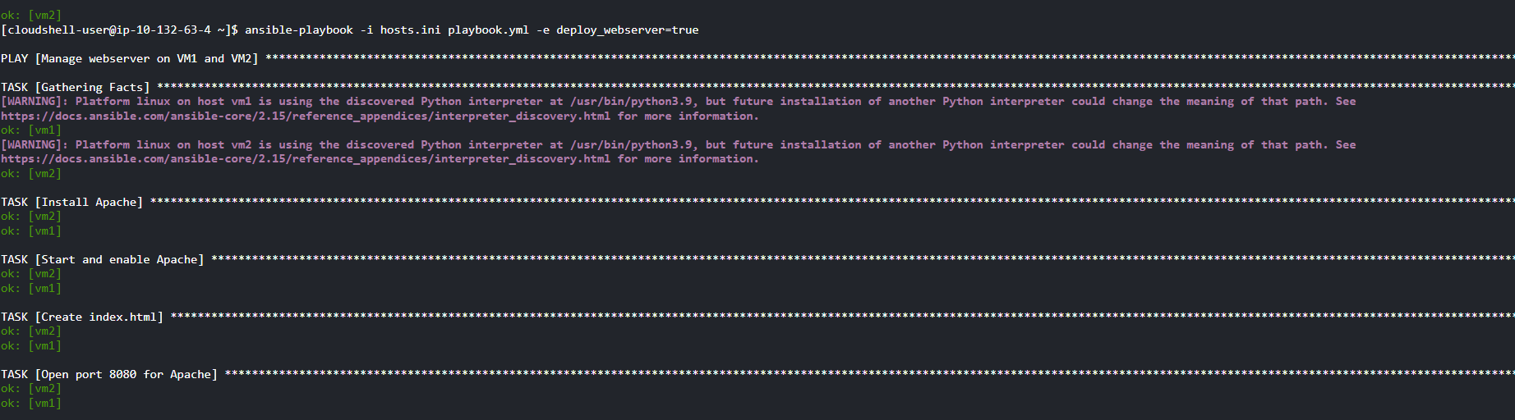

1. **Ansible undeploy**

Command used -> ansible-playbook -i hosts.ini playbook.yml -e undeploy_webserver=true

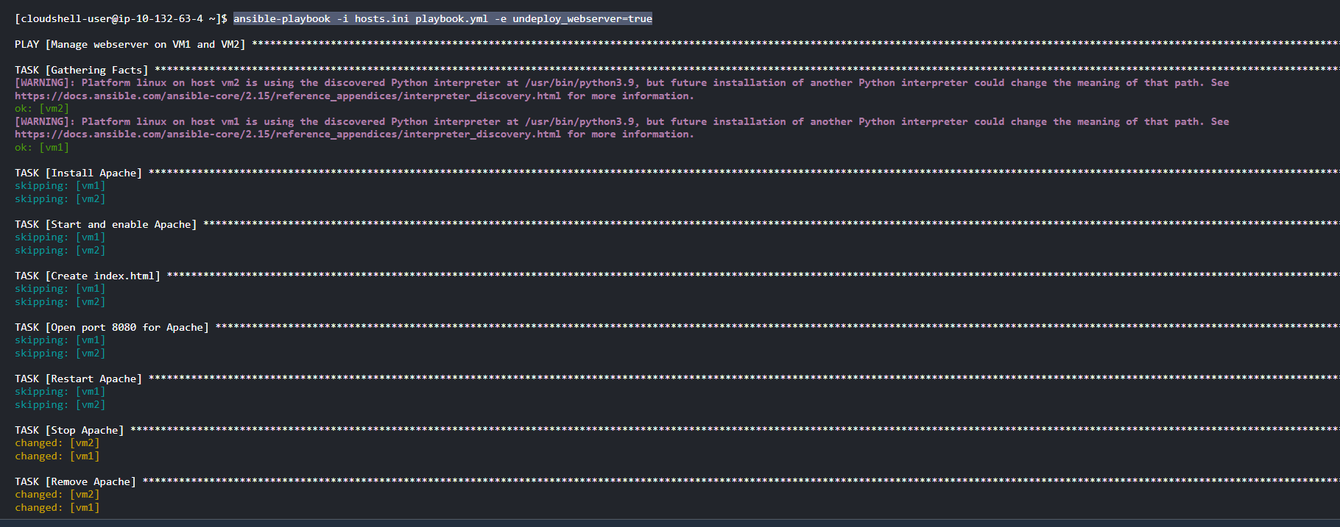

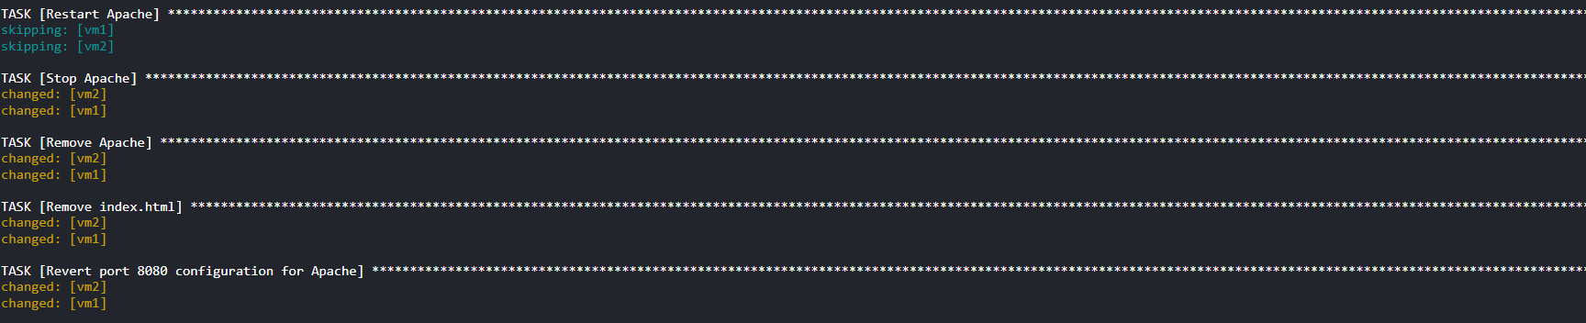

**LINKS**

* Link to demo video - [9_8_2024, 6_20_47 PM - Screen - Untitled video.webm](https://drive.google.com/file/d/1esl4o_elyl99RujNK-PACuT3xeg7xE58/view?usp=sharing)
* Link to github link - <https://github.com/Saurabh-Suchak/Enterprise-Software-Platform-Ansible>