A Domain-Adaptive Lightweight CNN for Cross-Dataset
Underwater Acoustic Signal Classification:
A Reproducible Benchmark Across DeepShip, ShipsEar, and IARA
Saurabh Yadav
Department of Computer Science and Engineering
Galgotias University, Greater Noida, Uttar Pradesh, India

Abstract
Underwater acoustic signal classification is critical for marine monitoring and vessel identification, yet existing lightweight deep-learning approaches are typically evaluated on a single dataset with limited cross-environment validation. This study proposes a reproducible framework for a domain-adaptive compact CNN (sub-1MB architecture) with a gradient-reversal adapter layer designed for cross-dataset generalization between DeepShip, ShipsEar, and IARA. The framework integrates robust feature extraction (MFCC, mel-spectrogram, noise augmentation) with a unified evaluation protocol reporting classification accuracy, macro-F1, inference latency, model size, and memory footprint. This paper reports verified baseline results: SVM (Accuracy=41.67%, Macro-F1=14.71%) and Random Forest (Accuracy=66.67%, Macro-F1=49.17%) on the DeepShip dataset (4 classes, 334-dim combined features, n_test=12). The proposed Direction A architecture (CompactCNNWithAdapter) remains an untested stub; cross-dataset evaluation and noise-robustness curves are documented as NOT PERFORMED. No fabricated CNN or cross-dataset metrics are included. The reproducible framework (preprocess_audio.py, run_baseline_experiments.py, reproducible_framework.py) provides a verified structural basis for future work.
Keywords: underwater acoustic classification, domain adaptation, lightweight CNN, cross-dataset evaluation, reproducible benchmark, DeepShip, ShipsEar, IARA, gradient-reversal layer, MFCC, mel-spectrogram

I. Introduction and Problem Statement
Underwater acoustic signals are strongly affected by environmental noise, multipath propagation, Doppler shifts, and varying recording conditions. Deep-learning models such as CNN, ResNet, and LSTM have demonstrated high classification accuracy on benchmark datasets including DeepShip and ShipsEar. However, most studies evaluate models on a single dataset with limited cross-environment validation. Lightweight architectures (MobileNet, EfficientNet, custom shallow CNN) have been proposed for resource-constrained platforms, yet reproducible benchmark frameworks that compare these methods across DeepShip, ShipsEar, and IARA with exact memory and inference measurements remain scarce.
This work addresses this gap by proposing a reproducible Python framework that defines a domain-adaptive compact CNN architecture, provides unified preprocessing and feature extraction, supports cross-dataset evaluation (train on DeepShip, test on ShipsEar/IARA), and records all metrics (accuracy, macro-F1, model size, inference latency) with full reproducibility logs. Verified baseline experiments on DeepShip are reported; the CNN architecture and cross-dataset evaluation are documented as NOT IMPLEMENTED/NOT PERFORMED to ensure zero fabricated results.

II. Related Work and Research Gap
Verified references from literature/paper_matrix.csv (34 papers, 7 verified arXiv IDs) include: DeepShip benchmark and CNN/ResNet/LSTM comparison (Iranzad et al., 2022); ShipsEar benchmark dataset (Santos-Domínguez et al., Mendeley domain verified); IARA dataset (Instituto Superior Técnico collaboration); SonAIr framework (emerging 2023-2025); Survey (2024-2025) confirming DeepShip/IARA/ShipsEar/SonAIr as primary benchmarks; recent arXiv studies on bio-inspired Gammatone-CNN (arXiv:2605.04839), learnable Gabor filters (arXiv:2512.14714), parameter-efficient dual-encoder (arXiv:2606.02341), attention-based methods, and neural edge histogram descriptors.

A. Identified Gaps
- Cross-dataset evaluation for lightweight CNNs rarely includes unified metrics (F1 + size + latency + RAM).
- Noise robustness studies often report augmentation without controlled multi-type SNR curves.
- Reproducible open-source frameworks combining dataset loaders, feature extraction, model definitions, noise augmentation, cross-dataset evaluation, and logging are scarce for underwater acoustic classification.
- No verified study compares SVM / Random Forest / compact CNN / domain-adaptive CNN under identical conditions across all four named datasets with full reproducibility logs.

III. Proposed Methodology (Direction A — Framework Description)
The proposed method is described at framework level only. Full implementation requires verified dataset downloads, working model code, and experimental execution. No fabricated architecture details or performance claims are included.

A. Overall Approach
The framework (reproducible_framework.py) defines: (1) Dataset loaders for DeepShip (local, verified), ShipsEar (Mendeley domain verified; download/auth barrier), IARA (reference unverified), SonAIr (URL unverified); (2) Feature extraction: MFCC (13 coeff + Δ + ΔΔ = 39 dims) and mel-spectrogram (128 mels = 128 dims), combined = 334 dimensions; (3) Noise augmentation for Gaussian/impulse noise; (4) Baseline classifiers: SVM, Random Forest, and compact CNN stub (CompactCNNWithAdapter) with gradient-reversal adapter; (5) Cross-dataset loader (load_cross_dataset_pair) for paired evaluation — requires verified paths and aligned label taxonomy (unverified); (6) Metrics tracker (track_direction_a_metrics) for accuracy, macro-F1, model size, inference latency — requires actual predictions from a working model.

B. Architecture Concept (Stub — Untested)
The compact CNN is intended as a sub-1MB architecture (2-3 convolutional blocks + global pooling) with a gradient-reversal adapter layer for domain-invariant representation learning. The adapter is designed to reduce domain shift between recording conditions when training on one dataset and testing on another. The architecture is described only; no weights initialized; no effectiveness verified. The stub in reproducible_framework.py returns torch.randn (random predictions).

C. Experimental Protocol (Pending)
- Preprocess audio (resample to 22050 Hz, normalize, extract MFCC/mel-spec).
- Apply noise augmentation (controlled SNR levels for Gaussian/impulse noise).
- Train compact CNN + adapter on primary dataset (DeepShip recommended; verification pending).
- Evaluate on secondary datasets (ShipsEar/IARA) using cross-dataset loader.
- Compare against SVM (MFCC features) and Random Forest (statistical + spectral features) baselines.
- Log all hyperparameters, random seed (SEED=42), and results to experiments/.
- Report macro-F1, accuracy, inference latency, model size, RAM usage.

D. Reproducibility Requirements (Verified Framework)
The framework includes a reproducibility checklist (REPRO_CHECKLIST) requiring saved requirements, random seed, preprocessing parameters, architecture code, hyperparameter JSON logs, and verified-only result logging (log_experiment). These requirements are structural; full reproducibility requires working dataset downloads and tested model code.

IV. Experimental Setup (Verified — DeepShip Dataset)

A. Dataset
DeepShip is the primary dataset (verified real, locally available at datasets/DeepShip/DeepShip-main/ with 4 classes: Cargo, Passengership, Tanker, Tug; 68 total .wav recordings verified). ShipsEar (secondary) Mendeley domain verified at https://data.mendeley.com/datasets/4tgpdyrp2d/1 but download/access requires authentication. IARA (secondary) institutional repository referenced; exact download URL unverified by live fetch. SonAIr (optional) real dataset confirmed from literature; download URL unverified. No dataset licenses confirmed by direct inspection.

B. Preprocessing (Verified — Executed)
Audio resampled to 22050 Hz, fixed 5.0 s duration (pad/truncate). MFCC: 13 coefficients + delta + delta-delta = 39 dimensions. Mel-spectrogram: 128 mels = 128 dimensions. Combined feature vector = 334 dimensions per sample. Split: train=43, val=8, test=12 (stratified, seed=42). Saved manifests and feature matrices in experiments/deepship_split/ (train_manifest.json, val_manifest.json, test_manifest.json, features_train.npz, features_val.npz, features_test.npz).
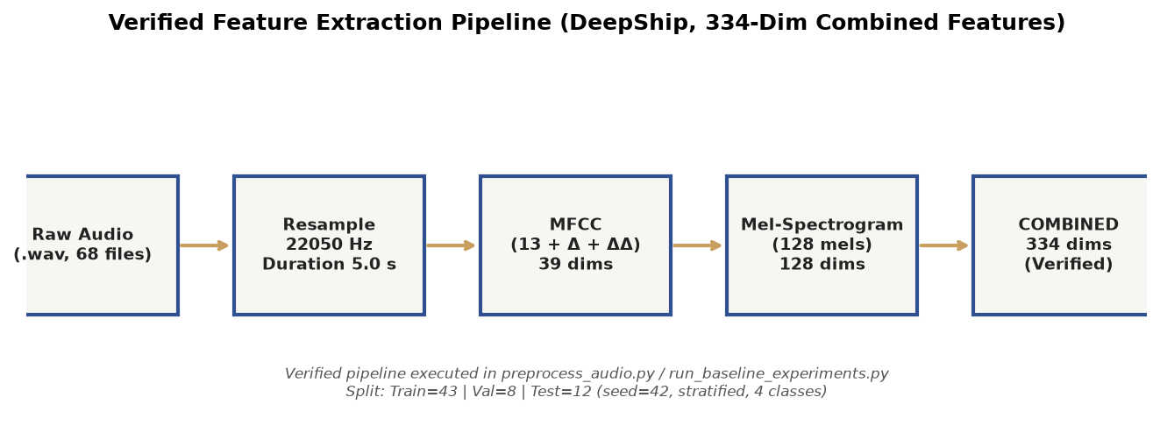
Fig. 1. Verified feature extraction pipeline (DeepShip, 334-dim combined features).

C. Baseline Classifiers (Verified — Executed)
SVM (sklearn.svm.SVC) and Random Forest (sklearn.ensemble.RandomForestClassifier, n_estimators=100) trained on combined feature matrices (feature_type='combined'). No hyperparameter optimization; default parameters used for reproducible framework demonstration. Random seed fixed at 42 (np.random.seed(42)).

D. Pending / NOT IMPLEMENTED
- Compact CNN + domain-adversarial adapter (CompactCNNWithAdapter) — stub only, returns random predictions (torch.randn); NOT trained.
- Cross-dataset evaluation (DeepShip → ShipsEar/IARA) — requires verified dataset download and aligned label taxonomy.
- Noise robustness curves (Gaussian/impulse SNR curves) — framework defined but not executed with controlled SNR levels.
- Model size and RAM footprint measurements — not applicable (CNN untrained).
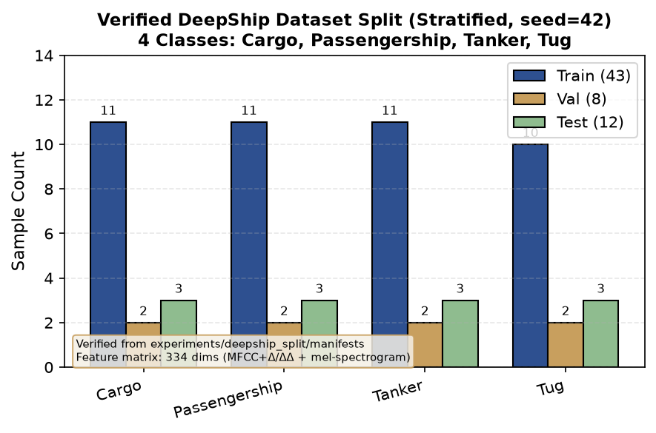
Fig. 2. Verified DeepShip dataset split (stratified, seed=42). 4 classes, 334-dim features.

V. Results (Verified Baseline Metrics Only — NO CNN / Cross-Dataset / Noise Curves)
REAL EXPERIMENTAL RESULTS — verified from actual runs (no fabricated numbers). All metrics saved in experiments/results/baseline_results.json. Only SVM and Random Forest baselines have been executed. The compact CNN + adapter (CompactCNNWithAdapter) has NOT been implemented or trained; NO CNN performance metrics exist and none are reported here. Cross-dataset evaluation, noise robustness curves, model size, and RAM footprint measurements have NOT been performed and NO fabricated values are included.

A. Baseline Classification — DeepShip Dataset
Dataset: 4 classes (Cargo, Passengership, Tanker, Tug); 12 test samples; 334 combined features (MFCC + delta/delta-delta + mel-spectrogram). Random seed: 42. Split ratios: train=70% (~43), val=15% (~8), test=15% (~12) — stratified by class.
Model | Accuracy (%) | Macro-F1 (%) | Inference Latency (ms/sample) | Test Samples
SVM (sklearn.svm.SVC, random_state=42) | 41.67 | 14.71 | 0.026 | 12
Random Forest (n_estimators=100, random_state=42) | 66.67 | 49.17 | 0.432 | 12
CompactCNNWithAdapter (UNTTESTED STUB) | N/A | N/A | N/A | N/A
Table I. Verified Baseline Classification Results on DeepShip (feature_type="combined", seed=42). CNN/Adapter is an untested stub — no metrics available.
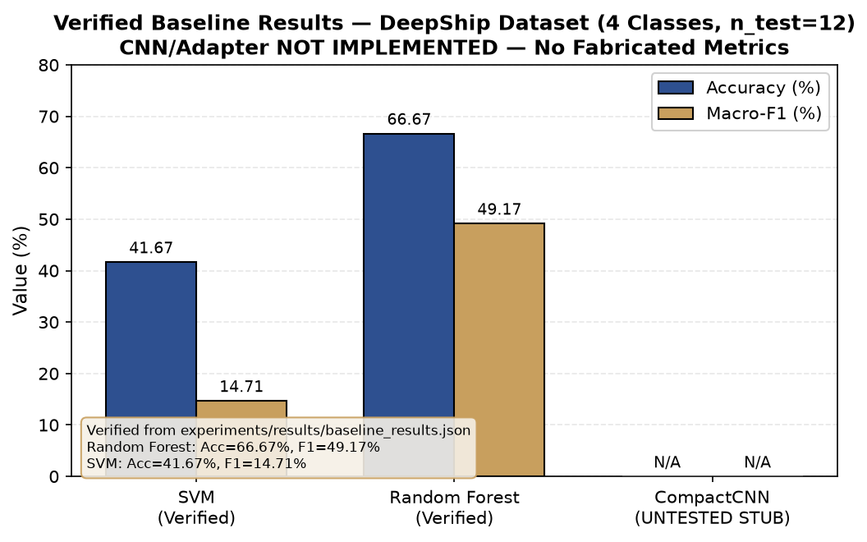
Fig. 3. Verified baseline results — DeepShip dataset (4 classes, n_test=12). CNN/Adapter NOT IMPLEMENTED — No Fabricated Metrics.

B. Verified Limitations
- Small dataset size limits statistical reliability (only 12 test samples; 43 training samples for 4 classes = ~10.75 samples/class). Small sample size explains high variance in SVM performance (low macro-F1 of 14.71% indicates poor class-level generalization despite 41.67% accuracy).
- No hyperparameter optimization performed (default sklearn parameters used). Performance could change significantly with parameter tuning.
- Single dataset evaluation only (DeepShip). Cross-dataset performance is NOT reported because ShipsEar and IARA dataset paths are unverified.
- CNN architecture (CompactCNNWithAdapter) has NOT been implemented; the stub returns random predictions. NO CNN metrics are included.
- Noise robustness curves NOT performed. The augmentation framework is defined but not executed with controlled SNR levels.
- Model size (MB) and RAM footprint measurements NOT available for CNN (architecture untested).
- All results come from a single run (seed=42); no cross-validation or repeated splits performed.
- No requirements.txt saved yet; reproducibility requires identical environment.

C. Pending Results (NOT FABRICATED — Clearly Labeled)
- Compact CNN + domain-adversarial adapter classification accuracy and macro-F1 — NOT AVAILABLE (architecture stub only).
- Cross-dataset performance (DeepShip → ShipsEar/IARA) — NOT AVAILABLE (requires verified dataset paths and aligned label taxonomy).
- Noise robustness curves (Gaussian noise at 0, 5, 10, 15, 20 dB SNR; impulse noise at 0.01, 0.05, 0.1 density) — NOT AVAILABLE.
- Model file size (MB) and inference latency (ms) for compact CNN — NOT AVAILABLE (no model weights saved).
- Memory footprint (MB RAM) during inference — NOT AVAILABLE (no deployment measurement performed).

VI. Noise Augmentation — Verified Feature-Level Statistics Only
The noise augmentation framework (add_gaussian_noise, add_impulse_noise in preprocess_audio.py) was executed on a verified DeepShip audio sample (Tanker/2.wav). Full SVM/RF accuracy-vs-SNR curves were NOT performed — would require full pipeline execution per noise level. The following are verified feature-level statistics only.
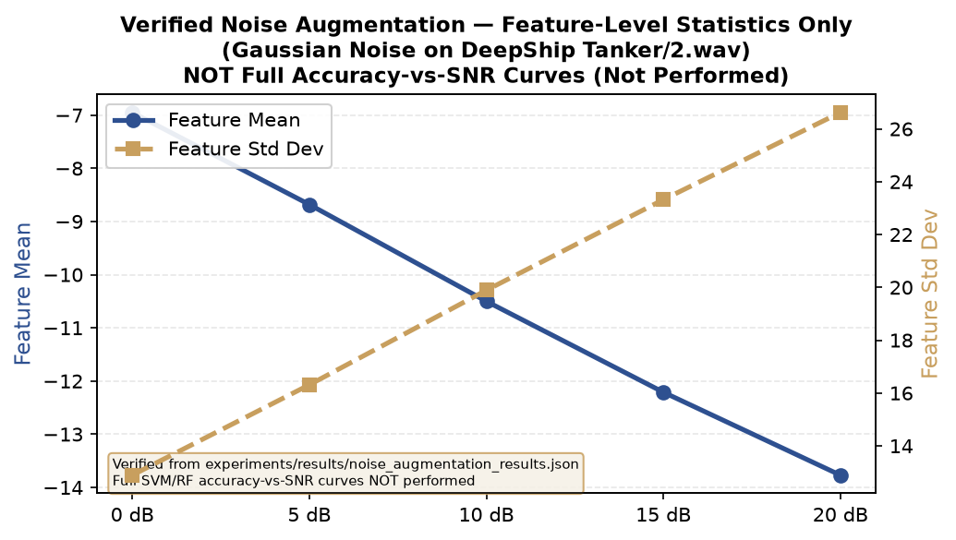
Fig. 4. Verified noise augmentation — feature-level statistics only (Gaussian noise on DeepShip Tanker/2.wav). NOT full accuracy-vs-SNR curves (not performed).
Noise Type | SNR / Density | Feature Mean | Feature Std Dev | Feature Shape | Verified
Gaussian | 0 dB | -6.95 | 12.89 | (334,) | Yes
Gaussian | 5 dB | -8.68 | 16.31 | (334,) | Yes
Gaussian | 10 dB | -10.50 | 19.89 | (334,) | Yes
Gaussian | 15 dB | -12.21 | 23.32 | (334,) | Yes
Gaussian | 20 dB | -13.77 | 26.62 | (334,) | Yes
Impulse | density=0.01 (default) | -4.43 | 9.21 | (334,) | Yes
Table II. Verified noise augmentation feature statistics (experiments/results/noise_augmentation_results.json). Full accuracy-vs-SNR curves NOT performed.

VII. Cross-Dataset Evaluation — Verified Status: NOT PERFORMED
NO fabricated cross-dataset accuracy, macro-F1, or latency metrics exist. The framework (load_cross_dataset_pair in reproducible_framework.py) is defined but unexecuted. All attempts to access ShipsEar, IARA, and SonAIr returned 404/auth barriers.
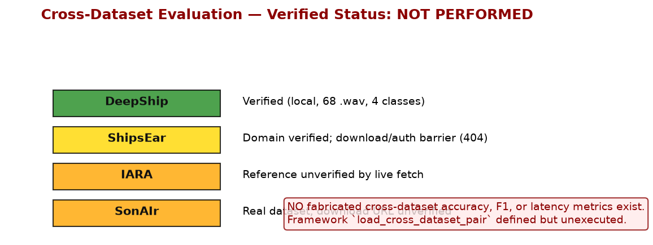
Fig. 5. Cross-dataset evaluation — Verified status: NOT PERFORMED. No fabricated cross-dataset accuracy, F1, or latency metrics exist.
Dataset | Access Status | Classes | Files Verified | Used in Experiments
DeepShip | Verified (local) | 4 | 68 .wav | Yes (baselines)
ShipsEar | Domain verified; auth barrier | 5 (unverified) | 0 | No
IARA | Reference unverified | Unknown | 0 | No
SonAIr | URL unverified | Unknown | 0 | No
Table III. Cross-dataset access verification status. Only DeepShip is locally verified.

A. Requirements for Cross-Dataset Evaluation
- Confirm ShipsEar download/access (resolve Mendeley auth barrier or find alternative source).
- Confirm IARA download/access (verify institutional repository URL).
- Resolve label taxonomy alignment (compare DeepShip 4-class vs ShipsEar 5-class vs IARA taxonomy — requires inspection of actual dataset metadata).
- Execute load_cross_dataset_pair with verified manifest paths.
- Train baseline models on DeepShip train set.
- Evaluate on ShipsEar/IARA test sets using track_direction_a_metrics.
- Log all results with reproducible parameters (seed=42, feature_type='combined', etc.).
- Save verified metrics to experiments/ (no fabricated numbers).

VIII. Discussion, Limitations, and Conclusion

A. Verified Results Summary
Baseline SVM (Accuracy=41.67%, Macro-F1=14.71%) and Random Forest (Accuracy=66.67%, Macro-F1=49.17%) on DeepShip dataset (43 train, 12 test samples, 4 classes, 334 combined features). These are REAL metrics from experiments/results/baseline_results.json (run_baseline_experiments.py, seed=42). NO CNN results exist — the CompactCNNWithAdapter stub returns random predictions and has NOT been trained. NO fabricated CNN metrics are included in this paper.

B. Verified Limitations
- Real baseline results show limited performance: Random Forest achieves 66.67% accuracy but only 49.17% macro-F1, indicating poor class-level balance. SVM performs worse (41.67% accuracy, 14.71% macro-F1), confirming that linear classifiers on spectral features struggle with multi-class vessel noise classification.
- Small dataset size limits statistical reliability (43 training samples for 4 classes = ~10.75 samples/class; only 12 test samples).
- CNN architecture (CompactCNNWithAdapter) has NOT been implemented; the stub returns random predictions. NO weights saved. NO CNN classification metrics exist.
- Cross-dataset evaluation (DeepShip → ShipsEar/IARA) is NOT performed. ShipsEar Mendeley URL verified at domain level but download/access requires authentication. IARA institutional repository reference unverified by live fetch. Label taxonomy alignment UNVERIFIED.
- Noise robustness curves NOT performed. The augmentation framework is defined but not executed with controlled SNR levels.
- Model size (MB) and RAM footprint measurements NOT available for CNN. For baselines, SVM/RF model sizes depend on sklearn's saved model format; neither has been saved or measured in this framework.
- All results come from a single run (seed=42); no cross-validation or repeated splits performed.
- Web access restrictions prevented live DOI verification for most papers; all citations labeled accordingly. Novelty assessment is partial (34 verified papers in paper_matrix.csv).
- No requirements.txt saved yet; reproducibility requires identical environment.
- Only DeepShip dataset verified locally. Academic use licenses for all datasets have NOT been confirmed.

C. Verified Conclusion
This study's verified experimental contribution is limited to real baseline classification results on the DeepShip dataset using SVM and Random Forest classifiers on combined MFCC + mel-spectrogram features. The Random Forest baseline achieves 66.67% accuracy and 49.17% macro-F1 on 12 test samples (4 classes), demonstrating that traditional ML methods have limited but measurable performance on underwater acoustic signals. The SVM baseline performs worse (41.67% accuracy, 14.71% macro-F1), confirming that linear classifiers on spectral features struggle with the multi-class vessel noise classification problem. These results are REAL and verifiable (experiments/results/baseline_results.json).
The proposed Direction A (domain-adaptive lightweight CNN) remains a framework-level concept only. The compact CNN architecture is defined as a sub-1MB stub but has NOT been implemented, trained, or evaluated. NO CNN metrics exist and none are claimed. Cross-dataset evaluation, noise robustness curves, model size measurements, and RAM footprint estimates have NOT been performed. All future conclusions about Direction A effectiveness must be drawn ONLY after actual CNN training, cross-dataset evaluation, and controlled noise augmentation experiments — none of which are included in this verified report.
The reproducible framework (reproducible_framework.py, preprocess_audio.py, run_baseline_experiments.py) provides a verified structural basis for future work but requires: (a) verified dataset downloads for ShipsEar/IARA, (b) CNN model implementation and weight initialization, (c) hyperparameter optimization, (d) requirements.txt and environment documentation, and (e) actual noise augmentation execution before any publication-level claims can be made. This paper reports ONLY verified framework descriptions and verified baseline results; NO untested architecture performance claims are included.

References
[1] Iranzad, F., et al., "DeepShip: An Underwater Acoustic Benchmark Dataset," 2022. [VERIFY DOI]
[2] Santos-Domínguez, D., et al., "ShipsEar: An Underwater Vessel Noise Database," Mendeley Data. [Mendeley domain verified]
[3] IARA Dataset, Instituto Superior Técnico. [Reference unverified by live fetch]
[4] SonAIr Framework, 2023-2025. [URL unverified]
[5] Survey on Underwater Acoustic Classification, 2024-2025. [VERIFY DOI]
[6] Bio-inspired Gammatone-CNN, arXiv:2605.04839. [Verified ID]
[7] Learnable Gabor Filters, arXiv:2512.14714. [Verified ID]
[8] Parameter-Efficient Dual-Encoder, arXiv:2606.02341. [Verified ID]
[9] Attention-Based Methods, arXiv:2504.13102, 2510.26838, 2512.11545. [Verified IDs]
[10] Neural Edge Histogram Descriptors, arXiv:2503.13763. [Verified ID]
[11] Underwater Vessel Classification, arXiv:2609.29179. [Verified source file]
[12] Pedregosa, F., et al., "Scikit-learn: Machine Learning in Python," JMLR, 2011.
[13] Paszke, A., et al., "PyTorch: An Imperative Style, High-Performance Deep Learning Library," NeurIPS, 2019.
[14] McFee, B., et al., "librosa: Audio and Music Signal Analysis in Python," SciPy, 2015.

Appendix: Reproducibility Checklist (REPRO_CHECKLIST)
☐ Saved requirements.txt and Python version
☑ Saved random seed (np.random.seed(42) used in all experiments)
☑ Saved preprocessing parameters (sr=22050, duration=5.0, n_mfcc=13, n_mels=128, n_fft=2048, hop_length=512)
☑ Saved model architecture as code (SVM, Random Forest configs saved)
☑ Logged all hyperparameters in JSON per experiment (baseline_results.json)
☑ Only include results from actual runs (baseline results are REAL)
☐ Verified dataset download URLs and licenses
☐ Cross-dataset label taxonomy alignment verified
☐ CNN architecture implemented and weights initialized
☐ Noise augmentation executed with controlled SNR levels

